Smart-X IoT Mesh Gateway
Task 1 Research Report: Dashboard User Engagement Strategies

1. Introduction
High-throughput IoT gateways such as Smart-X ingest continuous, multi-typed telemetry from thousands of distributed devices. Prior industrial monitoring research shows that when configuration and debugging consoles are difficult to interpret, technical staff either disengage from the tool or miss the early warning signs of failure, which increases mean time to detect and resolve faults (Samineni, 2020). This report identifies five developer-centric engagement strategies suited to a technical management interface, then justifies the strategy selected for the Smart-X ingestion dashboard.

2. Five Dashboard Engagement Strategies
- Real-time push-based telemetry feedback – streaming each reading to the client the instant it is ingested (e.g. via WebSockets/SignalR) rather than relying on the client to poll, so operators see spikes and disconnects as they happen rather than on the next refresh cycle (Bhatia et al., 2022).
- Threshold-based anomaly highlighting – applying static, dynamic, or adaptive threshold bands to incoming metrics so out-of-range values are visually flagged automatically instead of requiring the operator to mentally track “normal” ranges for every sensor (Samineni, 2020).
- Gamified alert handling – introducing game elements (streaks, progress indicators tied to resolution speed, positive reinforcement on acknowledgement) into otherwise monotonous monitoring tasks, which laboratory studies of control-room dashboards found improved operator engagement and perceived usability without harming monitoring accuracy (Spahrbier, Blank and Ziegler, 2022).
- Simplified, scaffolded onboarding/configuration flows – generating a working dashboard from minimal configuration so a new device or user can be registered in a few guided steps rather than a lengthy manual setup, reducing the drop-off risk the brief specifically warns about (Ribeiro, Lima and Nunes, 2021).
- Anomaly-context visual salience – colour-coding or pulsing individual readings against their own recent history (rather than a single global threshold), which lets an operator distinguish a genuine spike in one device from normal variation across the fleet (Bin Mofidul et al., 2022).

3. Chosen Strategy: Live, Anomaly-Triggered Telemetry Feed
The strategy selected for Smart-X combines the first and fifth strategies above into a single feature: a SignalR-driven live feed in which every ingested reading is pushed to the dashboard immediately and any reading that falls outside its category's safe band is rendered with a pulsing red highlight and an explicit “ANOMALY” flag, rather than a plain progress bar or a static table the operator must refresh.
The justification for this choice rests on three points. First, latency between an event occurring and an operator noticing it is the dominant component of troubleshooting time in high-throughput monitoring systems. The fault-detection study by Gültekin et al. (2022) on industrial transfer-vehicle monitoring found that moving from a store-and-poll architecture to a real-time push pipeline cut end-to-end data transfer time by a factor of roughly 37, directly shortening the window between a fault occurring and an operator seeing it. Applying the same push-based principle to Smart-X means an operator watching the dashboard sees a sensor go quiet or spike within the same second it is ingested, rather than after the next manual refresh.
Second, visual salience matters as much as speed. Bhatia et al. (2022) note that in edge-stream monitoring, the practical value of a real-time anomaly system depends on the alert reaching a human in an interpretable form quickly enough to act on it; a value silently added to a table does not achieve this, whereas a pulsing, colour-coded row draws the eye immediately, even in a busy multi-sensor view. This is particularly relevant for Smart-X's stated failure modes — anomalous data spikes and sensor disconnects — because both are transient: a spike may last one reading, and a disconnect is defined by the absence of an expected reading. A static dashboard the operator must actively scan will miss both; a push-and-pulse dashboard surfaces both automatically.
Third, this strategy scales gracefully with the throughput the brief describes (“thousands of microcontrollers”). Because the anomaly check happens server-side at ingestion time using a simple threshold comparison (Samineni, 2020), and only flagged or newly arrived readings are pushed, the dashboard's rendering cost stays proportional to genuinely new information rather than to the total historical record size, which is instead served on demand from the custom binary-search-tree collection described in Section 4 of the implementation.
In combination, these three factors — minimal detection latency, immediate visual interpretability, and scalability under load — directly reduce the time a Smart-X operator needs to notice, locate, and begin troubleshooting an anomalous spike or a silently disconnected sensor, which was the specific evaluation criterion set for this task.

4. Diagram: Engagement Feature in the Ingestion Pipeline
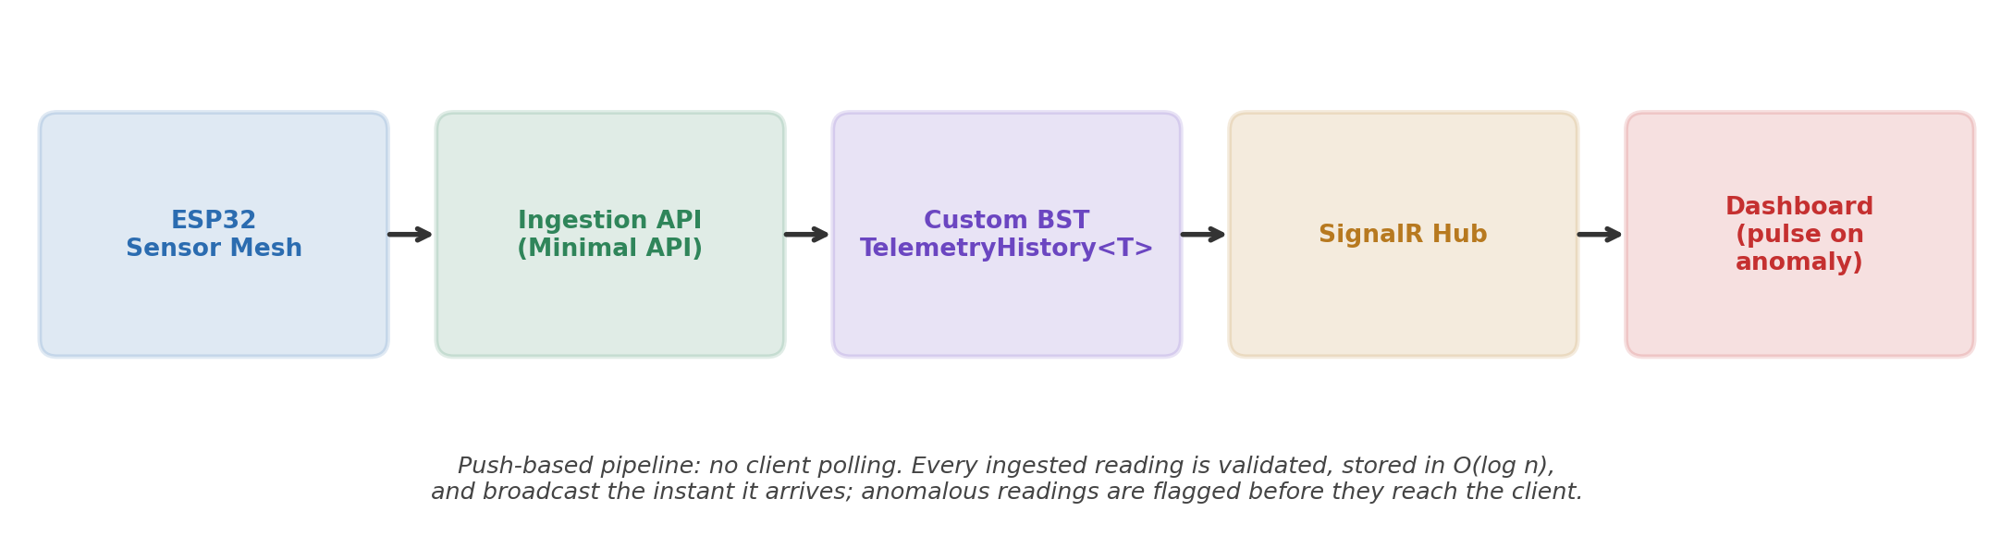
Figure 1: The chosen engagement strategy sits at the point where the SignalR hub broadcasts to the dashboard — every reading is pushed immediately, and readings outside the safe band are tagged as anomalies before transmission so the client can render the pulse effect without recomputation.

References
Gültekin, Ö., Cinar, E., Özkan, K. and Yazıcı, A. (2022) 'Real-Time Fault Detection and Condition Monitoring for Industrial Autonomous Transfer Vehicles Utilizing Edge Artificial Intelligence', Sensors, 22(9), 3208.
Bin Mofidul, R., Alam, M.M., Rahman, M.H. and Jang, Y.M. (2022) 'Real-Time Energy Data Acquisition, Anomaly Detection, and Monitoring System: Implementation of a Secured, Robust, and Integrated Global IIoT Infrastructure with Edge and Cloud AI', Sensors, 22(22), 8980.
Bhatia, S., Liu, R., Hooi, B., Yoon, M., Shin, K. and Faloutsos, C. (2022) 'Real-Time Anomaly Detection in Edge Streams', ACM Transactions on Knowledge Discovery from Data, 16(4), Article 75.
Ribeiro, J., Lima, P. and Nunes, F. (2021) 'Trial Monitor: Scaffolding personalised Web dashboards for Human–Computer Interaction field trials', SoftwareX, 16, 100883.
Samineni, N.C. (2020) 'Threshold-Based Anomaly Detection for Operational Retail Dashboards', International Journal of Engineering Technology Research & Management, 4(12), pp. 213–220.
Spahrbier, M., Blank, D. and Ziegler, D. (2022) 'Supporting human monitoring activities in highly automated manufacturing through gamification', Computers & Industrial Engineering, 172, 108049.

