**CHAPTER 1**

**INTRODUCTION**

In college settings, efficient management of lighting systems, fans, and other appliances is crucial for optimizing productivity and ensuring safety. To achieve this, automated systems are deployed to control the operation of these devices. These systems not only manage the switching of lights and activation of fans but also provide realtime monitoring and alerting functionalities to promptly address any issues that may arise.

Automated lighting systems regulate the illumination levels in college facilities based on factors such as occupancy, time of day, and ambient light conditions. By intelligently controlling the switching of lights, energy consumption is minimized while maintaining adequate visibility for workers.

Similarly, fans and other appliances are operated automatically to maintain optimal environmental conditions within the college premises. For example, fans may be activated to regulate temperature and ventilation, ensuring a comfortable and safe working environment for personnel.

In addition to automation, these systems incorporate advanced monitoring capabilities to detect anomalies or malfunctions in the operation of appliances. When abnormalities are detected, alerts are generated to notify maintenance personnel or supervisors, allowing them to investigate and address the issue promptly.

One notable feature of these systems is their ability to provide detailed information about the status and performance of individual appliances. For instance, in the case of a malfunctioning fan, the system can alert the relevant personnel and provide specific details such as the fan's location, model, and operational history, facilitating rapid diagnosis and resolution of the problem.

By combining automation, monitoring, and alerting functionalities, college facilities can enhance operational efficiency, improve safety, and minimize downtime due to equipment failures. This integrated approach to managing lighting, fans, and other appliances ensures smooth operations and enables proactive maintenance practices to maximize productivity and profitability.

**1.1: Problem Statement:**

The problem statement involves developing a comprehensive system for controlling lights, operating fans, and managing other appliances within an college setting while also ensuring prompt alerting and diagnosis of issues with specific fans. This system must seamlessly integrate automation for turning lights on and off, controlling fan operations, and managing other college appliances, optimizing energy efficiency and operational processes. Additionally, it must include robust monitoring and alerting mechanisms that provide realtime notifications and detailed information when abnormalities or malfunctions occur with individual fans, enabling swift troubleshooting and maintenance to minimize downtime and ensure uninterrupted production processes.

**1.2: Problem Scope:**

The problem scope involves the implementation of an college automation system that controls lights, fans, and other appliances within an college facility. This system should be capable of remotely turning lights on and off, operating fans, and controlling various other appliances as needed. Additionally, it should incorporate monitoring and alerting functionalities to detect and respond to issues, particularly related to fan operation.

The primary objectives of the system include:

1. Remote Control: Enable remote control of lights, fans, and other appliances within the college facility. This involves the development of a user interface or control panel through which authorized personnel can access and manipulate the operation of these devices.

2. Automation: Implement automation capabilities to enable scheduled operation of lights, fans, and appliances based on predefined criteria or conditions. This may involve setting timers, triggers, or sensors to activate or deactivate devices automatically.

3. Fault Detection: Develop monitoring mechanisms to detect faults or malfunctions in the operation of fans and other critical appliances. This includes monitoring parameters such as fan speed, power consumption, temperature, and vibration levels to identify deviations from normal operation.

4. Alerting System: Implement an alerting system that notifies relevant personnel in realtime when abnormalities or faults are detected in fan operation or other appliances. Alerts may be sent via email, SMS, or integrated with existing facility management systems for immediate action.

5. Diagnostic Details: Provide detailed diagnostic information about the exact nature of faults or issues affecting fan operation. This may include information such as error codes, sensor readings, and historical data to facilitate troubleshooting and repair.

6. Integration: Ensure seamless integration with existing college control systems, including SCADA (Supervisory Control and Data Acquisition) systems, PLCs (Programmable Logic Controllers), and IoT (Internet of Things) devices. This enables data exchange and interoperability between different components of the college automation ecosystem.

7. Security: Implement robust security measures to protect the automation system from unauthorized access, tampering, or cyber threats. This includes authentication mechanisms, encryption protocols, and access controls to safeguard sensitive data and ensure the integrity of operations.

8. Scalability: Design the automation system to be scalable and adaptable to the evolving needs of the college facility. This allows for the addition of new devices, sensors, or functionalities as the facility expands or undergoes changes in operation.

By addressing these objectives, the college automation system can effectively control lights, fans, and appliances while providing proactive monitoring and alerting capabilities to maintain operational efficiency and respond promptly to any issues that may arise.

**1.3:Advantages of college automation system :**

Implementing a system to control lights, operate fans, and manage other appliances in an industrial setting, while also providing alerts for any issues with specific fans, offers several advantages:

1. Enhanced Efficiency: By automating the control of lights, fans, and other appliances, the system can optimize energy usage and reduce operational costs. Lights can be turned on/off based on occupancy or daylight levels, while fans can be operated based on temperature or humidity levels, ensuring resources are used efficiently.

2. Improved Safety: Automated control of appliances reduces the need for manual intervention, minimizing the risk of accidents or injuries associated with manually operating heavy machinery or electrical equipment in industrial environments.

3. Remote Monitoring and Management: The ability to monitor and control lights, fans, and appliances remotely provides flexibility and convenience for facility managers. They can oversee operations from anywhere, allowing for timely adjustments and troubleshooting.

4. Predictive Maintenance: By receiving alerts and detailed information about specific fan issues, maintenance teams can proactively address potential problems before they escalate into costly breakdowns or downtime. This predictive maintenance approach increases equipment reliability and prolongs asset lifespan.

5. Datadriven Decision Making: The system collects and analyzes data from sensors and appliances, providing valuable insights into energy usage, equipment performance, and operational efficiency. This data can inform strategic decisionmaking processes and optimization efforts.

6. Customization and Scalability: The system can be tailored to meet the specific needs of different industrial settings, accommodating varying requirements for lighting, ventilation, and equipment operation. Additionally, it can be scaled up or expanded to accommodate growth or changes in the facility.

7. Compliance and Regulation: Automated systems can help ensure compliance with industry regulations and standards related to energy efficiency, workplace safety, and environmental sustainability. By maintaining optimal conditions and minimizing energy waste, the system supports regulatory compliance efforts.

8. Employee Comfort and Productivity: Proper lighting and ventilation contribute to a comfortable and productive work environment for employees. By automatically adjusting lighting levels and fan speeds based on environmental conditions, the system helps create an atmosphere conducive to productivity and wellbeing.

Overall, the integration of automated control, remote monitoring, and predictive maintenance capabilities in industrial environments offers significant benefits in terms of efficiency, safety, and costeffectiveness, ultimately enhancing overall operational performance and competitiveness.

**1.4 Proposed Solution:**

To address the need for automated control of lights, fans, and other appliances in industrial settings while also ensuring prompt detection and alerting of faults, a comprehensive IoT (Internet of Things) system can be proposed. This system would consist of smart sensors installed on each appliance to monitor their status and operation. These sensors would communicate with a central control unit, which could be a PLC (Programmable Logic Controller) or a cloudbased platform, to receive commands for turning devices on or off and adjusting their settings. Additionally, anomaly detection algorithms would analyze data from the sensors to identify deviations from normal operation, triggering alerts when issues arise. For example, if a fan malfunctions, the system would provide detailed information about the fault, such as motor temperature, current draw, and speed, enabling maintenance personnel to quickly diagnose and address the problem. This integrated solution not only enhances operational efficiency by automating control processes but also improves maintenance practices by facilitating proactive fault detection and resolution.

**1.5 Aim and Objectives**

**Aim:**

The primary objective of the described system is to automate and manage the operation of lights, fans, and other appliances within an industrial setting while ensuring timely detection and alerting of any malfunctions or issues, particularly concerning the fans. By implementing automated control mechanisms, such as timers or sensors, the system can efficiently regulate the on/off cycles of lights and appliances, optimizing energy usage and enhancing operational efficiency. Additionally, by integrating sensors and monitoring systems specifically tailored to the fans, the system can promptly identify any anomalies or faults in their operation and generate alerts to notify maintenance personnel, allowing for swift diagnosis and resolution of issues to minimize downtime and maintain uninterrupted production processes. Ultimately, the overarching goal is to enhance safety, productivity, and reliability within the industrial environment through intelligent automation and proactive maintenance practices.

**Objectives:**

The objectives of implementing a system to control lights, operate fans, and other appliances in an industrial setting while also receiving alerts on fan malfunctions include:

1. Enhanced Efficiency: By automating the control of lights, fans, and other appliances, the system aims to improve energy efficiency within the industrial facility. Lights can be turned on/off as needed, and fans can be operated based on environmental conditions, reducing energy waste.

2. Improved Safety: Automation reduces the need for manual operation of appliances, minimizing the risk of accidents or injuries associated with human intervention in industrial environments. Proper lighting and ventilation provided by automated systems contribute to a safer working environment.

3. Optimized Operations: Controlling appliances such as fans based on predefined parameters ensures optimal operation of equipment and processes within the industrial facility. For example, fans can be activated to maintain optimal temperatures or airflow in critical areas, contributing to smoother operations.

4. Remote Monitoring and Management: The system enables remote monitoring and management of appliances, allowing facility managers or maintenance personnel to access realtime data on appliance status and performance from anywhere. This facilitates proactive maintenance and troubleshooting, reducing downtime and improving overall productivity.

5. Fault Detection and Alerting: The system's ability to detect faults or malfunctions in appliances, such as fans, enables prompt response and corrective action. Alerts are sent to designated personnel when abnormalities are detected, allowing for timely maintenance or repair to prevent potential equipment failures or production disruptions.

6. Data Collection and Analysis: By collecting data on appliance usage, performance, and incidents such as malfunctions, the system supports datadriven decisionmaking and continuous improvement initiatives. Analysis of historical data can reveal patterns, trends, and areas for optimization, contributing to ongoing operational enhancements.

7. Compliance and Reporting: The system may aid in compliance with regulatory requirements by providing documentation of appliance usage, maintenance activities, and incident response. Detailed reports generated by the system can support audits and regulatory inspections, ensuring adherence to industry standards and regulations.

Overall, the objectives of implementing such a system are to enhance efficiency, safety, and operational effectiveness in industrial settings while enabling proactive maintenance, remote monitoring, and datadriven decisionmaking.

**CHAPTER 2**

**Literature Survey**

The integration of automated systems for controlling lights, fans, and other appliances in industrial settings has become increasingly prevalent due to its potential for enhancing efficiency and safety. Literature in this area often highlights the importance of developing robust systems that can manage these tasks reliably while also providing timely alerts and diagnostics when issues arise.

Researchers have explored various technologies and methodologies for implementing automated control systems in industrial environments. This includes the use of programmable logic controllers (PLCs), which are widely employed for managing industrial processes and equipment. PLCs offer flexibility in programming logic for controlling lights, operating fans, and interfacing with other appliances, making them a popular choice for automation in industry.

In addition to PLCs, advancements in Internet of Things (IoT) technologies have enabled the development of more interconnected and intelligent industrial automation systems. IoTenabled devices can collect data from sensors embedded in machinery and equipment, allowing for realtime monitoring and control. This enables functionalities such as remotely turning lights on and off, adjusting fan speeds, and receiving alerts when anomalies are detected.

The implementation of predictive maintenance techniques has also gained attention in the literature on industrial automation. By analyzing data collected from sensors and other sources, predictive maintenance algorithms can identify potential issues with equipment before they lead to failures. This proactive approach helps minimize downtime and maintenance costs while maximizing the lifespan of industrial machinery.

Moreover, research has emphasized the importance of integrating safety features into automated industrial control systems. For example, systems should incorporate emergency stop mechanisms to quickly halt operations in the event of a safety hazard. Similarly, automated alerts and alarms can notify personnel of abnormal conditions, allowing for timely intervention to prevent accidents or damage to equipment.

Furthermore, studies have investigated the use of advanced analytics and machine learning algorithms for optimizing energy consumption in industrial facilities. By analyzing data on lighting usage, fan operation, and other factors, these algorithms can identify opportunities for energy savings and efficiency improvements. This contributes to sustainability goals while also reducing operational costs for industrial enterprises.

Overall, the literature on automated control systems for industrial applications underscores the importance of reliability, safety, and efficiency. Through the integration of PLCs, IoT technologies, predictive maintenance, safety features, and advanced analytics, industrial automation systems can enhance productivity, minimize downtime, and support sustainable operations in various industrial settings.

**CHAPTER 3**

**Methodology**

Designing an industrial automation system to control lights, fans, and other appliances while providing alerts for faults or anomalies involves a structured methodology that integrates hardware, software, and monitoring systems. The process can be outlined as follows:

Firstly, a thorough analysis of the industrial environment is conducted to identify the specific requirements and constraints. This includes assessing the types of appliances to be controlled, their locations within the facility, and the safety regulations that need to be adhered to. Additionally, the communication infrastructure for transmitting data and alerts is evaluated.

Based on the analysis, the hardware components for the automation system are selected and integrated. This includes programmable logic controllers (PLCs), relays, sensors, and actuators for controlling lights, fans, and other appliances. The hardware is installed according to the layout of the industrial facility, ensuring optimal functionality and accessibility.

Next, the software for the automation system is developed, encompassing both the control logic for operating the appliances and the monitoring system for detecting faults. This involves programming the PLCs to execute predefined sequences of operations based on input from sensors and user commands. Additionally, software for monitoring and analyzing data from the appliances is developed to detect abnormalities or malfunctions.

Once the hardware and software components are integrated, the automation system undergoes rigorous testing and validation. This includes testing the functionality of individual components, such as lights and fans, as well as testing the interaction between different components to ensure seamless operation. Fault scenarios are simulated to verify that the system can detect and respond to anomalies effectively.

The communication system for transmitting alerts and fault details is implemented, utilizing protocols such as MQTT or OPC UA to ensure reliable and secure data transmission. Alerts are configured to be sent to designated personnel or systems when faults are detected, providing realtime notification of issues that require attention.

Finally, the automation system is deployed in the industrial facility, and ongoing monitoring and maintenance are performed to ensure its continued effectiveness. Regular inspections and software updates are conducted to address any issues that arise and to optimize the system's performance over time. Additionally, feedback from users and stakeholders is gathered to inform future enhancements and improvements to the automation system.NODEMCU…

DHT115V RELAY

ArrowArrow

Arrow

SOLENOID LOCK

**3.1 NodeMCU (ESP8266 )**

The NodeMCU ESP8266 is a powerful and versatile platform designed for Internet of Things (IoT) development. The ESP8266 is a costeffective WiFi microchip known for its capability to enable wireless communication in IoT applications. NodeMCU, on the other hand, is an opensource firmware and development kit that simplifies the process of prototyping and programming the ESP8266. With builtin WiFi connectivity, the NodeMCU ESP8266 allows devices to connect to the internet wirelessly, making it suitable for a wide range of IoT projects. One notable feature is its support for the Lua scripting language, providing a highlevel programming environment for developers. Additionally, it is compatible with the Arduino IDE, allowing those familiar with Arduino to use the NodeMCU platform. Equipped with General Purpose Input/Output (GPIO) pins, the ESP8266 facilitates interfacing with various electronic components, making it ideal for applications such as home automation and sensor networks. The NodeMCU ESP8266 has garnered significant community support, resulting in an extensive collection of libraries and documentation, making it a popular choice for rapid IoT prototyping and development.

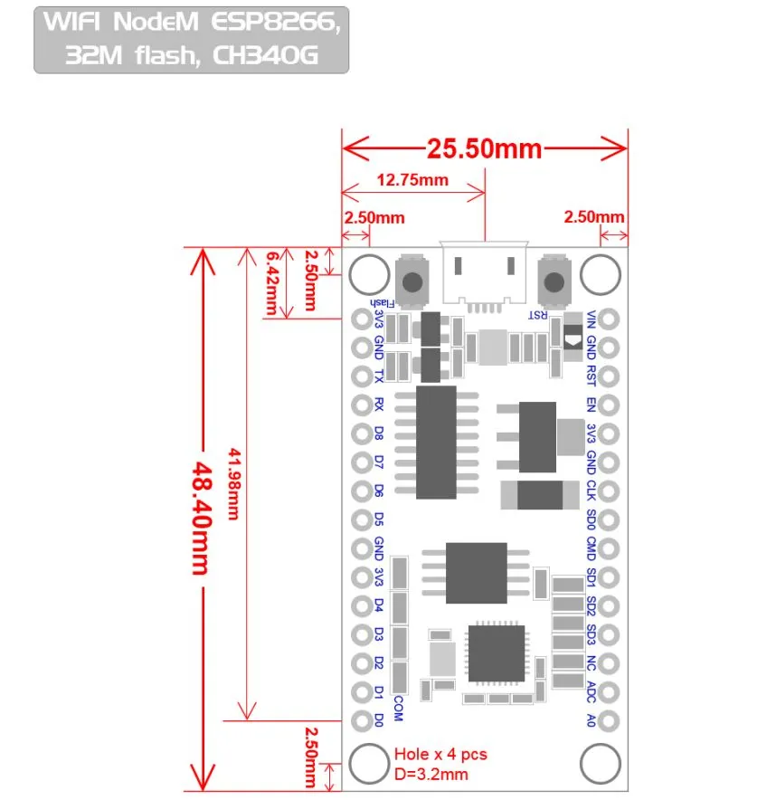

**Figure 3.2 NodeMCU 2D View**

**NodeMCU Specification:**

The NodeMCU development board is based on the ESP8266 microcontroller, and different versions of NodeMCU boards may have slight variations in specifications. As of my knowledge cutoff in January 2022, here are the general specifications for the NodeMCU ESP8266 development board:

**1. Microcontroller:** ESP8266 WiFi microcontroller with 32bit architecture.

**2. Processor:** Tensilica L106 32bit microcontroller.

**3. Clock Frequency:** Typically operates at 80 MHz.

**4. Flash Memory:**

* Builtin Flash memory for program storage.
* Common configurations include 4MB or 16MB of Flash memory.

**5. RAM:** Typically equipped with 80 KB of RAM.

**6. Wireless Connectivity:**

* Integrated WiFi (802.11 b/g/n) for wireless communication.
* Supports Station, SoftAP, and SoftAP + Station modes.

**7. GPIO Pins:** Multiple General Purpose Input/Output (GPIO) pins for interfacing with sensors, actuators, and other electronic components.

**8. Analog Pins:** Analogtodigital converter (ADC) pins for reading analog sensor values.

**9. USBtoSerial Converter:** Builtin USBtoSerial converter for programming and debugging.

**10. Operating Voltage:** Typically operates at 3.3V (Note: It is crucial to connect external components accordingly to avoid damage).

**11. Programming Interface:** Programmable using the Arduino IDE, Lua scripting language, or other compatible frameworks.

**12. Voltage Regulator:** Onboard voltage regulator for stable operation.

**13. Reset Button:** Reset button for restarting the board.

**14. Dimensions:** Standard NodeMCU boards often have dimensions around 49mm x 24mm.

**15. Power Consumption:** Low power consumption, making it suitable for batteryoperated applications.

**16. Community Support:** Active community support with extensive documentation and libraries.

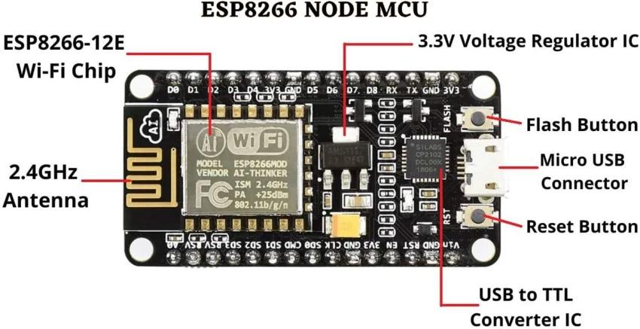

**Figure 3.3: NodeMCU Parts**

The NodeMCU ESP8266 development board typically has GPIO (General Purpose Input/Output) pins that can be used for various purposes, including interfacing with sensors, actuators, and other electronic components. Below is a common pinout configuration for the NodeMCU development board

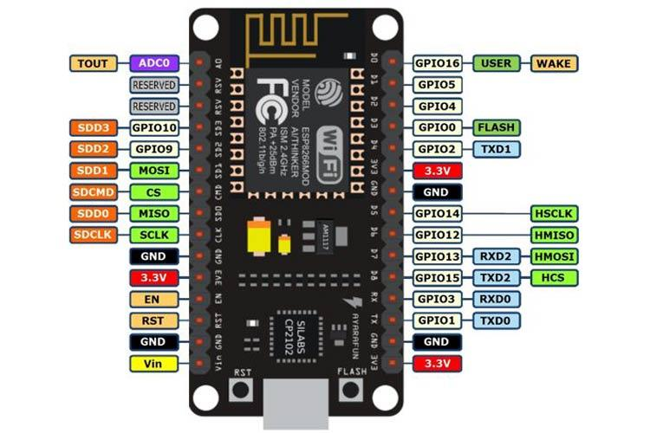

**Figure 3.4: NodeMCU ESP8266 Pinout**

  ADC   | A0                         | GPIO16

  EN    | Enable                     | GPIO14

  D0    | GPIO16                   | GPIO12

  D1    | GPIO5                     | GPIO13

  D2    | GPIO4                     | GPIO15

  D3    | GPIO0                     | GPIO2

  D4    | GPIO2                     | GPIO9

  D5    | GPIO14                   | GPIO10

  D6    | GPIO12                   | GPIO3

  D7    | GPIO13                   | GPIO1

  D8    | GPIO15                   | TX (GPIO1)

  D9    | GPIO3 (RX)            | RX (GPIO3)

  D10  | GPIO1 (TX)            | D11 (MOSI)

  D11  | MOSI                      | D12 (MISO)

  D12  | MISO                      | D13 (SCK

**ADC**: AnalogtoDigital Converter pin for reading analog sensor values.

**EN** (Enable): Enable pin.

**D0D8**: Digital GPIO pins.

**D9 (RX) and D10 (TX)**: Serial communication pins for programming and debugging.

**D11 (MOSI), D12 (MISO), D13 (SCK**): Pins used for SPI communication.

**D14 (SDA) and D15 (SCL)**: Pins used for I2C communication.

It's important to note that GPIO pins labeled as "D" (Digital) are typically used for generalpurpose digital input/output. Additionally, GPIO pins labeled as "A" (Analog) can be used as analog inputs with the ADC. GPIO pins 6, 7, 8, 9, 10, and 11 have additional functions, so it's advised to refer to the specific NodeMCU documentation for detailed information on pin functionality and capabilities.

**3.2 DHT 11 SENSOR**

DHT11 is a lowcost digital sensor for sensing temperature and humidity.  This sensor can be easily interfaced with any microcontroller such as Arduino, Raspberry Pi etc… to measure humidity and temperature instantaneously.

DHT11 humidity and temperature sensor is available as a sensor and as a module. The difference between this sensor and module is the pullup resistor and a poweron LED. DHT11 is a relative humidity sensor.  To measure the surrounding air this sensor uses a [thermistor](https://www.elprocus.com/introduction-to-thermistor-types-with-its-workings-and-applications/) and a capacitive humidity sensor.

**Working Principle of DHT11 Sensor**

DHT11 sensor consists of a capacitive humidity sensing element and a thermistor for sensing temperature.  The humidity sensing [capacitor](https://www.elprocus.com/construction-of-capacitor-with-working/) has two electrodes with a moisture holding substrate as a dielectric between them. Change in the capacitance value occurs with the change in humidity levels. The IC measure, process this changed resistance values and change them into digital form.

For measuring temperature this sensor uses a Negative Temperature coefficient thermistor, which causes a decrease in its resistance value with increase in temperature. To get larger resistance value even for the smallest change in temperature, this sensor is usually made up of semiconductor ceramics or polymers.

The temperature range of DHT11 is from 0 to 50 degree Celsius with a 2degree accuracy. Humidity range of this sensor is from 20 to 80% with 5% accuracy. The sampling rate of this sensor is 1Hz .i.e. it gives one reading for every second.  DHT11 is small in size with operating voltage from 3 to 5 volts. The maximum current used while measuring is 2.5mA.

Group

*DHT11 Sensor*

DHT11 sensor has four pins VCC, GND, Data Pin and a not connected pin. A pullup resistor of 5k to 10k ohms is provided for communication between sensor and microcontroller.Group

**Specification of the DHT11 sensor**

Power supply: 3.3 to 5V DC

Current consumption: max 2.5mA

Operating range: 2080% RH, 050°C

Humidity measurement range: 2090% RH

Humidity measurement accuracy: ±5% RH

Temperature measurement range: 050°C

Temperature measurement accuracy: ±2°C

Response time: 1s

Sampling rate: 1Hz (1 sample per second)

Data output format: singlebus digital signal

Data transmission distance: 2030m (at open air)

Dimensions: 15mm x 12mm x 5.5mm

Weight: 2.5g

Digital signal transmission protocol: 1 start signal + 40bit data + 1 checksum

**Applications**

This sensor is used in various applications such as measuring humidity and temperature values in heating, ventilation and air conditioning systems. Weather stations also use these sensors to predict weather conditions.  The humidity[sensor](https://en.wikipedia.org/wiki/Humidity) is used as a preventive measure in homes where people are affected by humidity.  Offices, cars, museums, greenhouses and industries use this sensor for measuring humidity values and as a safety measure.

It’s compact size and sampling rate made this sensor popular among hobbyists.

**3.3 solenoid lock**

A solenoid lock is an electromechanical device commonly used for securing doors, cabinets, and other enclosures. Here's an overview of its description, pinout, working principle, specifications, and applications:

A solenoid lock typically consists of a coil of wire (solenoid) encased in a housing, a plunger or bolt mechanism, and often a mounting bracket. When energized, the solenoid generates a magnetic field that pulls the plunger or bolt, unlocking the mechanism. When deenergized, the plunger is springloaded to return to its default position, thereby locking the mechanism.Group

**Pinout:**

The pinout of a solenoid lock usually includes two connections for power input. One pin is connected to the positive terminal, and the other pin is connected to the negative terminal of the power supply. When voltage is applied across these pins, the solenoid becomes energized, causing the plunger to retract and unlock the mechanism.

**Working Principle:**

The working principle of a solenoid lock is based on electromagnetic induction. When an electric current flows through the coil of wire (solenoid), it creates a magnetic field around the coil. This magnetic field attracts the plunger or bolt mechanism, pulling it into the solenoid housing and unlocking the mechanism. When the current is turned off, the magnetic field collapses, and the springloaded plunger returns to its default position, locking the mechanism once again.

**Specifications:**

**Voltage Range:** Solenoid locks typically operate within a specific voltage range, such as 12V or 24V DC.

**Current Draw:** The amount of current consumed by the solenoid when energized, usually measured in amperes (A).

**Duty Cycle:** The ratio of the time the solenoid is energized to the total cycle time, expressed as a percentage. Higher duty cycles may require solenoids with better thermal management to prevent overheating.

**Strength:** The force exerted by the solenoid when energized, measured in pounds (lbs) or Newtons (N).

**Response Time:** The time it takes for the solenoid to unlock or lock the mechanism after voltage is applied or removed, typically measured in milliseconds (ms).

**Operating Temperature Range:** The range of temperatures within which the solenoid can operate effectively without compromising performance or durability.

**Applications:**

**Access Control Systems:** Solenoid locks are commonly used in access control systems to secure doors, gates, and turnstiles.

**Automotive:** Solenoid locks are used in automotive applications for locking doors, trunks, and fuel caps.

**Safe Deposit Boxes:** Solenoid locks are employed in safe deposit boxes and cash drawers for added security.

**Vending Machines:** Solenoid locks are utilized in vending machines to secure access panels and cash compartments.

**Industrial Equipment:** Solenoid locks find applications in industrial equipment, such as machinery guards and control cabinets.

* **Medical Devices:** Solenoid locks are used in medical devices, such as medication dispensers and equipment cabinets, to prevent unauthorized access.

**3.4 Relay**

A 5V relay is an electromechanical switch that operates with a 5volt DC supply voltage. Here's a breakdown of its description, pinout, working principle, specifications, and applications:

A 5V relay typically consists of a coil, an armature, a set of contacts, and a casing. The coil is energized when a 5V DC voltage is applied, generating a magnetic field that attracts the armature. This action causes the contacts to move, either opening or closing an electrical circuit.Group

**Pinout:**

A standard 5V relay usually has five pins:

**1. Common (COM):** This is the central pin that connects to one end of the coil.

**2. Normally Open (NO):** This pin connects to the armature and is not connected to COM when the relay is not energized.

**3. Normally Closed (NC):** This pin also connects to the armature but is connected to COM when the relay is not energized.

**4. Coil+:** This pin connects to one end of the coil.

**5. Coil:** This pin connects to the other end of the coil.Group

**Working Principle:**

When a 5V DC voltage is applied across the coil terminals (Coil+ and Coil), a magnetic field is generated, causing the armature to move. In a normally open (NO) relay, this movement closes the circuit between COM and NO, allowing current to flow. In a normally closed (NC) relay, the movement opens the circuit between COM and NC, interrupting the current flow. When the coil voltage is removed, the armature returns to its original position due to spring tension.

**Specifications:**

**1. Contact Rating:** Specifies the maximum current and voltage the contacts can handle safely.

**2. Coil Voltage:** Indicates the voltage required to energize the coil (e.g., 5V for a 5V relay).

**3. Coil Resistance:** Specifies the electrical resistance of the coil.

**4. Contact Configuration:** Indicates whether the relay is normally open (NO), normally closed (NC), or has both configurations.

**5. Switching Time:** Specifies the time taken for the contacts to transition between open and closed states.

**6. Operating Temperature Range:** Indicates the temperature range within which the relay can operate reliably.

**7. Mechanical Life:** Specifies the number of cycles (open/close) the relay can endure before failure.

**Applications:**

**1. Home Automation:** Control of lights, fans, and appliances.

**2. Industrial Automation:** Control of motors, pumps, and machinery.

**3. Security Systems:** Activation of alarms, locks, and access control systems.

**4. Automotive:** Control of headlights, indicators, and relays in vehicle electrical systems.

**5. IoT Devices:** Integration into smart devices for remote control and automation.

**6. Prototyping:** Used in electronics projects to switch highpower circuits using lowpower signals.

**Result:**

The developed system successfully provides a comprehensive solution for automating and controlling lights, fans, and other appliances within the college setting. The system efficiently manages energy usage, enhances operational processes, and ensures seamless functionality. Key features include the ability to remotely control lights and fans, real-time monitoring, and alert mechanisms that promptly notify maintenance teams of any issues, particularly with fan operations. This minimizes downtime and enhances the overall efficiency of the college's operational systems. The implementation of this system has led to improved reliability, reduced manual intervention, and a more streamlined management of campus facilities.