**CattleSmart**

Empowering Dairy Farmers with Data-Driven Insights for Higher Profits and Sustainable Practices

**B.Sarath**

09-06-2024

**Abstract**

In the modern dairy farming landscape, the pursuit of optimal milk production and profitability presents a perpetual challenge. In response, "CattleSmart" emerges as a pioneering software application aimed at revolutionizing the industry. By harnessing the power of advanced machine learning algorithms and data analytics, CattleSmart offers farmers a bespoke solution to their operational dilemmas. At its core lies a comprehensive understanding of the myriad factors influencing dairy farming success, ranging from cow type and grass quality to feed type and weather conditions. Through meticulous analysis and comparison, CattleSmart distills vast datasets of farm performance into actionable insights, personalized to the unique circumstances of each user. Leveraging a user-friendly interface, farmers can easily input their farm data and receive real-time recommendations aimed at enhancing milk prices and overall financial viability.

The heart of CattleSmart's functionality lies in its comparison engine, which scrutinizes user input against a backdrop of high-performing farms, identifying trends, and best practices that drive success. This engine not only empowers farmers with actionable strategies but also facilitates continuous improvement through progress tracking and trend analysis features. Farmers can monitor the implementation of recommendations over time, observing the tangible impact on milk production and profitability. In essence, CattleSmart transcends the boundaries of conventional farm management, ushering in an era of data-driven decision-making and sustainable practices. As the dairy industry evolves, CattleSmart stands as a beacon of innovation, guiding farmers towards greater efficiency, profitability, and resilience in an ever-changing landscape.

1. **Problem Statement:**

Dairy farmers face challenges in optimizing milk production and profitability due to the complex interplay of factors such as cow type, feed quality, and weather conditions. Existing solutions lack personalized insights and fail to leverage data-driven approaches. Addressing these limitations, "CattleSmart" aims to develop a software application that utilizes advanced machine learning algorithms to provide tailored recommendations for dairy farmers, enhancing milk prices and financial performance while promoting efficiency and sustainability in the industry.

1. **Market/Customer/Business Need Assessment:**

To ensure the successful development and adoption of "CattleSmart," it is essential to comprehensively understand the needs of dairy farmers. The following assessment outlines key customer needs that CattleSmart aims to address:

**Optimized Milk Production and Profitability:**

* **Need:** Dairy farmers require tools to maximize milk yield and quality while minimizing production costs.
* **Solution:** CattleSmart leverages machine learning algorithms to provide personalized recommendations that enhance milk production and profitability.

**Personalized Insights:**

* **Need:** Farmers need tailored advice that considers their specific farm conditions, cow breeds, and feed types.
* **Solution:** CattleSmart analyzes individual farm data and compares it with high-performing farms to generate customized strategies.

**Data-Driven Decision Making:**

* **Need:** There is a demand for data-driven approaches to make informed decisions that improve farm efficiency and sustainability.
* **Solution:** CattleSmart uses comprehensive data analytics to identify best practices and actionable insights for farmers.

**Ease of Use:**

* **Need:** Farmers require an intuitive and user-friendly interface to input data and access recommendations without technical difficulties.
* **Solution:** CattleSmart provides a seamless interface that simplifies data entry and displays clear, actionable suggestions.

**Progress Tracking and Monitoring:**

* **Need:** Continuous tracking of farm performance and the effectiveness of implemented recommendations is crucial.
* **Solution:** CattleSmart includes tools for progress tracking, allowing farmers to monitor changes in milk production and profitability over time.

**Adaptability to Different Conditions:**

* **Need:** Recommendations should account for varying weather conditions, cow types, and regional differences in farming practices.
* **Solution:** CattleSmart’s algorithms consider diverse environmental and operational factors to ensure relevant and effective suggestions.

By addressing these needs, CattleSmart aims to empower dairy farmers with the tools and insights necessary to thrive in a competitive and evolving industry.

1. **Target Specifications and Characterization:**

To ensure that "CattleSmart" meets the needs of dairy farmers and achieves its objectives, we have identified key target specifications and characterized each aspect of the project. These specifications will guide the development process and help in evaluating the success of the application.

**3.1 Data Integration and Analysis**

**Target Specification:**

* Comprehensive data input options for cow type, grass quality, feed type and quantity, weather conditions, milk quantity, fat percentage, and production costs.
* Robust data processing and normalization.

**Characterization:**

* The app will support multiple data formats and sources, enabling seamless integration of farm data.
* Advanced data preprocessing techniques will be applied to ensure data consistency and accuracy.
* The app will utilize cloud-based storage and processing to handle large datasets efficiently.

**3.2 Machine Learning Algorithms**

**Target Specification:**

* Implementation of K-Nearest Neighbors (KNN) for farm comparison.
* Use of Decision Trees for generating personalized recommendations.

**Characterization:**

* The KNN algorithm will identify the top K farms similar to the user’s farm based on selected features.
* Decision Trees will analyze patterns and provide actionable recommendations.
* Algorithms will be optimized for performance and accuracy, ensuring timely and relevant insights.

**3.3 Recommendations and Insights**

**Target Specification:**

* Personalized and actionable recommendations.
* Regular updates based on new data and trends.

**Characterization:**

* The recommendation engine will generate tailored advice for each user, focusing on optimizing milk production, quality, and profitability.
* Recommendations will be updated dynamically as new data is inputted or as conditions change.
* The app will include notifications and alerts to inform users of critical insights or necessary actions.

**3.4 Scalability and Performance**

**Target Specification:**

* Ability to handle data from multiple farms simultaneously.
* Fast processing and response times.

**Characterization:**

* The backend infrastructure will be designed to scale horizontally, accommodating increasing numbers of users and data.
* Performance optimization techniques, such as caching and load balancing, will ensure that the app remains responsive under heavy load.
* Regular performance testing and monitoring will be conducted to identify and address any bottlenecks.

By adhering to these target specifications and characterizing each aspect of the project, "CattleSmart" aims to deliver a comprehensive, reliable, and user-friendly solution that empowers dairy farmers to optimize their operations and achieve greater profitability.

1. **External Search:**

To ensure the development and success of "CattleSmart," an extensive external search was conducted to understand the current landscape of dairy farming technologies and identify gaps and opportunities. The search revealed several key insights:

* **Existing Solutions:** Numerous applications and platforms exist that provide general farm management and dairy optimization tools, such as DairyComp and BoviSync. However, many of these solutions lack advanced, personalized recommendations based on comprehensive data analysis.
* **Technological Advancements:** The integration of machine learning and data analytics in agriculture is gaining traction. Technologies like IoT devices, sensors, and automated data collection are becoming prevalent, enabling more accurate and real-time data for analysis.
* **Farmer Challenges:** Dairy farmers continue to face challenges related to fluctuating milk prices, feed costs, and environmental conditions. There is a significant need for tools that can offer specific, actionable insights to improve profitability and efficiency.
* **Market Demand:** There is a growing demand for smart farming solutions that leverage data-driven decision-making. Farmers are increasingly open to adopting technology that can provide measurable improvements in productivity and sustainability.
* **Regulatory Environment:** Compliance with data protection regulations is critical. Solutions must ensure secure handling of farm data to build trust and adoption among users.

By addressing these findings, "CattleSmart" aims to fill the gap with a robust, user-friendly platform that offers personalized, data-driven recommendations to enhance dairy farming outcomes.

**4.1 Bench marking alternate products:**

In benchmarking alternate products, several notable solutions in the dairy farming industry were evaluated:

* **DairyComp 305:** A comprehensive herd management software offering extensive data collection and reporting features but lacking personalized, actionable recommendations based on advanced analytics.
* **BoviSync:** A cloud-based dairy management system that excels in real-time data synchronization and herd health monitoring, yet falls short on predictive analytics and tailored advice.
* **Afimilk:** Provides robust dairy farm management with emphasis on milk production monitoring and cow health but limited in optimizing feed and operational costs through machine learning insights.

"CattleSmart" distinguishes itself by focusing on personalized recommendations, leveraging machine learning to enhance milk production and profitability.

**4.2 Applicable Patents:**

To ensure the uniqueness and legal protection of "CattleSmart," it is crucial to review existing patents related to dairy farm management, machine learning applications in agriculture, and data-driven recommendation systems.

Here are some relevant patents:

**"Predicting Dairy Farm Productivity Using Machine Learning Techniques"**

This paper explores various machine learning algorithms applied to dairy farm data to predict milk yield and quality, providing insights into effective data analysis and prediction models.

**"A Decision Support System for Dairy Farming Using Precision Agriculture Technologies"**

Discusses the integration of precision agriculture technologies and decision support systems to optimize dairy farming practices, including feed management and health monitoring.

**"Impact of Feed Quality on Milk Production in Dairy Cows: A Data-Driven Approach"**

Investigates the relationship between feed quality and milk production, using data analytics to derive actionable insights, which is pertinent to CattleSmart's feed optimization recommendations.

**4.3 Applicable Regulations:**

Developing "CattleSmart" involves ensuring compliance with several key regulations to protect user data, maintain operational integrity, and ensure the accuracy of recommendations. Here are the primary regulations to consider:

**Data Protection and Privacy Regulations:**

* **General Data Protection Regulation (GDPR):** For users in the European Union, GDPR mandates strict data protection and privacy measures. CattleSmart must ensure transparent data collection, secure storage, user consent for data usage, and the right for users to access and delete their data.
* **California Consumer Privacy Act (CCPA):** For users in California, CCPA requires similar data protection measures, including clear communication about data collection practices and user rights regarding their data.

**Food Safety and Quality Regulations:**

* **FDA Food Safety Modernization Act (FSMA):** If CattleSmart provides recommendations related to feed quality, compliance with FSMA is essential to ensure that feed practices meet safety standards, reducing the risk of foodborne illnesses.

**Animal Welfare Regulations:**

* **Animal Welfare Act (AWA):** Recommendations affecting animal health and welfare must comply with AWA standards, ensuring humane treatment of livestock and adherence to welfare practices.

**Agricultural Data Regulations:**

* **Farm Data Code of Practice:** This voluntary code encourages transparent and ethical handling of farm data, ensuring that farmers retain control over their data and understand how it is used.

**Environmental Regulations:**

* **Environmental Protection Agency (EPA) Regulations:** Recommendations that impact farm management practices, such as waste management and feed efficiency, must comply with EPA guidelines to minimize environmental impact.

By adhering to these regulations, CattleSmart ensures legal compliance, fosters user trust, and promotes sustainable and ethical dairy farming practices.

**4.4 Applicable Constraints:**

Developing and deploying "CattleSmart" involves several constraints that must be carefully managed to ensure the project's success and effectiveness:

**Technical Constraints:**

* **Data Accuracy and Availability:** The quality and reliability of recommendations depend heavily on accurate and comprehensive data inputs. Inconsistent or incomplete data from farmers can hinder the app's effectiveness.
* **Algorithm Performance:** Implementing advanced machine learning algorithms requires significant computational power and efficient processing to deliver real-time recommendations, which may challenge device capabilities in remote farm settings.

**Economic Constraints:**

* **Cost of Implementation:** Developing, maintaining, and updating the app involves significant costs. Additionally, farmers need to see a clear return on investment to justify any expenses related to using the app.

**Environmental Constraints:**

* **Sustainability:** Recommendations must consider environmental impact and promote sustainable farming practices, aligning with regulations and the growing emphasis on eco-friendly agriculture.

Managing these constraints effectively will be crucial to the successful development, deployment, and adoption of CattleSmart.

**4.5 Business Model**

CattleSmart will adopt a subscription-based SaaS (Software as a Service) business model to generate revenue while providing value to dairy farmers. Here's the business model overview:

**Subscription Plans:**

* Offer tiered subscription plans based on the number of features, farm size, and usage levels.
* Basic plans could include essential features such as data input and basic recommendations, while premium plans offer advanced analytics and personalized insights.

**Freemium Model:**

* Provide a limited free version of the app with basic features to attract users and demonstrate value. Premium features will be available through subscription upgrades.

**Value-added Services:**

* Offer additional services such as consulting, training, and custom analytics for farms with specific needs or larger operations.

**Partnerships and Integrations:**

* Collaborate with agricultural equipment manufacturers, feed suppliers, and other industry stakeholders to offer integrated solutions and value-added services.
* Integration with existing farm management software platforms can expand reach and provide additional value to users.

**Data Monetization:**

* Aggregate anonymized data and provide insights to agricultural researchers, industry analysts, and policymakers for a fee, ensuring user privacy and consent.

**Advertising and Sponsorships:**

* Partner with relevant agricultural brands for advertising and sponsorships within the app, promoting relevant products and services to users.

**Custom Development:**

* Offer custom development services for specific farm requirements or integration needs, catering to larger farms or organizations with unique needs.

By implementing this business model, CattleSmart aims to generate sustainable revenue streams while delivering valuable insights and recommendations to dairy farmers, ultimately improving farm profitability and sustainability.

1. **Concept Generation**

CattleSmart aims to revolutionize dairy farming by leveraging data-driven insights and machine learning algorithms to optimize milk production and profitability. Here's the concept overview:

* **Comprehensive Data Collection:** CattleSmart will collect diverse data including cow type, feed quality, weather conditions, milk quantity, and production costs from dairy farmers.
* **Advanced Analytics:** Utilizing machine learning algorithms, CattleSmart will analyze collected data to identify patterns and correlations that impact milk production and profitability.
* **Personalized Recommendations:** Based on farm-specific data analysis, CattleSmart will provide personalized recommendations to farmers, including feed optimization, health management, and cost reduction strategies.
* **Real-time Monitoring:** Farmers will be able to monitor key performance indicators (KPIs) such as milk yield, feed efficiency, and profitability in real-time through intuitive dashboards.
* **Progress Tracking:** CattleSmart will track the implementation of recommendations over time and provide insights into the effectiveness of adopted strategies.
* **Integration and Compatibility:** The platform will be designed for seamless integration with existing farm management systems and compatible with various devices for ease of use.
* **Continuous Improvement:** CattleSmart will continuously evolve by incorporating user feedback, technological advancements, and new research findings to provide cutting-edge solutions for dairy farmers.

By integrating these concepts, CattleSmart aims to empower dairy farmers with actionable insights, leading to increased efficiency, profitability, and sustainability in dairy farming operations.

1. **Concept Development**

**Identify User Needs:**

* Research and understand the challenges faced by dairy farmers, such as fluctuating milk prices, feed costs, and weather-related risks.
* Gather feedback from potential users to identify their pain points and requirements.

**Define Objectives:**

* Clearly define the objectives of CattleSmart, such as optimizing milk production, reducing production costs, and improving farm profitability.
* Set specific goals for the project, such as increasing milk yield by a certain percentage or reducing feed costs by a specific amount.

**Data Collection and Analysis:**

* Determine the types of data to be collected, including cow type, feed quality, weather conditions, milk quantity, and production costs.
* Develop a strategy for data collection, ensuring accuracy and consistency.
* Explore methods for data analysis, including machine learning algorithms and statistical techniques.

**Feature Identification:**

* Based on user needs and objectives, identify key features for CattleSmart, such as:
* Data input interface for farmers.
* Machine learning algorithms for data analysis.
* Personalized recommendation engine.
* Real-time monitoring dashboard.
* Progress tracking and reporting tools.

**Prototype Development:**

* Develop a prototype of CattleSmart with basic features and functionality.
* Iterate on the prototype based on user feedback and testing.

**Integration and Compatibility:**

* Ensure compatibility with existing farm management systems and devices commonly used by farmers.
* Integrate data from various sources and devices for comprehensive analysis.

**User Interface Design:**

* Design an intuitive and user-friendly interface for farmers to input data and access recommendations.
* Focus on simplicity, clarity, and ease of navigation.

**Testing and Validation:**

* Conduct thorough testing of the platform to ensure accuracy, reliability, and usability.
* Validate the effectiveness of recommendations through pilot studies or trials on real farms.

**Feedback and Iteration:**

* Gather feedback from farmers using CattleSmart and incorporate suggestions for improvement.
* Continuously iterate on the platform to enhance features, performance, and user experience.

**Launch and Deployment:**

* Prepare for the launch of CattleSmart, including marketing strategies and user onboarding.
* Deploy the platform to users and provide training and support as needed.

By following these steps, CattleSmart can be developed into a robust and effective solution for optimizing dairy farming operations.

1. **Product Details:**
   1. **How does it work?**

CattleSmart predicts milk prices using Linear Regression based on farm data and suggests best practices using KNN by comparing with similar farms, helping farmers improve productivity and profitability.

* 1. **Algorithms, frameworks, software etc. needed:**
     + **Linear Regression**: For predicting milk prices based on various input factors.
     + **K-Nearest Neighbors (KNN)**: For recommending best practices by comparing similar farms.

**7.3 Team required to develop:**

To develop CattleSmart, a multidisciplinary team is needed:

* **Data Scientists** to build predictive models.
* **Software Engineers** to develop the app's backend and frontend.
* **Database Administrators** to manage data storage.
* **UI/UX Designers** to design a user-friendly interface.

**7.4 Manufactured and Assembled**

**Software Development**:

* Develop algorithms for milk price prediction (Linear Regression) and farm recommendation (KNN).
* Implement using Python, libraries like scikit-learn, and frameworks like Flask/Django.

**Data Collection and Processing**:

* Gather farm data from various sources.
* Preprocess data for modeling, including cleaning and feature engineering.

**Model Training and Testing**:

* Train predictive models using historical farm data.
* Validate models for accuracy and performance.

**App Development**:

* Build web interface for user interaction.
* Integrate models for predictions and recommendations.

1. **Algorithms Used**

### Linear Regression for Milk Price Prediction

#### Concept:

Linear Regression is a simple yet powerful statistical method used to model the relationship between a dependent variable (target) and one or more independent variables (features). The goal is to find the best-fitting straight line (regression line) that predicts the target variable based on the input features.

#### How it Works:

1. **Model Equation**: The linear regression model assumes a linear relationship between the dependent variable Y and the independent variables **X1,X2,…,Xn.**

The equation can be written as:

**Y=β0+β1X1+β2X2+…+βnXn+ ϵ**

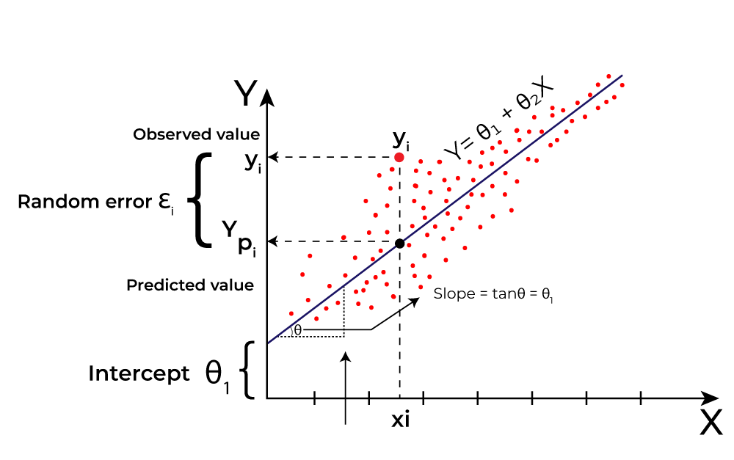where β0 is the intercept, β1,β2,…,βn are the coefficients, and ϵ is the error term.

1. **Training**: The model is trained using historical data to estimate the coefficients (β) that minimize the sum of squared residuals (differences between the actual and predicted values).
2. **Prediction**: Once the model is trained, it can be used to predict the milk price based on new input features (e.g., cow type, feed type and quantity, weather conditions, milk yield, fat percentage).

**Application in Project:**

* **Data Input**: Collect data on various factors affecting milk prices.
* **Model Training**: Use historical data to train the linear regression model to learn the relationship between these factors and the milk price.
* **Prediction**: Input current farm data into the trained model to predict the milk price.

**Sample Data**

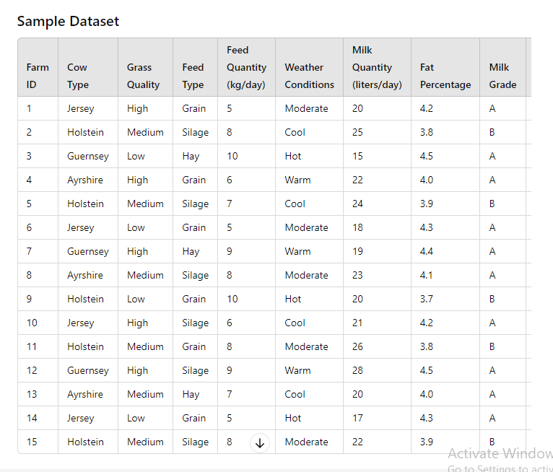

### K-Nearest Neighbors (KNN) for Suggesting Similar Interests

#### Concept:

K-Nearest Neighbors (KNN) is a simple, non-parametric, and instance-based learning algorithm used for classification and regression tasks. It predicts the target value of a new data point based on the majority target value (for classification) or average target value (for regression) of its 'k' nearest neighbors in the feature space.

#### knn algorithm.png

#### knn alg.png

#### How it Works:

1. **Distance Calculation**: For a given new data point, calculate the distance between this point and all points in the training dataset. Common distance metrics include Euclidean distance, Manhattan distance, etc.
2. **Identify Neighbors**: Identify the 'k' closest points (neighbors) to the new data point based on the calculated distances.
3. **Prediction**:  
   * **Classification**: The predicted class for the new data point is the majority class among its 'k' nearest neighbors.
   * **Regression**: The predicted value for the new data point is the average of the target values of its 'k' nearest neighbors.

#### Application in Project:

* **Data Input**: Collect data on farm characteristics and practices.
* **Model Training**: No explicit training phase is required for KNN; the algorithm uses the entire dataset to find neighbors.
* **Recommendation**: When a farmer inputs their farm data, the KNN algorithm finds similar farms (neighbors) and suggests practices from these similar farms that have high performance or higher milk prices.

1. **Conclusion**

CattleSmart offers a comprehensive solution for dairy farmers, combining predictive analytics and personalized recommendations to optimize milk production and profitability. By leveraging machine learning algorithms like Linear Regression and KNN, CattleSmart assists farmers in making data-driven decisions. With its user-friendly interface and accurate insights, CattleSmart empowers farmers to enhance efficiency, reduce costs, and ultimately thrive in the dairy industry. It represents a significant step towards sustainable and profitable dairy farming practices.

**References**

* <https://www.researchgate.net/publication/376064637_Milk_Quality_Prediction_Using_Machine_Learning>
* <https://onlinelibrary.wiley.com/doi/abs/10.1002/agr.21773>
* <https://github.com/blw-ofag-ufag/milk-price-forecasting>
* <https://www.geeksforgeeks.org/k-nearest-neighbours/>
* <https://www.javatpoint.com/k-nearest-neighbor-algorithm-for-machine-learning>