Lab = 2.1
2303A53012
Batch =46

Task-1
Prompt 1 (Main prompt to Gemini)
You are a Python programming assistant.
Generate a Python function that:
1. Accepts a list of numerical values as input
2. Calculates and returns the mean, minimum, and maximum of the list
Also include:
- Sample input list
- Printed output showing mean, min, and max
- Code that can be directly run in Google Colab
Explain the code briefly.
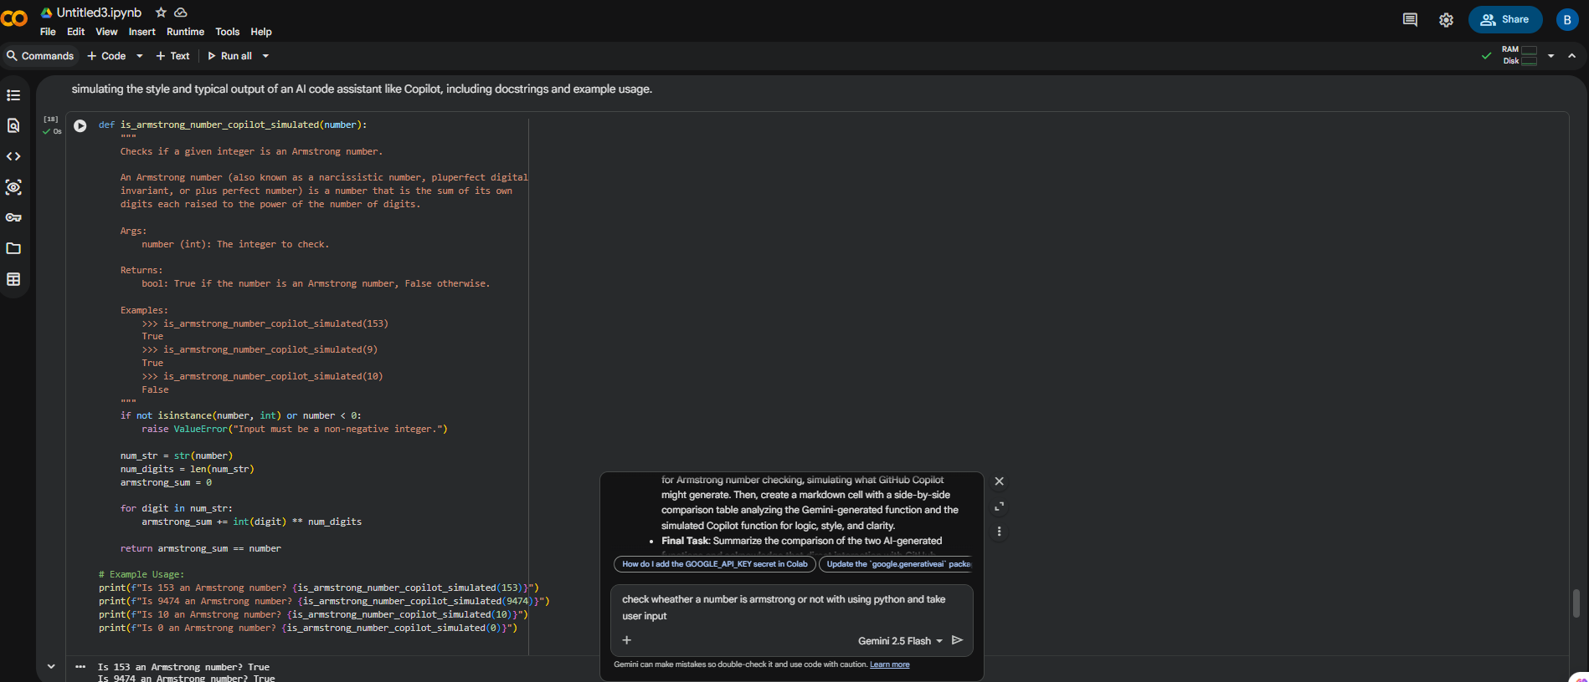
Gemini Prompt (Screenshot)
Generate a Python program that checks whether a given number is an Armstrong number.
Use comments and include sample input and output.
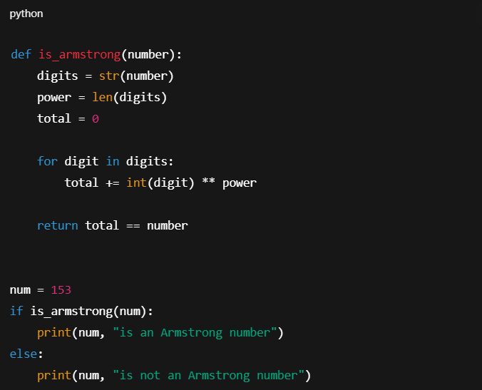

153 is an Armstrong number
Task-2
GitHub Copilot Prompt (Comment in Python File)
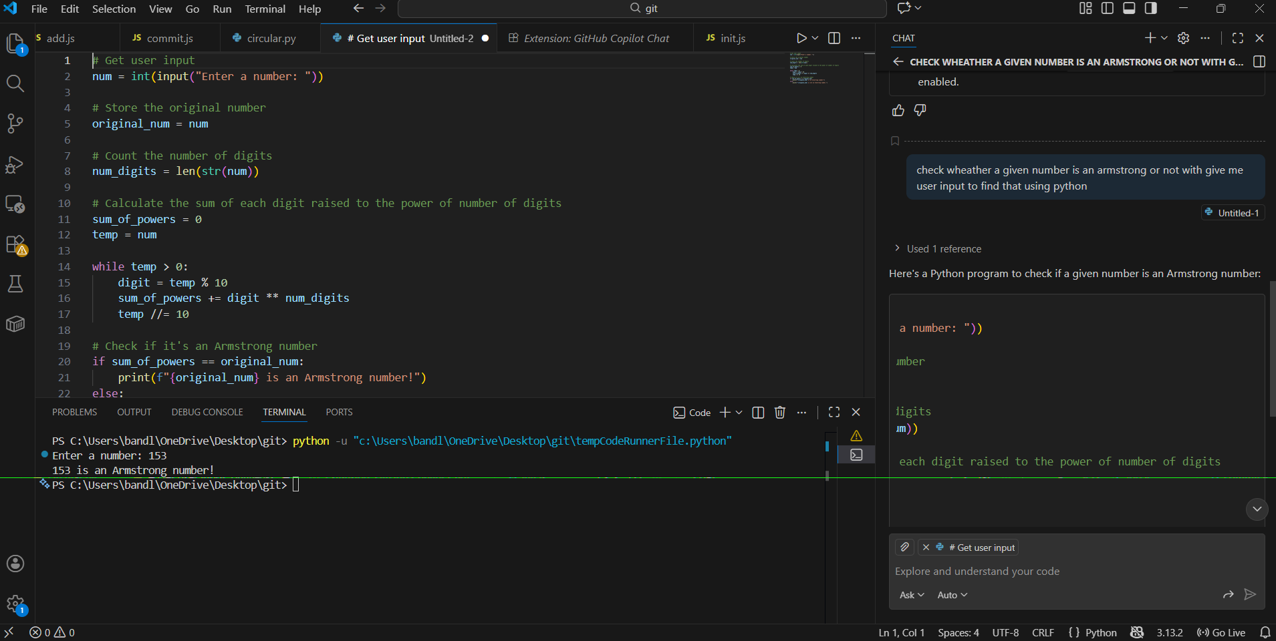

TASK 3: Leap Year Validation – Cursor AI
Write a Python program to check whether a given year is a leap year.
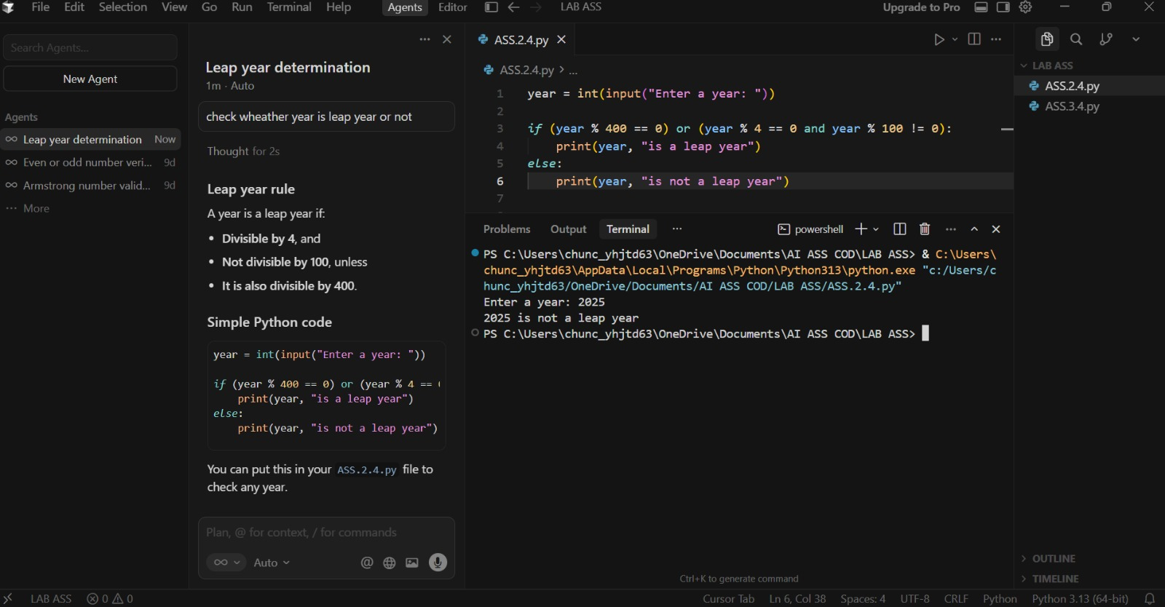
Generate an optimized Python program to check leap years using proper conditions.
Use a function and include sample output.

TASK 4: Odd/Even Sum – Student Logic + AI Refactoring
