SOFTWARE ENGINEERING MINI-PROJECT
Software Architecture & Design Specification
Real-Time Chat Application Using Socket Programming
Deliverable 3 – IEEE-Style Architecture and Design

Document Control
Item | Details
Document | Software Architecture & Design Specification
Project | Real-Time Chat Application Using Socket Programming
Version | 1.0
Architecture Style | Client–Server with layered responsibilities

1. Introduction

1.1 Purpose
This document defines the software architecture and detailed design of the Real-Time Chat Application. It describes the major components, architectural pattern, security architecture, interfaces, sequences, error handling, and traceability to the SRS.

1.2 Scope
The design covers the client, chat server, authentication, connection/session management, message routing, validation/security, user data, and communication interfaces.

1.3 Design Goals
- Real-time bidirectional communication.
- Clear separation between client and server responsibilities.
- Support for multiple concurrent users.
- Input validation and access control.
- Maintainable and testable components.

2. Architecture

2.1 Architectural Pattern
The system uses a Client–Server architecture with layered responsibilities. Clients initiate communication with the server, while the server manages authentication, active connections, message routing, and access control. This separation supports independent development and testing of client and server functionality.

2.2 Component Diagram
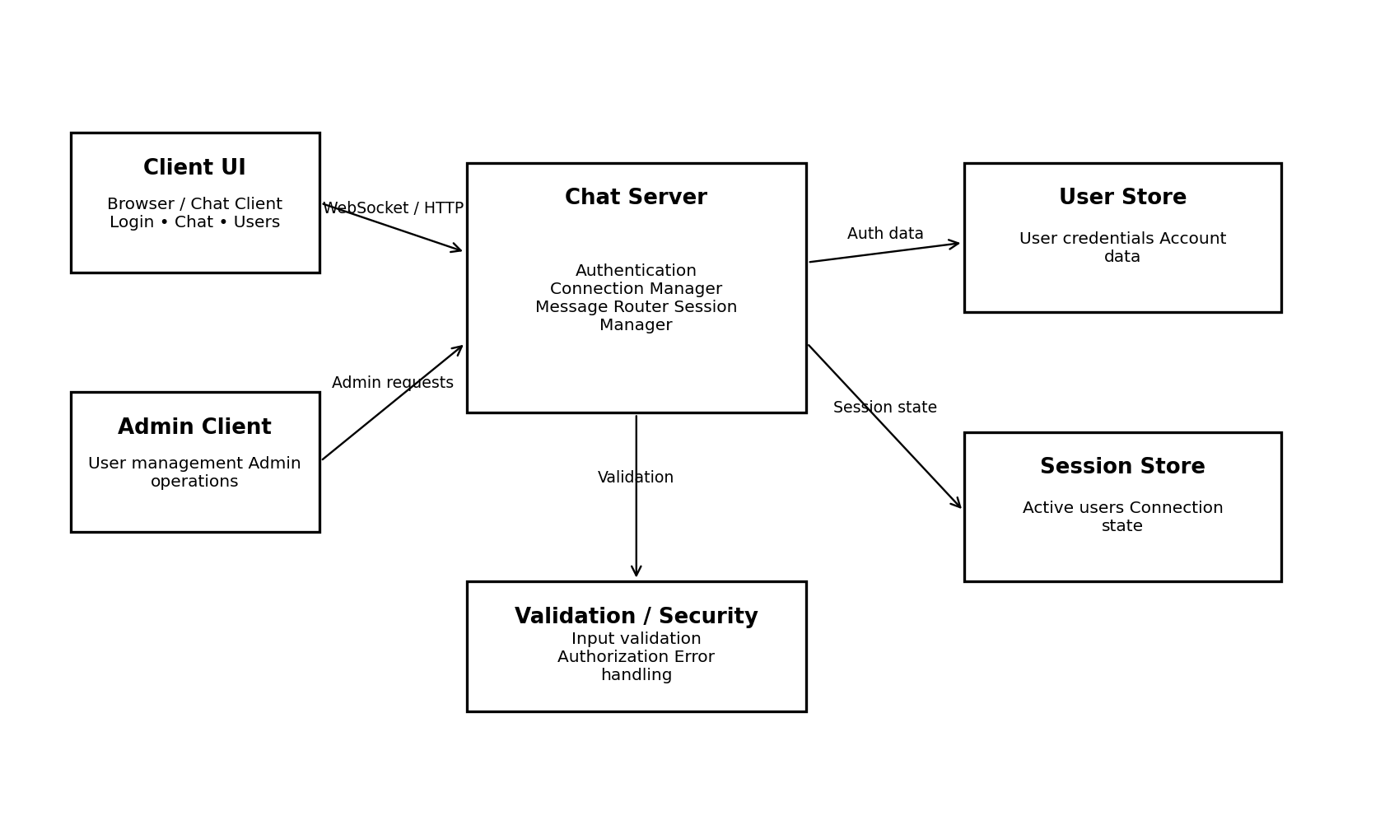
Figure 1. High-level component architecture of the chat application.

2.3 Component Description
Component | Responsibility | Related SRS
Client UI | Registration/login, chat interface, messages, timestamps, online users, logout. | FR-01–FR-04, FR-06–FR-18
Chat Server | Accept connections, authenticate users, maintain sessions, route messages. | FR-02, FR-05, FR-08, FR-12–FR-20
Connection Manager | Create/maintain/terminate socket connections and connection status. | FR-05, FR-13–FR-15, FR-20
Message Router | Routes valid messages to intended recipient(s). | FR-07–FR-09, FR-19
Validation/Security | Input validation, authentication and authorization checks. | FR-17, FR-18, SEC-01–SEC-04, NFR-09
User Store | Stores/retrieves account information required for authentication. | FR-01–FR-03
Session Store | Maintains active-user and connection state. | FR-13, FR-16

2.4 Data and Communication Flow
- Client sends an authentication or chat request to the server.
- Server validates the request and checks authorization where required.
- For a valid message, the server routes the message to the appropriate recipient(s).
- The client displays the received message and relevant status information.
- Connection/session state is updated when users join, leave, or disconnect.

3. Traceability to Requirements
Architecture/Design Element | SRS Trace | Purpose
Authentication component | FR-01–FR-03, SEC-01 | User registration and access control
Connection Manager | FR-05, FR-13–FR-15, FR-20 | Persistent connections and disconnection handling
Message Router | FR-07–FR-09, FR-19 | Real-time message delivery
User list/session state | FR-12, FR-16, NFR-02 | Concurrent users and active-user visibility
Validation/Security layer | FR-17, FR-18, NFR-09, SEC-02 | Input validation and security
Server modularity | NFR-06, NFR-08 | Maintainability and scalability

4. Security Architecture

4.1 Security Controls
- Authentication is performed before protected chat operations are permitted.
- Authorization checks are applied to administrative operations.
- User-provided data is validated before processing.
- Unauthenticated clients are prevented from accessing protected messaging functions.
- Session/connection state is controlled by the server.

4.2 Security Objectives
- Prevent unauthorized access to protected chat functionality.
- Maintain integrity of server-side operations through validation and access control.

5. Detailed Design

5.1 Sequence Diagram – Sending a Message
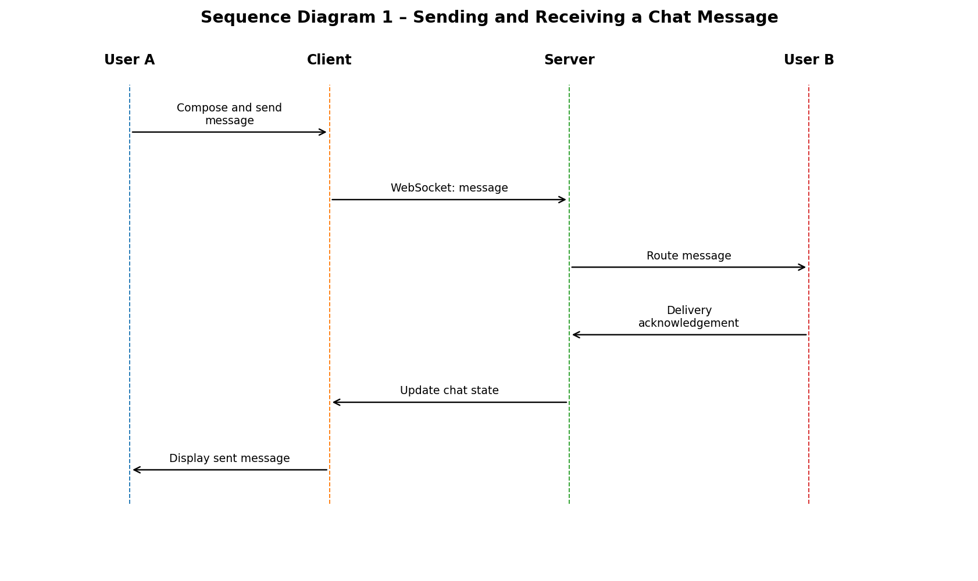

5.2 Sequence Diagram – Authentication
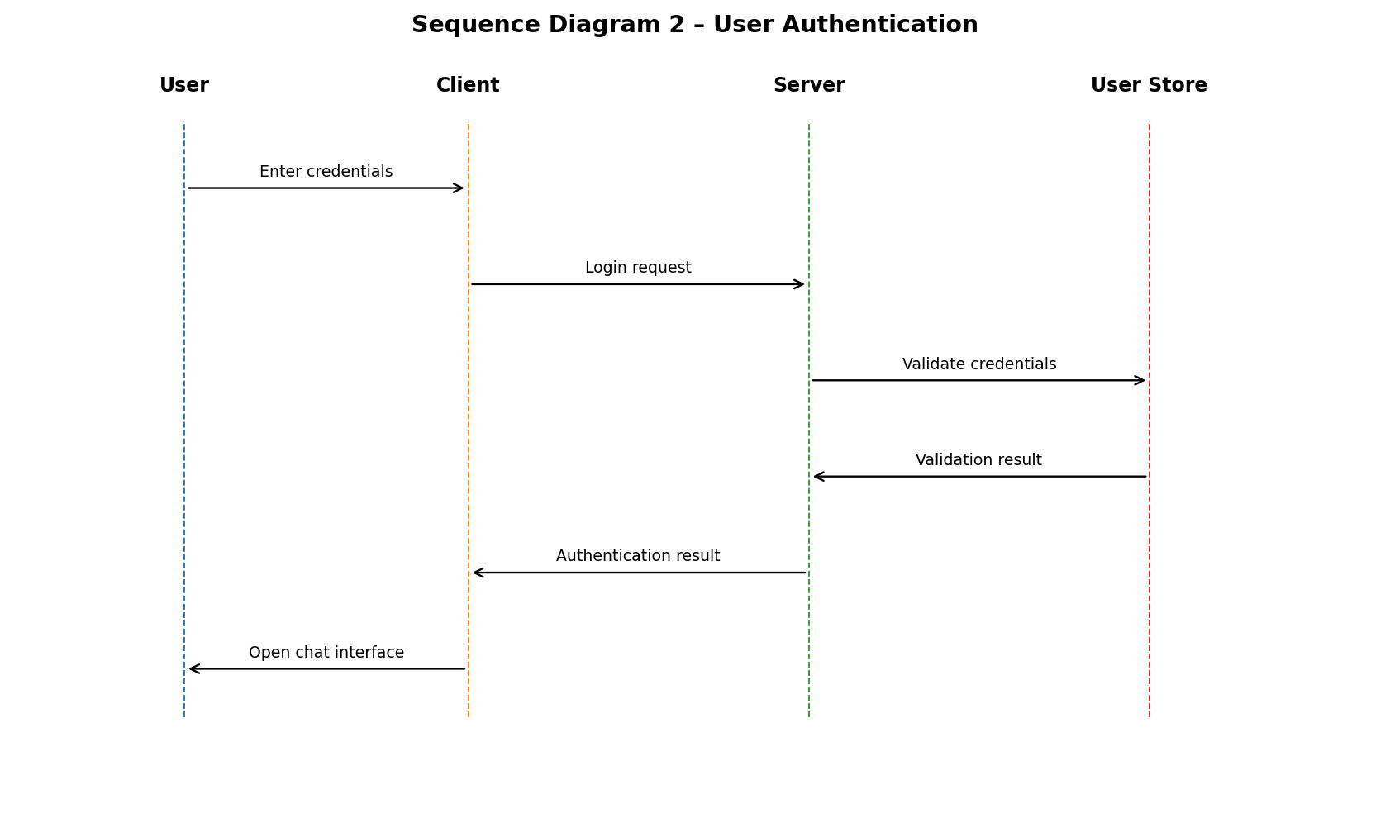

5.3 API / Communication Design
Operation | Direction | Input | Output | Purpose
REGISTER | Client → Server | Username + registration data | Success/error response | Create account
LOGIN | Client → Server | Credentials | Authentication result/session | Authenticate user
JOIN_CHAT | Client → Server | Authenticated session | Join/status response | Enter chat service
SEND_MESSAGE | Client → Server | Recipient/chat + message | Acknowledgement/error | Send message
MESSAGE | Server → Client | Routed message + timestamp | Display/update | Deliver message
USER_LIST | Server → Client | Active session state | Connected-user list | Show online users
LOGOUT | Client → Server | Authenticated session | Logout/status | End session

5.4 Error Handling
Error Condition | System Response | Related SRS
Invalid credentials | Reject login and display an authentication error. | FR-03
Empty/invalid message | Reject message before transmission. | FR-17, FR-18
Server unavailable | Notify user that connection cannot be established. | FR-20
Unexpected disconnect | Update connection state and notify affected user(s) as applicable. | FR-15, FR-20
Unauthorized operation | Reject operation and return an access-control error. | SEC-01, SEC-04
Malformed input | Reject or safely handle input without processing it as valid data. | NFR-09, SEC-02

6. Deployment Considerations
For the student implementation, the server may run on localhost or a controlled network machine. Clients connect using the configured server address and communication port. The selected runtime and dependencies must be installed before deployment.

7. Design Constraints and Assumptions
- The selected socket/WebSocket framework remains the primary communication mechanism.
- The initial design focuses on text messaging.
- Database/session persistence details may be adapted to the selected implementation.
- The architecture is intended to support the requirements defined in the SRS.

