Bryce Egley

CS475

Project 1 Write Up

1. Tell what machine you ran this on

Flip (Linux)

1. What do you think the actual volume is?

25.3135

1. Show the performances you achieved in tables and graphs as a function of NUMNODES and NUMT

Graph

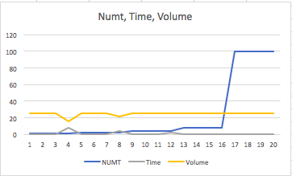

Table

|  |  |  |  |
| --- | --- | --- | --- |
| NUMT | NUMNODES | Time | Volume |
| 1 | 50 | 0.00020805 | 25.3158 |
| 1 | 100 | 0.000793301 | 25.3133 |
| 1 | 1000 | 0.0781911 | 25.3147 |
| 1 | 10000 | 8.06405 | 16 |
| 2 | 50 | 0.000185315 | 25.3158 |
| 2 | 100 | 0.00054105 | 25.3133 |
| 2 | 1000 | 0.0736 | 25.313 |
| 2 | 10000 | 4.21385 | 21.4736 |
| 4 | 50 | 0.000175411 | 25.3158 |
| 4 | 100 | 0.000495911 | 25.3133 |
| 4 | 1000 | 0.0450765 | 25.3124 |
| 4 | 10000 | 2.37438 | 25.7908 |
| 8 | 50 | 0.000198267 | 25.3158 |
| 8 | 100 | 0.000394562 | 25.3133 |
| 8 | 1000 | 0.0124191 | 25.3126 |
| 8 | 10000 | 1.49359 | 25.3287 |
| 100 | 50 | 0.00341723 | 25.3158 |
| 100 | 100 | 0.00305681 | 25.3133 |
| 100 | 1000 | 0.0101467 | 25.3125 |
| 100 | 10000 | 0.661112 | 25.3135 |

1. What patterns are you seeing in the speeds?

As NUMT decreases and NUMNODES increases the time increases.

With more NUMT and NUMNODES the volume appears to get more accurate.

1. Why do you think it is behaving this way?

This is because it takes more time for just one thread, that is why the time gets longer. With more nodes and threads we run more heights so the volume gets more accurate.

1. What is the Parallel Fraction for this application, using the Inverse Amdahl equation?

S = 0.0008322 / 0.000175411 = 4.744286276231252

Float Fp = (4./3.)*(1.-(1./ 4.744286276231252) );

Fp = 0.836696306977488

1. Given that Parallel Fraction, what is the maximum speed-up you could *ever* get?

27.763 maximum speed up