Bryce Egley

CS475

Project 2 Write Up

1. Tell what machine you ran this on

Flip (Linux) which has 24 processors

1. Create a table with your results.

Using 100 Bodies 200 steps

|  |  |  |  |
| --- | --- | --- | --- |
| NumThreads | Megabodies/Second | schedule | grain |
| 1 | 17.3015 | dynamic | coarse |
| 2 | 34.4321 | dynamic | coarse |
| 4 | 53.6595 | dynamic | coarse |
| 8 | 81.4476 | dynamic | coarse |
| 20 | 41.4171 | dynamic | coarse |
| 30 | 56.286 | dynamic | coarse |
| 50 | 53.2944 | dynamic | coarse |
| 100 | 37.519 | dynamic | coarse |
| 1 | 17.9893 | static | coarse |
| 2 | 35.4617 | static | coarse |
| 4 | 57.2263 | static | coarse |
| 8 | 76.9138 | static | coarse |
| 20 | 46.6154 | static | coarse |
| 30 | 59.2395 | static | coarse |
| 50 | 49.2686 | static | coarse |
| 100 | 31.0105 | static | coarse |
| 1 | 11.8708 | dynamic | fine |
| 2 | 19.2832 | dynamic | fine |
| 4 | 9.09995 | dynamic | fine |
| 8 | 8.68168 | dynamic | fine |
| 20 | 5.58825 | dynamic | fine |
| 30 | 1.24179 | dynamic | fine |
| 50 | 0.920859 | dynamic | fine |
| 100 | 0.464927 | dynamic | fine |
| 1 | 16.3333 | static | fine |
| 2 | 26.821 | static | fine |
| 4 | 19.1316 | static | fine |
| 8 | 15.3076 | static | fine |
| 20 | 1.97259 | static | fine |
| 30 | 1.62212 | static | fine |
| 50 | 0.949757 | static | fine |
| 100 | 0.491028 | static | fine |

1. Draw a graph. The X axis will be the number of threads. The Y axis will be the performance in whatever units you sensibly choose. On the same graph, plot 4 curves:
2. coarse+static

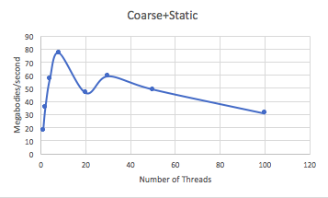

1. coarse+dynamic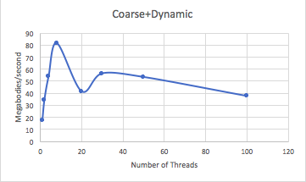
2. fine+static

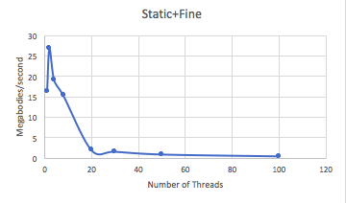

1. fine+dynamic

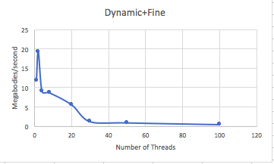

1. What patterns are you seeing in the speeds?

I notice that all 4 graph increase initially, then decrease. This turning point in fine happens at 2 threads and in coarse happens at 8 threads.

There doesn’t seem to be huge difference between static and dynamic. Static looks slightly better. Coarse seems much better in terms of megabits/second then fine.

1. Why do you think it is behaving this way?

The overall trend we see of increase and then decrease pattern follows the performance as a function of number of threads that we learned about in lecture. More threads divide up the work, however once you have too many threads then too much time is spent on communication between the threads and less on work.

It seems that coarse grained works better than fine grained since the computing is being split into larger tasks whereas fine grained computing is broken into make small tasks.