Bryce Egley

CS475

Project 7 Write Up

1. What machines you ran this on

Answer: I ran this on Rabbit which 2 E5-2630 Xeon Processors

1. Show the Sums{1] ... Sums[512] vs. shift scatterplot

Answer:

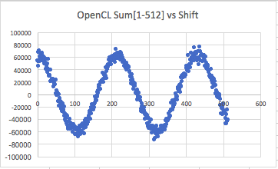

1. Tell me what you think the secret sine wave's period is, i.e., what multiples of *shift* give you maxima in the Sums[\*] scatterplot?

 Answer:

1. Draw a bar chart showing the performance for your 1-thread OpenMP, your n-thread OpenMP, your SIMD, and your OpenCL. Pick appropriate units. Make "faster" go up.

Answer:

1. State what the hidden sine-wave period is, i.e., at what multiples of *shift* are you seeing maxima in the graph?

Answer:

1. What patterns are you seeing in the performance bar chart? Which of the four tests runs fastest, next fastest, etc.? By a little, or by a lot?

Answer:

1. Why do you think the performances work this way?

Answer: