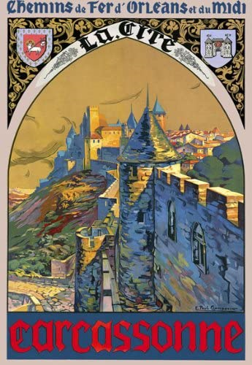
Game Design Document
[
]

Carcassonne
[
]

A board game tutorial game

임경태
2020-06-24

