AITAM QUEST 2006

ADITYA INSTITUTE OF TECHNOLOGY AND MANAGEMENT

A TASTE OF THE FUTURE:THE ELECTRONIC TONGUE

BY

FROM

GUDLAVALLERU ENGINEERING COLLEGE

:

123seminarsonly.com

ABSTRCT:
This topic includes brief introduction of the modern electronic device.The electronic tongue is a system for automatic analysis and recognition (classification) of liquids or gases. Researchers hope the electronic tongue can be used by industry to ensure that beverages coming off assembly lines are uniform in flavor. They also plan to go beyond the four tastes of the human tongue and use the device to analyze such substances as blood or urine, or to test for poisons in water. But can an electronic tongue mimic the sophisticated palates of wine tasters? Eventually, its developers say, it may come close. The food and beverage industries may want to use the tongue to develop a digital library of tastes proven to be popular with consumers, or to monitor the flavors of existing products. some sensing methods are applied.It explains designing of electronic tongue This new technology has many advantages.It includes many applications we discussed here.
INTRODUCTION:
Our tongue is equipped with taste receptors in our taste buds. They are found on bumps on your tongue called papillae. Some people think that every bump on their tongue is, itself, a taste bud, but that is not true. Each papilla has many taste buds within it. In addition, we have taste buds that are not even on our tongues. Some taste buds are found in our throats, cheeks, and in the roof of our mouths.A taste bud is composed of a cluster of long, epithelial cells. Some of these epithelial cells have been modified to be taste cells which are our taste receptor cells. Other epithelial cells in the taste bud are called supporting cells.
All the cells in the taste bud lie with their apical surface facing a pore, called the taste
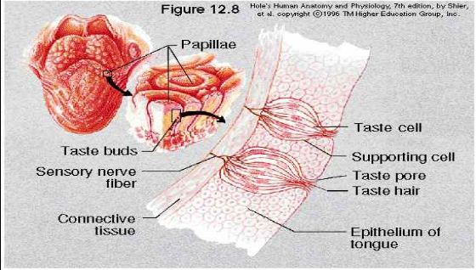

pore. This pore is basically an opening in the surrounding tongue tissue to allow exposure of the apical surfaces of the taste cells to the environment in order to receive their chemical stimulus. The apical surfaces of the taste cells have a lot of surface area to interact with their environment, since they are covered with microvilli. These microvilli (which are tiny, tiny projections, much smaller than cilia) are called taste hairs.Now, let's see how we taste something. When we eat food we are able to taste it only when the food dissolves. As the food dissolves, some of the sugar dissolves into your saliva. This dissolved sugar now moves within the saliva to any place in your mouth where your saliva travels. As it covers the front of the tongue, the saliva oozes into the taste pores. The dissolved sugar interacts with the microvilli on the taste cells, and causes a receptor potential. Meanwhile, some of this same, sweetened saliva reaches the posterior edge of the tongue. It oozes into the taste pores back there on the tongue and doesn't affect the taste cells at all.The taste cells in the taste buds in the anterior edge of the tongue are specialized to detect sweetness (dissolved sugar). But those on the posterior edge of the tongue are specialized to detect bitterness-- so they don't respond to the dissolved sugar.
THE ELECTRONIC TONGUE:
The electronic tongue is a system for automatic analysis and recognition (classification) of liquids or gases, including arrays of non-specific sensors, data collectors and data analysis tools. It contains tiny beads analogous to taste buds. Each "bud" is designed to latch onto specific flavor molecules and change colors when it finds one, be it sweet, sour, bitter or salty. The buds are housed in pits on the surface of the tongue itself, which is made of silicone.Each one of these pits looks like a little pyramid, and it's just the right size that we can take one of these taste buds and nestle it down inside. Researchers hope the electronic tongue can be used by industry to ensure that beverages coming off assembly lines are uniform in flavor. They also plan to go beyond the four tastes of the human tongue and use the device to analyze such substances as blood or urine, or to test for poisons in water. But can an electronic tongue mimic the sophisticated palates of wine tasters? Some day, the tongue might speed up blood analysis by testing everything from cholesterol to medications in a person's bloodstream, all at the same time. The food and beverage industries may want to use the tongue to develop a digital library of tastes proven to be popular with consumers, or to monitor the flavors of existing products. This new technology has many advantages. Problems associated with human senses, like individual variability, impossibility of on-line monitoring, subjectivity, adaptation, infections, harmful exposure to hazardous compounds, mental state, are no concern of it.
SENSING METHODS APPLIED:
• Conductivity sensors
􀂾 MOSFET- Metal oxide silicon field effect transistor
􀂾 CP- Conducting Polymer
• Piezoelectric sensors
􀂾 QMB- Quartz Crystal Microbalance
􀂾 SAW- Surface Acoustic Wave
• Optical sensors
PATTERN RECOGNITION:
The electronic tongue performance is dependent on the quality of functioning of its pattern recognition block. Various techniques and methods can be used separately or together to perform the recognition of the samples. After measurement procedure the signals are transformed by a preprocessing block. The results obtained are inputs for Principal Components Analysis, Cluster Analysis or Artificial Neural Network.Measurement Sensors arrays' outputs are arranged in data matrix.
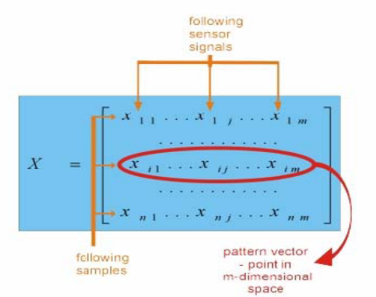
Each sample is characterized by unique and typical set of data, forming "fingerprint" of an analyte in m-dimensional pattern space. Preprocessing is the phase in which linear transformation on the data matrix is performed (without changing the dimensionality of the problem) in order to enhance qualitativeinformation. Typical techniques include manipulation of sensor baseline, normalization, standardization and scaling of response for all the sensors in an array.
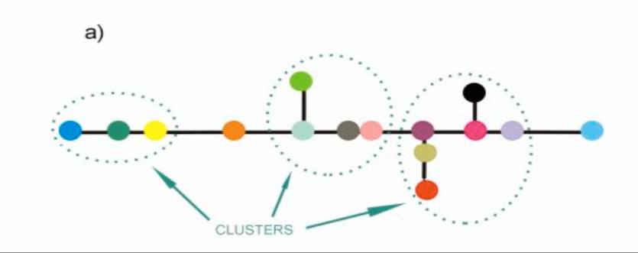
Principal Component and Cluster Analysis
A multi-sensor system produces data of high dimensionality - hard to handle and

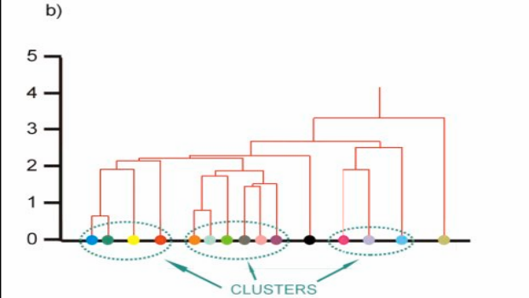

visualize. Principal Component Analysis (PCA) and Cluster Analysis (CA) are
multivariate pattern analysis techniques reducing dimensionality of the problem and reducing high degree of redundancy. PCA is a linear feature-extraction technique finding most influential, new directions in the pattern space,explaining as much of the variance in the data set as possible. This new directions - called principal components - are the base for a new data matrix. Usually 2 or 3 of them are sufficient to transfer more than 90% of the variation of the samples.The base principle of Cluster Analysis is the assumption of close position of similarsamples in multidimensional pattern space. Similarity between each 2 samples is calculated as a function of the distance between them - usually in Euclidean sense – and displayed on a dendrogram.
2. Cluster Analysis
a), b) different types of dendrograms
Artificial Neural Networks (ANN):
Neural Networks are information processing structures imitating behavior of human brain. Their main advantages, such as: adaptive structure, complex interaction between input and output data, ability to generalize, parallel data processing and handling incomplete or high noise level data make them useful pattern recognition tools. There are

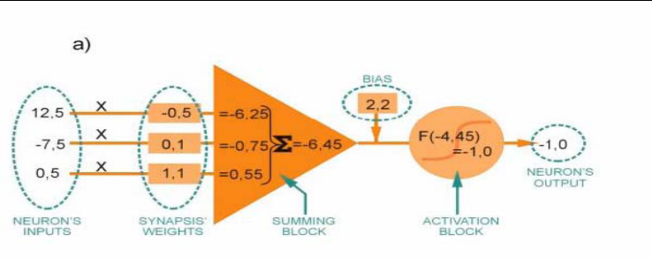
many possible architectures and algorithms available in the literature, but the mostcommon in measurement applications is feed-forward network (multilayer perceptron MLP) and back-propagation learning algorithm.The base units of artificial neural networks are neurons and synapses. Neurons are organized in layers and connected by synapses. Their task is to sum up their inputs and non-linear transfer of the result, which is then transmitted via synapsis with modification by means of the synapsis weights - this signal, in turn, is the input for the next layer of the network .
Neural Networks:
a) single neuron
b) feed-forward network
The use of ANN involves 3 phases:
• The learning phase - after establishing number of neurons, layers, type of architecture, transfer function and algorithm, network is forced to provide desired outputs corresponding to a determined input. It is made by adjusting the synapses weights in order to minimize the difference between desired and current output.
• The validation phase - verification of the generalization capability of network by means of data different (but with similar characteristics) from data used in the learning phase.
• The production phase - in which the network is capable of providing outputs
corresponding to any input.
DESIGN OF THE ELECTRONIC TONGUE:
The researchers designed the e-tongue to be structurally similar to the human tongue, which has four different kinds of receptors that respond to distinct tastes. The human tongue creates a pattern in the brain to store and recall the taste of a particular food. To build the e-tongue, the scientists positioned 10 to 100 polymer micro beads on a silicon chip about one centimeter square. They arranged the beads in tiny pits to represent taste buds and marked each pit with dye to create a red, green, and blue (RGB) color bar.The colors change when the scientists introduce chemicals to the e-tongue. A camera on a chip connected to a computer then examines the colors and performs a simple RGB analysis that in turn determines what tastes are present. Yellow, for example, would be response to high acidity, or a sour taste.The e-tongue now uses simple markers to detect different types of taste: calcium and metal ions for salty, pH levels for sour, and sugars for sweet.The e-tongue can also "taste" cholesterol levels in blood, cocaine in urine, or toxins in water.
APPLICATIONS OF E-TONGUES:
• Foodstuffs Industry
• food quality control during processing and storage (water, wine, coffee,
milk, juice…)
• optimalization of bioreactors
• control of ageing process of cheese, whiskey
• automatic control of taste
• Medicine
• clinical monitoring in vivo
• Safety
• searching for chemical/biological weapon
• searching for drugs, explosives
• friend-or-foe identification
• Environmental pollution monitoring
• monitoring of agricultural and industrial pollution of air and water
• identification of toxic substances
• Quality control of air in buildings, closed accommodation (i.e. space station,
control of ventilation systems)
• Chemical Industry
• products purity
• in the future - detection of functional groups, chiral distinction
Legal protection of inventions - digital "fingerprints" of taste
ELECTRONIC TASTE CHIPS CUSTOMIZED FOR BIODEFENSE APPLICATIONS:
Recent work from The University of Texas at Austin has led to the development of a powerful new "electronic taste chip" technology. By mimicking the chemical features of the human taste bud, the chip has the capacity to analyze rapidly the chemical and biochemical content of complex fluids such as human blood, environmental samples, and bioaerosol specimens. This technology is extremely versatile, making it suitable for the measurement of electrolytes, protein antigens, antibodies, whole bacteria and DNA/RNA.While these chips exhibit impressive analytical and diagnostic capabilities as compared with gold tandards such as pH meters for acidity and ELISA for protein analysis, their compact design and low cost also allows for their use in numerous military and civilian
applications which require autonomous operation. Moreover, because molecular detection is confined to a miniaturized chamber etched into a silicon chip, multiple tests can be performed simultaneously. The technology has the capacity to be mass-produced in commercial quantities at minimal cost. Testing requires a single drop of fluid and disposable cartridges, customized for specific applications can be created using highly parallel chip fabrication and solid-state bead synthetic procedures. This electronic taste chip technology can be used to identify and quantify analytes in the solution-phase via colorimetric and fluorescence changes to receptor and indicator molecules that are covalently attached to the polymer micro spheres. The optical response of each micro sphere is monitored in real-time using a charged coupled device (CCD), allowing for near-real-time analysis of complex fluids. Most recently, micro bead arrays have been fashioned specifically for the detection of chemical weapons precursors and degradation products as well as for the identification of bacterial spores from the bacillus family.

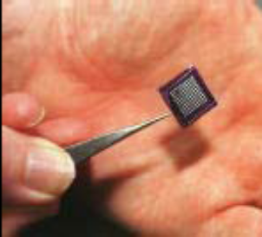
Tiny squares on the chip taste pollution in water
ELECTRONIC TONGUE TO ‘TASTE’ POLLUTION:
A miniature electronic "tongue" which could taste pollution in rivers is being developed by researchers at Cardiff University, UK. The team, led by Professor David Barrow, has managed to miniaturize conventional detection technology to produce a device that could potentially be mass produced at low cost.The tasting part of the device is working and the team is developing the computerized system which will respond to its inputs. The electronic tongue uses a technique for separating mixtures known as chromatography, which needs detectors with a large surface area.Conventional chromatographic detectors pass liquids or gases through columns packed with tiny glass beads.Big area Chemical detectors on the beads sense the presence of other substances in the fluid. The Cardiff team used hydrofluoric acid to etch millions of tiny pores and channels into a silicon chip. This created a huge surface area in a tiny space.UK researchers are developing a unique electronic ‘tongue’ that can be dipped into rivers or industrial effluent streams to ensure that the water does not contain anything sinister.The ‘tasting’ part of the system can be fabricated from very small components, making it potentially easy and inexpensive to mass-produce. The next step would be to link the tongue to a computerized ‘brain’ to analyze the signals it generates.The system is based on an analytical technique called chromatography (a technique for separating mixtures). Here, the chemical sample, contained in a liquid or a gas, is passed through or over a solid ‘matrix’ which has a high surface area – for example a glass cylinder packed with silica beads. It is possible to attach a variety of chemical ‘hooks’ on to the beads, so that as the sample passes down the column of beads different components will be ‘grabbed’ by the hooks to differing extents. In this way the various components
can be separated from the mixture and analyzed.The Cardiff researchers’ system works on broadly similar principles, but on a much smaller scale. If a silicon chip is treated with hydrofluoric acid in a controlled way, it becomes etched with millions of tiny pores and channels, of dimensions of nanometers.
ELECTRONIC TONGUE THAT MIMICS THE REAL THING:
While artists may complain that critics' taste exists only in their mouths, UT Austin engineers and scientists have now successfully placed it on a silicon chip.
Using chemical sensors, these University of Texas at Austin researchers designed an electronic tongue that mimics the real thing. Like its natural counterpart, it has the potential someday to distinguish between a dazzling array of subtle flavors using a combination of the four elements of taste: sweet, sour, salt and bitter. And in some ways it has outdone Mother Nature: it has the capacity to analyze the chemical composition of a substance as well.The device, which has the potential to incorporate hundreds of chemical micro sensors on a silicon wafer, has a multitude of potential uses. The food and beverage industry wantsto develop it for rapid testing of new food and drink products for comparison with a computer library of tastes proven popular with consumers.But the artificial tongue can also be used for more distasteful purposes, to analyze cholesterol levels in blood, for instance, or cocaine in urine, or toxins in water. The National Institutes of Health recently gave the UT group $600,000 to develop a tongue version to replace the multiple medical tests done on blood and urine with one fast test.The team attached four well-known chemical sensors to minute beads and placed the beads in micro-machined wells on a silicon wafer. Like a human tongue, the wells mimicked the tongue's many cavities that hold chemical receptors known as taste buds.Each bead, like a tongue's receptor, had a sensor that responded to a specific chemical by changing color. One turned yellow in response to high acidity, purple under basic conditions. Then the researchers read the sensor's results through an attached camera-ona-chip connected to a computer.The sensors responded to different combinations of the four artificial taste elements with unique combinations of red, green and blue, enabling the device to analyze for several different chemical components simultaneously.From the silicon tongue, the team hopes to create a process to make artificial tongues more cheaply and quickly, placing them on a roll of tape, for example, to be used once and thrown away.

ELECTRONIC TONGUE DETECTS MOULD:
Not only can an electronic tongue monitor the prevalence and growth of microorganisms,it can also sense the difference between various forms of fungi and bacteria. An objectiveof the project as a whole is to be able to make use of an electronic tongue in the future to monitor whether foodstuffs are fit for human consumption.Today’s monitoring methods involve taking samples from production and analyzing them in a laboratory. But it can take several days to cultivate mold and bacteria. If an analysis uncovers a problem, it can be difficult to determine exactly what packages need to be pulled. The electronic tongue, on the other hand, can be mounted directly in a production facility, where it can continuously monitor production. It can even withstand the strong detergents used to clean machines. The instrument consists of four metal electrodes that are inserted into a sample and then charged with electric voltage. The current that arises varies in strength between different samples depending on the content of electro-active substances. Microorganisms alter the content of such substances in the sample, which is registered by the electronic tongue. The metering provides large quantities of data, and, with the aid of special statistical methods, relevant information can be gleaned. The development of the electronic tongue is still in the research stage. It may be several years before it is available for use in the food industry.
CONCLUSION:
Up to now we have seen about the electronic tongue is a system for automatic analysis and recognition (classification) of liquids or gases.We have discussed this new technology has many advantages.There exists sensing methods too. Problems associated with human senses, like individual variability, impossibility of on-line monitoring, subjectivity, adaptation, infections, harmful exposure to hazardous compounds, mental state, are no concern of it.we also come to know how the electronic tongue detects mould.
REFERENCES:
www.nptel.iitm.ac.in
www.ieeexplore.ieee.org
http://site.ebrary.com/lib/gudlavalleru

