**SR 4.1: Algorithm Implementation: Sort algorithm**

**FIRST STEP**

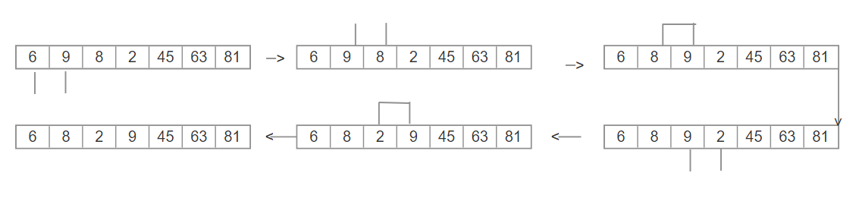

* 6 and 9 no swipe.
* 9 and 8 swipe.
* 9 and 2 swipe.

**SECOND STEP**

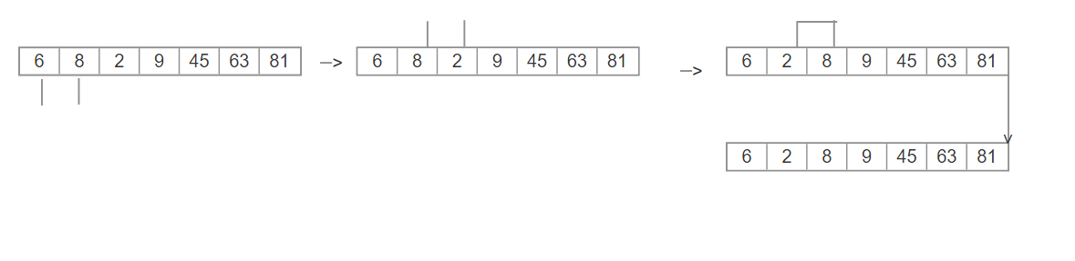

* 6 and 8 no swipe.
* 8 and 2 swipe.

**THIRD STEP**

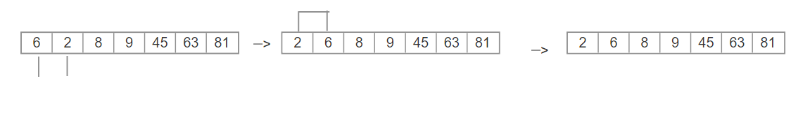

* 2 and 6 swipe.

**HEAP DATA SORT ALGORITHM**

**TREE DIAGRAM**

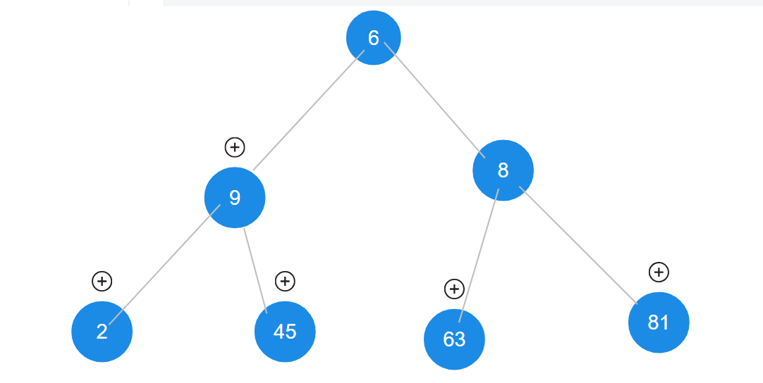

**HEAP 1**

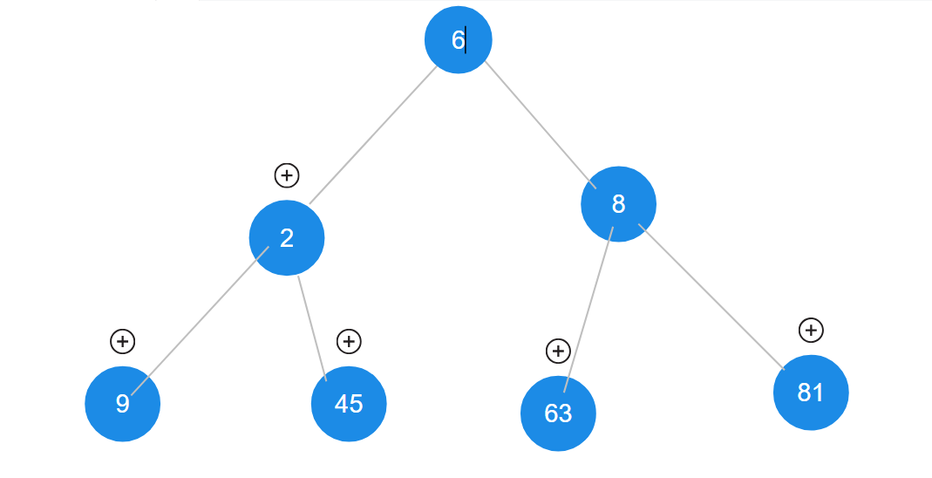

* Swipe 9 and 2

**HEAP 2**

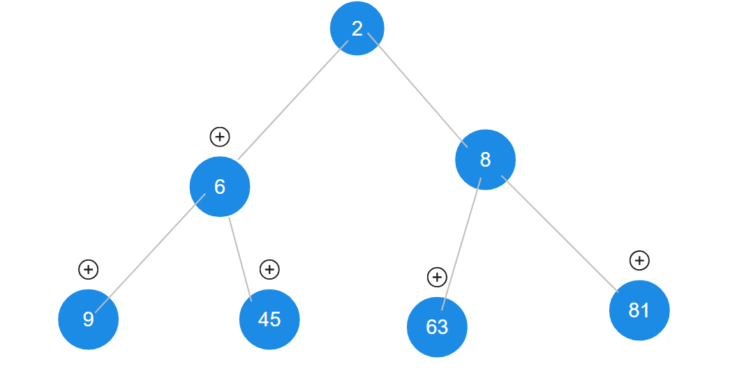

* Swiped 6 and 2