User Guide

October 2016

Version 1.0

Table of Contents

1 How to register 3

2 How to login 3

3 How to post an advert 4

4 How to purchase the product being advertised 5

5 How do I search for an advert 5

6 Homepage 6

8 Frequently asked questions 7

# How to register

In order to use the core functionality of this site (post adverts) you need to be a registered user. You will be requested to type in the following details:

* Name
* A valid email address

We do not require you to have a password. Once you have filled in this information a verification email will be sent to the email address you registered with. This email will contain a randomly generated code you will need to type in in order to complete registration. You will not be considered a valid user until you confirm your account with the verification code.



# How to login

With the assumption that you have successfully completed the registration process in order to login you will be required to type in your username, thereafter you will be sent an email with a link that will verify your login, this link will only be available for a predefined set of hours or until you logout, whichever comes first.

# How to post an advert

With the assumptions that you are a registered user and are currently logged in. you would need to click on the “create advert” button. Upon clicking on this button you will be redirected to a new page where you will be required to fill information pertaining to your advert such as:

* Description
* Price
* Category
* Location

Our app will suggest a location based on your current location, you can then chose to accept this location or type in your own. The same would apply for the category. Our category detection algorithm will suggest relevant categories based on the information you have provided.

Once you have confirmed the category, more fields relating to the category selected will be populated, for example if you are posting an advert for livestock we will request that you fill in information such as

* Grade
* Gender
* Age

Whereas if your advert fell under the motor vehicle category you would be requested to fill in information such as

* Petrol/diesel
* Automatic/manual
* Make/model
* Year

Once you have filled out all the required fields you can click on the “Post Advert” button and your advert will now be live for both registered users and guests to see.

Screen capture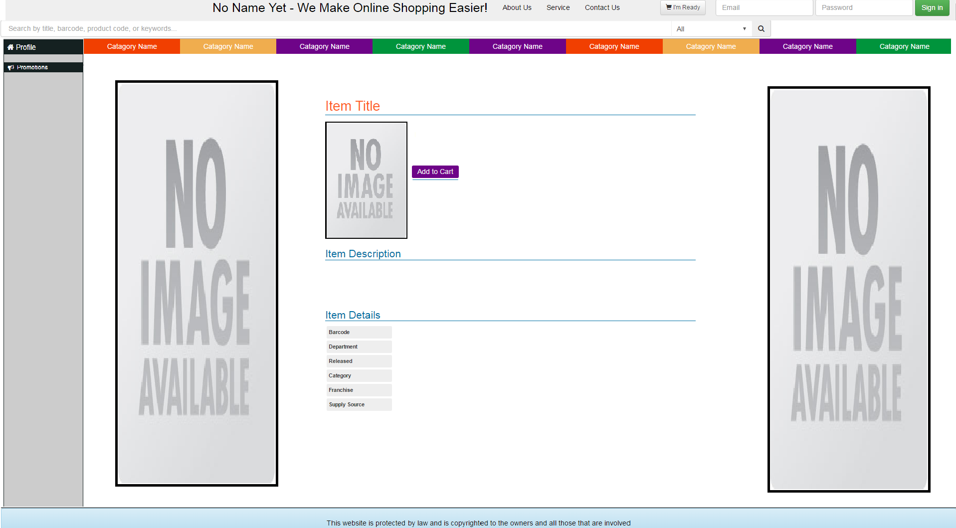re

# How to purchase the product being advertised

When contacting a seller you do not have to be a registered user. If you come across an advert you like, click on it and you will see the sellers contact details at the bottom of the page.

# How do I search for an advert

Our app allows for two types of searches, a quick search where you would type in a keyword such as “car” and we will populate the relevant data, alternatively you will be able to perform a refined search, this is where you are given the option to search by anything. Using the same category detection algorithm used when creating an advert various fields will be populated based on the category you have chosen, this will ensure that you a properly refined search. The search bar will be located on the left hand side of every screen. Please refer to point 4.

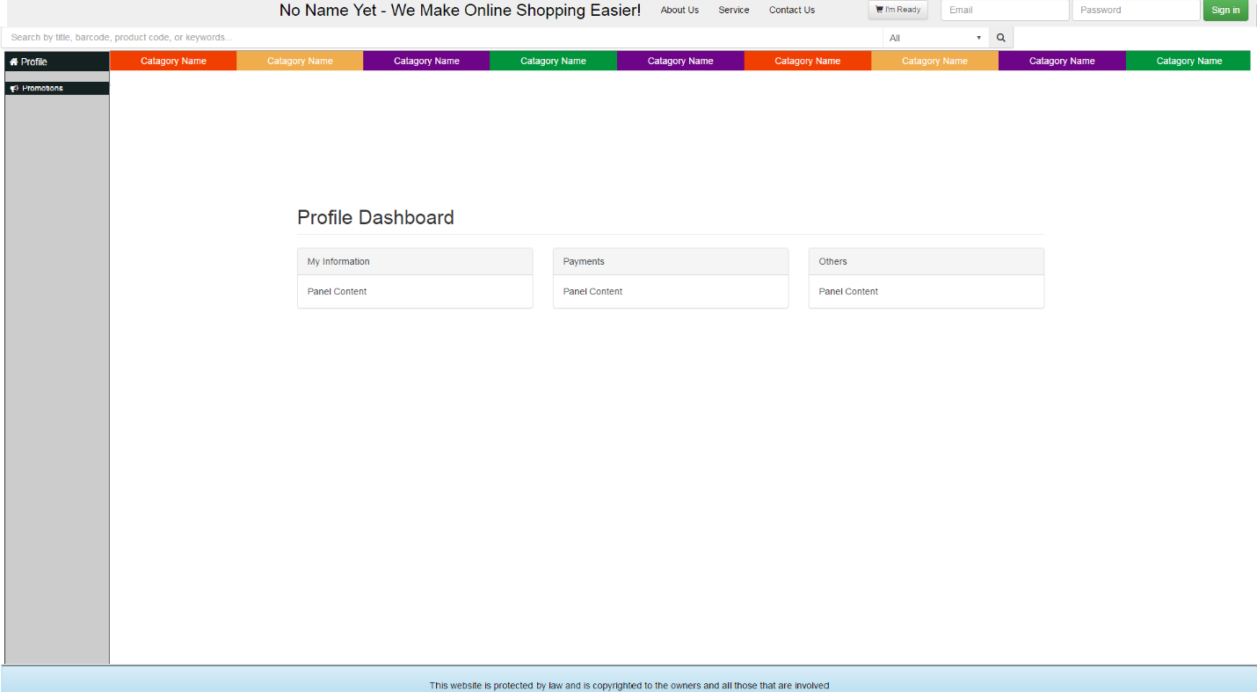

# Homepage

This home page will differ depending on whether you are a guest browning the site or a registered user. If you are a guest browsing the site the home page will consist of the latest adverts posted, you will be able to perform both the quick and refined searches as well as browse and view information on all adverts however when you request to contact a seller you will be prompted to either register or login (points 1 and 2 respectively).

When you are singed in your home screen will differ in the sense that you will have access to your users profile (a link on the top right hand corner).

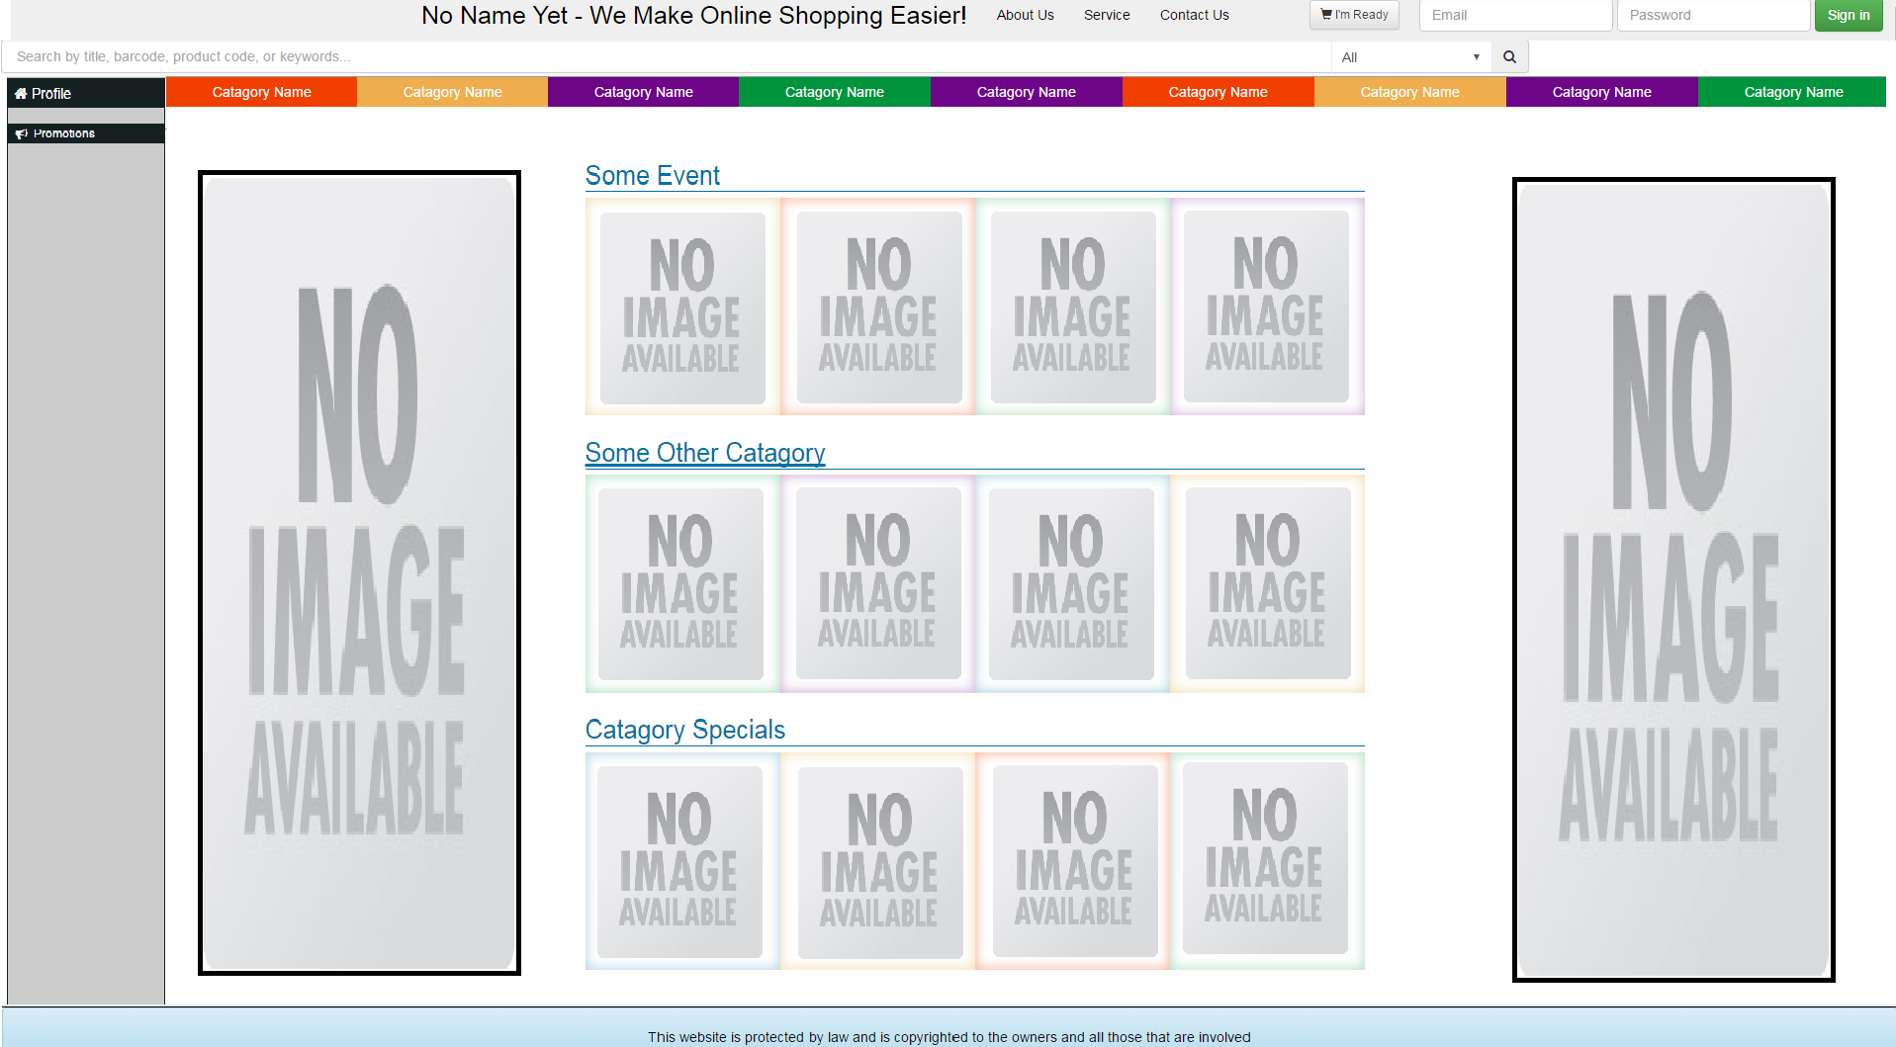

# Frequently asked questions

**How many ads can I Post on the website?**

You can post as many ads as you like one the site. Make your ads unique. Unique means that the ads are substantially different from each other. So please do not post the same as over and over again. This restriction is to prevent user spamming.

**What are popular ads?**

These are the ads that appear at the top of their category because of their popularity.

More people read these ads because of their position.

**Are ads screened before they appear on the website?**

We rely on the users to help us report bad ads on the site as every ad cannot be manually view by our development team. We strongly advise users to be on guard and report any suspicious ads.

**How do I edit, delete or post my ad?**

See point 4