# 

# Installation

Windows 64-bit systems have two options: 1) standard windows installation 2) general installation with step-by-step instructions

## General

1. Copy source code to a local drive
2. Install Miniconda for Python 3.x (if you already have Anaconda or Miniconda installed skip to 4)
3. Windows: Open Anaconda Prompt

Linux/Mac: Open Terminal

1. Update conda

Command: conda update -n base -c default conda

1. note: [frhodo_environment.yml path] refers to the full path to frhodo_environment.yml

Windows: Type: conda env create -f "[frhodo_environment.yml path]"

Example: conda env create -f "C:\Frhodo\frhodo_environment.yml"

Linux/Mac: Type: conda env create -f [frhodo_environment.yml path]

Example: conda env create -f /Users/TSikes/Documents/Frhodo/frhodo_environment.yml

## Windows Step-by-Step

1. Navigate your web browser to <https://github.com/Argonne-National-Laboratory/Frhodo> and download

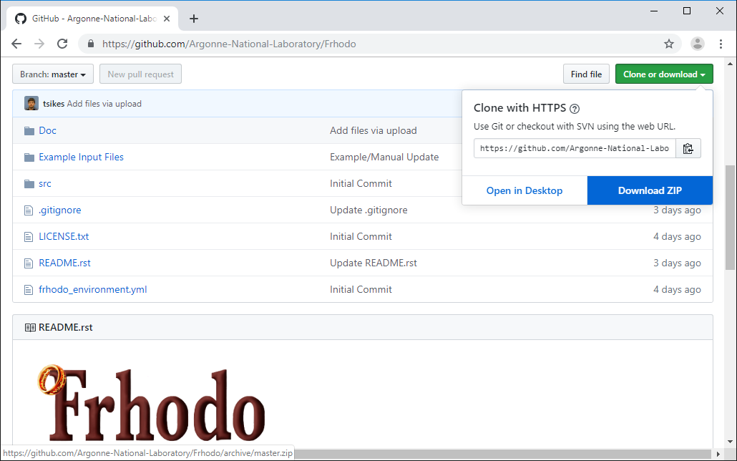

1. During this step if you would like to sign up for notifications to new releases, this can be done here

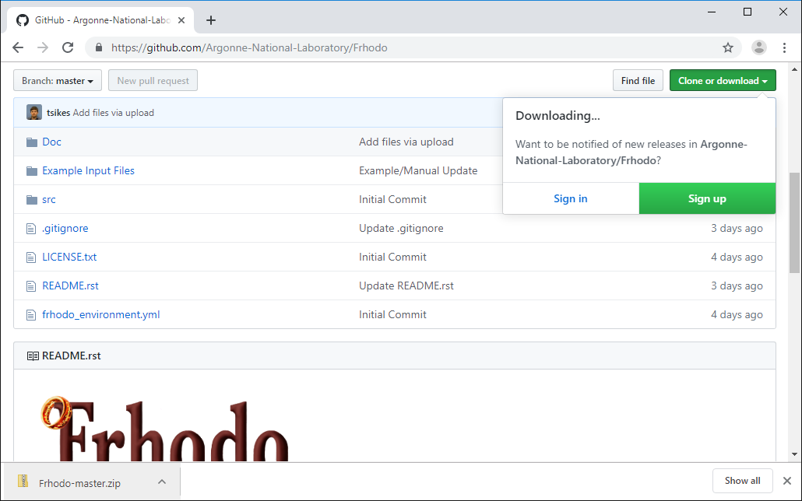

1. Extract the zip file and move the folder containing src to wherever you would like to store the program

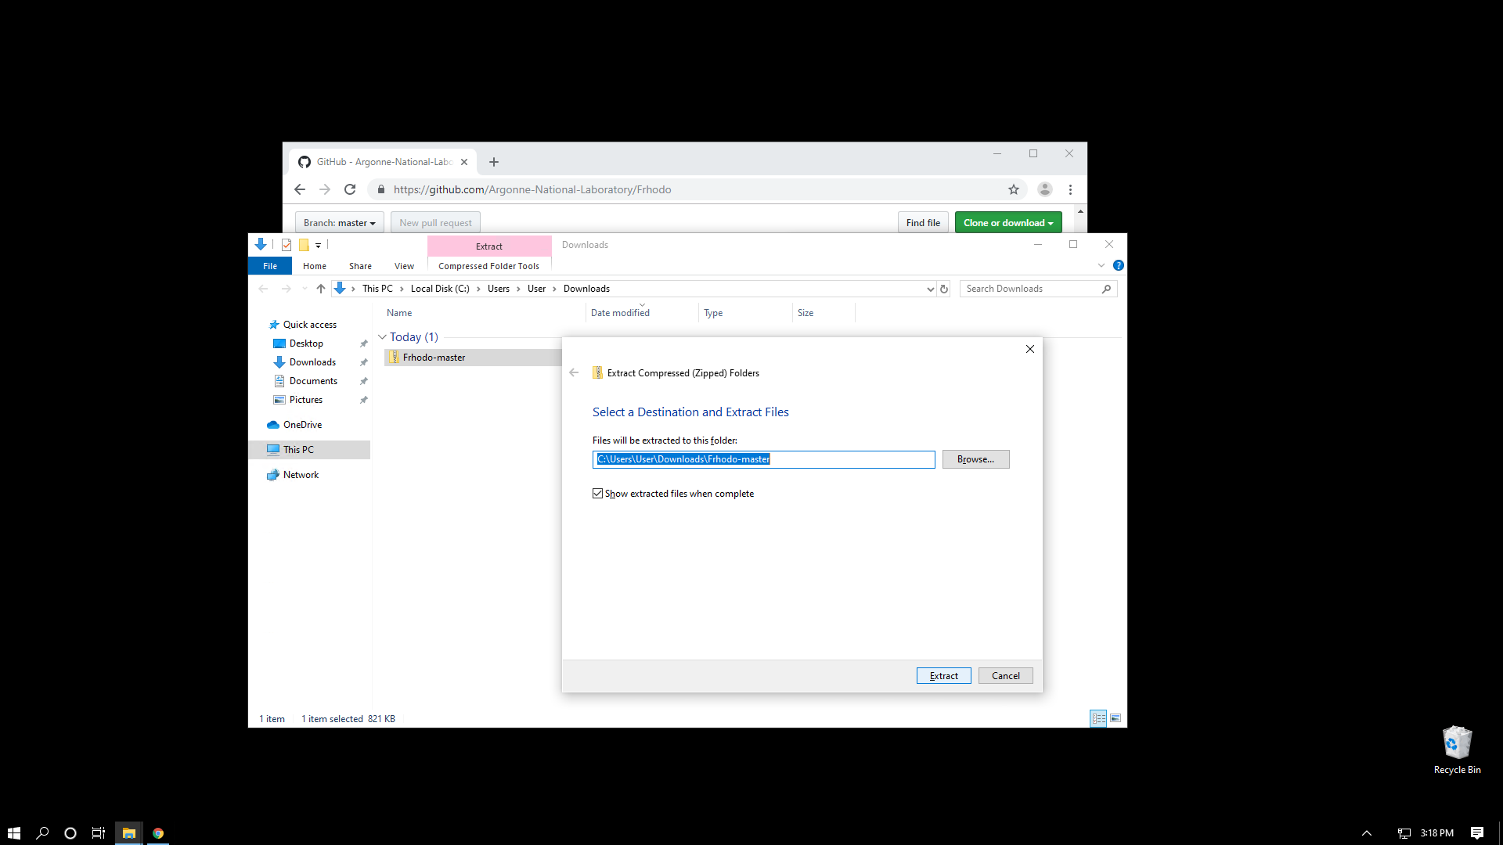

1. Download Miniconda

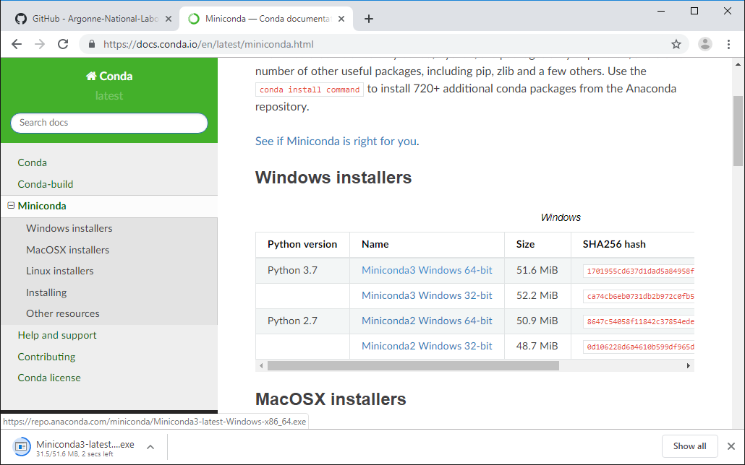

1. Install Miniconda with standard options. If you install for everything, which requires admin privileges, you will need to remember to open future Anaconda Prompts with admin privileges (this is not recommended).

|  |  |  |  |
| --- | --- | --- | --- |
|  | → |  | → |
|  | → |  | → |
|  | → |  | → |

1. Open Anaconda Prompt

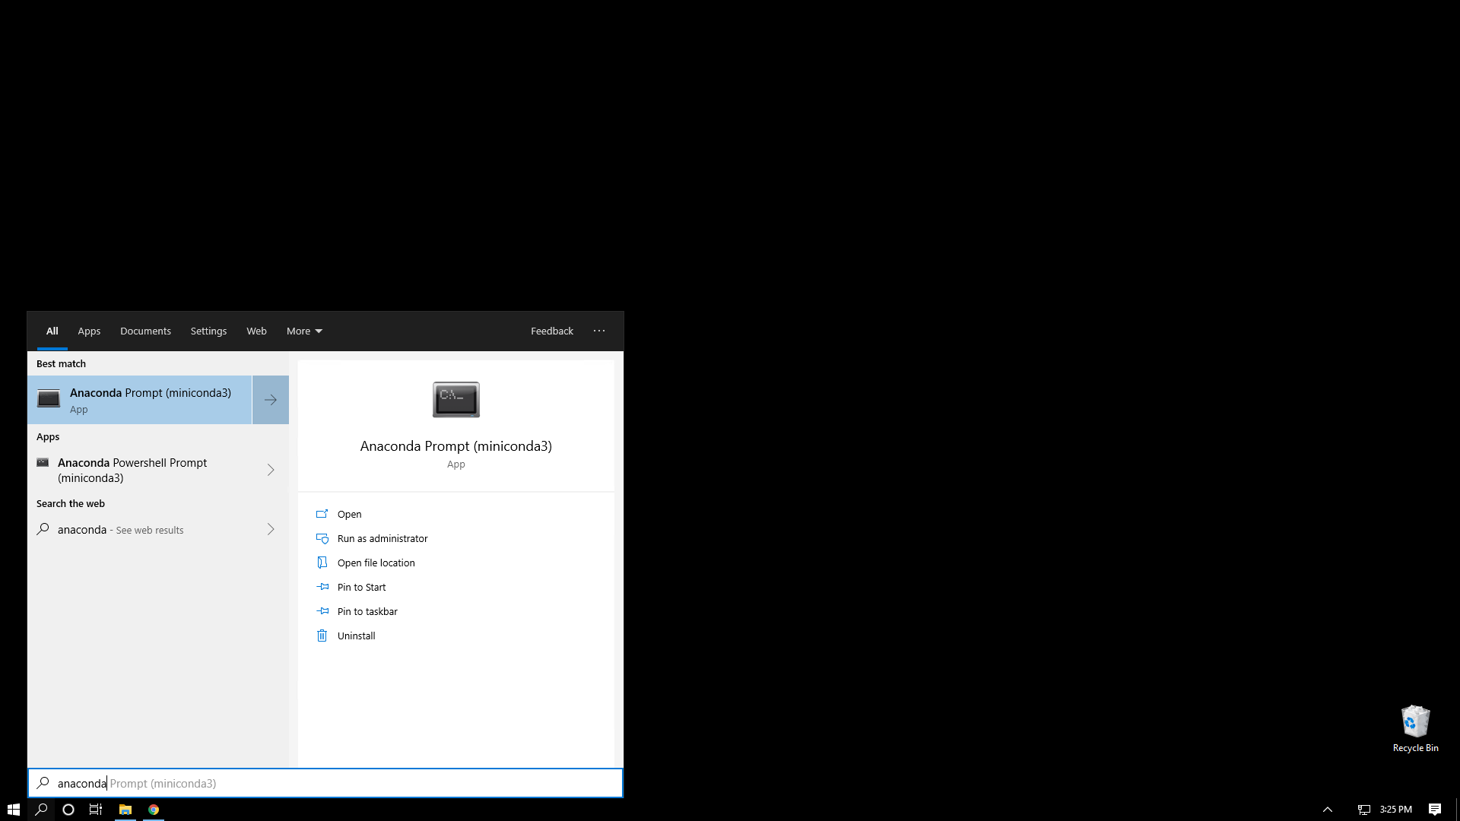

1. Update Anaconda

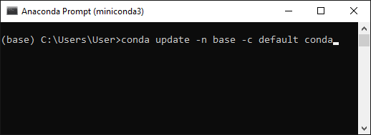

1. Install Frhodo environment

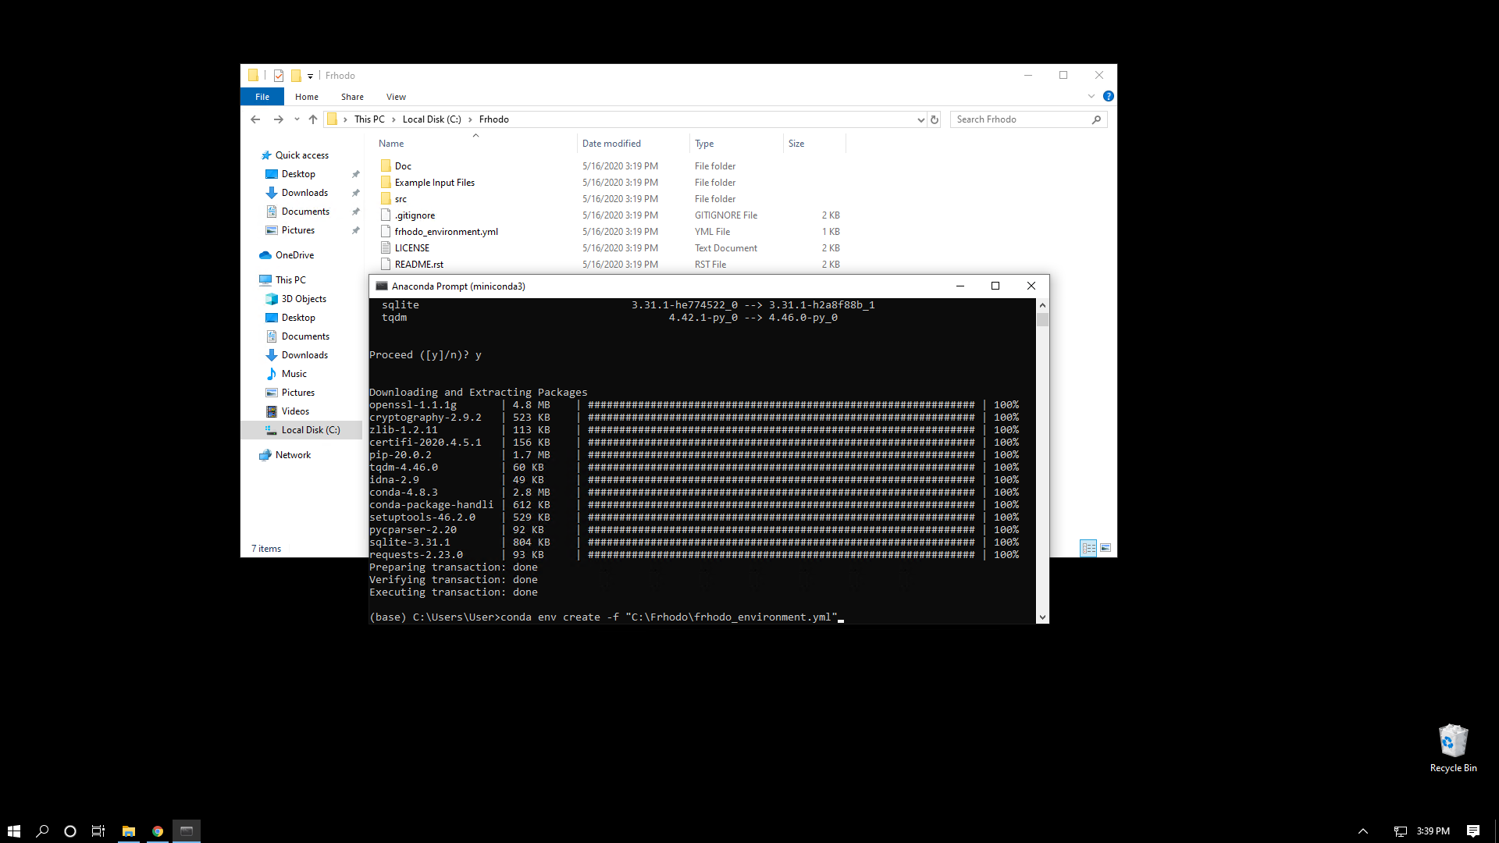

1. Frhodo is now installed, proceed to the run section

# Run

## General

If you have installed from executable, run like any other program

|  |  |
| --- | --- |
| General Instructions | Anaconda |
|  | 1. Open anaconda prompt |
| 1. Activate Frhodo environment | 1. Type: conda activate frhodo |
| 1. Run main.py from the Frhodo environment | 1. Type: python "[main.py path]"   * [main.py path] refers to full path of src/main.py which was downloaded |

If you have any errors at startup about imports and you have similar packages installed elsewhere, ensure you are pointing to the correct packages in the Frhodo environment. This might require you delete your homebrew version of Python/Cantera/etc.

## Advanced

#### Calling from IDE

If using Notepad++ as your IDE continue to a) else refer to b). If you are uncertain where the paths you need you can type “where python” in the Anaconda Prompt and it will give you the location of the activated environment. You can change the activated environment by typing “conda activate [env]” where [env] could be base, frhodo, etc.

|  |  |
| --- | --- |
| Ex: |  |

My [Main conda path] is C:\Users\TSikes\AppData\Local\Continuum\miniconda3

My [Conda env path] is C:\Users\TSikes\AppData\Local\Continuum\miniconda3\envs\frhodo

[main.py path] is main.py’s full file path

* 1. If using Notepad++ as your IDE then the NppExec (install this through the plugin manager) Execute window should have the following:

NPP_SAVE

cd "$(FULL_CURRENT_PATH)"

CMD /C ""[Main conda path]\Scripts\activate.bat" "[Conda env path]" && python -u "[main.py path]""

* 1. If you would like to use another IDE you can call:

CMD /C ""[Main conda path]\Scripts\activate.bat" "[Conda env path]" && python -u "[main.py path]""

# File Structure

## Experiment Directory Format

Experiment Directory → Shock1.exp, Shock1.rho, Shock2.exp, Shock2.rho, etc. are within 1 subdirectory of specified directory. If multiple shocks of the same number exist, the highest level one is used.

* Search specified directory and 1st level subdirectories for “.exp” file
* Use “.exp” file’s root directory as directory for .rho, and raw signal files

### Experimental Parameters Format (“.exp” file)

The experimental files holds experimental information in a configuration file format. Required fields are:

|  |  |  |  |  |  |  |  |  |  |  |  |  |  |  |  |  |  |  |  |  |  |
| --- | --- | --- | --- | --- | --- | --- | --- | --- | --- | --- | --- | --- | --- | --- | --- | --- | --- | --- | --- | --- | --- |
| |  |  |  | | --- | --- | --- | | Parameter | Shorthand Name | Units | | Driven section temperature | T1 | °C | | Driven section pressure | P1 | Torr | | Driver section pressure | P4 | Psi | | Pressure transducer spacing | PT Spacing | mm | | Avg time between transducers | tOpt | μs | | Sample Rate* | SampRate | Hz |  * This parameter, while still required, is only used in conjunction with the optional raw experimental observable file |

One solution if your experiment is not shock tube-based is to set the mixture within Frhodo, alter T5 and P5, and then copy the conditions (T1, P1, and U1) to make into an .exp file. This will create an experiment file that will give you your specified conditions and load properly whenever you change shock number.

The incident shock velocity (U1) is set by PT Spacing/tOpt. If this does not fit your experiment, you could set tOpt to be 1/conversion factor between the expected units [mm/μs] and your experimental units. Then you can simply set PT Spacing to be your shock velocity.

Below is an example of what the configuration file would look like. Species can be extended beyond 1.

|  |
| --- |
| [Mixture]  Mol_0_Formula="Kr"  Mol_0_Mol frc=0.960  Mol_1_Formula="cC7H14"  Mol_1_Mol frc=0.040  [Expt Params]  T1=21.000000  P1=5.010000  P4=30.000000  tOpt=116.557292  PT Spacing=120.000000  SampRate=50000000.000000 |

### Experimental Observable Format (“.rho” file)

Data is expected to be in CSV format with no headers. Column 1 is the time in μs and column 2 is the experimental observable in CGS units. Below is an example of the experimental observable file.

|  |
| --- |
| 1.493735E-1,3.551242E-4  1.693735E-1,3.529244E-4  1.893735E-1,3.501086E-4  2.093735E-1,3.450050E-4  2.293735E-1,3.379656E-4  2.493735E-1,3.284624E-4  2.693735E-1,3.185193E-4 |

### Raw Experimental Observable Format (“.sig” file)

**Note: This file is completely optional**.

Frhodo will function without it. The only loss is that the “Raw Signal” plot will be empty.

Data is expected to be a single column of values in a text document. These values are assumed to be sampled at the frequency taken from the “.exp” file’s Sample Rate with time 0 being the first value. Below is an example of the raw experimental observable format.

|  |
| --- |
| 738  752  756  743  743  755  744 |

## Mechanism Directory Format

Mechanism Directory → [file with “mech” keyword in chemkin format], [file with “thermo” keyword]

|  |  |
| --- | --- |
| File extension | File |
| .therm | Chemkin format thermodynamics file |
| .mech or .ck | Chemkin format kinetics file |
| .tran | Chemkin format transport file (not currently used) |
| .cti | Cantera format mechanism file |

* Chemkin format kinetics file can contain thermo data or it can be a separate file
  + If the thermo data is in mech then the therm file is not needed
* Currently only NASA7 is supported for thermodynamic expressions
* Due to how some of the user interface is currently generated, large mechanisms will take a long time to process, but they will work. The current design is developed for mechanisms < 200 reactions.

## Simulation Directory Format

Simulation Directory (program will create if it doesn’t exist) → Experimental Set Name → Shock x

* If multiple simulations are saved there will be an additional folder with Sim x and a log file of comments made by the user
* The mechanism can be changed based on a pulldown box which contains all files in the folder with the “mech” keyword

# Shock Solver

Coupled shock solver based on FROSH. Assumes frozen chemistry across shockwave. Values for both incident shock and reflected shock are calculated. The incident shock values are used for the incident shock reactor and the reflected shock values are used for the 0D reactors.

Shock properties are automatically populated based on the shock.exp file. It assumes the units from this file to be: P1 [Torr], T1 [°C], shock trigger time [μs], and shock trigger distances [mm].

The shock solver works in reverse by assuming the last state changed is set. In other words, if T2 changed P2 is held constant.

# Mixture

Exp names are autopopulated from shock.exp. Thermo names are autopopulated from the mechanism provided.

The simulation will not run if an unknown exp name exists

# Simulation Settings

## Incident Shock Reactor

Ode solver can be selected as Radau or BDF. Radau is slightly slower but more accurate at extreme rates, its sample factor must be increased for a smooth curve. BDF is faster otherwise. The difference between the two is on the order of 10s of milliseconds, so probably indistinguishable to the human eye.

The ODE solver uses an adaptive step, initial value problem solver. The sample factor is actually increasing the number of points between the solver’s chosen points to interpolate between.

# Tables

The mechanism is shown in two formats: Bilbo (log(A)) and Chemkin format. Reactions can be expanded to edit them directly in the program and within memory. Only reactions with a modified Arrhenius or Arrhenius third body definition can be edited. This is a deliberate choice.

Right- click:

General: opens menu to automatically copy the rate coefficients of all expanded reactions, reset all reactions, expand/collapse all reactions, or set dependent reactions.

Coefficients: opens menu to reset box value, copy, paste, or set new reset value

## Dependent Reactions

Dependent reactions can be set by mathematical equations which relate various pre exponential factors or other variables. For example: =A2*2+A3/4 would set the variable to (reaction 2’s pre exponential factor) *2 + (reaction 3’s pre exponential factor)/4

# Plot

Draggable items on the plots are: weight dots, weight arrows, and simulation line. The changes made can be found in either the optimization tab or the time offset in the experiment settings tab. Right click on plot with no tools selected for additional options.

For Pan/Zoom, left click pans, right click zooms

For Zoom-to-rect, left click zooms in, right click zooms out.

## Shortcuts:

|  |  |
| --- | --- |
| **Command** | **Shortcut(s)** |
| Home/Reset | **double right-click plot** or **h** or **r** |
| Back | **c** or **left arrow** or **backspace** |
| Forward | **v** or **right arrow** |
| Pan/Zoom | **p** |
| Zoom-to-rect | **o** |
| Cancel Pan/Zoom tools | **esc** while active |
| Constrain pan/zoom to x axis | hold **x** when panning/zooming with mouse |
| Constrain pan/zoom to y axis | hold **y** when panning/zooming with mouse |
| Preserve aspect ratio | hold **ctrl** when panning/zooming with mouse |
| Toggle major grids | **g** when mouse is over an axes |
| Toggle minor grids | **G** when mouse is over an axes |

The Raw Signal plot shows the schlieren raw signal, if provided, and the averages. The markers are draggable.

# Saving

Upon saving a comment box will pop up. This comment box has shortcuts of Ctrl+Enter and Ctrl+S, in addition to hitting Save, to save. This appends to a log of the simulations run. The output files are put into CGS units. If the Output Save Times box is empty, all ODE time steps will be saved. All selected variables will be saved in their own text files. The default is to save for all species and reactions, but this can be changed.

# Sim Explorer

The Sim Explorer is for investigating variables beyond just the experimental observable for a given experiment. Multiple variables can be shown Y1 and Y2 (the left y-axis and right y-axis, respectively). Multiple species or reactions can be shown by selecting them with the check box. Legends will be created for multiple species/reactions and can be moved by the user.

# Optimization

To begin using the optimization routines, first enable “Load Full Series Into Memory” under the Files tab. Then you can add the experimental series that you are accessing through your choice of Experimental Directory by going to Tables -> drop down menu -> Series Viewer -> Add Series. This should generate a minimized table for you to select which experiments you would like to include in the optimization. The final requirement is that at least one reaction have rate coefficient uncertainties. This is done in one of the mechanism tabs. If a reaction turns purple, then it will be optimized. Additional constraints on the rate expression coefficients can be applied, but are not required. The optimization can be run either through the optimization tab’s Run Optimization or through the toolbar Run. An optimization can be aborted through the toolbar Abort.

Additional options on the optimization can be found in the Optimization tab. When computing the loss function, the weight function as shown for each experiment will be used. Modify this to suit your needs on each experiment. Multiprocessing is enabled and works by splitting up simulations to each processor within a given loop. This is to maximize responsiveness to the user.

Whenever the optimization is successfully completed, the optimized mechanism will be saved in the mechanism directory with the same base mechanism name and “ – opt 1” added to it, where 1 is an iterating number based on how many other optimizations you have in your directory.

Time uncertainty is a range around time offset.

Ex: time uncertainty = 0.2 and time offset = 0 → time = -0.2 – 0.2

Ex: time uncertainty = 0.5 and time offset = 0.5 → time = 0 – 1

# Bugs/Crashes

If a bug or crash occurs, please copy any text that is shown. Report it and give as much detail about what you were doing within the program for the best chance of us being able to find it and patch it.