Challenge 4
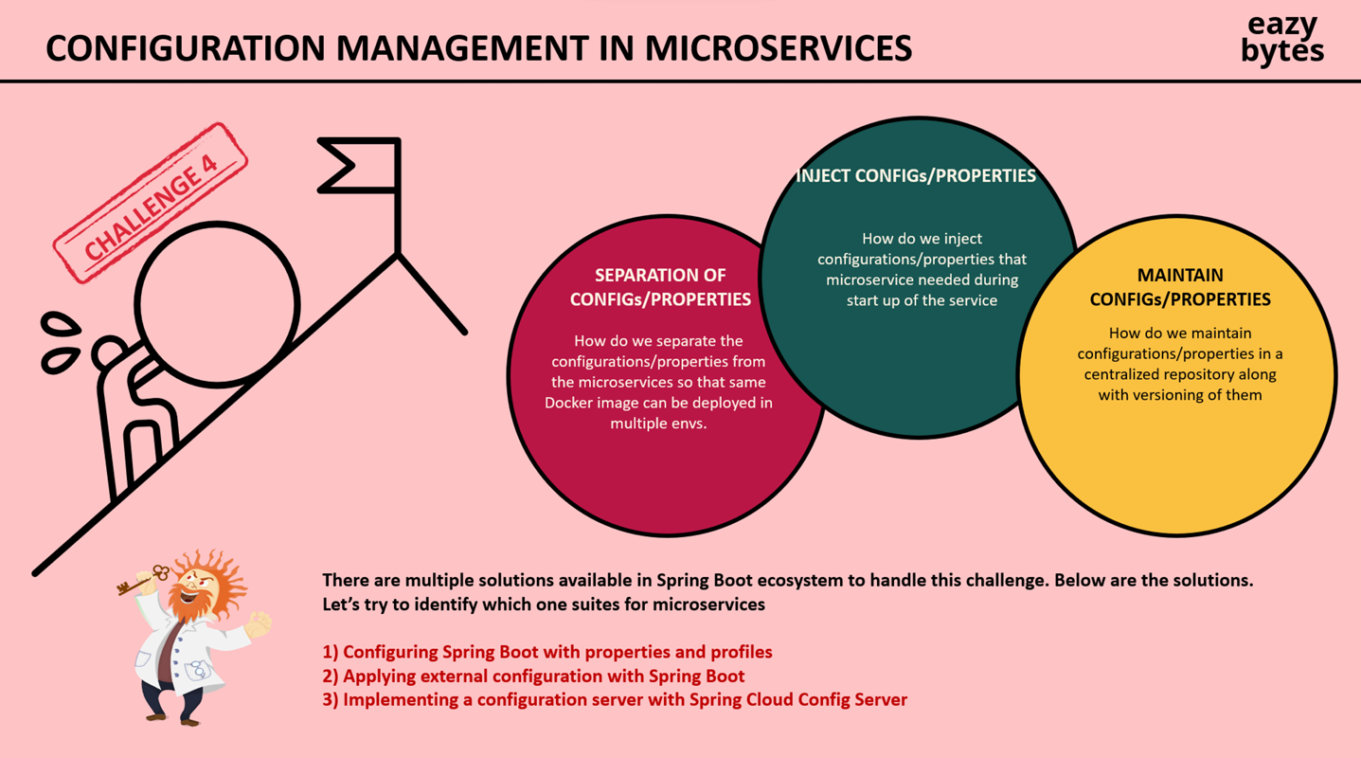

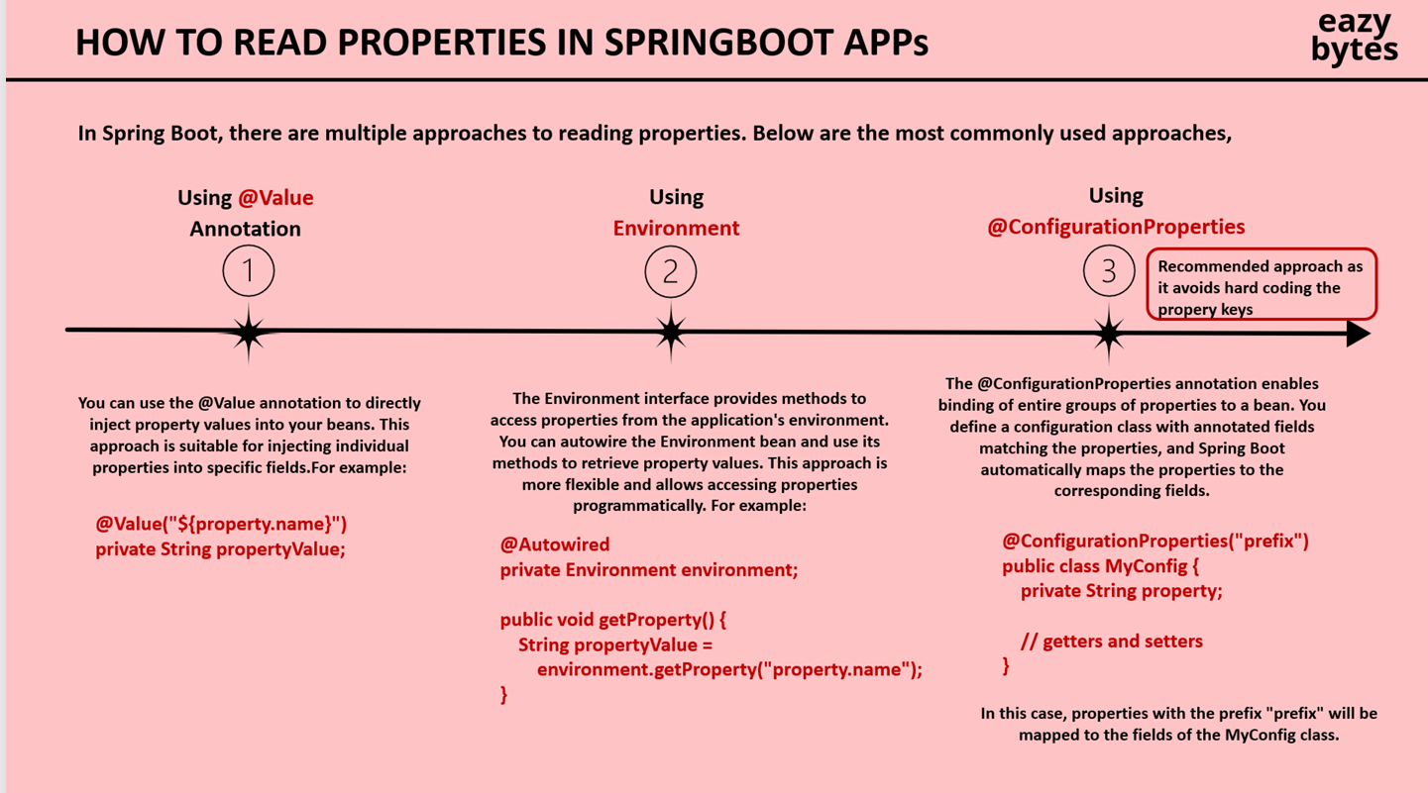
@ConfigurationProperties and @EnableConfigurationProperties
We have 2nd option as well using record
- Profiles
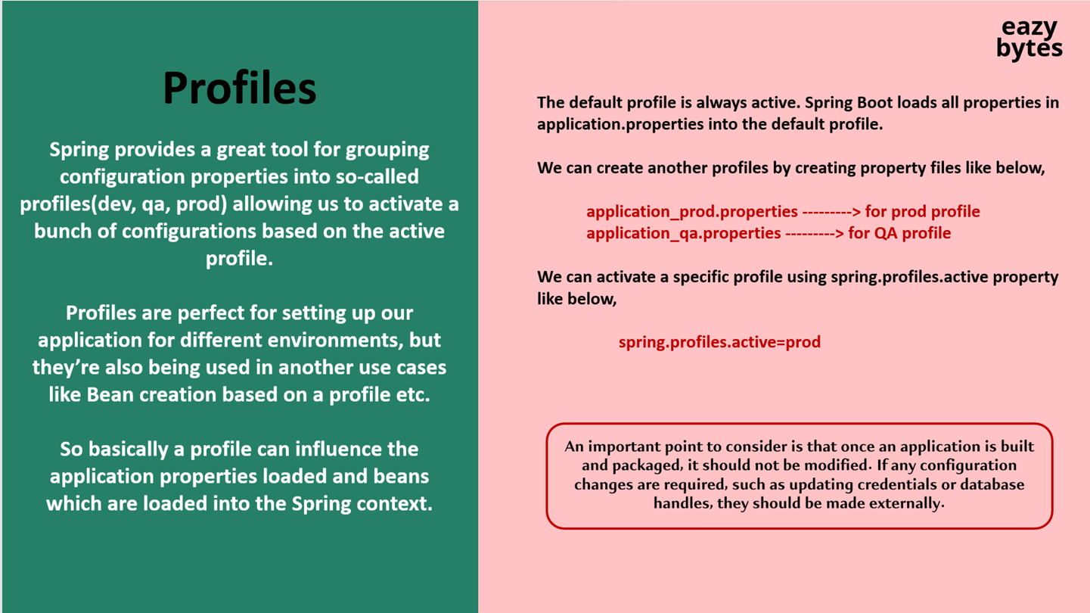
spring.config.import[0]=application_qa.properties
spring.config.import[1]=application_prod.properties
spring.profiles.active=prod
Above all 3 should be In default application.properties
And in respective env properties file need to add below property
spring.config.activate.on-profile=qa
NOTE :- If you name application-{profile}.properties not “_” then spring.config.import is not necessary.
- Command line arguments
java -jar accounts-service-0.0.1-SNAPSHOT.jar --learning.value.annotation=”something1”

- JVM system properties
Java -Dlearning.value.annotation=”something2” -jar accounts-service-0.0.1-SNAPSHOT.jar

- Environment variables
Convert all letters to uppercase and replace dots or dashes with underscores
env:LEARNING_VALUE_ANNOTATION=”something3”; java -jar accounts-service-0.0.1-SNAPSHOT.jar

