Challenge 4
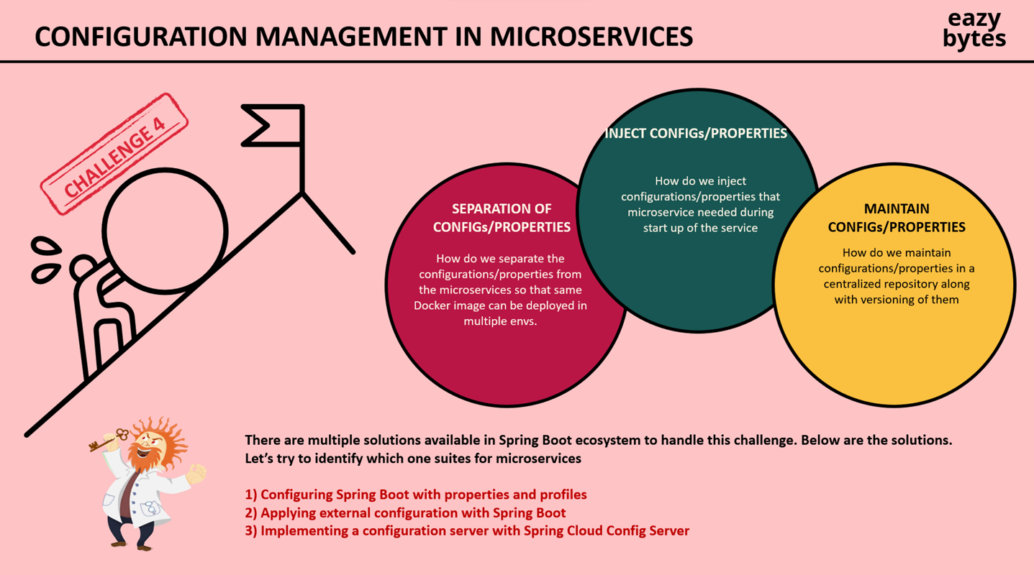

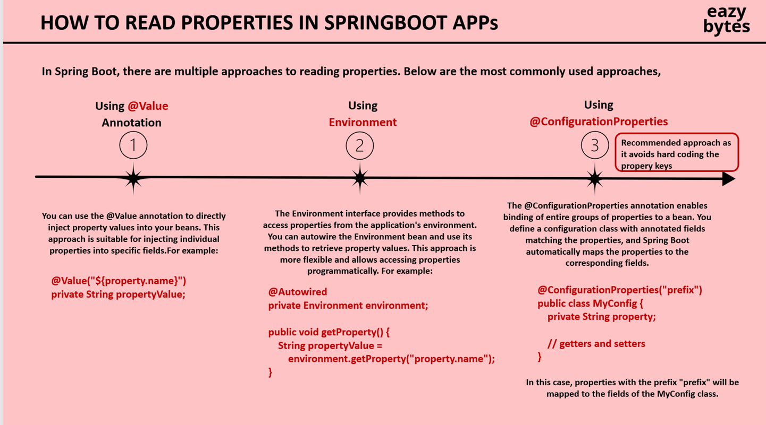
@ConfigurationProperties and @EnableConfigurationProperties
We have 2nd option as well using record
- Profiles
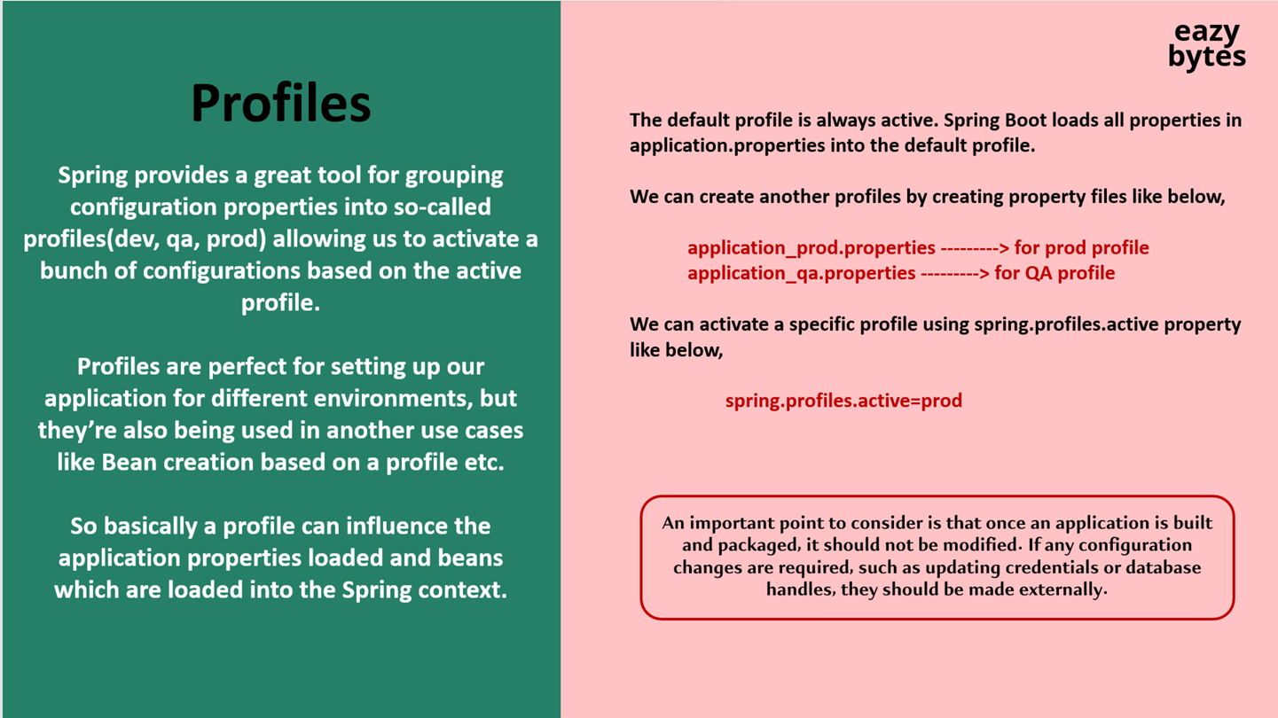
spring.config.import[0]=application_qa.properties
spring.config.import[1]=application_prod.properties
spring.profiles.active=prod
Above all 3 should be In default application.properties
And in respective env properties file need to add below property
spring.config.activate.on-profile=qa
NOTE :- If you name application-{profile}.properties not “_” then spring.config.import is not necessary.
- Command line arguments {highest precedence}
java -jar accounts-service-0.0.1-SNAPSHOT.jar --learning.value.annotation=”something1”

- JVM system properties {Second precedence}
Java -Dlearning.value.annotation=”something2” -jar accounts-service-0.0.1-SNAPSHOT.jar

- Environment variables {Third precedence}
Convert all letters to uppercase and replace dots or dashes with underscores
env:LEARNING_VALUE_ANNOTATION=”something3”; java -jar accounts-service-0.0.1-SNAPSHOT.jar

- Do above in IDEA
Command line  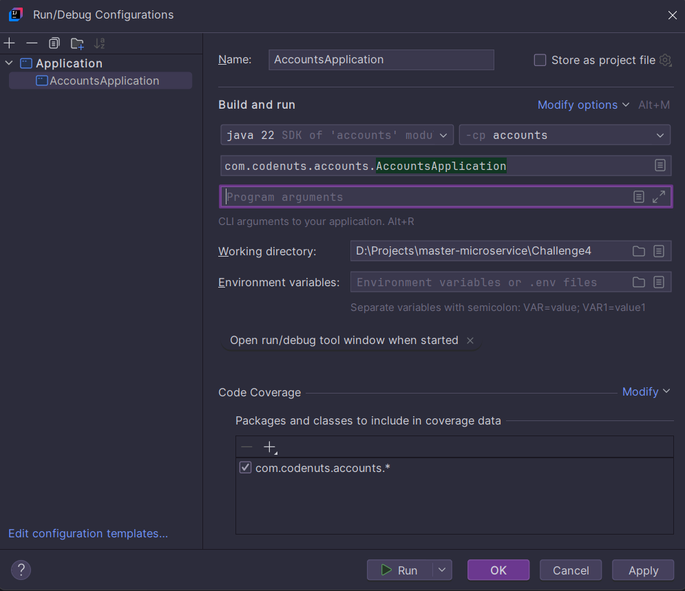  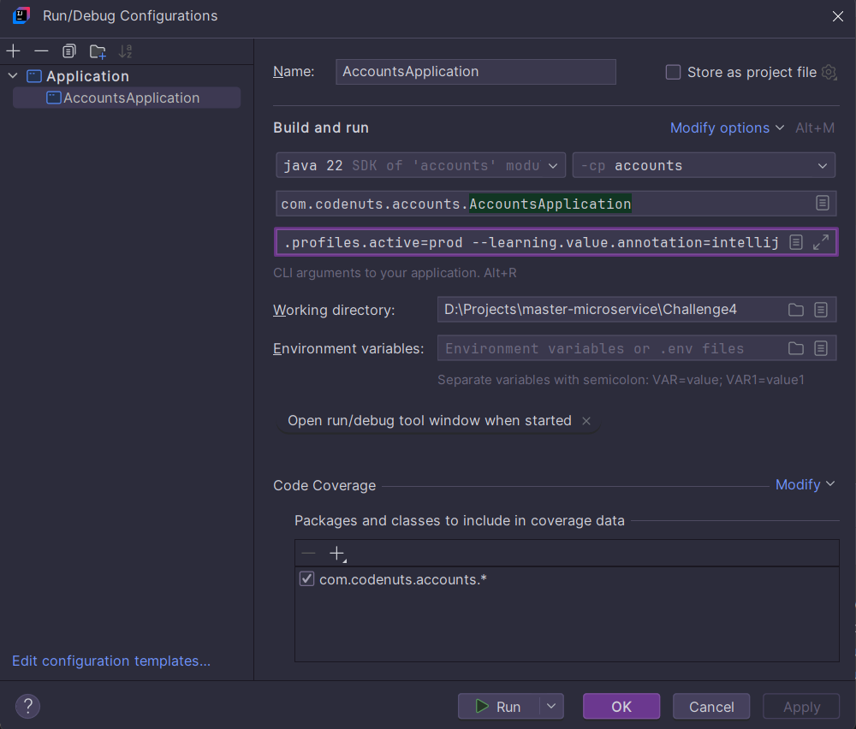 | JVM  Enable VM Options  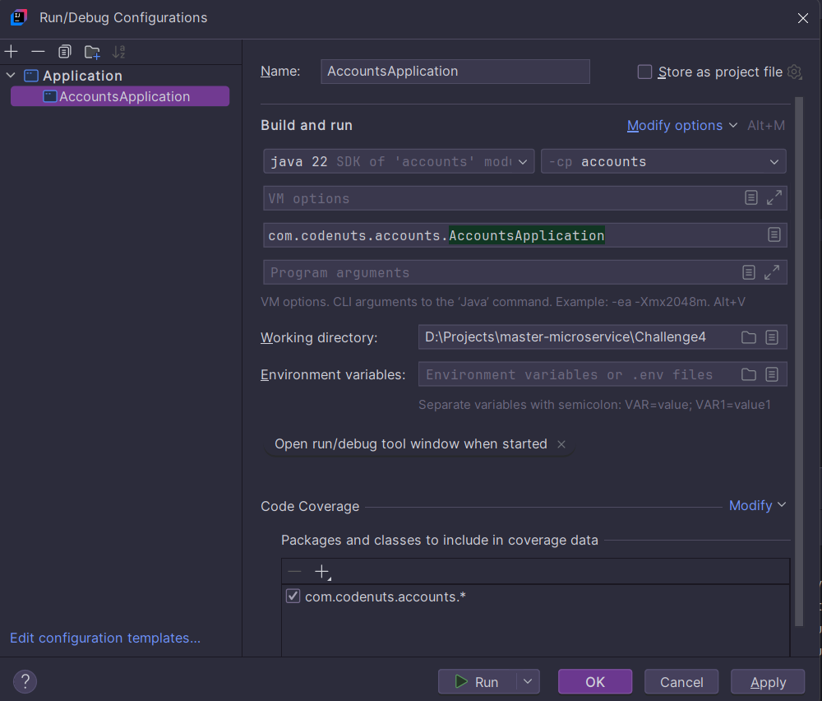  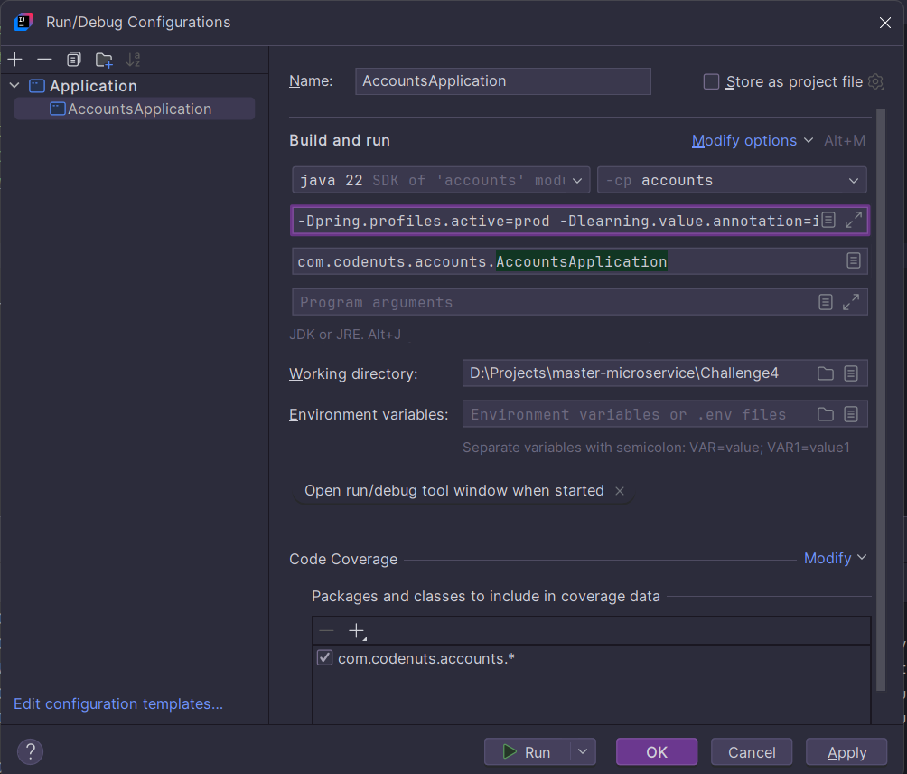 | Env  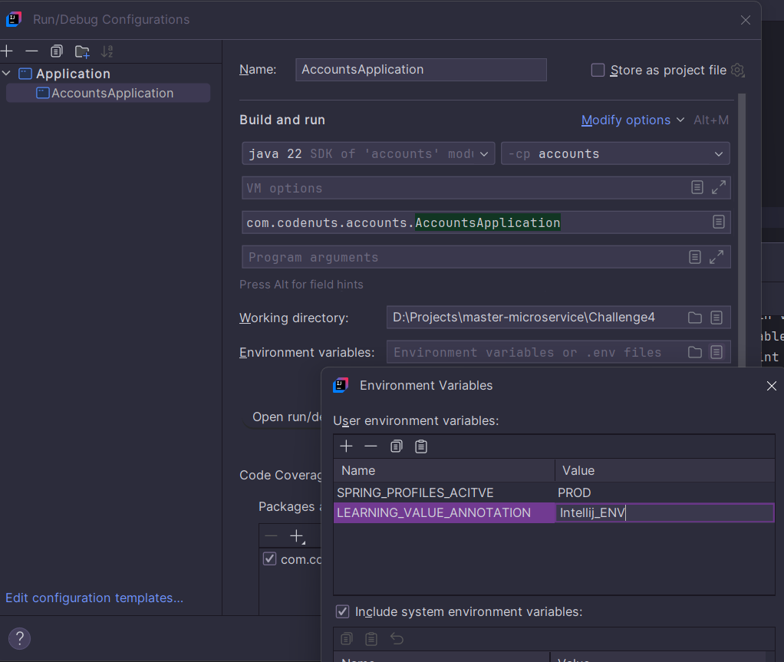

NOTE: Drawbacks externalizing configurations using commands are below
- This often involves executing separate commands and manual set up for application, which can lead to errors.
- If you have 50 microservice this requires more manual effort and each has 50 pods?
- Lack of track revisions and audit the configuration changes like code changes track we can’t achieve.
- Granular access.
- To store secrets and we can’t encrypt and store
- And if you change any configuration property at runtime using above commands you need to restart again.

- Spring Cloud Config
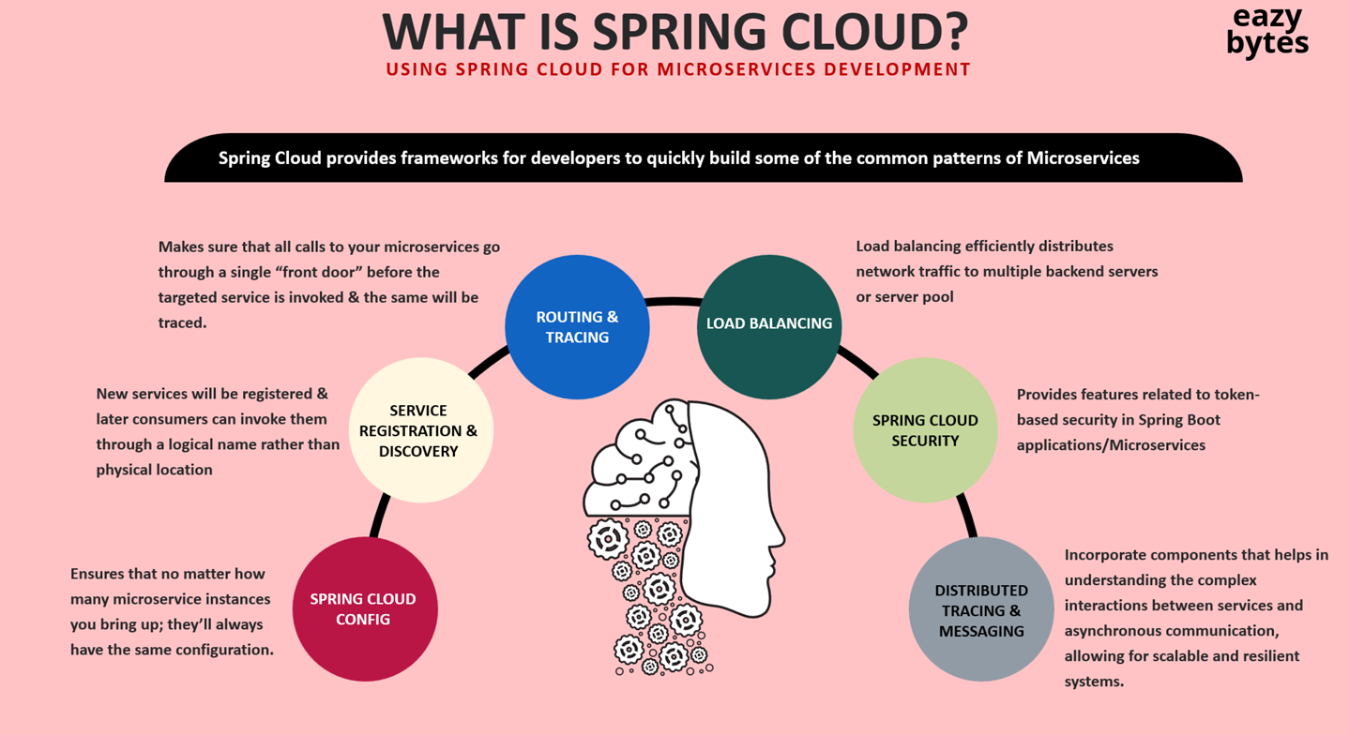

Create new project for config server with dependency ConfigServer , Actuator , Devtools and @EnableConfigServer.
- Then keep all microservice config properties and add configuration in config server to load all properties
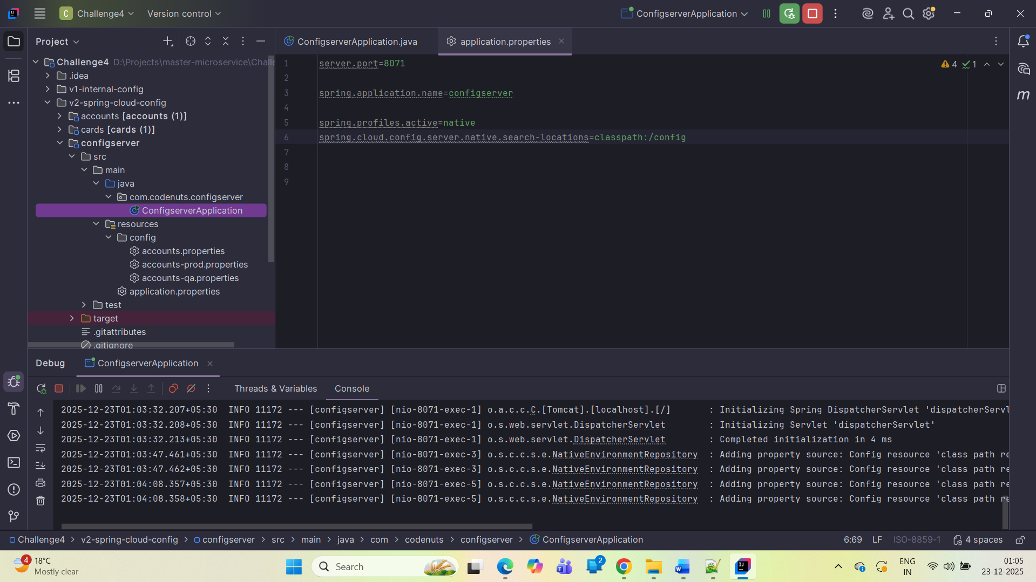
http://localhost:8071/accounts/prod
http://localhost:8071/accounts/qa
http://localhost:8071/accounts/default

- In other microservice add config client dependency and spring cloud dependency management for version handling and add below one and test it
And run accounts service by activating any profiles by any above commands
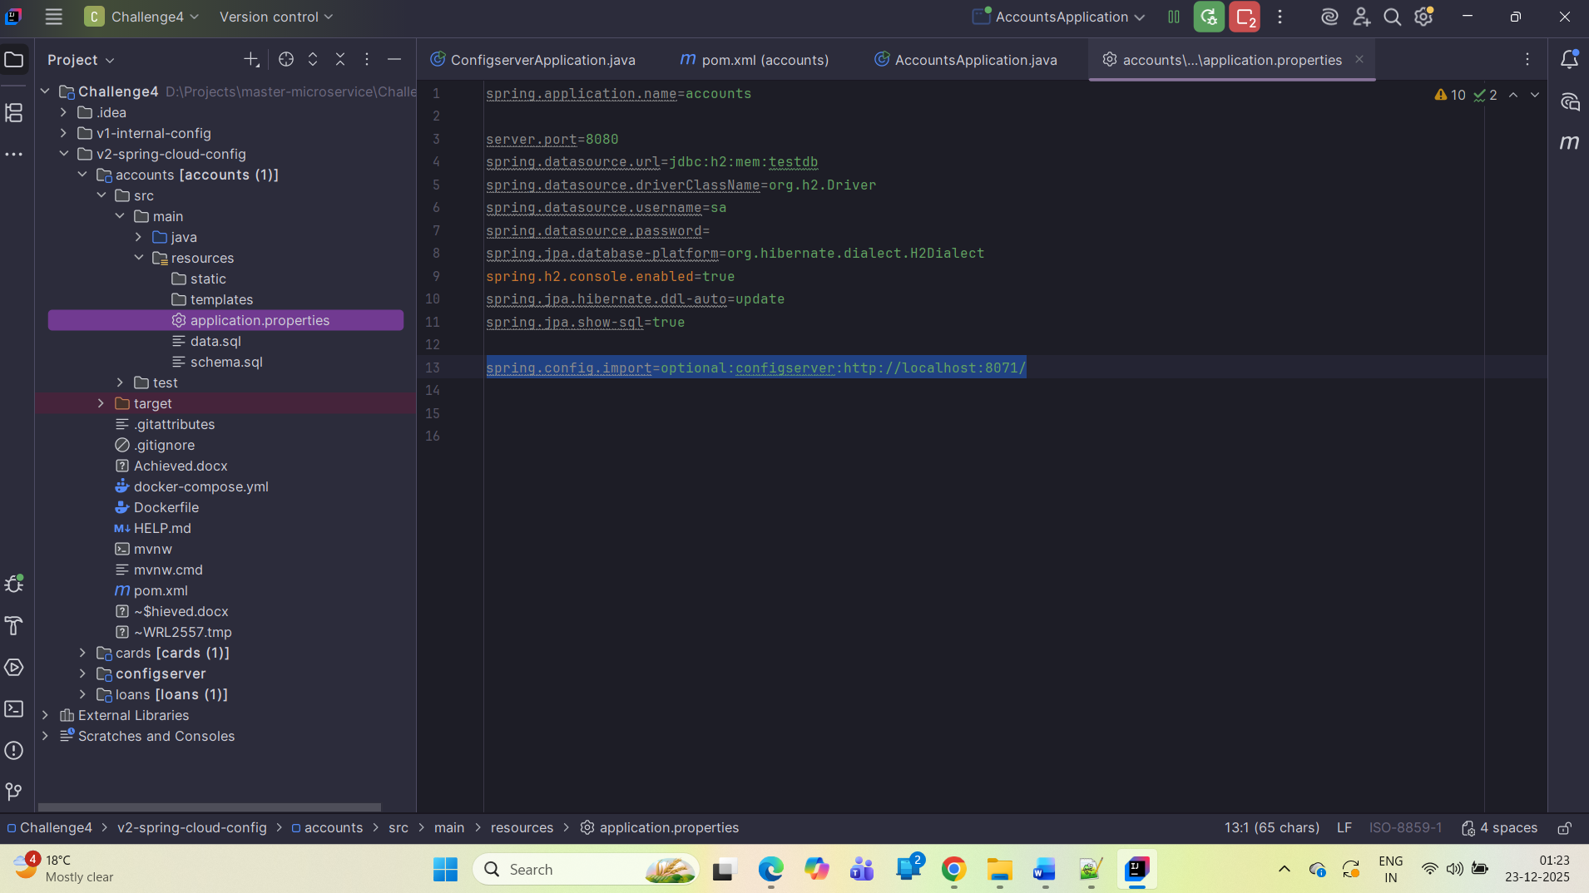
- Filesystem
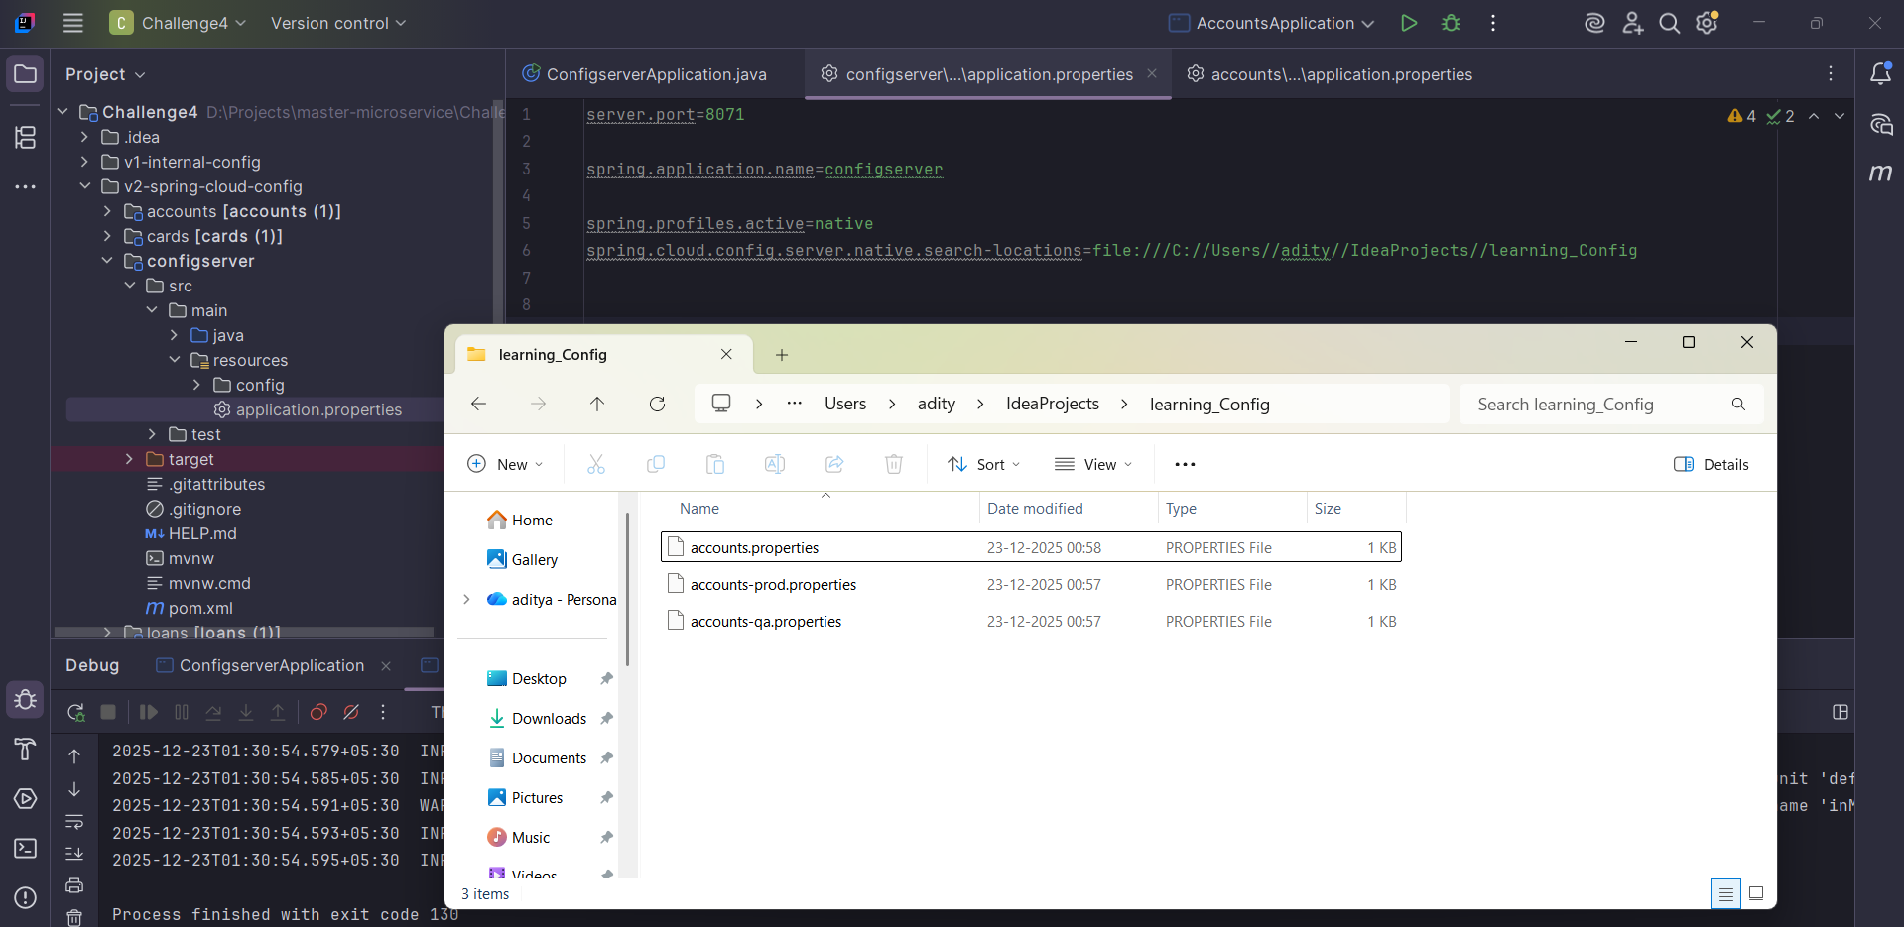
- Git
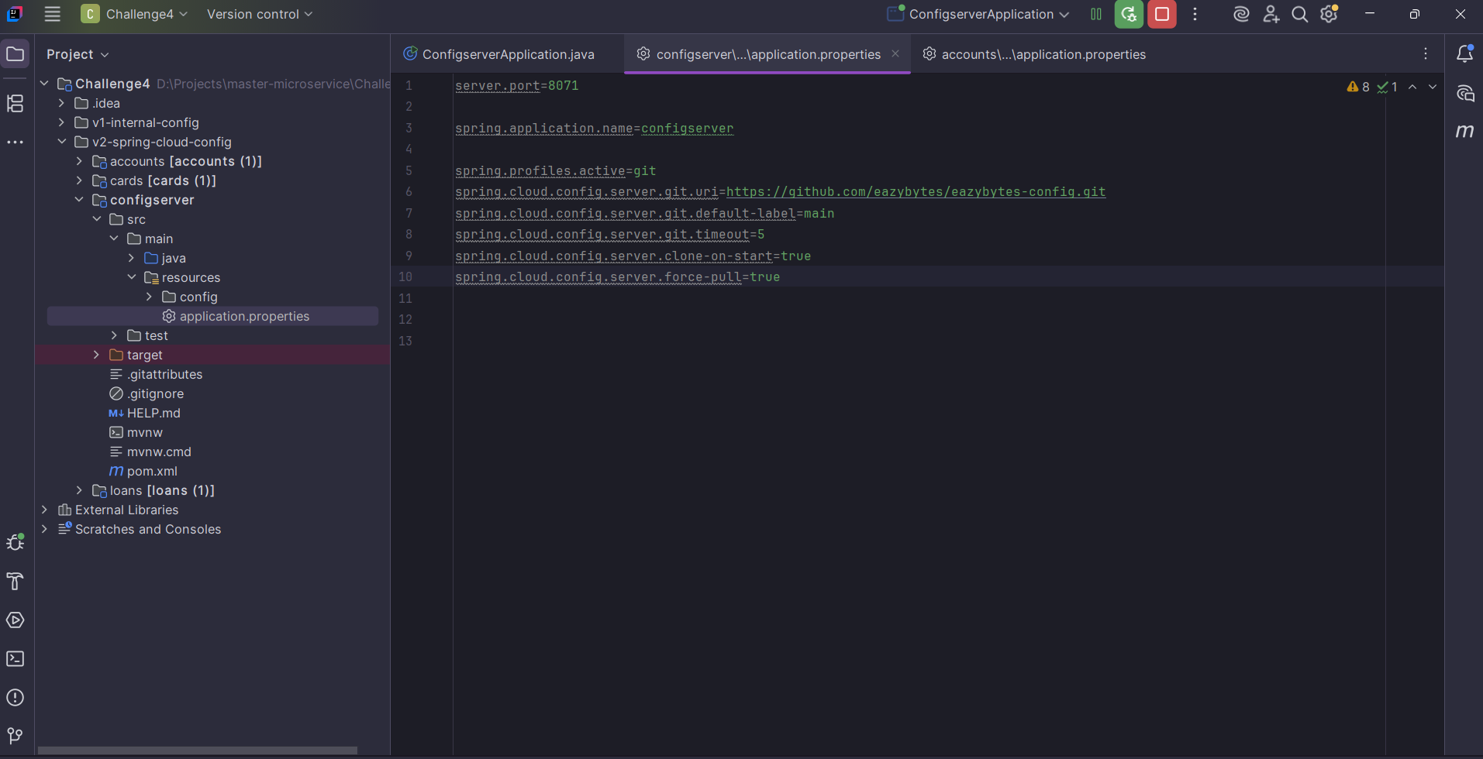
Test config server : http://localhost:8071/accounts/qa

- Encrypt and decrypt
encrypt.key=1Wa#6&haKO08 {like this in configserver application.properties}
and http://localhost:8071/encrypt and http://localhost:8071/decrypt

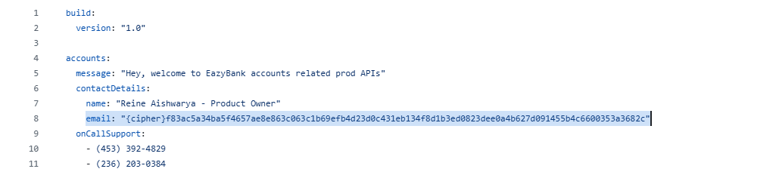

You can add like above config server will automatically decrypt and send to microservice.

- Refresh

Actuator will not enabled management endpoints by default and rather than exposing refresh alone lest expose everything add below in both config server and microservice.
management.endpoints.web.exposure.include=*

once configserver and accounts are running change in file {target folder if it is native not for git} and hit http://localhost:8080/actuator/refresh for accounts then check for changes.

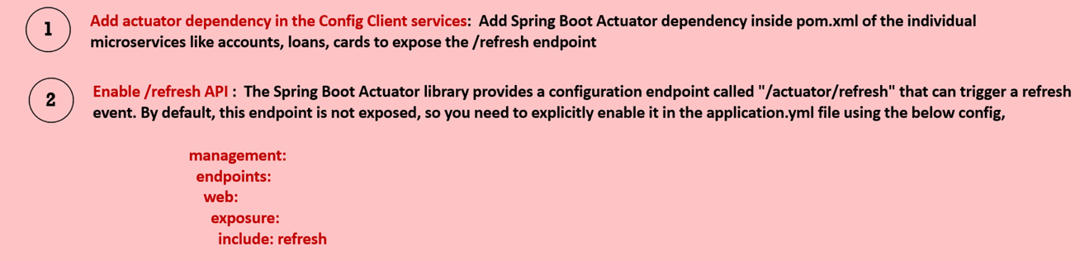

If you use @ConfigurationProperties, you do not need @RefreshScope. Spring Boot handles the refresh of @ConfigurationProperties beans automatically when a refresh event occurs

- Using Spring Cloud Bus and Spring Cloud Config monitor
- Run first rabbitMQ
docker run -it --rm --name rabbitmq -p 5672:5672 -p 15672:15672 rabbitmq:4-management
- <dependency>
<groupId>org.springframework.cloud</groupId>
<artifactId>spring-cloud-starter-bus-amqp</artifactId>
</dependency>
Add above dependency in accounts , configServer as well
- We already enabled busrefresh as well
- 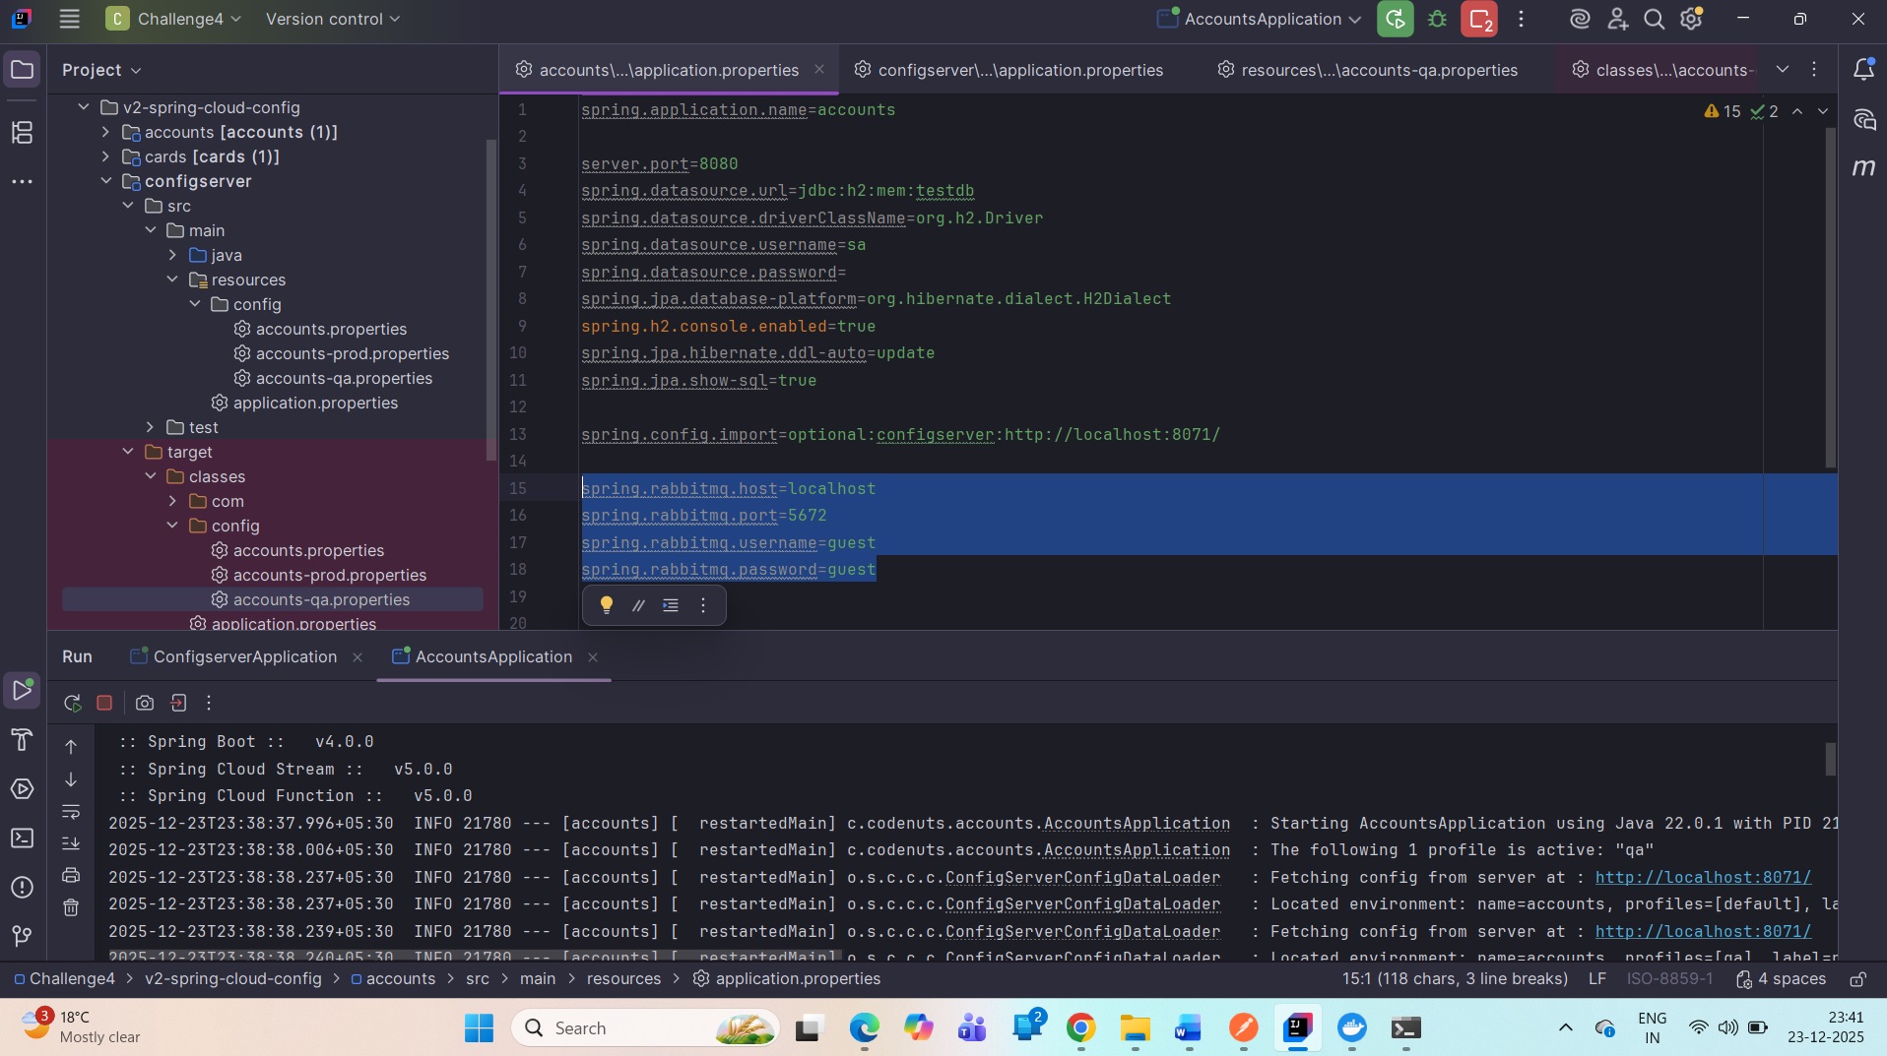
Update rabbitMq details connectivity in accounts service, configServer as well
- Change the property and trigger http://localhost:8080/actuator/busrefresh {accounts to refresh properties , cards and loans also get refreshed as all are connected to same rabbitMq that’s the advantage of this} and test your endpoint
- We have another automatic approach using Spring cloud Config monitor.

