Challenge 3
Deployment, Portability {we can deploy our 100s microservice easily across env like SIT, UAT, PROD}, Scalability.

example: - Containers in Cargo ship.

Solution?
Containerize - Containers offer a self-contained and isolated env for applications, by including all necessary dependency, by this approach we can easily run in all cloud env.

Docker is an open-source platform provide ability to package and run an application in a loosely isolated env called container.

How container is better than VM’s
In VM’s for each VM assigned to each service we need to install jdk, maven etc like this we need to create all necessary application libraries manually but by containerization we can overcome this challenge easily, and if you try to restart VM the application will get down as well.
And Challenge 3 we will face in VM
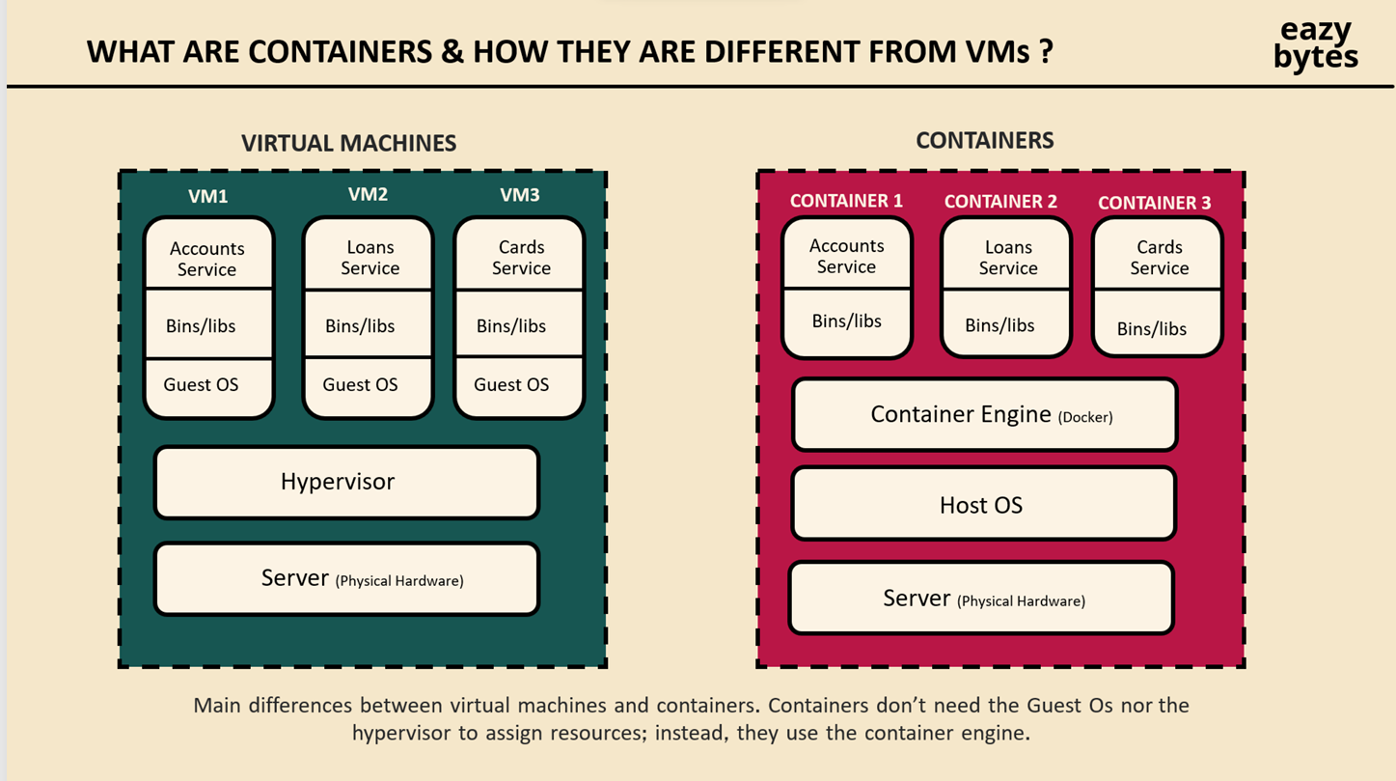
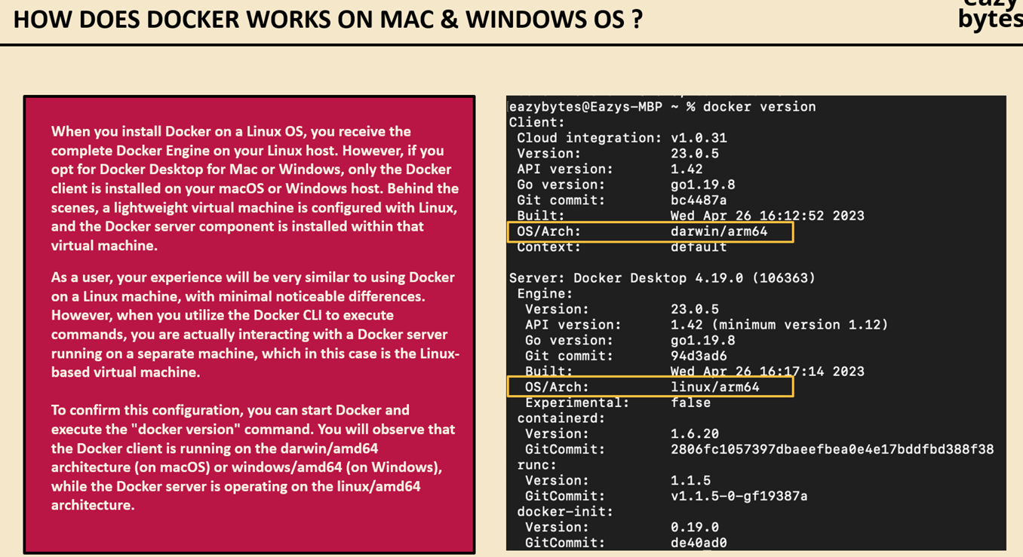
Install Docker by visiting to https://www.docker.com/ to install Docker Desktop. And signup if not I have account already{bangaruadi}

Below is the 3 approached for Docker image generation.
- Manual approach
- First update in pom.xml as packaging as jar
- mvn spring-boot:run {run this command in pom.xml path after mvn clean install}
- java -jar target/accounts-0.0.1-SNAPSHOT.jar
- write Dockerfile as in account service and run docker desktop and run with below command
- docker build . -t bangaruadi/accounts:s4 {docker build . -t <userName>/<serviceName>:<tag>} [to convert to image]
- docker images
- docker run -p 8080:8080 bangaruadi/accounts:s4 {command to convert image created from above command to container}
{ docker run -p <port to expose to external world>:<internally running port> bangaruadi/accounts:s4}

http://localhost:8080/swagger-ui/index.html#/

docker start <container id>
docker stop <container id>

- Buildpacks
- First update in pom.xml as jar
- Below is next step
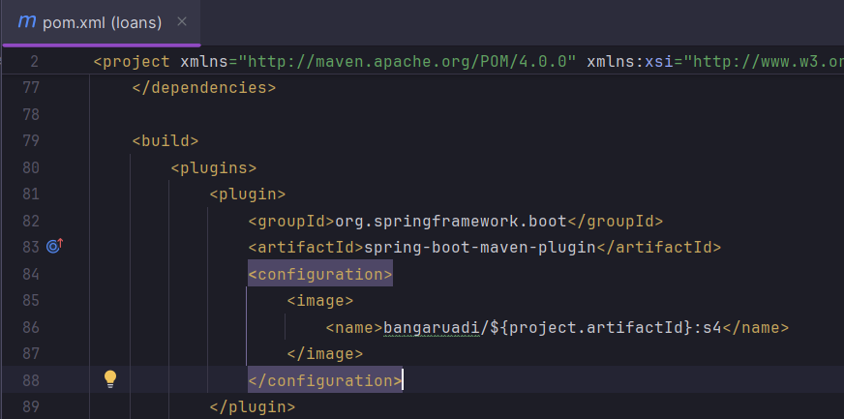

- mvn spring-boot:build-image {run in pom.xml path}
- docker images
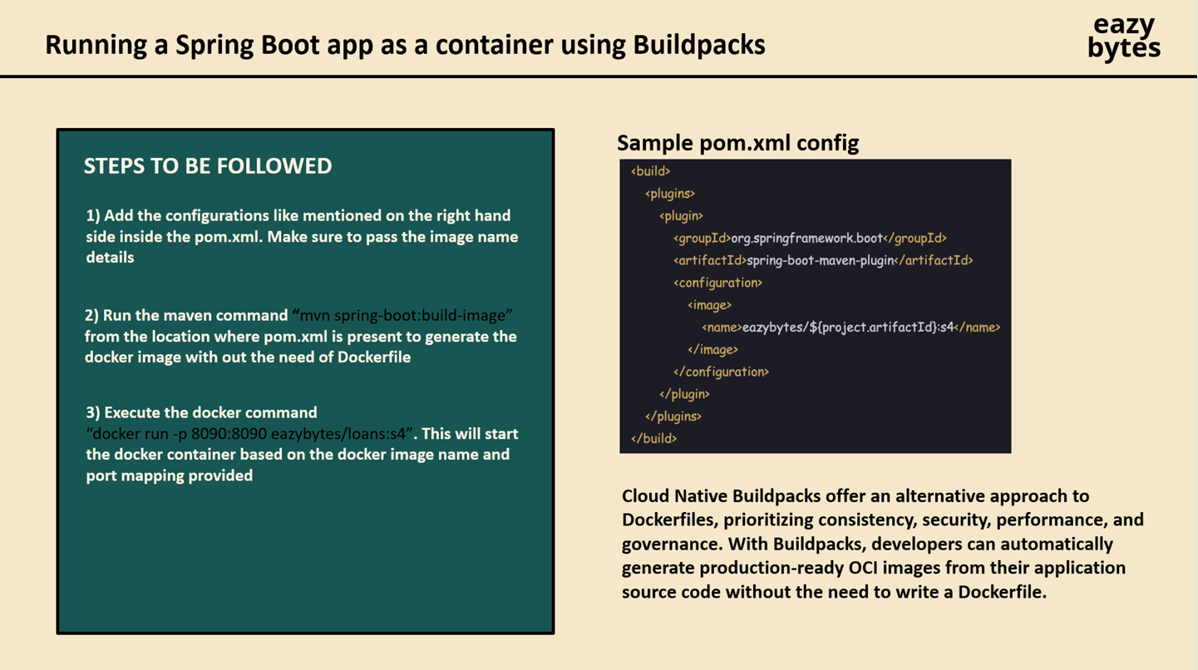

- Google jibs
- First update in pom.xml as jar
- Steps for this
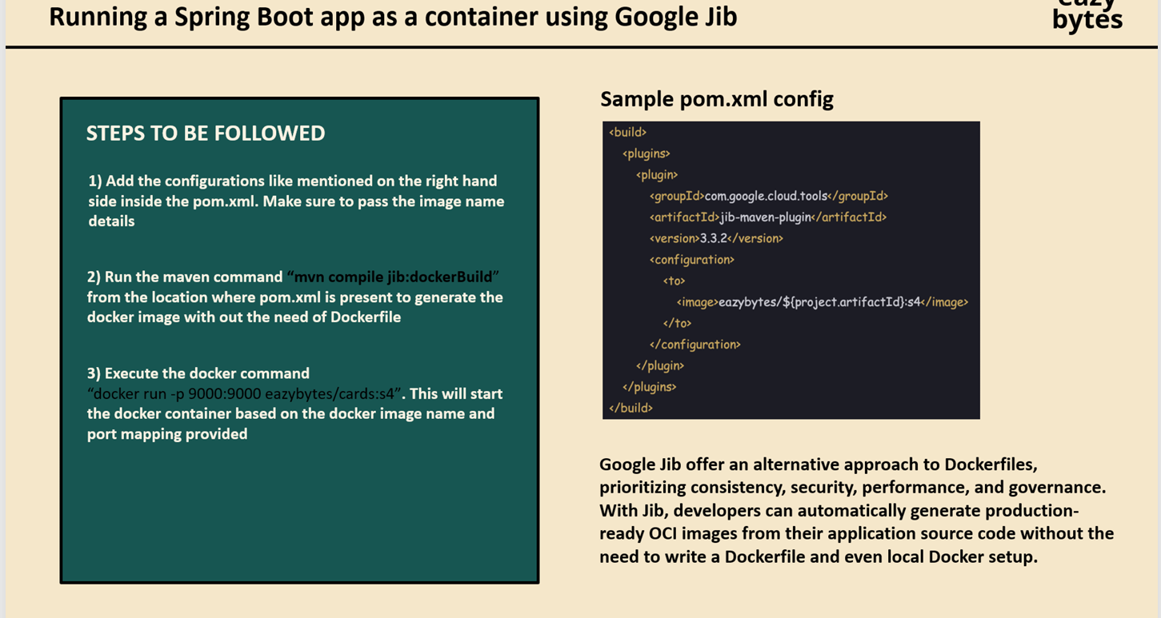

Features · Cloud Native Buildpacks - buildpacks is winner compare to 3 options

- docker image push docker.io/bangaruadi/accounts:s4 {to push to docker my repository before running this command make sure image is created and can see in local docker desktop}
NOTE: Please spend some time on docker commands

docker-compose.yml go thoroughly once and its commands.

