Mini Project 1

**Implement Movie Ticket Booking System**

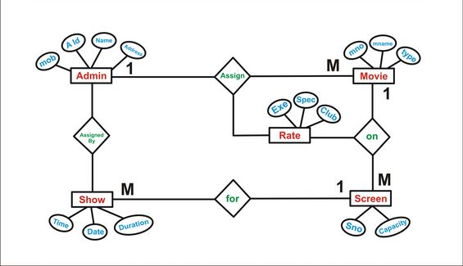

By,

Parimal Mehta 16BCE118

Parth Panchal 16BCE115

# Salient Features

* A Home/Welcome page – Like a menu to access every option
* Log In
* Forgot Password – Implemented via OTP and email.

**For Admin**

* Adding a movie to a database
* View history of changes to movie roster
* View a summary of customer actions – Number of Views, Complaints, Visits, Bookings

**For Customer**

* Sign Up
* View log of previous bookings
* Movie Info page – Link a trailer, Description, Genre, Category, Language
* Booking a Movie – Selecting Date and Time
* Selecting Seats – Booked seats should be greyed out
* Display a confirmation page before payment
* Rate and Review a movie
* View reviews by fellow customers
* Promo Codes – For a loyal customer
* Food and Drinks
* Booking for R rated movies should be age verified.
* Payment

# Progress

**With basic functionality :**

* Log In UI
* Sign Up UI
* Change Password UI

**Just UI :**

* View Movies
* View Movie Info
* Book Movie – Excluding actual seat selection
* Confirmation screen

# Timeline

* Basic Layout/UI
* Add functionality – First Draft
* Add extra features – Final Draft
* Host on Cloud – Optional

# Diagrams

## Use Case

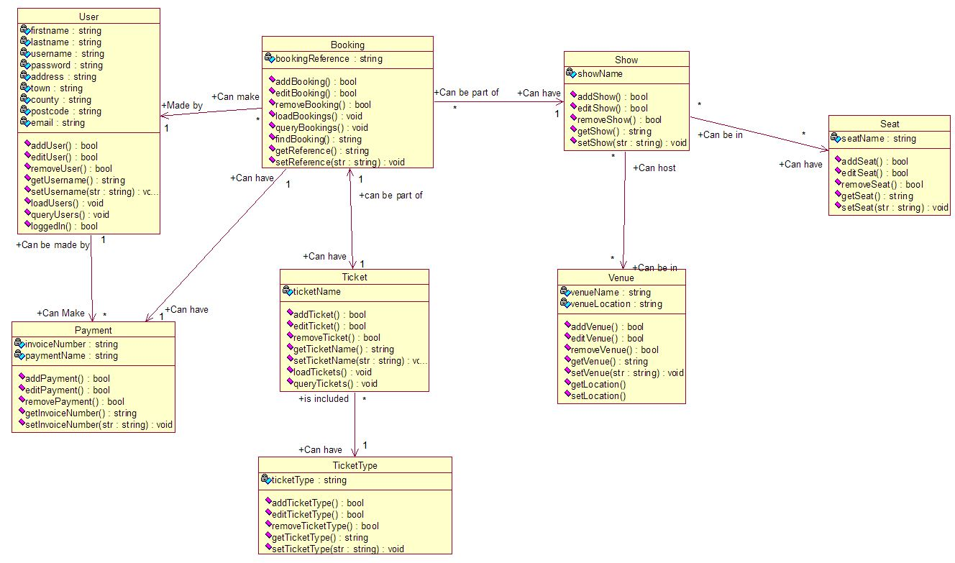

## Sequence

## 

## Class

## 