**Design Parameters:**

Architecture:  **DFF**

Technology: **Skywater OpenPDK 130nm**

Size: **40um*37um= 0.0015mm2**

Tools Used: **Virtuoso Cadence**

**Schematic**

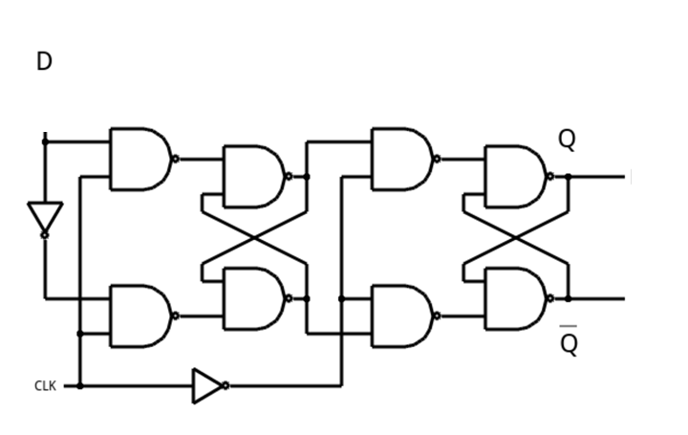

**Test Circuit**

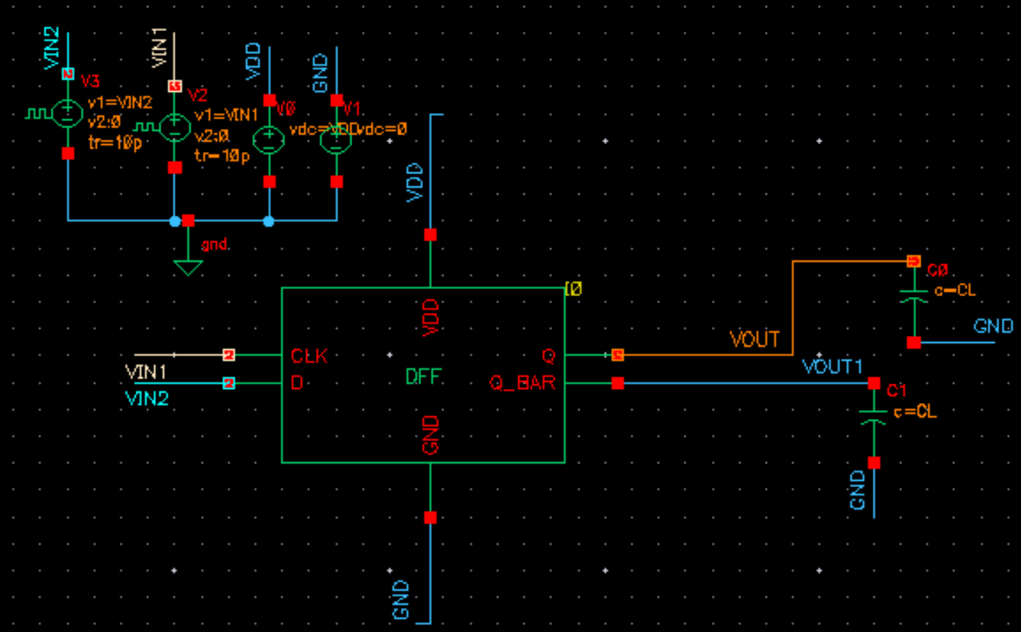

**Generated Layout:**

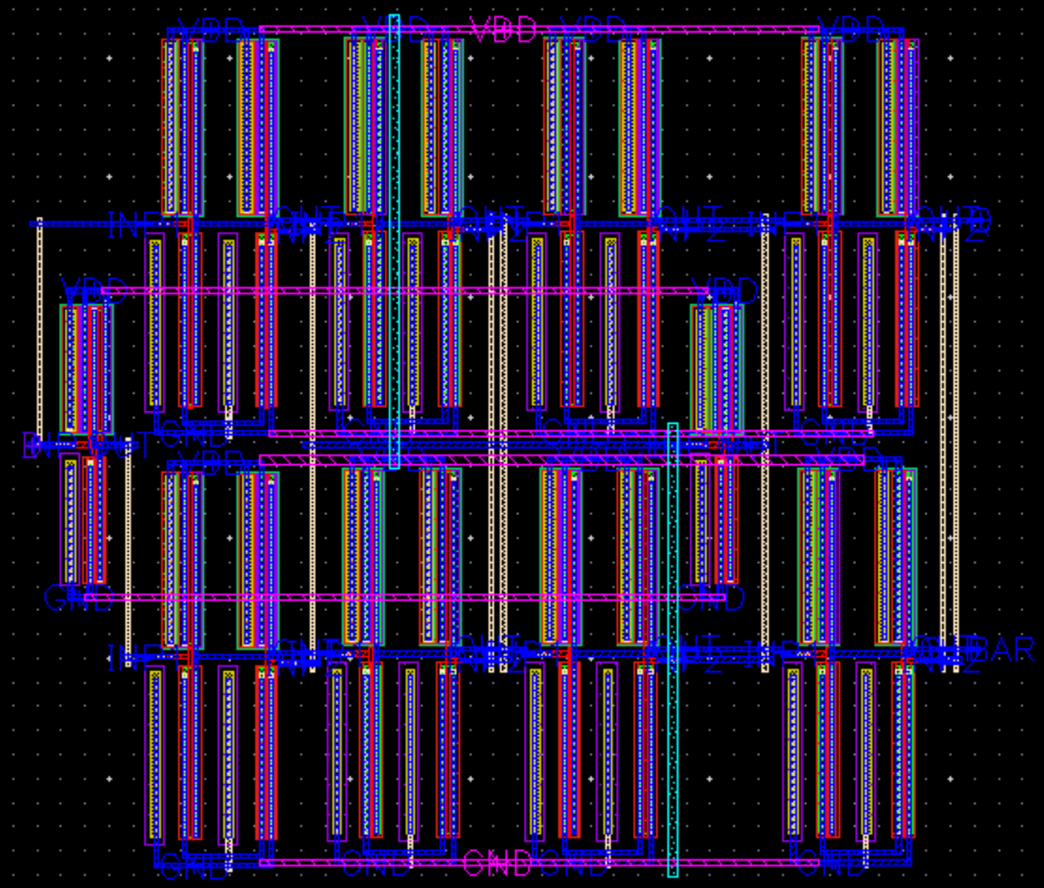

**Uploaded Files:**

* Gds file: DFF.gds
* Synthesized Verilog file: DFF.lvs.v
* Spice Netlist: DFF.sp
* PEX Netlist: DFF.pex.netlist

**Results:**

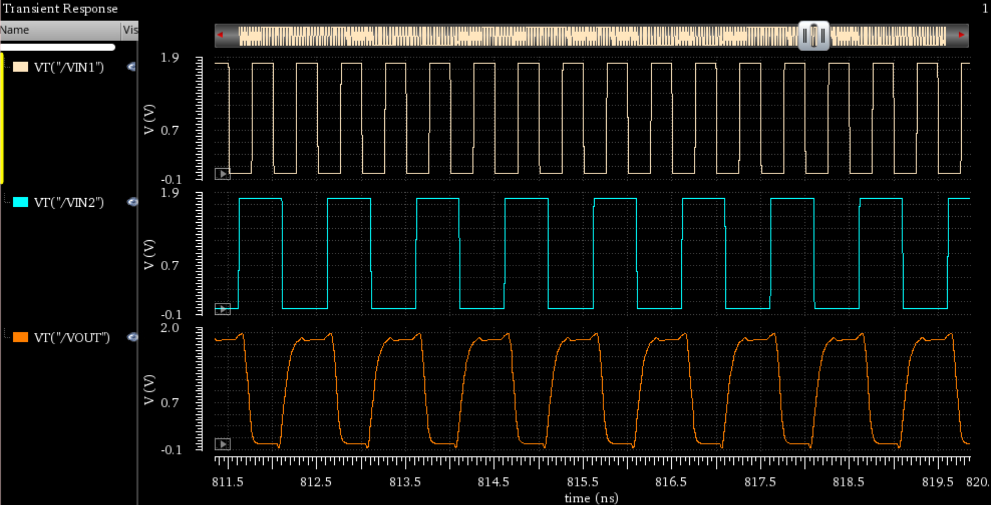

**CLK 2G**

**D_in 1G**

**Q_out**