**Design Parameters:**

Architecture:  **Inverter based Transmitter (To drive the input cap of Channel)**

Technology: **Skywater OpenPDK 130nm**

Size: **21um*13um= 0.0003mm2**

Tools Used: **Virtuoso Cadence**

**Schematic**

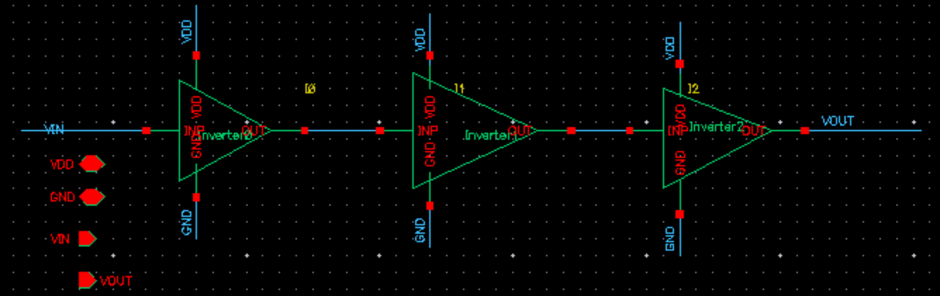

**Test Circuit**

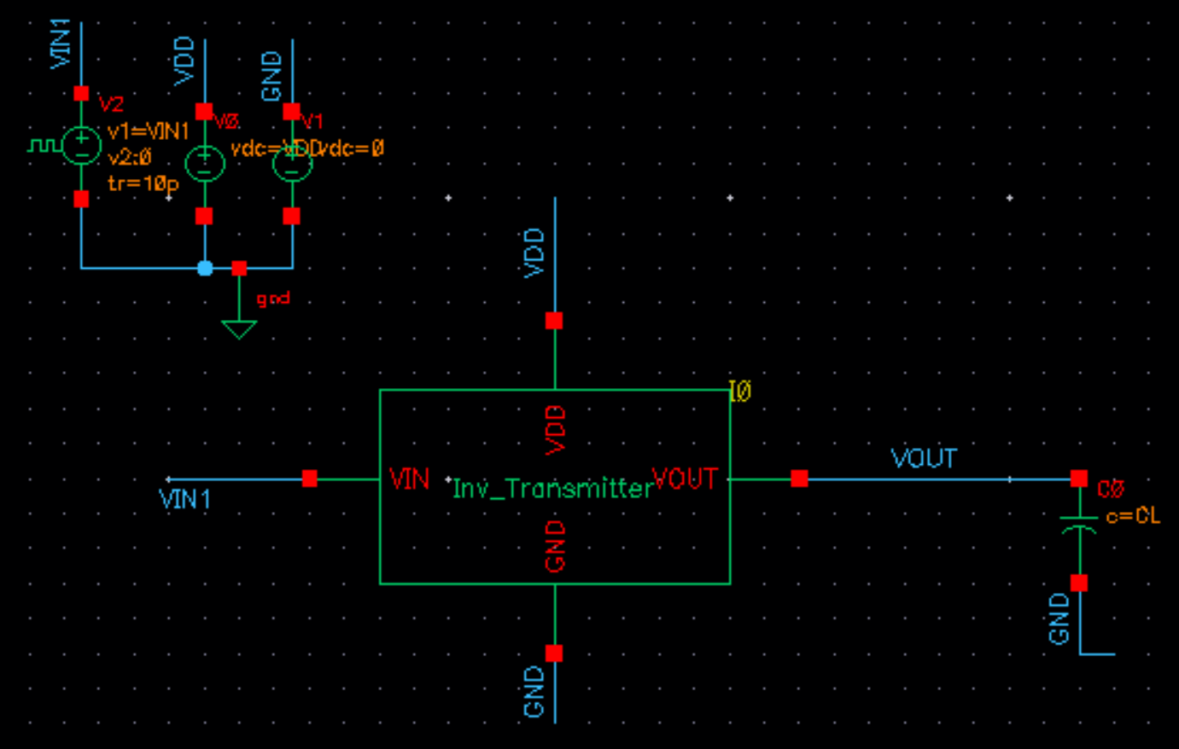

**Generated Layout:**

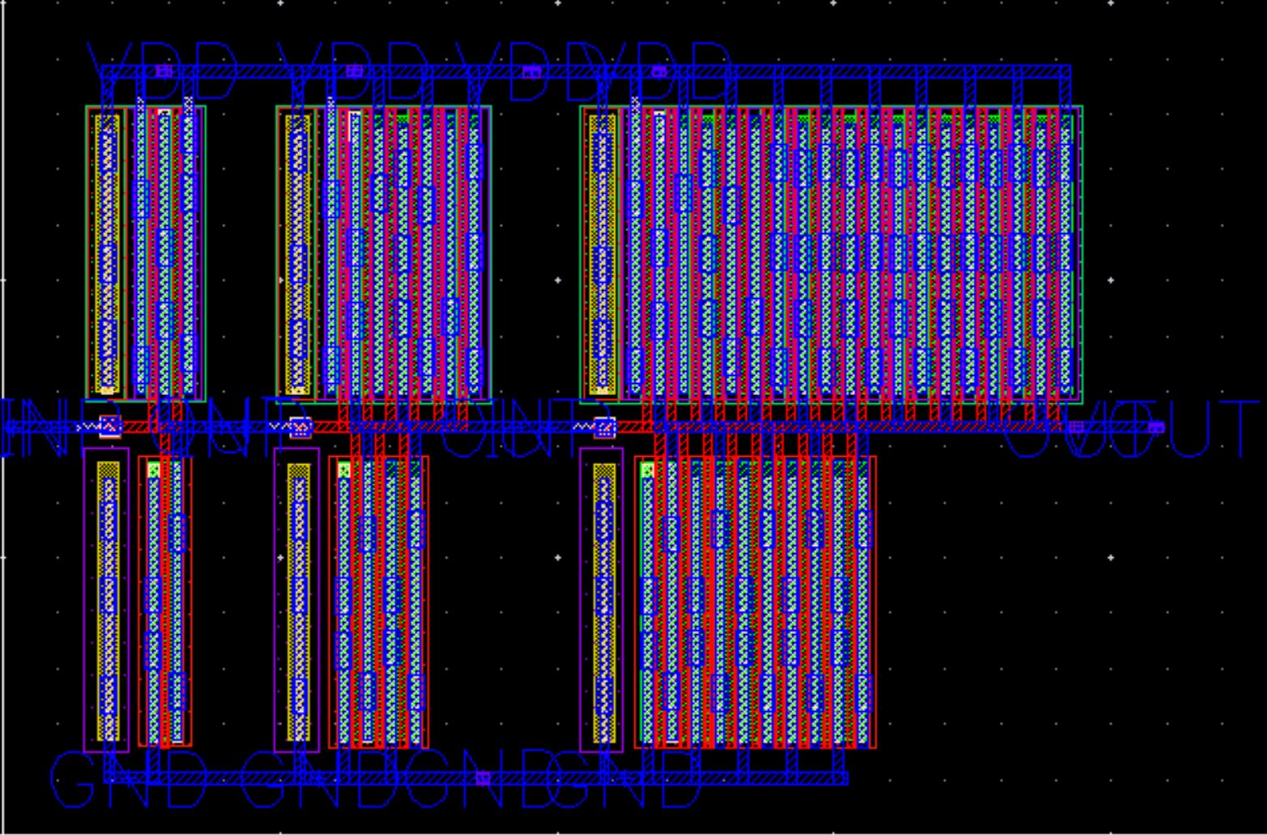

**Uploaded Files:**

* Gds file: Inv_Transmitter.gds
* Spice Netlist: . /FULL_TX/ Inv_Transmitter.sp
* PEX Netlist: . /FULL_TX/ Inv_Transmitter.pex.netlist

Also the files required to view the schematic, layout and calibre views in cadence are also present.

**Results:**

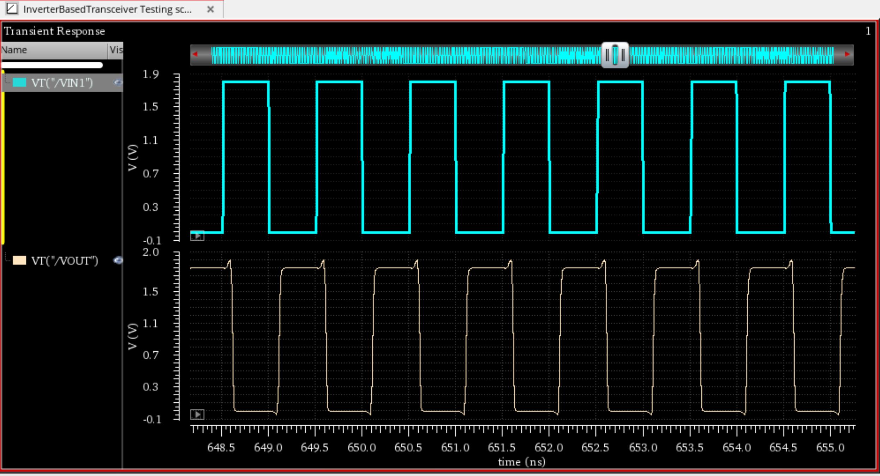

**Data_in**

**Data_out**