**Design Parameters:**

Architecture: **Resistive FB Inverter**

Technology: **Skywater OpenPDK 130nm**

Size: **10um*17um= 0.00017mm2**

Tools Used: **Virtuoso Cadence**

**Symbol**

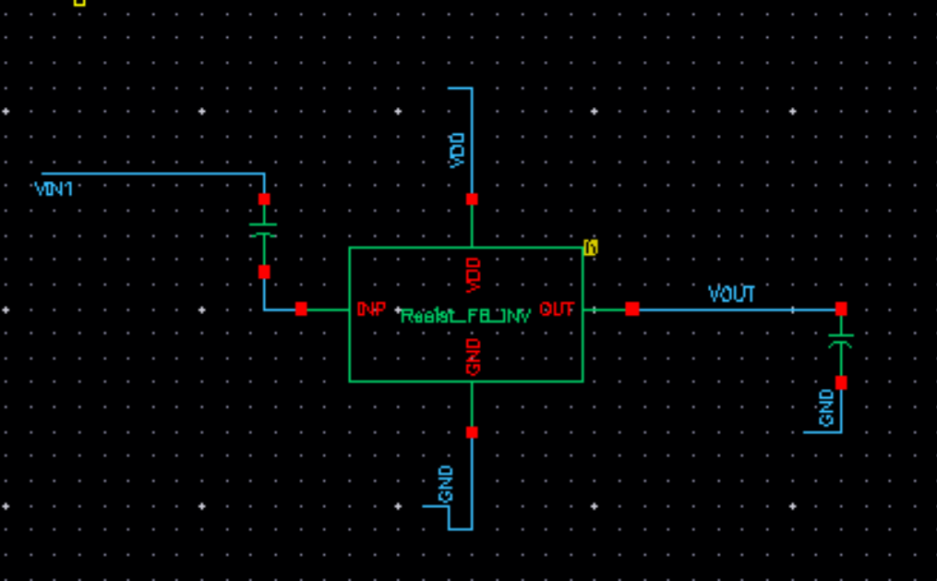

**Generated Layout:**

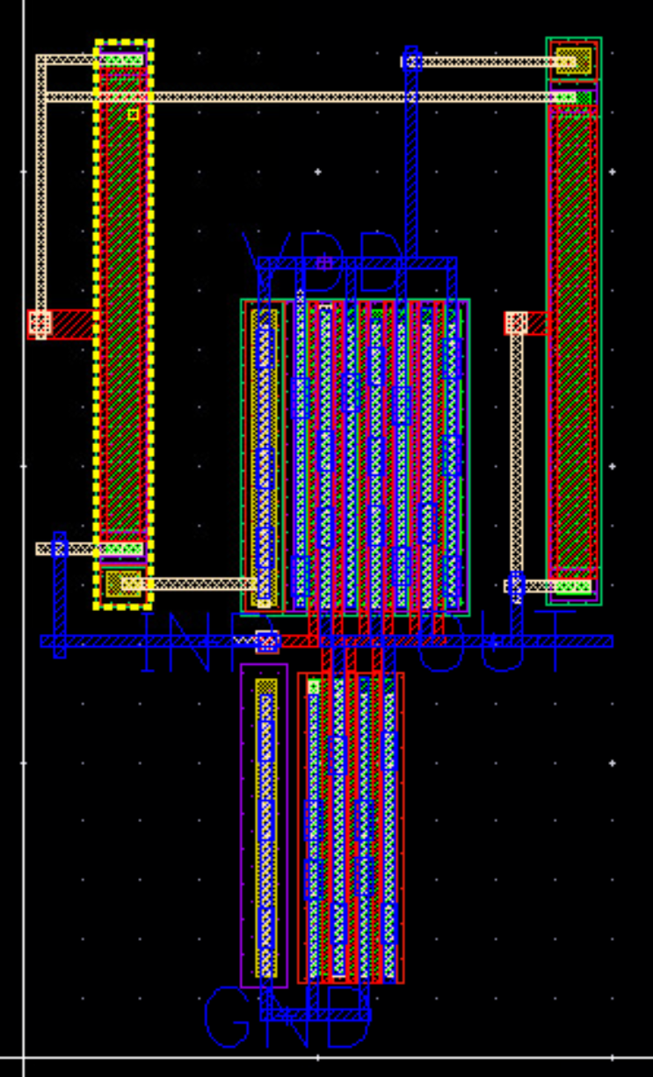

**Uploaded Files:**

* Gds file: Res_FB_Inv.gds
* Spice Netlist: Res_FB_Inv.sp
* PEX Netlist: Res_FB_Inv.pex.netlist

**Results:**

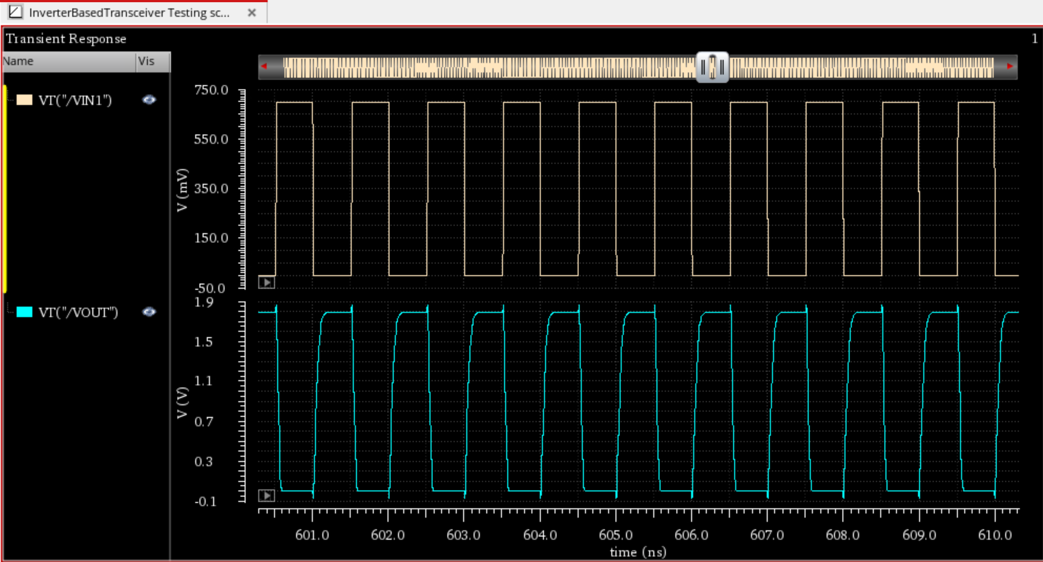

**Output (1.8 Vpp)**

**Input (700m Vpp)**