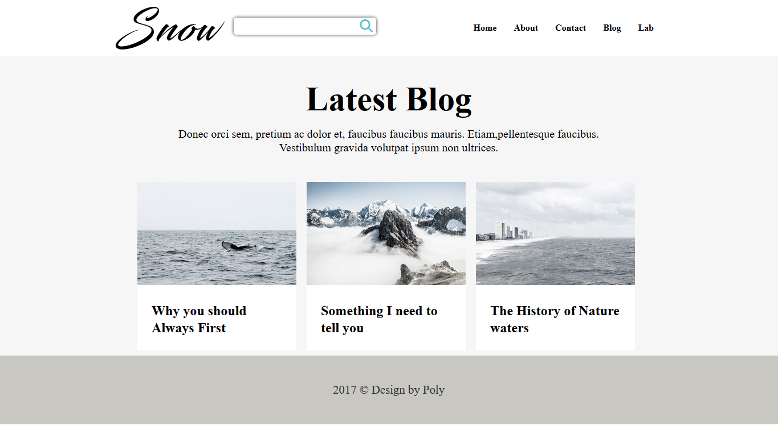

Snow

**Home**

**About Contact Blog Lab**

**Latest Blog**

Donec orci sem, pretium ac dolor et, faucibus faucibus mauris. Etiam,pellentesque faucibus. Vestibulum gravida volutpat ipsum non ultrices.

**Why you should Always First**

**Something I need to**

**The History of Nature**

**tell you**

**waters**

2017 © Design by Poly