PRACTICAL EXAMINATION
Technical Requirement: Launch a mock API server using json-server to read/write data from/to the database.json file on an appropriate port (e.g., http://localhost:9999).
PROBLEM DESCRIPTION
You are required to build an internal movie listing and ticket booking application for a boutique cinema. The application consists of two main pages: the Movie List Page (with search and filter functionalities) and the Ticket Booking Page (with showtime selection and an interactive seat map).
PART 1: INPUT DATA (database.json)
Create a database.json file at the root of your mock API project.
PART 2: REQUIREMENTS
Question 1: Routing Configuration (1.5 points)
Utilize the react-router-dom (v6) library to configure the following routes within the <App /> component:
- Path /movies: Renders the Movie List Page (MovieListPage).
- Path /tickets/create: Renders the Ticket Booking Page (TicketBookingPage).
- For any undefined or fallback URL paths (*), automatically redirect the user to the /movies path.
Question 2: Movie List Page - MovieListPage (4.5 points)
Design the user interface using react-bootstrap. The layout must be split into two main sections: a top Search Bar, and a lower section containing a left Sidebar (for Genres) and a right main content area (for the Movie List).
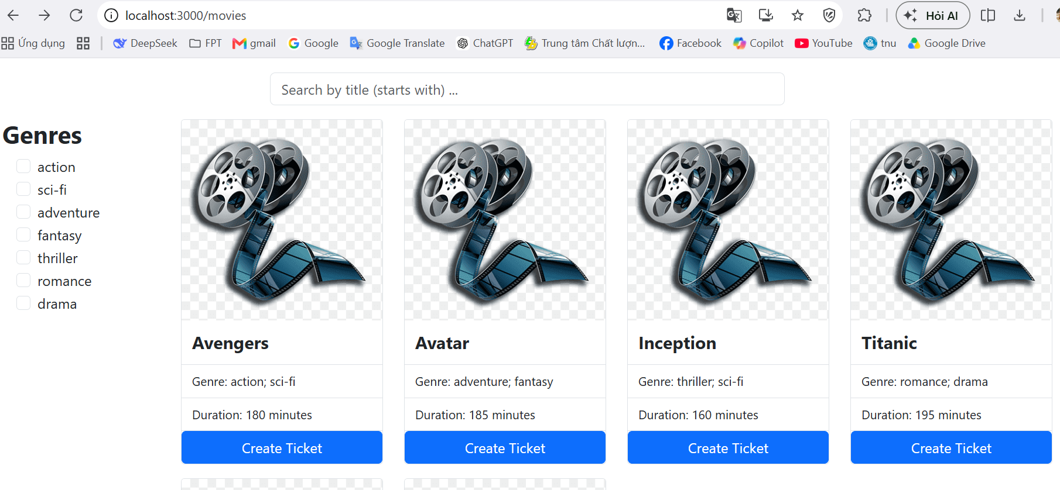
- Data Fetching & API Integration (1.5 pts):
  - Read the status parameter from the URL Query String (e.g., /movies?status=now-showing).
  - Send a GET request to /movies filtered by the retrieved status to display the corresponding movies. If no status parameter is present, fetch and display all movies.
- Dynamic Genre List Extraction (1.0 pt):
  - Fetch all movies from the database, dynamically extract unique (non-duplicate) genres, and render them as a list of Checkboxes in the left Sidebar.
- Combined Search and Filter Functionality (1.0 pt):
  - Search: As the user types into the text input, filter the movies whose titles start with the input string (case-insensitive, ignoring leading/trailing whitespaces).
  - Genre Filter: When one or more genre checkboxes are ticked, display only the movies that contain at least one of the selected genres.
  - 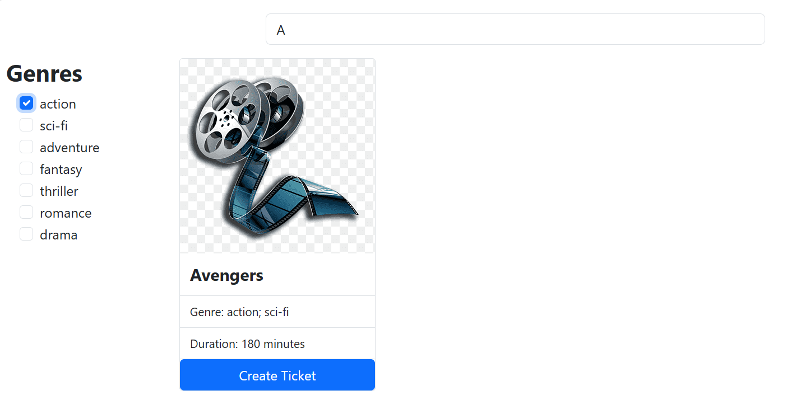
- Ticket Booking Navigation (1.0 pt):
  - Display each movie inside a Bootstrap <Card> containing: a default placeholder thumbnail image, Title, Genre list, Duration, and a "Create Ticket" button.
  - Clicking the "Create Ticket" button must navigate the user to /tickets/create?movie_id=[movie_id].
Question 3: Ticket Booking Page - TicketBookingPage (4.0 points)
Design the ticket booking interface which accepts a movie_id query parameter from the URL.
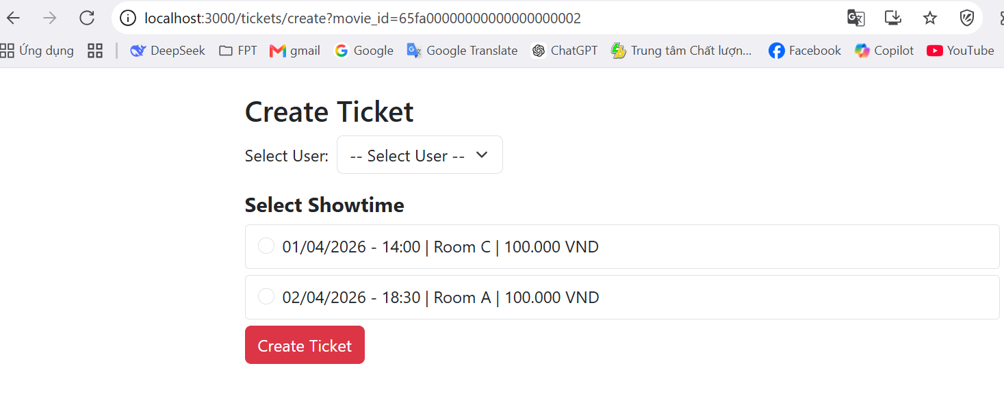
- Initial Data Loading (1.0 pt):
  - When the page initializes, utilize a concurrent asynchronous mechanism (Promise.all) to fetch data from the following endpoints: showtimes filtered by movieId, rooms, tickets, and users.
  - Render the showtimes for the selected movie as a group of Radio Buttons, sorted in ascending chronological order. Format the showtime label as: [DD/MM/YYYY] - [HH:MM] | [Room Name] | [Base Price] VND. The currently selected showtime must have a distinct background color.
- Dynamic Seat Map Rendering (1.5 pts):
  - The seat map for the corresponding room should only be displayed after a specific showtime is selected.
  - Filter the tickets array for the active showtime to identify seats with a status of either "booked" or "paid". These seats must be disabled and styled with a gray background color (#adb5bd).
  - Style the remaining available seats dynamically based on their category: VIP seats (#ffc107) and Normal seats (#87CEEB). Temporarily highlight currently selected seats in red (#dc3545).
  - Real-time Total Price Calculation: Display the total amount dynamically. If a selected seat is a VIP type, its price is calculated as Showtime Base Price $\times$ 1.2. Otherwise, it takes the base price.
- Ticket Creation & Booking Submission (1.5 pts):
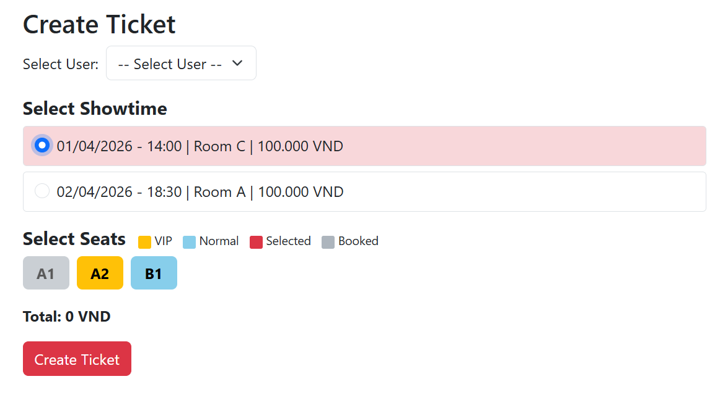
  - When the user clicks the "Create Ticket" button, validate that a user, a showtime, and at least one seat have been selected. Display an alert message if any validation fails.
  - If valid, execute individual POST requests to /tickets for each selected seat containing: showtime ID, seat ID, user ID, calculated price, default status "booked", current timestamp (ISO String), and payment method "cash".
  - While the API requests are pending, disable the submit button and change its text to "Creating..." to prevent duplicate submissions. Upon successful creation, show a success alert, reset the selected seats state, and refresh the seat map to lock the newly booked seats.

