

**Shale-PIZZAAsss**

**Supervisor:** *Lê Tuấn Xuyên*

**Semester:** *01*

**Batch No:** *T1.2401.E0*

**Group No:** *04*

|  |  |  |
| --- | --- | --- |
| **Order:** | **Full name** | **Roll No.** |
| *1.* | *Bành Nhật Quang* |  |
| *2.* | *Hoàng Nhật Phúc* |  |
| *3.* | *Trần Hoàng Nhân* |  |
| *4.* | *Nguyễn Quang Ánh* |  |
| *5.* | *Phùng Chấn Kiệt* |  |

***Month****: 05* ***Year****: 2024*



This is to certify that

**Mr. Bành Nhật Quang**

**Mr. Hoàng Nhật Phúc**

**Mr. Trần Hoàng Nhân**

**Mr. Nguyễn Quang Ánh**

**Mr. Phùng Chấn Kiệt**

Have successfully Designed & Developed

**Shale-PIZZAAsss**

Submitted by:

**Mr. Banh Nhat Quang**

Date Of Issue:

17 – MAY - 2024

Authorized Signature:

**Mr. Banh Nhat Quang**

**Content**

Content

Acknowledge

Synopsis

Problem Definition

Customer Requirements Specifications

Architecture and design of the project

1. Home Page must display the image section of the website.
2. Color combination must be made precise in the application.
3. Links such as
   1. Home
   2. Menu
      1. Pizza
      2. Garlic Breads
      3. Pizza Sandwiches
      4. Desserts
      5. Beverages
   3. Menu Download
   4. Store Location
   5. Locations
   6. Contact Us
   7. Feedback
   8. Franchise Info
4. Other Additional Links such as
   1. Weekend Special
   2. Combo offers
   3. Gallery
5. Navigation of the project must be made precise
6. Look and feel must be made user friendly.

Task Sheet

**Acknowledge**

As we understand that the eProject is a step-by-step learning environment that closely simulates the classroom and Lab-based learning environment into actual implementation. It is a project implementation at your fingertips!! An electronic, live juncture on the machine that allows you to.

* Practice step by step i.e. laddered approach.
* Build a larger more robust application.
* Usage of certain utilities in applications designed by user.
* Single program to unified code leading to a complete application.
* Learn implementation of concepts in a phased manner.
* Enhance skills and add value.
* Work on real-life projects.

Give a real-life scenario and help to create applications that are more complicated and useful.

Mentoring through email support.

First of all, I would like to thank India Aptech for allowing my team to work on this fantastic eProject. We had a great experience with eProject this time.

Next, We would like to express my special thanks to our mentor, Mr. Tuan Xuyen for the time and effort that he provided throughout the project. Your helpful advice and suggestions were beneficial to us during the completion of the project. In this respect, We are forever grateful to you.

Besides several mistakes we made in the project, we hope to have more opportunities to widen our knowledge in the web-developing world.

We will try to continue to learn and improve ourselves even more in the future.

Yours Sincerely, Team Group 04.

**Synopsis**

The Objective of this program is to give a sample project to work on real life projects. These applications help you build a larger, more robust application.

The objective is not to teach you JavaScript/Dreamweaver but to provide you with a real life scenario and help you create basic applications using the tools.

You can revise the chapters before you start with the project.

This project is meant for students who have completed the module of ***Dreamweaver***. These programs should be done in the Lab sessions with assistance of the faculty if required.

It is very essential that a student has a clear understanding of the subject. Students should go through the project and solve the assignments as per requirements given.

Kindly get back to the eProjects Team in case of any doubts regarding the application or its objectives.

**Problem Statement**

Shale-PIZZAAsss is famous for Pizzas, Pasta food. Shale-PIZZAAsss was opened with one restaurant in the year 1960 and now it has more than 1000 restaurants across the countries. A website needs to be designed to display the menus, Contact Us (so as to call a make order). Details of various franchises, locations, feedback must be included.

**Requirement Specification:**

The Web site is to be created based on the following requirements.

1. Home Page must display the image section of the website.
2. Color combination must be made precise in the application.
3. Links such as
   * Home
   * Menu
     1. Pizza
     2. Garlic Breads
     3. Pizza Sandwiches
     4. Desserts
     5. Beverages
   * Menu Download
   * Store Location
   * Locations
   * Contact Us
   * Feedback
   * Franchise Info
4. Other Additional Links such as
   * Weekend Special
   * Combo offers
   * Gallery
5. Navigation of the project must be made precise
6. Look and feel must be made user friendly.
7. **Home and Products Pages**
8. **Home Page**

This page is used to show hot deals, hot discounts and best-selling products. It also contains company’s information and order function.

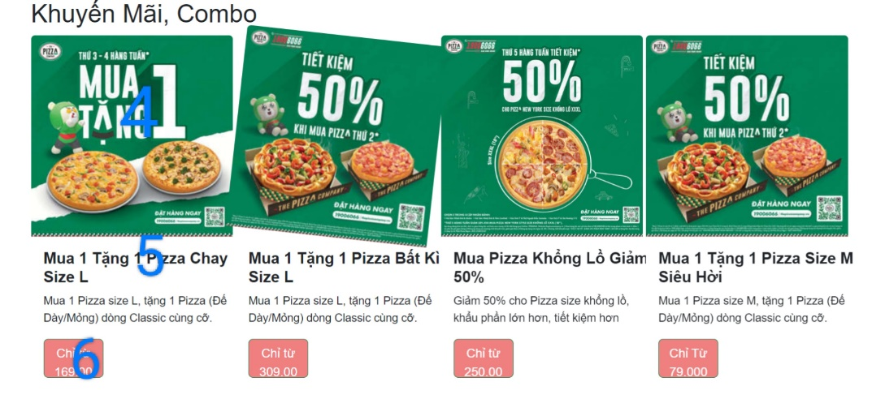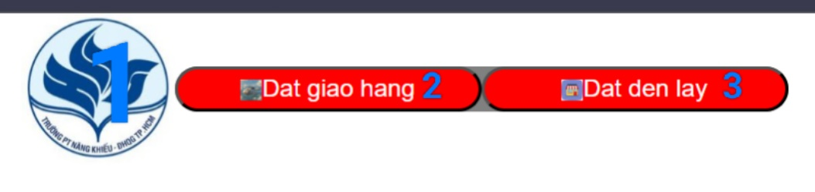

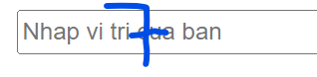

|  |  |  |  |
| --- | --- | --- | --- |
| **No** | **Type** | **Validation** | **Action** |
| 1 | Click |  | Navigation to Home page |
| 2 | Click |  | Navigation to order & shipping page |
| 3 | Click |  | Navigation to order & takeaway page |
| 4 | Click |  | Navigation to More Detail |
| 5 | Click |  | Navigation to More Detail |
| 6 | Click |  | Navigation to “Buy It Now” function |
| 7 | Text | Must be a valid address | Enter address and then shipping or suggest nearest store |

1. **Products Page**

The Promotion page is used to view details of pizza category, main products of the company.

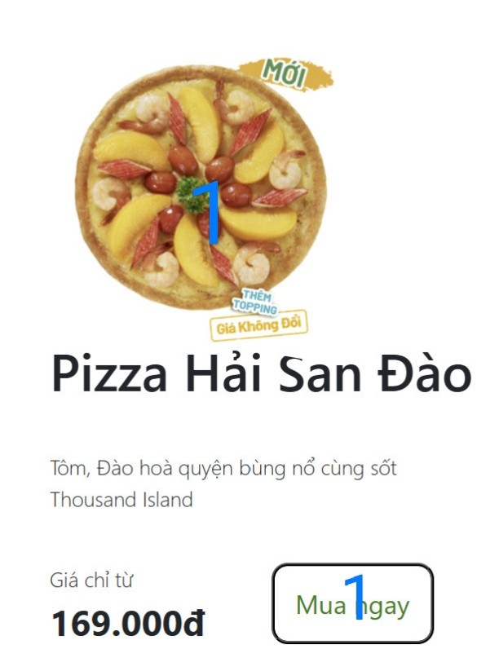

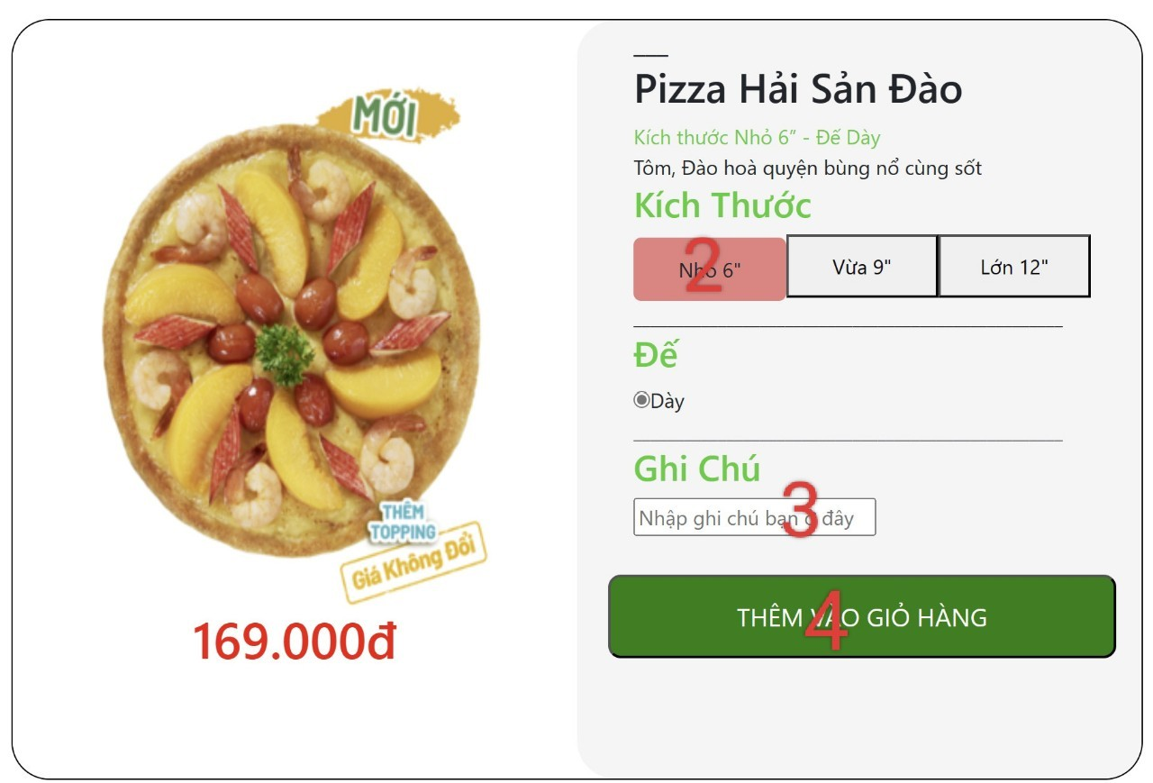

|  |  |  |  |
| --- | --- | --- | --- |
| **No** | **Type** | **Validation** | **Action** |
| 1 | Click |  | Navigation to “Add to cart” function |
| 2 | Click |  | Choose pizza size |
| 3 | Text | None | For customers to take note. |
| 4 | Click |  | Submit and add to cart |