Aufgabe 1
CSS | Erklaerung | Werte | Beispiel
color |  | Red, blue, grey,...
font-family |  | font names | font-family: "Trebuchet MS", Verdana, sans-serif;
font-size |  | Px,em,rem
font-style: |  | Normal, italic, oblique
font-weight |  | normal, bold  lighter, bolder  100–900
text-transform |  | None  uppercase  lowercase  capitalize  full-width
text-decoration |  | None  underline  overline  line-through
text-shadow | 1. horizontal  2. vertical  3. blur  4. color base |  | text-shadow: 4px 4px 5px red;  text-shadow: -1px -1px 1px #aaa,  0px 4px 1px rgba(0,0,0,0.5);
text-align |  | Left,right, center,justify
line-height
Word-spacing  letter-spacing |  |  | p::first-line {  letter-spacing: 2px;  word-spacing: 4px;  }
@font-face |  |  | @font-face {  font-family: "myFont";  src: url("myFont.ttf");  }

@font-face {
font-family: 'ciclefina';
src: url('fonts/cicle_fina-webfont.eot');
src: url('fonts/cicle_fina-webfont.eot?#iefix') format('embedded-opentype'),
url('fonts/cicle_fina-webfont.woff2') format('woff2'),
url('fonts/cicle_fina-webfont.woff') format('woff'),
url('fonts/cicle_fina-webfont.ttf') format('truetype'),
url('fonts/cicle_fina-webfont.svg#ciclefina') format('svg');
font-weight: normal;
font-style: normal;
}

Aufgabe 2

Notizen Text:
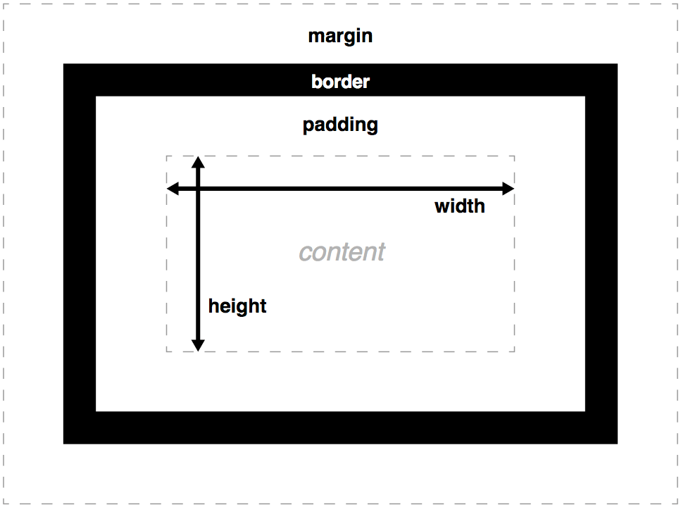

background-color
background-image
background-clip

outline

size constrains instead of absoute sizes
min-width
max-width
min-height
max-height

width: 70%;
max-width: 1280px;
min-width: 480px;
margin: 0 auto;
display: block;
margin: 0 auto;
max-width: 100%;
box-sizing
border-box

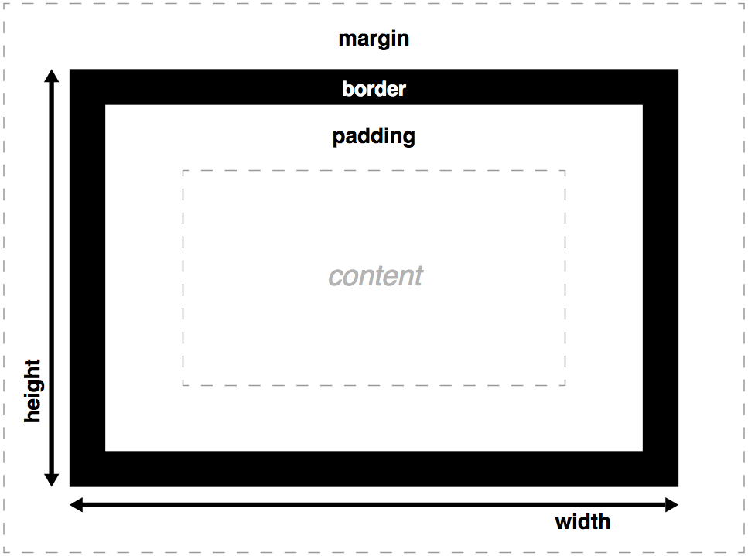

Aufgabe 2.1:

box types
block
<div>
<article>
<h1>
<p>
inline
<a>
<img>
<strong>
inline-block
<span>

CSS: display: block;

Aufgabe 2.2:
Die Höhe einer Inline-Box ist in der Regel von der verwendeten Schriftart abhängig
Die Breite von Inline-Boxen wird allein durch den Inhalt bestimmt

Gesamtbreite --> siehe erstes Bild

Margins have a specific behavior called margin collapsing: When two boxes touch against one another, the distance between them is the value of the largest of the two touching margins, and not their sum.

Aufgabe 2.3:
The Boxes ajust their size to the size of the window.
max-width: 1280px;
min-width: 480px;

Aufgabe 2.4:
overflow
auto
hidden
visible

