The Velocite Systems

Protected Point to Point Solution

Functional Specification

Updated: September 24, 2010

Table of Contents

1 Executive Description 3
2 Protected Point to Point Solution 5
2.1 Application 5
2.1.1 Administration 6
2.1.2 Initialization 7
2.1.3 Packet Intercept and Routing 8
2.1.4 Session Processing 8
2.1.5 Encryption ReKeying 9
2.1.6 Session recovery 9
3 Installation 11
4 Performance 12
4.1 Throughput 12
4.2 Scalability 12
4.3 Availability 12
5 Troubleshooting 13
5.1 Messages 13
5.2 Support 13
5.3 Software Updates 13
6 Standards Compliance 14
7 Glossary 16

Executive Description
Computer network systems are being used for growing quantities of critical organization data. The transport of this data is traditionally protected by a private link, or a Virtual Private Network (VPN) over the Internet. The remainder of this document shall use the VPN term as representative of all such private links. General purpose VPNs are capable of interfacing with multiple clients, but at a cost. For example, when used between data centers, the performance suffers.
For long lasting connections between data centers, the encryption keys need to be replaced periodically to ensure that the VPN is secure. The traditional VPN method for doing this is to close the existing VPN session and renegotiate the key exchange. Because of the performance cost, this is not done frequently. Also, the act of renegotiating the keys signals to any observer that the keys are being replaced.
The Velocite Systems Protected Point to Point (P³) Solution creates an encrypted, tunnel connection between data end points (data centers, server-to-server, server to client, …) that replaces keys WITHOUT closing the encrypted session. The control information to accomplish this is carried within the encrypted session, making it impossible to determine that is occurring from simple monitoring of the connection.
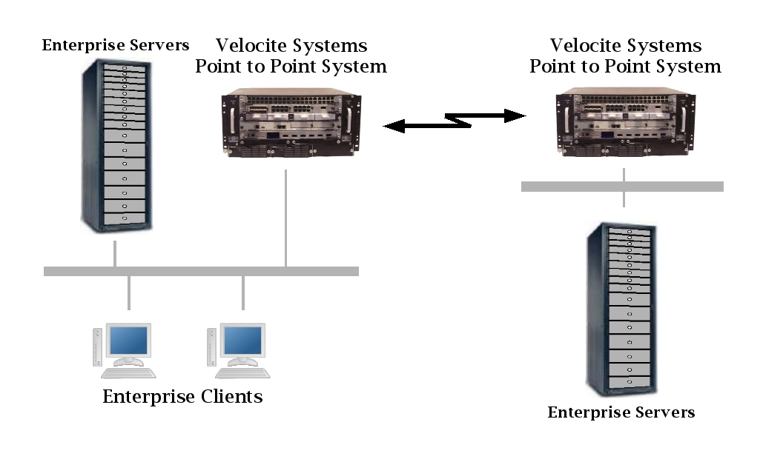Figure 1: Velocite Systems Protected Point to Point Solution
Velocite Systems P³ Systems operate in pairs to establish an encrypted Point-to-Point connection. The encrypted session uses either AES 128 or AES 256 encryption keys, and these keys are dynamically replaced frequently to make it extremely difficult to break the encryption of the link.
Velocite Systems P³ Systems may be configured as a cluster group to share a single IP address. This provides load balancing and failover.

Protected Point to Point Solution
Velocite Systems P³ Systems operate in pairs to establish an encrypted Point-to-Point connection. There is a primary and secondary in each pairing. The encrypted session uses either AES 128 or AES 256 encryption keys.
The primary P³ Solution produces new keys that are delivered to the secondary P³ System to be used for encrypting network sessions. These keys are changed at regular intervals, to provide a secure channel without disrupting the session. To ensure their protection, an encrypted control channel within the session is established to handle the dynamic replacement of keys, to make it extremely difficult to break the encryption of the link.
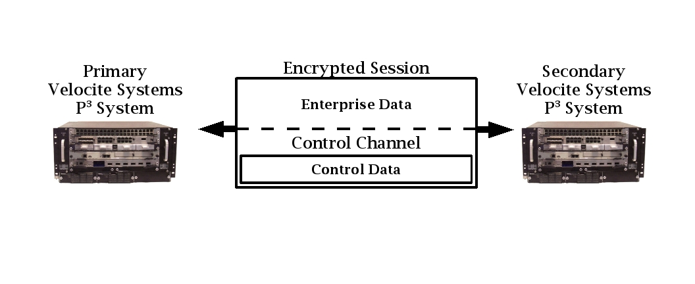Figure 2: Secure Data and Control Communications

Application
The Velocite Systems P³ Solution application performs six functions. Of these, only the Administration interface is seen by administrators, the rest occur within the P³ Systems. The functions are:
- Administration
- Initialization
- Packet Intercept and Routing
- Session processing
- Encryption ReKeying
- Session recovery

Administration
The administration function provides the interface to manage configuration files. The configuration data is used during initialization of the P³ Systems.
The following data is maintained for the Primary P³ System:
- The encryption algorithm, which is either AES 128 and AES 256.
- The list of secondary P³ Systems allowed to establish connections with the primary.
- If the system is to be a designated secondary, the IP address of the primary P³ System with which to establish connections is defined.
- The number of keys to be included in a Key Array.
- The P³ System routing table
The following data is maintained for a Secondary P³ System:
- The IP address of the primary P³ System with which to establish connections.
The majority of administration is performed from the primary P³ System. However, the initial deployment of a secondary system requires the local IP addresses and the IP address of the primary P³ System for the secondary to establish a connection. If the IP addresses are not already set when the secondary is powered up, the administrator is prompted for this information.
The functions available to administrators are:
- User creation: There are three levels of access for authorized administrators. Each level includes the privileges of the levels below them. The restrictions on access are as follows:
  - Level 1: This is the lowest level of administration and allows for access to logging information only.
  - Level 2: This level of administration allows access to existing sessions for shutdown or restart.
  - Level 3: This level of administration allows full access to modify configuration parameters and create new administration users.
- User validation: The administration application must validate each user's authorized access before performing any function. In the user interface, unauthorized functions should not be displayed.
- Encryption Key algorithm: The primary P³ System generates keys using the NIST FIPS 197 Advanced Encryption Algorithm. The key size may be either 128 or 256 bits, and is configured by an authorized administrator.
- ReKeying period: The keys used to encrypt a session between primary and secondary P³ Systems are replaced periodically. The frequency of replacement is configured by an authorized administrator.
- Deregistration period: If a session between a primary and secondary P³ Systems is lost, the keys in use are deregistered, which means they will not be used for a period of time. The length of time keys are deregistered is configured by an authorized administrator.
- Routing table definition: The primary P³ System may have sessions with multiple secondary P³ Systems. If so, a P³ System routing table must be defined to identify all network destinations for each secondary P³ System.
- Designated secondary: A primary P³ System may operate as a secondary with another P³ System. A designated secondary appears to be a secondary to the configured primary.

Initialization
The Velocite Systems P³ Solution initialization conforms to the IPsec standard defined in RFC 4301 and its supporting standards. The protocol is modified to enable the encryption keys to be replaced dynamically.
A secondary P³ System makes the connection request for the main session. Secondaries will not accept connection requests themselves.
When the main session is established, the primary P³ System initializes the Control Channel using messages defined for the Velocite Systems P³ Solution. The messages transmitted through the Control Channel appear to be normal data, but are encrypted using keys that are different from the data session.

Packet Intercept and Routing
Each P³ System must intercept packets with the IP and other protocol headers intact. The packets are then encrypted and forwarded to the correct P³ System, which decrypts the packet and forwards it to the local network.
If a primary P³ System establishes sessions with more than one other P³ System, it routes packets to the correct P³ System through the P³ session. To accomplish this it uses a P³ System routing table to match the destination IP address of each packet to the correct secondary P³ System.
In the outbound packet intercept process, the primary P³ System intercepts each packet destined for another P³ System with the IP and other protocol headers intact. If there are more than one connections established, the destination address is matched using the P³ System routing table definition. Then the full packet is encrypted and forwarded to the correct P³ System.
In the inbound packet intercept process, the encrypted packet data is decrypted. If the destination IP address of the packet is the P³ System, the packet data is handled specially. Otherwise, the full packet is forwarded to the local network.
The P³ Systems special handling of control channel data includes encryption and decryption using the control channel encryption key and bypassing the TCP/IP stack to manage the unencrypted data.
In the outbound control packet process, predefined IP and TCP headers are prepended to the control data. Then the full packet is encrypted and the result is treated like normal data.
In the inbound control packet process, the full packet is decrypted. The predefined IP and TCP headers are removed from the control data and the data is forwarded directly to the control application to be processed.

Session Processing
The Velocite Systems P³ Solution supports only one usage scenario defined in the IKEv2 specification, which is the Security Gateway to Security Gateway Tunnel.
The primary P³ System may have sessions with multiple secondary P³ Systems. If so, packets received from the local network are routed to the correct secondary P³ System, as described in the Packet Intercept and Routing section.
The full IP packets received from the local network are encrypted and used as the payload data of the encrypted packet. These packets are structured using the Encapsulating Security Header (ESH) and Encapsulating Security Payload (ESP), as defined in RFC 4303. The Velocite Systems P³ Solution requires the addition of a 32-bit field at the end of the ESH and immediately before the ESP. The format of encrypted packets is:
| ESH size | 4 octets | Variable length |
| ESH | P3 ID | ESP |
where the fields are:
- ESH: The Encapsulating Security Header of the IPsec protocol.
- P³ ID: The Identification number of the packet.
- ESP: The Encapsulating Security Payload of the IPsec protocol.
Data received by one P³ System from the other is decrypted, which may be handled in hardware. The data is then either forwarded to its destination or the Control Channel Decryption process.
When Control Channel data is to be sent to another P³ System, predefined TCP and IP headers are prepended. Only the address fields are processed by the receiving P³ System, so the headers may be statically defined. The entire packet is encrypted using the control encryption key, and it is then handled the same as a data packet.
If, after decrypting a packet, the destination is seen to be the P³ System itself, the packet is decrypted using the control encryption key. Then the IP and TCP headers are removed and the data is forwarded to the Control Channel application.

Encryption ReKeying
The Velocite Systems Encryption ReKeying Process replaces encryption keys frequently. When this is to occur, the primary P³ System notifies the secondary, supplies the new keys, and indicates the ReKeying point.
The primary P³ System generates new keys for both the main session and the Control Channel. The keys are replaced using Velocite Systems P³ Solution control messages.
The primary P³ System sends a control message with the data and control key values. When the secondary receives the message, it updates the keys it is using and returns a status message. If the status is good, the primary updates the keys it is using and sends a message to indicate the first packet it will encrypt using the new keys. The secondary returns a message indicating the first packet it will encrypt using the new keys.
If the status is not success, the primary attempts again for up to four times. If this does not result in success, Session Recovery is performed.

Session recovery
There are two Velocite Systems P³ Systems configuration modes that may be used together or individually to reduce the likelihood of failure:
- Clustering: In this mode, there are multiple P³ Systems that share the same IP address.
- Failover: In this mode, a backup takes over the functions of the main P³ System.
If a session is lost in spite of the backup configuration, the primary P³ Solution performs the following steps:
- Login termination: When a session failure occurs, all enterprise connections to the primary P³ System are immediately terminated. In the case of TCP sessions, this should be done by sending a Reset. For other protocols, an ICMP Destination Unreachable packet may be generated.
- Notify administrators: An error message with all available information on the failure is logged to the enterprise logging facility to notify administrators of the failure.
- Deregister session keys: The primary P³ System deregisters the session and control keys used for the network session to prevent an unauthorized host from re-establishing a session using the old keys.
If a session is lost in spite of the backup configuration, the secondary P³ Solution performs the following steps:
- Login termination: When a session failure occurs, all enterprise connections to the secondary P³ System are immediately terminated. In the case of TCP sessions, this should be done by sending a Reset. For other protocols, an ICMP Destination Unreachable packet may be generated.
- Session retry: After a brief wait, the P³ System attempts to automatically re-establish the session with the primary P³ System and continues to do this periodically.
  - The first time the P³ System sets the wait period to 5 seconds, and after that period, attempts to connect to the primary.
  - Each time the connection cannot be established, 5 seconds is added to the wait time and after that period, the connection is attempted.
  - When the wait period is 1 minute, the wait time is not increased, so that the secondary will attempt to connect to the primary once a minute.

Installation
The Velocite Systems P³ Solution is essentially a turnkey system. However, some installation configuration is required. All P³ Systems must have a static routing table defined to be able to forward packets to or from the local network correctly. This is accomplished with a script that prompts the administrator for IP addresses.
Each secondary P³ System must have the IP address of the primary P³ System it is to request a connection with defined. Also, the initial encryption configuration must be set. This is included in the script.
Primary P³ Systems have a more complex configuration, and an application to manage this is included. Administrators can run this application for initial configuration as well as maintenance and troubleshooting.

Performance

Throughput
The throughput of the Velocite Systems P³ Solution is equal to the throughput of traditional network encryption over equivalent connection infrastructure. The minimum period of key generation to ensure the security of the sessions is once every ten minutes for every session.

Scalability
The Velocite Systems P³ Solution system includes two options to allow the required scalability for an enterprise:
  - Optional Hardware Key Generation: If the enterprise environment requires a large number of encryption keys to be generated frequently, the Key Servers may be fitted with Hardware Key Generation.
  - P³ Solution Load Balancing mode: In this mode, all P³ Solutions are active and share an IP address. They also mirror each other's storage or are connected to a Storage Area Network. There is one primary P³ Solution that manages connection requests and forwards the request to the next available P³ Solution.

Availability
The P³ Solutions supports the following failover mode of operation:
  - P³ Solution Failover mode: In this mode, a primary and one or more backup P³ Solutions are operational. If the primary P³ Solution fails, the designated backup automatically becomes the primary. Secondary P^{3 P3} Solutions re-establish network sessions with the new primary. When the original primary recovers, it becomes the designated backup, and may become the primary by using an administrative command.

Troubleshooting

Messages
All failure messages issued by either the primary or secondary P³ Solution include a reason code to assist administrators in troubleshooting or reporting the problem.

Support
Velocite Systems Standard, Extended, and Premier support options are available.

Software Updates
The Velocite Systems P³ Solution provides a single update manager for all of the platform's software components. The applications installed by the users of the platform are not automatically included in that package management.

Standards Compliance
The Velocite Systems P³ System conforms to the following security standards:
  - NIST FIPS 140-2 standard for encryption
The implementation of the Velocite Systems P³ System conforms to the following Internet Engineering Task Force (IETF) standards:
  - IP Security
    - RFC 4301: Security Architecture for the Internet Protocol
    - RFC 3723: Securing Block Storage Protocols over IP
  - ESP and AH Headers
    - RFC 4302: IP Authentication Header (AH)
    - RFC 4303: Encapsulating Security Payload (ESP)
    - RFC 4835: Cryptographic Algorithm Implementation Requirements For ESP And AH
  - Key Exchange
    - RFC 3547: Group Domain of Interpretation
    - RFC 4109: Algorithms for IKEv1
    - RFC 4306: Internet Key Exchange (IKEv2) Protocol
    - RFC 4307: Cryptographic Algorithms for Use in the Internet Key Exchange Version2 (IKEv2)
    - RFC 4308: Cryptographic Suites for IPsec
    - RFC 4718: IKEv2 Clarifications and Implementation Guidelines
    - RFC 4945: IPsec PKI Profile of IKEv1/ISAKMP, IKEv2, and PKIX
  - Cryptographic Algorithms
    - RFC 2410: NULL Encryption Algorithm and Its Use With IPsec
    - RFC 3173: IP Payload Compression Protocol (IPComp)
    - RFC 3526: More Modular Exponential (MODP) Diffie-Hellman groups for Internet Key Exchange (IKE)
    - RFC 3686: Using AES Counter Mode With IPsec ESP
    - RFC 4309: Using AES CCM Mode With IPsec ESP
    - RFC 4434: AES-XCBC-PRF-128 algorithm for IKE
    - RFC 4615: AES-CMAC-PRF-128 Algorithm for IKE
    - RFC 4754: IKE and IKEv2 Authentication Using ECDSA
    - RFC 5282: Using Authenticated Encryption Algorithms with the Encrypted Payload of IKEv2

Glossary
The following terms and abbreviations are used in this document.
Protected Point to Point (P³) Solution: A secure connection over a public, routed network between enterprise data centers. The security is provided by establishing an encrypted session between two P³ Systems and encapsulating all packets forwarded to them in encrypted packets, making it appear that all traffic between the two is a single, encrypted session.
Protected Point to Point (P³) System: The hardware device used as an endpoint in a P³ session. This includes all necessary network interfaces and specialized hardware for performing tasks, such as encryption.
Protected Point to Point (P³) Suite: The software available to configure a primary or secondary P³ System. This may include the key manager, the encryption engine, the Velocite Systems Encryption ReKeying Process application, and the clustering and failover feature.
Protected Point to Point (P³) Session: The session established between two P³ Systems that carries both data and control information.
Control Channel: An encrypted session established between the two P³ Systems used to exchange control information between them. The session packets are treated the same as any other data from the perspective of the P³ Session. This session is encrypted with keys that are different from those used for the P³ Session.
Velocite Systems Encryption ReKeying Process (VSERP): The process of replacing encryption keys for both the Encrypted Session and the Control Session without closing and restarting either of those sessions. The information for the new keys is transmitted using the Control Session.
IP Security Architecture (IPsec): A protocol suite for securing Internet Protocol (IP) communications by authenticating and encrypting each IP packet of a data stream. IPsec also includes protocols for establishing mutual authentication between agents at the beginning of the session and negotiation of cryptographic keys to be used during the session.
Authentication Header (AH): This header and the associated protocol is used to provide connectionless integrity and data origin authentication for IP datagrams.
Encapsulating Security Payload header (ESP): This header and the associated protocol is used to provide confidentiality, data origin authentication, connectionless integrity, an anti-replay service, and limited traffic flow confidentiality.
Advanced Encryption Standard (AES): The encryption standard adopted by the US government. It includes three key ciphers: AES-128, AES-192, AES-256. Each cipher has a 128 block size, with key sizes of 128, 192, and 256, respectively.
Internet Key Exchange (IKE): This protocol performs mutual authentication between two parties and establishes an IKE security association (SA) that includes shared secret information that can be used to efficiently establish SAs for Encapsulating Security Payload (ESP) and/or Authentication Header (AH) and a set of cryptographic algorithms to be used by the SAs to protect the traffic that they carry.
Clustering: A technique of grouping computers to act as if they were a single computer. In particular, a single network address is shared between them, and packets destined for that address may be processed by any of the computers in the cluster group.
Failover: A technique for providing the capability to automatically start using a redundant, backup computer in the event of the failure of the currently active computer. This requires most or all applications to continue processing without interruption.

