The Velocite Systems

Protected Point to Point

Solution

System Specification

Table of Contents

1 Executive Description 3
1.1 Purpose and Scope 3
2 Product Overview 4
3 Product Description 7
3.1 Components 7
3.1.1 Administration 7
3.1.2 Initialization 8
3.1.3 Packet Intercept and Routing 9
3.1.4 Session Processing 11
3.1.5 Data Encryption 13
3.1.6 Encryption ReKeying 14
3.1.7 Session recovery 16
3.2 Data files 18
3.2.1 Primary P3 System 18
3.2.2 Secondary P3 System 18
3.3 Control Messages 18
3.3.1 Status Requests and Responses 23
3.4 Dependencies 23
4 Configuration Options 25
4.1.1 Primary P3 System 25
4.1.2 Secondary P3 System 25
4.1.3 Clustering 25
4.1.3.1 Primary Control Handling 26
4.1.3.2 Secondary Control Handling 26
4.1.4 Failover 26
5 Messages 28
5.1.1 Primary P3 System 28
5.1.2 Secondary P3 System 28
6 Support 29
6.1 Testing 29
6.1.1 Hardware testing 29
6.1.2 Primary P3 System 29
6.1.3 Secondary P3 System 29
6.2 System Updates 30
7 Standards Compliance 31
8 Glossary 33

Executive Description
Computer network systems are being used for growing quantities of critical organization data. The transport of this data is traditionally handled by a private link, or a Virtual Private Network (VPN) over the Internet. The remainder of this document shall use the VPN term as representative of all such private links. General purpose VPNs are capable of interfacing with multiple clients, but at a cost. For example, when used between data centers, the performance suffers.
For long lasting connections between data centers, the encryption keys need to be replaced periodically to ensure that the VPN is secure. The traditional VPN method for doing this is to close the existing VPN session and renegotiate the key exchange. Because of the performance cost, this is not done frequently. Also, the act of renegotiating the keys signals to any observer that the keys are being replaced.
The Velocite Systems Protected Point to Point (P³) Solution creates an encrypted, tunnel connection between data end points (data centers, server-to-server, server to client, …) that replaces keys WITHOUT closing the encrypted session. The control information to accomplish this is carried within the encrypted session, making it impossible to determine that is occurring from simple monitoring of the connection.
The Velocite Systems Protected Point to Point (P³) Solution increases the safety of replacing keys by manipulating the data prior to being encrypted. This makes it difficult to target fields within the data or even to recognize whether the data has been correctly decrypted, which raises the cost of attempting to break the encryption keys.
Velocite Systems P³ Systems support clustering and failover. This increases performance and reliability.

Purpose and Scope
This document defines the implementation requirements, interfaces, and recovery procedures that the Velocite Systems P³ Systems must meet to deliver its objectives.

Product Overview
To provide secure data transport, P³ Systems operate in pairs to establish an encrypted Point-to-Point connection. The encrypted session uses either AES-128 or AES-256 encryption keys, and these keys are dynamically replaced periodically to make it extremely difficult to break the encryption of the link.
The figure, Base P³ Solution Configuration, displays the components of the primary and secondary P³ Systems. Data is transported securely between these over an encrypted connection. The replacement of encryption keys is handled over the Control Channel, which is described below.
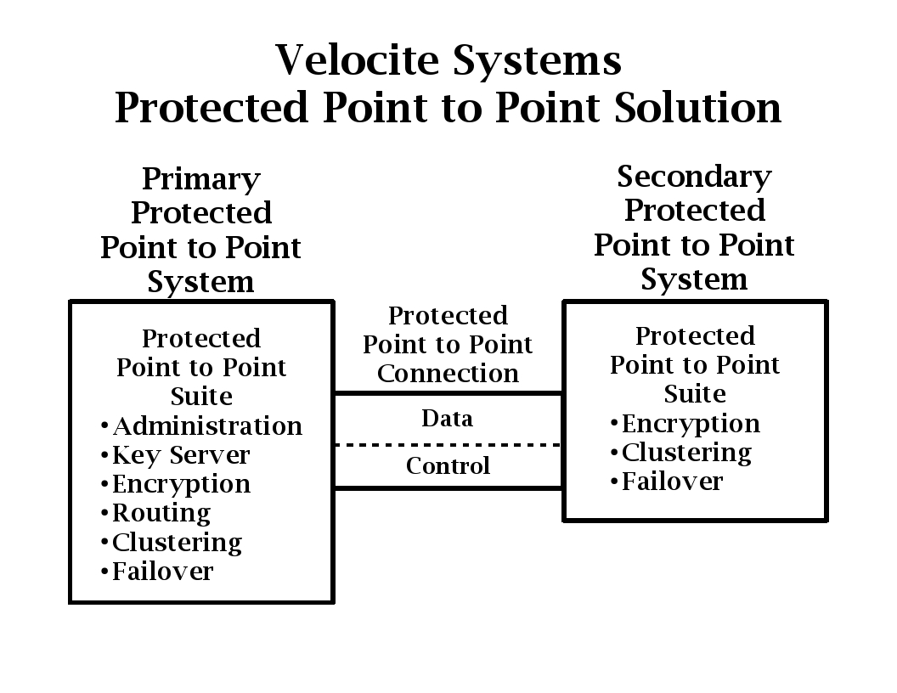Figure 1: Base P³ Solution Configuration
The primary P³ System generates encryption keys and distributes them to each secondary P³ System with which is has a session. The keys are maintained only as long as they are in use. If the session is lost, the keys are deregistered and not reused for a configurable period of time.
The secondary P³ System establishes a session with the primary. The primary P³ System is then responsible for initializing the encrypted session, key generation, ReKeying, and administrative functions. Encryption and key generation may be performed by software or a hardware module.
Periodically, the encryption keys are replaced, using the Velocite Systems Encryption ReKeying Protocol. This is transported over an encrypted Control Channel within the Encrypted Session itself, so that the key replacement event cannot be observed by monitoring the session.
The figure, Multiple P³ System Configuration, displays an example of how a P³ Solution may be configured to support multiple enterprise data centers.
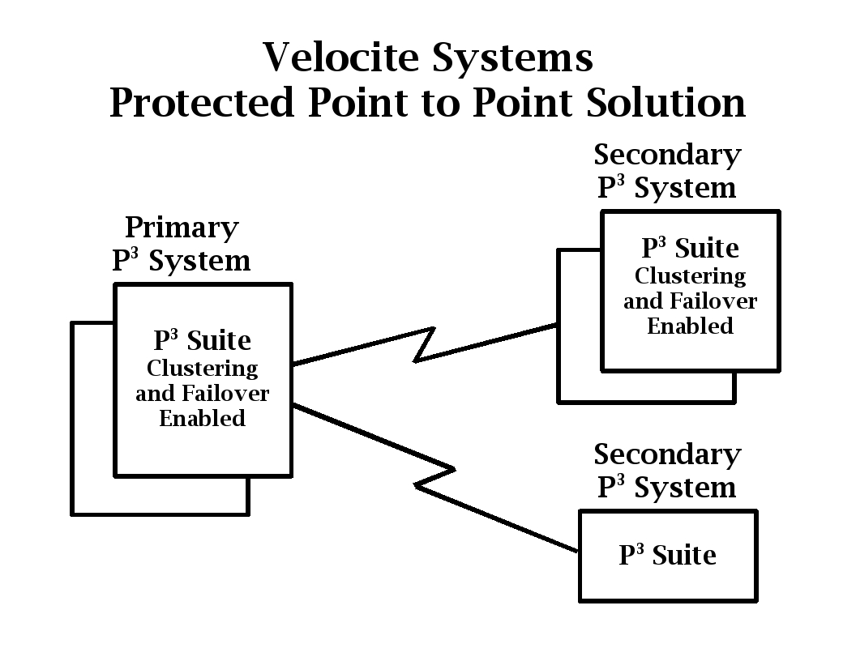Figure 2: Multiple P³ System Configuration
The primary P³ System performs routing when there are multiple sessions established with secondary P³ Systems.
The figure, Primary P³ System plus Secondary, shows the configuration to support intercommunication between multiple data centers.
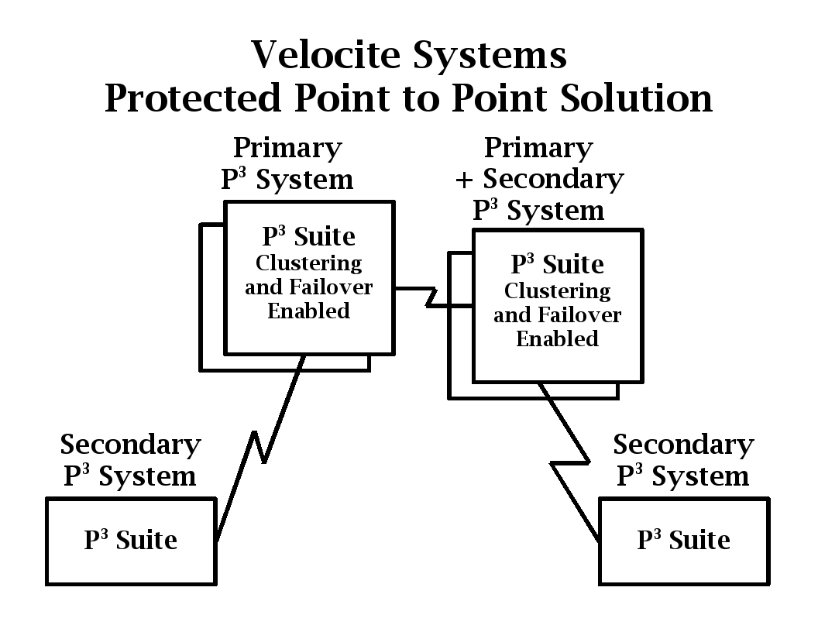Figure 3: Primary P³ System plus Secondary
Velocite Systems P³ Systems may be configured as a cluster group to share a single IP address. This provides load balancing and failover.
Both P³ Systems are accessible by only a limited number of authorized administrators. Administration functions on secondary P³ Systems are performed remotely from the primary.

Product Description
The Velocite Systems Protected Point to Point Solution consists of primary and secondary P³ Systems. These are described in the Components section. The configuration and data files are described in the Data Files section. The messages exchanged between components are described in the Control Messages section. The procedural and operating systems dependencies are described in the Dependencies section.

Components
The Velocite Systems P³ Suite of software establishes and manages a secure channel through which multiple sessions between enterprise data centers may be connected. All network traffic being transported through this channel is encrypted.
There are six components within the Velocite Systems P³ Suite:
- Administration
- Initialization
- Packet Intercept and Routing
- Session processing
- Encryption ReKeying
- Session recovery
The actions taken during these processes are logged, and if there are any failures, error messages are issued to the enterprise logging facility.

Administration
The administration process manages configuration files for application data that is described in the Data Files section. The application provides an interface for modifying these configuration files.
The majority of administration is performed from the primary P³ System. The initial deployment of a secondary system requires the local IP addresses and the IP address of the primary P³ System for the secondary to establish a connection. The administrator is prompted for this when the secondary is powered up, if the IP addresses are not already set.
The functions available to administrators are:
- User creation: There are three levels of access for authorized administrators. Each level includes the privileges of the levels below them. The restrictions on access are as follows:
  - Level 1: This is the lowest level of administration and allows for access to logging information only.
  - Level 2: This level of administration allows access to existing sessions for shutdown or restart.
  - Level 3: This level of administration allows full access to modify configuration parameters and create new administration users.
- User validation: The administration application must validate each user's authorized access before performing any function. In the user interface, unauthorized functions should not be displayed.
- Encryption Key algorithm: The primary P³ System generates keys using the NIST FIPS 197 Advanced Encryption Algorithm. The key size may be either 128 or 256 bits, and is configured by an authorized administrator.
- ReKeying period: The keys used to encrypt a session between primary and secondary P³ Systems are replaced periodically. The frequency of replacement is configured by an authorized administrator.
- Deregistration period: If a session between a primary and secondary P³ Systems is lost, the keys in use are deregistered, which means they will not be used for a period of time. The length of time keys are deregistered is configured by an authorized administrator.
- Routing table definition: The primary P³ System may have sessions with multiple secondary P³ Systems. If so, a P³ System routing table must be defined to identify all network destinations for each secondary P³ System.
- Designated secondary: A primary P³ System may operate as a secondary with another P³ System. A designated secondary appears to be a secondary to the configured primary.

Initialization
The Velocite Systems P³ Solution initialization conforms to the IPsec standard defined in RFC 4301 and the standards referenced in that document.
There are two steps in the initialization process:
- Main session establishment: The connection request is made by secondary P³ Systems. Secondaries will not accept connection requests themselves. There are three steps to establish the main encrypted session:
  - The secondary P³ System makes a connection request to the primary P³ System based on a configuration file with a list of valid primary system network addresses defining the order of connection attempts.
  - The primary P³ System uses configuration file with a list of valid secondary system network addresses to determine whether the request is valid, and if so accepts it. This must support a requirement for extra validation in the event of a session failure, which is described in the Session Recovery section. There may also be additional verification methods using the Status Request control message.
  - The session is initialized using the Internet Key Exchange version 2, as defined in RFC 4306. This includes support for Internet Security Association and Key Management Protocol (ISAKMP), as defined in RFC 2408, Internet Key Exchange (IKE), as defined in RFC 2409, and the Authentication Header (AH), as defined in RFC 4302.
- Control channel establishment: The primary P³ System establishes an encrypted Control Channel that is carried within the encrypted session as if it were data but uses different keys from the data session.
The control session communicates information between the P³ Systems by exchanging control messages. The supported messages are defined in the Control Messages section.
There are three steps in control channel initialization utilizing messages as defined in the Control Messages section:
  - The primary sends the secondary a Set Key Array message. If the secondary sends a successful response, initialization continues. Otherwise, two more attempts are made, and if neither is successful, the main encrypted session is closed and Session Recovery is initiated.
  - The primary performs the Encryption ReKeying Process as described below.
  - The primary sends a Status Request message for additional information to validate the identity and readiness of the secondary. If this step is not completed successfully, the main encrypted session is closed and Session Recovery is initiated.

Packet Intercept and Routing
Each P³ System must intercept packets with the IP and other protocol headers intact. The packets are then encrypted and forwarded to the correct P³ System, which decrypts the packet and forwards it to the local network.
If a primary P³ System establishes sessions with more than one other P³ System, it routes packets to the correct P³ System through the P³ session. To accomplish this it uses a P³ System routing table to match the destination IP address of each packet to the correct secondary P³ System.
There are four steps in the outbound packet intercept process:
- Get the destination IP address: The primary P³ System intercepts each packet destined for another P³ System with the IP and other protocol headers intact.
- Determine routing: If there are more than one connections established, the destination address is matched in the P³ System routing table as follows:
  - The destination IP address is ANDed with the subnet mask of each entry in the table.
  - If the result equals the network address of that entry, the packet is forwarded to the P³ System IP address of that entry.
- Encrypt packet: The full packet is encrypted.
- Forward packet: The packet is forwarded to the correct P³ System.
There are three steps in the inbound packet intercept process:
- Decrypt packet: The encrypted packet data is decrypted.
- Forward packet: If the destination IP address of the packet is the P³ System, the packet data is handled specially. Otherwise, the full packet is forwarded to the local network.
The P³ Systems handle control channel data as a special case. This includes encryption and decryption using the control channel encryption key and bypassing the TCP/IP stack to manage the unencrypted data.
There are three steps in the outbound control packet process:
- Build packet header: Predefined IP and TCP headers are prepended to the control data.
- Encrypt packet: The full packet is encrypted.
- Process as normal data: The result is treated like normal data in steps 3) and 4) of the outbound packet intercept process above.
There are three steps in the inbound control packet process:
- Decrypt packet: The full packet is decrypted.
- Remove packet header: The predefined IP and TCP headers are removed from the control data.
- Process control data: The data is forwarded directly to the control application to be processed.
The figure, Packet Handling, displays an overview of the packet intercept and routing functionality.
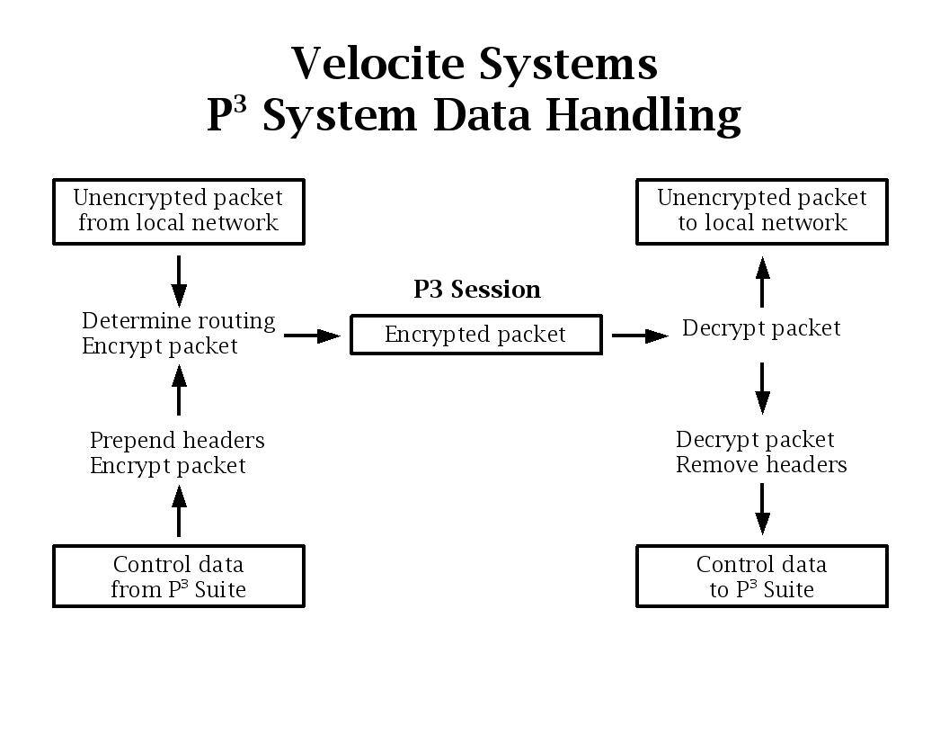Figure 4: Packet Handling

Session Processing
During normal session processing, the P³ Systems must perform routing, encryption, and decryption to deliver data efficiently and securely. There are six steps in these processes:
- Data routing: The primary P³ System may have sessions with multiple secondary P³ Systems. If so, packets received from the local network are routed to the correct secondary P³ System, as described in the Packet Intercept and Routing section.
- Data Encryption: The full IP packet received from the local network is encrypted and used as the payload data of the encrypted packet. The Data Encryption section describes how the safety of encryption is increased.
- Data Transport: Packets are structured using the Encapsulating Security Header (ESH) and Encapsulating Security Payload (ESP), as defined in RFC 4303. The anti-replay feature must be explicitly disabled so that the session is not automatically restarted when the ESH Sequence Number reaches its maximum size.
The Velocite Systems P³ Solution inserts a 32-bit field at the end of the ESH and immediately before the ESP. The Velocite Systems P³ Solution supports only one usage scenario defined in the IKEv2 specification: Security Gateway to Security Gateway Tunnel.
The format of encrypted packets is:
| ESH size | 4 octets | Variable length |
| ESH | P3 ID | ESP |
where the fields are:
- ESH: The Encapsulating Security Header of the IPsec protocol.
- P³ ID: The Identification number of the packet is an unsigned 32-bit integer. It indicates which encryption key is used to decrypt the packet payload. The use of this field is as follows:
  - The ID is incremented for each packet by the P³ System transmitting it. When the maximum value is reached, the next value is zero.
  - When ReKeying occurs, the ID of the first packet to be encrypted and decrypted using the new key is set.
  - The starting ID of the previous key and the starting ID of the new key set the bounds (modulo 2³²) for the packets to be decrypted using the previous key. This allows for out of order packets to be decrypted using the correct key.
  - The ID is unique to each half session. In other words, when ReKeying occurs, the starting ID for packets from the primary P³ System to the secondary will usually be different from that of packets from the secondary to the primary.
- ESP: The Encapsulating Security Payload of the IPsec protocol.
- Data Decryption: Data received by one P³ System from the other is decrypted, which may be handled in hardware. Then the following determination is made:
  - If the destination is the P³ System itself, the data is forwarded to the Control Channel Decryption process.
  - Otherwise, the data is forwarded to its destination.
- Control Channel Encryption: When Control Channel data is to be sent to another P³ System, the following occurs:
  - A predefined TCP header is prepended. The fields are ignored by the receiver, so it is not necessary to calculate a valid checksum.
  - A predefined IP header is then prepended. Only the address fields are processed by the receiving P³ System, so it is not necessary to calculate a valid checksum.
  - The entire packet is encrypted using the control encryption key. It is then handled the same as a data packet.
- Control Channel Decryption: If, after decrypting a packet, the destination is seen to be the P³ System itself, the following occurs:
  - The packet is decrypted using the control encryption key.
  - The IP and TCP headers are removed.
  - The data is handled by the Control Channel application.

Data Encryption
The Velocite Systems P³ Solution increases the safety of transporting keys over the same session as data in three ways:
- Limit differences in packet sizes: During session setup or shutdown, many protocols exchange standardized messages. Because these are typically small enough to fit into less than a full Ethernet packet, it is possible to identify them by monitoring for patterns in the size of packets. To prevent these patterns, a P³ System uses three buffer sizes:
  - Small: 128 bytes
  - Medium: 640 bytes
  - Large: Full Ethernet packet
- Add pad characters from existing data: For packets that are smaller than the buffer size being used, pad characters must be added. If these were all zeros, it would be possible to target the end of packets when attempting to break the encryption key. Therefore, non-zero pad characters are added. In order to make the characteristics of the data consistent, the pad characters are taken from the data.
The pad characters are generated by selecting a random number, such as a checksum, and selecting the 3 lower order bits, to be used as a step value. (If this is zero, another step value is selected.) If the size of the data is at least three times the step counter, only the data is used. Otherwise the headers are counted as data. An index is set to the step counter value and the first pad character is the data at the index offset. The index is incremented by the step counter and the second pad character is at the offset of the new index. If the value of the index exceeds the length of the data, the length of the data is subtracted from the index and the next pad character is located at the offset of the new index.
- Relocation of data within a packet: A similar problem exists for network protocol headers at the beginning of the encrypted packet. The unencrypted P³ header contains addresses that are usually within the destination network of the encrypted header. These and other header fields could be used as somewhat constant data for breaking the key. To make the beginning of the data vary between packets, each buffer to be encrypted is divided into two to eight blocks of varying size. Each of these blocks is randomly shuffled with a mapping of how to reassemble them included in the data. Then the data is encrypted.
The mapping of shuffled blocks is organized as follows:
| 2 bytes | 2 bytes | Variable | 2 bytes |
| Location | Length | Block | Location |
There is an initial location field which is then followed by two to eight 'Length/Block/Location' fields. The format of the fields are:
  - Location: The offset of the next block of data, as well as which block is found at that location. The offset value of the final location field is zero.
111. .... .... .... = Block ID (0 - 7)
...1 1111 1111 1111 = Offset of next block
  - Length: The length of the block following this field.
  - Block: The actual data in the block, which is reassembled in order by the receiving P³ System.

Encryption ReKeying
The Velocite Systems Encryption ReKeying Process replaces encryption keys frequently. When this is to occur, the primary P³ System notifies the secondary, supplies the new keys, and indicates the ReKeying point. There are three steps in the ReKeying process:
- Key generation: The primary P³ System generates new keys for both the main session and the Control Channel. The primary may generate a new key or randomly select one from the key array. The key array is defined as follows:
  - During session initialization, the primary P³ System sends an array of encryption keys to the secondary and maintains the array in its information for that secondary.
- Key distribution: The primary P³ System sends a Key Replacement control message with the data and control key value, and the flag set to indicate whether each key is an actual key or an index into the key array.
- Key Verification: When the secondary receives the Key Replacement control message, it determines whether either key is in the key array, and if so, retrieves the key. It then prepares the encryption module to use the new key as follows:
  - The Encryption Module must be capable of using four keys simultaneously:
    - Data key 0: This is the 'old' encryption key for the main Velocite Systems session encryption.
    - Control key 0: This is the 'old' encryption key for the Velocite Systems control message encryption.
    - Key Number 0: This is the P³ Number of the first packet encrypted using data key 0.
    - Data key 1: This is the 'new' encryption key for the main Velocite Systems session encryption.
    - Control key 1: This is the 'new' encryption key for the Velocite Systems control message encryption.
    - Key Number 1: This is the P³ Number of the first packet encrypted using data key 1.
  - When the new keys from a Key Replacement message have been determined, the secondary P³ System copies Data Key 1 to Data Key 0 and Control Key 1 to Control Key 0. It also sets the Key Number for both Keys 0 to that of Keys 1.
  - The Key Number of Keys 1 is incremented and then the new Data Key 1 and Control Key 1 are set.
  - If there is an error at any point, a Key Status message is sent with the appropriate error flag bit set and the keys and key numbers are restored.
  - Otherwise, a Key Status message is sent with all error flag bits set to zero.
- ReKeying, primary: The primary P³ System handles the Key Status message as follows:
  - If the Key Status message is not received within a timeout period, it sends a duplicate of the Key Replacement message with the Retransmit flag bit set. If more than four retransmitted messages are sent, it begins the session recovery process.
  - If the Key Status message is received with errors, it sends a duplicate of the Key Replacement message with the Retransmit flag bit set. If more than four retransmitted messages are sent, it begins the session recovery process.
  - If the Key Status message is received with no errors, it performs the following:
    - Perform Key Verification from step 6) on the Keys 0 and 1.
    - Send a ReKeying message to the secondary, with the P³ Number of the first packet to be encrypted with the new key.
    - All data sent over the main encrypted session or through the control channel is encrypted with the new data or control key.
    - Any packet received by the secondary from the primary with a P³ Number between key number 0 and key number 1 (modulo 2³²) is decrypted using data or control key 0.
- ReKeying, secondary: When the secondary receives the ReKeying message, it performs the following:
    - Send a ReKeying message to the primary, with the P³ Number of the first packet to be encrypted with the new key.
    - All data sent over the main encrypted session or through the control channel is encrypted with the new data or control key.
    - Any packet received by the primary from the secondary with a P³ Number between key number 0 and key number 1 (modulo 2³²) is decrypted using data or control key 0.

Session recovery
There are two Velocite Systems P³ Systems configuration modes that may be used together or individually to reduce the likelihood of failure. These are described in detail in the Configuration Options section.
- Clustering: In this mode, there are multiple P³ Systems that share the same IP address.
- Failover: In this mode, a backup takes over the functions of the main P³ System.
If there is a session failure between a primary and secondary P³ System in spite of the backup configuration, the Velocite Systems P³ Solution provides a procedure for safely terminating sessions and notifying administration personnel.
Session failure recovery is performed by the primary P³ Systems in four steps:
- Failure detection: The primary P³ System determines that a session with a secondary has failed if any of the following occur:
  - A network error is reported by the TCP/IP stack
  - There is no answer to any Heartbeat Query messages within a four minute period
- Login termination: When a session failure occurs, all enterprise connections to the primary P³ System are immediately terminated. In the case of TCP sessions, this should be done by sending a Reset. For other protocols, an ICMP Destination Unreachable packet may be generated.
- Notify administrators: An error message with all available information on the failure is logged to the enterprise logging facility to notify administrators of the failure.
- Deregister session keys: The primary P³ System deregisters the session and control keys used for the network session to prevent an unauthorized host from re-establishing a session using the old keys.
    - Save the keys being used for the failed session to be tested against the keys generated when the session is re-established.
    - Test new keys against keys saved from failed sessions.
The secondary P³ System performs four steps:
- Failure detection: The secondary P³ System determines that a session with a primary has failed if any of the following occur:
  - A network error is reported by the TCP/IP stack
  - No Heartbeat Query messages are received within a four minute period, even after an unsolicited Heartbeat Answer message has been sent
- Login termination: When a session failure occurs, all enterprise connections to the secondary P³ System are immediately terminated. In the case of TCP sessions, this should be done by sending a Reset. For other protocols, an ICMP Destination Unreachable packet may be generated.
- Session retry: After a brief wait, the P³ System attempts to automatically re-establish the session with the primary P³ System and continues to do this periodically.
  - The first time the P³ System sets the wait period to 5 seconds, and after that period, attempts to connect to the primary.
  - Each time the connection cannot be established, 5 seconds is added to the wait time and after that period, the connection is attempted.
  - When the wait period is 1 minute, the wait time is not increased, so that the secondary will attempt to connect to the primary once a minute.

Data files

Primary P³ System
The following data files are maintained for the Primary P³ System :
  - Initialization data: This includes the following configuration information:
    - The encryption algorithm, which is currently a choice between AES 128 and AES 256.
    - The list of secondary P³ Systems allowed to establish connections with the primary.
    - If the system is to be a designated secondary, the IP address of the primary P³ System with which to establish connections is defined.
    - The number of keys to be included in a Key Array.
    - The P³ System routing table, which consists of the following fields:
      - Destination network: One of the networks that is local to the secondary P³ System being defined.
      - Network mask: The network mask of that local network.
      - P³ System address: The IP address of the secondary P³ System.

Secondary P³ System
The following data files are maintained for the Secondary P³ System :
  - Initialization data: This includes the following configuration information:
    - The IP address of the primary P³ System with which to establish connections.

Control Messages
Control Messages are the method by which the P³ Solution manages the encryption session and keys. The format of the Control Messages is:
| 4 octets | 1 octet | Variable length |
| Size | Command | Data |
where the fields are:
- Size: The total size of the message, including the size field itself
- Command: An 8-bit number
- Data: The data, if any, associated with the command
The supported Velocite Systems Control Messages are defined below, with the command number in parentheses:
- Set Key Array (1): A primary P³ System may generate a list of keys which is maintained in memory by the secondary. During ReKeying, the index into the list can be used to assign a new key. This message may be sent at any time during the session. The Set Key Array data fields are:
| 1 octet | 3 octets | Variable length |
| Flags | Key Array Size | Key Array |
where the fields are:
  - Flags: The flag field is a bit field with the following values:
1111 .... = Reserved (ignored)
.... 1111 = Encryption type
where the supported encryption types are:
    - 1 = AES 128, key length 128 bits
    - 2 = AES 256, key length 256 bits
  - Key Array Size: The number of keys in the array
  - Key Array: The list of keys to be stored in the key array, which is described in the ReKeying message.
- Key Array Acknowledgment (2): The Key Array Acknowledgment data fields are:
| 1 octet |
| Flags |
where the fields are:
  - Flags: The flag field is a bit field in which success is indicated by zero errors. Otherwise, the following errors are defined:
1111 11.. = Reserved (ignored)
.... ..1. = Error saving key array
.... ...1 = Error in control data
- Key Replacement (3): The value of a new key is sent before the notification of its use. The Key Replacement data fields are:
| 1 octet | Index or key length | Index or key length |
| Flags | Data Key | Control Key |
where the fields are:
  - Flags: The flag field is a bit field with the following values:
1111 1... = Reserved (ignored)
.... .1.. = Retransmit
.... ..1. = Data encryption key from array (DINDEX)
.... ...1 = Control encryption key from array (CINDEX)
  - Data Key: If the DINDEX flag bit is set, the length is 4 octets, and the value is the index into the key array, which was set using the Set Key Array message. Otherwise, the field is the new data encryption key, and the length depends on the encryption type.
  - Control Key: If the CINDEX flag bit is set, the length is 4 octets, and the value is the index into the key array, which was set the Set Key Array message. Otherwise, the field is the new control encryption key, and the length depends on the encryption type.
- Key Status (4): The Key Status data fields are:
| 1 octet |
| Flags |
where the fields are:
  - Flags: The flag field is a bit field with the following values:
1111 .... = Reserved (ignored)
.... 1... = Error in data key index
.... .1.. = Error in data key
.... ..1. = Error in control key index
.... ...1 = Error in control key
- Rekey (5): The Rekey data fields are:
| 4 octets |
| Key number |
where the fields are:
  - Key Number: The P³ Number of the first encrypted packet to use the new keys. This field follows the Encapsulating Security Header, which is described in the Session Processing section.
- Heartbeat Query (6): The Heartbeat Query data fields are:
| 4 octets | 4 octets |
| Timestamp | Sequence # |
where the fields are:
  - Timestamp: The timestamp is the time that the primary P³ System sends the message. This field is composed of two values: The high order 20 bits are the number of seconds after midnight. The low order 12 bits are the high order 12 bits of the system sub-second time.
  - Sequence Number: The sequence number starts at one and is incremented each time a heartbeat query is sent. When the maximum value is reached, the next value is one.
- Heartbeat Answer (7): The Heartbeat Answer data fields are:
| 4 octets | 4 octets |
| Timestamp | Sequence # |
where the fields are:
  - Timestamp: The timestamp is the time that the secondary P³ System sends the message. This field is composed of two values: The high order 20 bits are the number of seconds after midnight. The low order 12 bits are the high order 12 bits of the system sub-second time.
  - Sequence #: The sequence number is that of the Heartbeat Query message being answered. If the number is zero, the status is unsolicited, which requires an immediate Heartbeat Query from the primary P³ System.
The heartbeat information is sent 5 to 30 seconds to validate that the session is established. The timestamp data is used to calculate the average round trip time of control information. The period is configurable, but if no query or answer is received for a period of 4 minutes, the session is assumed to have failed.
- Status Request (8): The supported status requests are defined in the following Status Requests section. The Status Request data fields are:
| 2 octets | 2 octets | Variable length |
| Request # | Request Size | Status Requests |
where the fields are:
  - Request number: The request number starts at one and is incremented each time a Status Request is sent. When the maximum value is reached, the next value is one.
  - Request Size: The number of Status Request fields.
  - Status Requests: Each status request is a text field terminated by the NULL character.
- Status Response (9): The Status Response data fields are:
| 2 octets | 2 octets | Variable length |
| Request # | Response Size | Status Responses |
where the fields are:
  - Request number: The request number is that of the Status Request message being answered. If the number is zero, the status is unsolicited, which means it is an alert message.
  - Response Size: The number of Status Response fields.
  - Status Responses: Each status response is a text field of the form, “Key=Value”, and terminated by the NULL character.
- Update Information (10): The Update Information data fields are:
| 1 octet | 4 octets | Variable length |
| Flags | Update Size | Update Data |
where the fields are:
  - Flags: The flag field is a bit field with the following values:
1111 11.. = Reserved (ignored)
.... ..1. = Update is configuration
.... ...1 = Update is code
  - Update Size: The length in octets of the Update Data.
  - Update Data: The update data (to be defined).
- Update Acknowledgment (11): The Update Acknowledgment data fields are:
| 1 octet |
| Flags |
where the fields are:
  - Flags: The flag field is a bit field in which success is indicated by zero errors. Otherwise, the following errors are defined:
1111 11.. = Reserved (ignored)
.... ..1. = Error applying update
.... ...1 = Error in update data
- Shutdown (12): The Shutdown data fields are:
| 1 octet |
| Flags |
where the fields are:
  - Flags: The flag field is a bit field in which success is indicated by zero errors. Otherwise, the following errors are defined:
1111 11.. = Reserved (ignored)
.... ..1. = Restart after maximum timeout
.... ...1 = Restart immediately
- Shutdown Acknowledgment (13): The Shutdown Acknowledgment data fields are:
| 1 octet |
| Flags |
where the fields are:
  - Flags: The flag field is a bit field in which success is indicated by zero errors. Otherwise, the following errors are defined:
1111 111. = Reserved (ignored)
.... ...1 = Shutdown acknowledged

Status Requests and Responses
The Velocite Systems P³ Solution uses status requests to exchange information and status between P³ Systems. The supported requests are:
- DISK: The amount of disk space available to the P³ System. A primary may send this Status Request message, or a secondary may send this Status Response unsolicited as an alert.
  - Response: DISK=# where # is the number of kilobytes of available disk space.
- CPUMAX: The maximum amount of CPU usage since the previous CPUMAX Status Request message. A primary may send this Status Request message, or a secondary may send this Status Response unsolicited as an alert.
  - Response: CPUMAX=# where # is the maximum CPU usage as a percentage.
- CPUAVG: The average amount of CPU usage since the previous CPUAVG Status Request message. A primary may send this Status Request message, or a secondary may send this Status Response unsolicited as an alert.
  - Response: CPUAVG=# where # is the maximum CPU usage as a percentage.

Dependencies
The Velocite Systems P³ System is expected to be used in an environment in which all hosts on the data network are controlled by the organization's central management. This requires, at a minimum, the Velocite Systems platform applications must support the following:
- System access: Support for operating system user authorization
- Networking: Support for both IPv4 and IPv6 networks
- Routing: All P³ Systems must have a static routing table defined to be able to forward packets to or from the local network correctly
- IPsec: By default, the anti-replay service is enabled for ESP packets. Because this forces a new session to be established, it must be disabled for every P³ System.

Configuration Options
The Velocite Systems P³ Solution includes optional configuration modes that may be used together or individually to enhance performance and reliability.

Primary P³ System
A primary P³ System may be configured to be a designated secondary when communicating with another primary. A designated secondary appears to be a secondary P³ System to the primary, in that it make a connection request and allows the primary to manage the session keys.

Secondary P³ System
The secondary P³ System may run in “headless” mode, without a keyboard, mouse, and console. However, these are required for the initial power up to set the local IP addresses and the IP address of the primary P³ System to request a connection.

Clustering
The purpose of creating a cluster group is to improve performance on a high volume network. In this mode, multiple P³ Systems share the same IP address and the processing load is distributed.
To implement a cluster group, the operating system must support the feature. (For Linux, see http://www.austintek.com/LVS/LVS-HOWTO/HOWTO.)
The structure of the clustering configuration includes:
- Director: The Director accepts packets and routes them to the appropriate group member. This may be handled by one of the P³ Systems or it may be a separate unit. The former should include a failover capability.
- Realserver: The Realserver is the group member that processes packets.
A common use of clustering is for web server farms. In this application, many sessions are established, and the Director sends all packets of a single session to the same Realserver. The Velocite Systems secondary P³ System establishes a single session with the primary and all packets of this session may be distributed to any of the Realservers. Therefore, the Director algorithm for distributing to Realservers may need to be modified.
Because the application does not actually process any data except that of the Control Channel, there does not need to be an awareness of the application state between members of the cluster group. To share control information, the Velocite Systems application must establish a connection between all members of the group. The method for sharing this information is different for primary and secondary P³ Systems.

Primary Control Handling
There are three steps for handling control information in a primary cluster group:
- Message Agreement: Before sending a message, a primary P³ System must contact the members of the group to notify them of the message about to be sent. Each member must validate the information to be updated in their store for the target secondary and return the result to the originating member.
- Message Execution: The P³ System sends the message to the secondary following normal procedures.
- Message Result: The P³ System notifies the members of the group with the status of message. Each member must validate the information to be updated in their store for the target secondary and return the result to the originating member.

Secondary Control Handling
There are two steps for handling control information in a primary cluster group:
- Message Receipt: When a secondary P³ System receives a control message, it must process that message normally. However, before sending a reply, it must forward the message to the members of the group. Each group member must process the message and return the result to the originating member.
- Message Reply: The P³ System sends the reply to the message to the primary following normal procedures.

Failover
The purpose of failover is to provide reliability. In this mode, a backup takes over the functions of the main P³ System without interrupting the Encrypted Session.
To implement failover, High Availability must be supported by the operating system. (For Linux, see http://clusterlabs.org/wiki/Main_Page.) The preferred configuration is N-to-N. The functions that must be duplicated are:
- Session maintenance: This may be as simple as sending an ARP packet to local hosts to map the P³ System network address to the backup system.
- Control processing: The state of the connections between primary and secondary P³ Systems must be maintained. This functionality is similar to that of clustering, but may not require full acknowledgment on the part of the backup.
- Clustering support: If failover is configured for a cluster group, the Director needs to be duplicated in the backup. This must be activated only when a failover event occurs.
When the failed P³ System is restored, there must be a Failback procedure. This may be accomplished in two ways:
- Restore the original relationship of active P³ System and backup.
- Reverse the relationship making the restored P³ System the backup.
For either method, the failed system must be updated with the current state of the active P³ System.

Messages
All failure messages issued by either the primary or secondary P³ System include a reason code to assist administrators in troubleshooting or reporting the problem.

Primary P3 System
The primary P³ System handles key management and session status:
- Session initialization success
- Session initialization failure
- Session failure
- Key generation failure
- ReKeying failure

Secondary P3 System
The secondary P³ System handles key session status only:
- Session initialization with primary success
- Session initialization with primary failure
- Session failure
- ReKeying failure

Support

Testing

Hardware testing
The standard Velocite Systems hardware testing will be performed on each system built. This testing will include:
  - Verify correct hardware assembly
  - Ensure that the system POST's
  - Ensure all fans and cooling are working correctly
  - Validate the Hardware Configuration (BIOS, RAID... etc)
  - Validate the Operating System installation
  - Driver installation and hardware tests from inside the OS.

Primary P3 System
The primary P³ System has the following tests performed prior to delivery:
  - Boot up
  - Key generation
  - Accept connection requests from secondary P³ Systems
  - Establish control channel
  - Stream encryption
  - Stream decryption
  - ReKeying
  - Recovery scenarios

Secondary P3 System
The secondary P³ System has the following tests performed prior to delivery:
  - Boot up
  - Contact primary P³ System
  - Establish control channel
  - Stream encryption
  - Stream decryption
  - ReKeying
  - Recovery scenarios

System Updates
The Velocite Systems P³ System incorporates an update system that provides simple accessibility, testing, and application of software updates.

Standards Compliance
The Velocite Systems P³ System conforms to the following security standards:
  - NIST FIPS 140-2 standard for encryption
The implementation of the Velocite Systems P³ System conforms to the following Internet Engineering Task Force (IETF) standards:
  - IP Security
    - RFC 4301: Security Architecture for the Internet Protocol
    - RFC 3723: Securing Block Storage Protocols over IP
  - ESP and AH Headers
    - RFC 4302: IP Authentication Header (AH)
    - RFC 4303: Encapsulating Security Payload (ESP)
    - RFC 4835: Cryptographic Algorithm Implementation Requirements For ESP And AH
  - Key Exchange
    - RFC 3547: Group Domain of Interpretation
    - RFC 4109: Algorithms for IKEv1
    - RFC 4306: Internet Key Exchange (IKEv2) Protocol
    - RFC 4307: Cryptographic Algorithms for Use in the Internet Key Exchange Version2 (IKEv2)
    - RFC 4308: Cryptographic Suites for IPsec
    - RFC 4718: IKEv2 Clarifications and Implementation Guidelines
    - RFC 4945: IPsec PKI Profile of IKEv1/ISAKMP, IKEv2, and PKIX
  - Cryptographic Algorithms
    - RFC 2410: NULL Encryption Algorithm and Its Use With IPsec
    - RFC 3173: IP Payload Compression Protocol (IPComp)
    - RFC 3526: More Modular Exponential (MODP) Diffie-Hellman groups for Internet Key Exchange (IKE)
    - RFC 3686: Using AES Counter Mode With IPsec ESP
    - RFC 4309: Using AES CCM Mode With IPsec ESP
    - RFC 4434: AES-XCBC-PRF-128 algorithm for IKE
    - RFC 4615: AES-CMAC-PRF-128 Algorithm for IKE
    - RFC 4754: IKE and IKEv2 Authentication Using ECDSA
    - RFC 5282: Using Authenticated Encryption Algorithms with the Encrypted Payload of IKEv2

Glossary
The following terms and abbreviations are used in this document.
Protected Point to Point (P³) Solution: A secure connection over a public, routed network between enterprise data centers. The security is provided by establishing an encrypted session between two P³ Systems and encapsulating all packets forwarded to them in encrypted packets, making it appear that all traffic between the two is a single, encrypted session.
Protected Point to Point (P³) System: The hardware device used as an endpoint in a VPPPC. This includes all necessary Network Interfaces and specialized hardware for performing tasks, such as encryption.
Protected Point to Point (P³) Suite: The software available to configure a primary or secondary P³ System. This may include the key manager, the encryption engine, the Velocite Systems Encryption ReKeying Process application, and the clustering and failover feature.
Encrypted Session: The session established between two P³ Systems that carries both data and control information.
Control Channel: An encrypted session established between the two P³ Systems used to exchange control information between them. The session packets are treated the same as any other data from the perspective of the Encrypted Session. This session is encrypted with keys that are different from those used for the Encrypted Session.
Velocite Systems Encryption ReKeying Process (VSERP): The process of replacing encryption keys for both the Encrypted Session and the Control Session without closing and restarting either of those sessions. The information for the new keys is transmitted using the Control Session.
IP Security Architecture (IPsec): A protocol suite for securing Internet Protocol (IP) communications by authenticating and encrypting each IP packet of a data stream. IPsec also includes protocols for establishing mutual authentication between agents at the beginning of the session and negotiation of cryptographic keys to be used during the session.
Authentication Header (AH): This header and the associated protocol is used to provide connectionless integrity and data origin authentication for IP datagrams.
Encapsulating Security Payload header (ESP): This header and the associated protocol is used to provide confidentiality, data origin authentication, connectionless integrity, an anti-replay service, and limited traffic flow confidentiality.
Advanced Encryption Standard (AES): The encryption standard adopted by the US government. It includes three key ciphers: AES-128, AES-192, AES-256. Each cipher has a 128 block size, with key sizes of 128, 192, and 256, respectively.
Internet Key Exchange (IKE): This protocol performs mutual authentication between two parties and establishes an IKE security association (SA) that includes shared secret information that can be used to efficiently establish SAs for Encapsulating Security Payload (ESP) and/or Authentication Header (AH) and a set of cryptographic algorithms to be used by the SAs to protect the traffic that they carry.
Clustering: A technique of grouping computers to act as if they were a single computer. In particular, a single network address is shared between them, and packets destined for that address may be processed by any of the computers in the cluster group.
Failover: A technique for providing the capability to automatically start using a redundant, backup computer in the event of the failure of the currently active computer. This requires most or all applications to continue processing without interruption.

