The Velocite Systems

Secure Storage Process

Functional Specification

Table of Contents

1 Executive Description 3
2 Secure Storage Solution 6
2.1 Application 6
2.1.1 Administration 6
2.1.2 Initialization 7
2.1.3 Key Management 8
2.1.4 File Encryption/Decryption 8
2.1.5 Agent Processing 9
2.1.6 Disconnected mode operation 9
3 Installation 11
4 Troubleshooting 13
4.1 Recovery 13
4.2 Messages 13
4.3 Support 13
4.4 Software Updates 13
5 Standards Compliance 14
6 Glossary 16

Executive Description
Computer data systems are being used for growing quantities of critical organization data, including video, audio, and graphical formats. Traditionally, this data has been protected by preventing access to the storage systems where it is kept. However, the development of mobile systems with large storage capabilities have made it possible for the data to be transported away from this protected environment.
One of the solutions to this problem has been to encrypt the storage media where the data is kept. Current encryption technologies will automatically encrypt disk partitions using a single key for the entire partition. If individual files are to be encrypted, a manual request must be made. With the increased power of computer systems, a dedicated effort to breaking the key used to encrypt a partition is realistic.
Velocite Systems has engineered a solution to this issue that gives organizations fine-tuned control over the encryption of their data. The Velocite Systems Secure Storage Solution encrypts enterprise files automatically, each with a unique key.
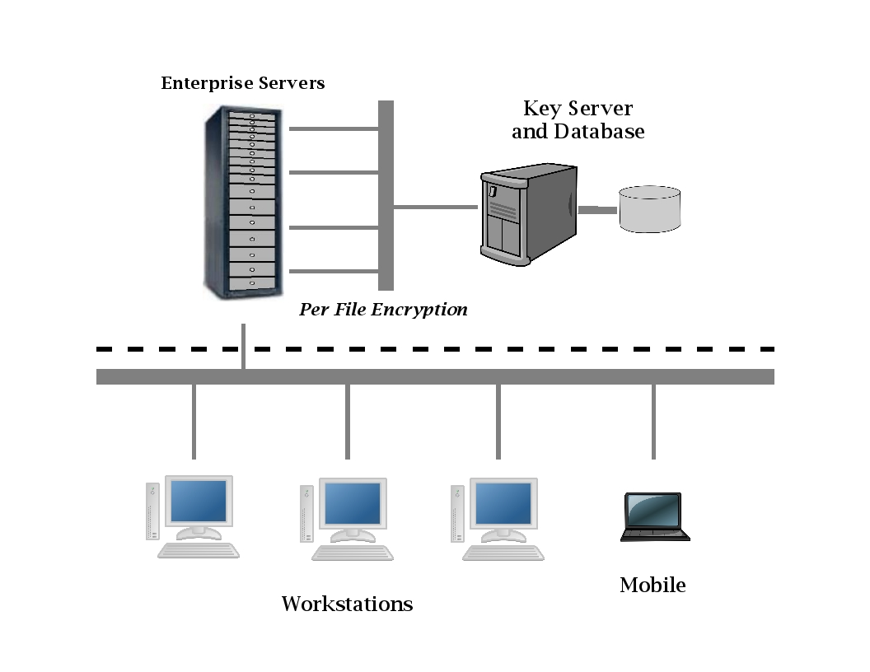Figure 1: Velocite Systems Secure Storage Solution
By encrypting every designated file with a unique key, the only way to access critical data is by using authorized applications, which are easier to secure.
There are three modules in the Velocite Systems Secure Storage Solution:
- Key Server: The Key Server generates and manages keys. The Key Server generates an AES256 key for every file. These keys are stored in a database included in the Key Server application. The Key Server is accessible by only authorized administrators.
- Encryption Engine: The Encryption Engine accepts an encryption key and data buffer. It uses the key to encrypt or decrypt the data buffer which is returned to the caller.
- File System Agent: The File System Agent intercepts file data as it is being read or written, requests the file's encryption key from the Key Server, and then passes both the key and the data to the Encryption Engine for processing. When the processed data is returned, the Agent forwards it to its destination or returns an error code to the file system.
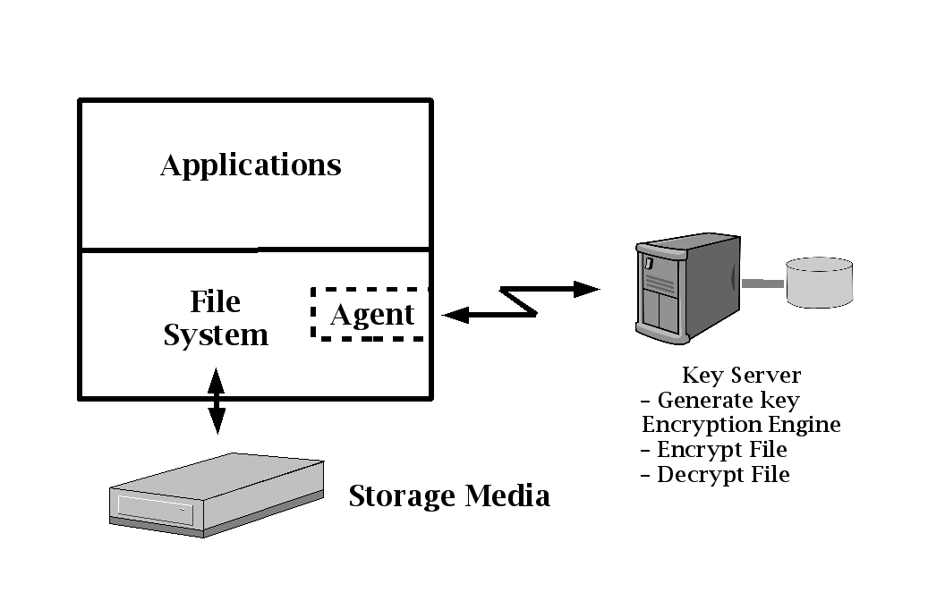Figure 2: Key Server, Encryption Engine, and Agent
Agents consist of a common abstraction layer and a plugin specific to the file system with which it interfaces. There must be an Agent for each enterprise system to have files encrypted.
The Encryption Engine may reside on the same server as the Key Server, on the same enterprise host as an Agent, or on a separate host dedicated to encryption. More than one of these combinations is supported, as each Agent is configured to define the Encryption Engine to use.
If the Encryption Engines do not reside on the enterprise hosts, a high speed network should be dedicated to the communication between the hosts and the Encryption Engine host.
The Key Server host and Encryption Engine hosts may be configured to provide failover. If the Key Server cannot be accessed in spite of failover, key management is handled temporarily by the Agent running on the enterprise server. When the Key Server has been recovered, the Agent synchronizes with the main Key Server.

Secure Storage Solution
The Velocite Systems Secure Storage Process encrypts every file with a unique key. This process is transparent to the user when both creating and accessing files.

Application
The Velocite Systems Secure Storage Solution performs six functions. Of these, the Administration interface and some of Key Management are seen by administrators, the rest occur transparently by the Secure Storage System modules. The functions are:
- Administration
- Initialization
- Key management
- File encryption/decryption
- Agent processing
- Disconnected mode
The actions taken during these processes are logged, and if there are any failures, error messages are issued to the enterprise logging facility.

Administration
The administration function provides the interface to manage configuration files. The configuration data is used during initialization and processing of the Secure Storage Systems.
To provide a common look and feel, the Administration interface is capable of managing all data files. It automatically detects which components are installed on the host and only displays the interface to those data files.
The functions available to administrators are:
- User creation: There are two levels of access for authorized administrators. The second level includes the privileges of the first level. The restrictions on access are as follows:
  - Level 1: This is the lowest level of administration and allows for access to logging information only.
  - Level 2: This level of administration allows full access to modify configuration parameters and create new administration users.
- User validation: The administration application validates each user's authorized access before performing any function. In the user interface, unauthorized functions are not displayed.
- Server authorization: The enterprise server Agents that are allowed to communicate with the Key Server and Encryption Engine are defined in configuration files that are managed in the administrator interface.
- Key import/export: If a file is to be backed up or relocated to a different enterprise server, the encryption keys for the files are exported from the originating system and imported to the new system to allow those files to be decrypted.
- Database audit: The Key Server database provides audit information, and the Key Server interface provides the capability to generate these reports. Authorized users may review the key database to validate it for auditing purposes.

Initialization
The initialization of the Key Server, Encryption Engine, and Agent are independent of each other.
- Key Server
The Key Server database, which stores the encryption keys for files, is accessed and validated. This includes verifying that encryption keys in the Key Server database are accessible, that new encryption keys can be generated, and that keys which are deregistered can be identified.
The Key Server starts listening for connection requests from Agents. When one is received, the access of the requesting Agent host is verified. If access is authorized, a secure connection with the Agent is established using the IPsec protocol.
- Encryption Engine
The Encryption Engine listens for connection requests from Agents. When one is received, the access of the requesting Agent host is verified. If the Agent is not on the same host as the Encryption Engine, a secure connection with the Agent is established using the IPsec protocol.
- Agent
The Agent reads the IP address of the Key Server from its configuration file and attempts to establish a secure connection with it. Then the Agent obtains the IP address of the Encryption Engine from its configuration file and attempts to establish a connection with it. If the Encryption Engine is not on the same host as the Agent, the connection is encrypted, using the IPsec protocol. Finally, the Agent encrypt and decrypt the configuration file to test this functionality.

Key Management
Key management is handled automatically by the Key Server. The Key Server supports key generation by either software or hardware. The keys are stored in a database that contains each key's file name, file path, and key value.
When a message is received from an Agent, the Key Server retrieves the key from the key database using the file path and file name. If the request does not return a key, a new one is generated and the key with its associated information is stored. Then the key is sent to the Agent.
When a file is deleted, its encryption key must be deregistered. The deregistration period is configurable, but must be a minimum of two weeks to allow for a backup copy of a file to be restored.

File Encryption/Decryption
When the File System Agent detects that data is being read or written, it tests the file partition, path, and name against the configured list of files to encrypt. If there is no match, the data is forwarded to the file system. Otherwise, the encryption key for the file is requested from the Key Server.
The Key Server queries the key database for the file. If the query returns the encryption key, it is sent to the requesting Agent. Otherwise, a new key is generated and saved in the database, with the associated file information, and the key is sent to the requesting Agent.
When the key is received, the Agent transfers the key and the data buffer to the Encryption Engine. The Encryption Engine returns the status and, if successful, a buffer with the encrypted/decrypted data.
The File System Agent returns the data to the file system driver to be stored or forwarded to an application. If there is an error at any point in the process, an error code is returned to the file system and a reason code, if appropriate.
The Agent and Key Server handle the following special conditions:
  - File deletion: If a file is being deleted, the Agent notifies the Key Server, which deregisters the key for the file.
  - Key export: If a file is to be exported to backup media or another enterprise server, it must not be decrypted. If the key needs to be exported, this is handled using the Agent administration component.
  - Key import: If a file is to be imported from backup media or another enterprise server, the key must be imported using the Agent administration component.

Agent Processing
The File System Agent consists of a File Handler Layer, that is common to all platforms, and a Plugin Interface, that is unique to each supported file system.
The File Handler Layer communicates with the Key Server and Encryption Engine. It determines what action to perform on files based on the configuration file description of directories and files to be encrypted. It maintains state information and processes files accordingly.
The File Handler Layer also maintains the encryption key Most Recently Used (MRU) list which is used if the Key Server is unaccessible.
The Plugin Interface intercepts files being read or written, gets information about the files from the file system, and presents it to the File Handler Layer in a format for making a determination of what action to take. The Plugin Interface also returns status codes to the file system in its native mode.

Disconnected mode operation
If either the Key Server or the Encryption Engine cannot be accessed by an Agent, it goes into Disconnected Mode state. This is handled differently for the Key Server and the Encryption Engine.
  - Key Server Disconnected Mode
If the Agent requests a key and does not receive a response within two seconds, it issues an error message and sets the internal state to Key Server Disconnect.
Agents maintain a list of the most recently used (MRU) file encryption keys in memory. When a file is accessed, the MRU is searched for the key. If the key is found, the process works normally. If the key is not found, an error code is returned to the application requesting the file and a reason code if appropriate.
The Agent periodically attempts to re-establish a connection to the Key Server. When this is successful, it issues a message indicating the recovery and sets the internal state to Normal Key Server.
  - Encryption Engine Disconnected Mode
If the Agent requests that a buffer be processed and does not receive a response within two seconds, the Agent issues an error message and sets the internal state to Encryption Engine Disconnect.
When a file is accessed and the encryption key is found in the MRU, the local Encryption Engine processes it.
The Agent periodically attempts to re-establish a connection to the Encryption Engine. When this is successful, it issues a message indicating the recovery and sets the internal state to Normal Encryption.

Installation
The Velocite Systems Secure Storage Solution components have minimal installation requirements.
  - Key Server
The Key Server administration program is used to define the valid network addresses of enterprise servers allowed to connect to the Key Server. The administration program may also be used to change the default length of time a key is to be deregistered before it is permanently deleted, which is two weeks.
  - Encryption Engine
If the Encryption Engine is installed on a host separate from the enterprise servers, the Encryption Engine administration program is used to define the valid network addresses of enterprise servers allowed to connect to the Encryption Engine.
  - Agents
Each enterprise server to have files encrypted must have an Agent installed. The procedure uses the installation program that is native to the server operating system.
The Agent administration program is used to define the following information:
    - The IP address of the Key Server.
    - The IP address of the Encryption Engine or LOCAL.
    - The maximum number of keys to maintain in the MRU list (default is 256).
    - The description of directories and files that are to be encrypted. The syntax of this configuration information is (Note: Fields in all capitals are keywords.):
ENCRYPT|NOENCRYPT,partition|ANY,path|ANY,filespec|ANY
where the fields are:
      - ENCRYPT: The matching files are to be encrypted, which is the default.
      - NOENCRYPT: The matching files are not to be encrypted.
      - partition: The partition qualifier, such as “C:\” in Microsoft Windows or “/usr” in Linux/ Unix.
      - path: A fully qualified path that may use the “*” wildcard. If the last field is a directory, then every file and directory below it will obey the ENCRYPT/NOENCRYPT command.
      - filespec: The file specification, which may use the following symbols:
        - Text: Match on the exact filename characters.
        - “*”: Match on any combination of valid filename characters.
        - “[character_list]”: Match on any single character in the list (ie. “file[12]“ will match file1 or file2 but not file1a).
      - ANY: The field is not tested against the file. Note that at least one of partition, path, and filespec must be defined.
      - expiration: The length of time a key is maintained in the deregistered pool after its file has been deleted. If this field is not included, the default expiration period is two weeks.

Troubleshooting

Recovery
The recovery procedures for the Velocite Systems Secure Storage Process includes the following conditions:
- Key database failure: If there is a failover system for the Key Server, the database is mirrored, and therefore recovery is automatic. Otherwise, the enterprise backup solution must include the key database, and in the event of a failure, the database can be restored to the condition it was in prior to the failure.
- Key Server failure: If there is a failover system for the Key Server, recovery is automatic. Otherwise, operations in the Velocite Systems system must run in disconnected mode until the Key Server is restored from backups.

Messages
All failure messages issued by the Key Server include a reason code to assist administrators in troubleshooting or reporting the problem.

Support
Velocite Systems Standard, Extended, and Premier support options are available.

Software Updates
The Velocite Systems Secure Storage Process provides a single update manager for all of the appliance's software components. The applications installed by the users of the appliance are not automatically included in that package management.

Standards Compliance
The Velocite Systems Secure Storage Solution conforms to the following security standards:
  - NIST FIPS 140-2 standard for encryption
  - CIPS certification for the Key Server software
Network encryption conforms to the following Internet Engineering Task Force (IETF) standards:
  - IP Security
    - RFC 4301: Security Architecture for the Internet Protocol
    - RFC 3554: On the Use of SCTP with IPsec
    - RFC 3723: Securing Block Storage Protocols over IP
  - ESP and AH Headers
    - RFC 4302: IP Authentication Header (AH)
    - RFC 4303: Encapsulating Security Payload (ESP)
    - RFC 4304: Extended Sequence Number Addendum to IPsec DOI for ISAKMP
    - RFC 4835: Cryptographic Algorithm Implementation Requirements For ESP And AH
  - Key Exchange
    - RFC 3547: Group Domain of Interpretation
    - RFC 4109: Algorithms for IKEv1
    - RFC 4306: Internet Key Exchange (IKEv2) Protocol
    - RFC 4307: Cryptographic Algorithms for Use in the Internet Key Exchange Version2 (IKEv2)
    - RFC 4308: Cryptographic Suites for IPsec
    - RFC 4718: IKEv2 Clarifications and Implementation Guidelines
    - RFC 4945: IPsec PKI Profile of IKEv1/ISAKMP, IKEv2, and PKIX
  - Cryptographic Algorithms
    - RFC 2410: NULL Encryption Algorithm and Its Use With IPsec
    - RFC 3173: IP Payload Compression Protocol (IPComp)
    - RFC 3526: More Modular Exponential (MODP) Diffie-Hellman groups for Internet Key Exchange (IKE)
    - RFC 3686: Using AES Counter Mode With IPsec ESP
    - RFC 4309: Using AES CCM Mode With IPsec ESP
    - RFC 4434: AES-XCBC-PRF-128 algorithm for IKE
    - RFC 4615: AES-CMAC-PRF-128 Algorithm for IKE
    - RFC 4754: IKE and IKEv2 Authentication Using ECDSA
    - RFC 5282: Using Authenticated Encryption Algorithms with the Encrypted Payload of IKEv2

Glossary
The following terms and abbreviations are used in this document.
Secure Storage Solution: The encryption of files used by enterprise servers, where each file is encrypted with a unique key.
Key Server: The server where encryption keys are generated and managed for all files in the Secure Storage Solution.
Encryption Engine: The application where encryption and decryption is handled in the Secure Storage Solution. This may reside on the same host as the Key Server, a separate host, or the same host as each Agent.
Agent: Software that resides on an enterprise server to intercept each file as it is being read or written. The Agent requests the encryption key for the file from the Key Server and sends the key and the data to the Encryption Engine to be processed.
Secure Storage Suite: The software available to configure a Secure Storage Solution. This may include the applications for a Key Server, an Encryption Engine, and one or more Agents.
IP Security Architecture (IPsec): A protocol suite for securing Internet Protocol (IP) communications by authenticating and encrypting each IP packet of a data stream. IPsec also includes protocols for establishing mutual authentication between Agents at the beginning of the session and negotiation of cryptographic keys to be used during the session.
Authentication Header (AH): This header and the associated protocol is used to provide connectionless integrity and data origin authentication for IP datagrams.
Encapsulating Security Payload header (ESP): This header and the associated protocol is used to provide confidentiality, data origin authentication, connectionless integrity, an anti-replay service, and limited traffic flow confidentiality.
Advanced Encryption Standard (AES): The encryption standard adopted by the US government. It includes three key ciphers: AES-128, AES-192, AES-256. Each cipher has a 128 block size, with key sizes of 128, 192, and 256, respectively.
Internet Key Exchange (IKE): This protocol performs mutual authentication between two parties and establishes an IKE security association (SA) that includes shared secret information that can be used to efficiently establish SAs for Encapsulating Security Payload (ESP) and/or Authentication Header (AH) and a set of cryptographic algorithms to be used by the SAs to protect the traffic that they carry.
Failover: A technique for providing the capability to automatically start using a redundant, backup computer in the event of the failure of the currently active computer. This requires most or all applications to continue processing without interruption.

