The Velocite Systems

Secure Storage Solution

System Specification

Table of Contents

1 Executive Description 3
1.1 Purpose and Scope 3
2 Product Overview 4
3 Product Description 6
3.1 Components 6
3.1.1 Administration 6
3.1.2 Initialization 7
3.1.3 Key Management 8
3.1.4 File Encryption/Decryption 9
3.1.5 Agent Processing 10
3.1.6 Disconnected Mode 11
3.1.6.1 Key Server Disconnected Mode 11
3.1.6.2 Encryption Engine Disconnected Mode 12
3.2 Data files 13
3.2.1 Key Server 13
3.2.2 Encryption Engine 13
3.2.3 Agents 13
3.3 Control Messages 14
3.4 Dependencies 18
3.4.1 Procedural 18
3.4.2 System 18
4 Messages 19
5 Support 20
5.1 Testing 20
5.1.1 Hardware testing 20
5.1.2 Key Server 20
5.1.3 Encryption Engine 20
5.1.4 File System Agent 21
5.2 System Updates 21
6 Standards Compliance 22
7 Glossary 24

Executive Description
Computer data systems are being used for growing quantities of critical organization data, including video, audio, and graphical formats. Traditionally, this data has been protected bu preventing access to the storage systems where it is kept. However, the development of mobile systems with large storage capabilities have made it possible for the data to be transported away from this protected environment.
One of the solutions to this problem has been to encrypt the storage media where the data is kept. Current encryption technologies will automatically encrypt disk partitions using a single key for the entire partition. If individual files are to be encrypted, a manual request must be made. With the increased power of systems, a dedicated effort to breaking the key used to encrypt a partition is realistic.
Velocite Systems has engineered a solution to this issue that gives organizations fine-tuned control over the encryption of their data. The Velocite Systems Secure Storage Solution is a hardware and software subsystem that secures individual files automatically, each with a unique key. It is built on a modular and scalable infrastructure that will meet demanding requirements for security and performance.

Purpose and Scope
This document describes the implementation requirements of the security software used to achieve the high degree of security. It defines the functional requirements, interfaces, and recovery procedures that the Velocite Systems Secure Storage Solution must meet to deliver its objectives.

Product Overview

The Velocite Systems Secure Storage Solution secures enterprise data by encrypting every designated file with a unique key. This means that the only way to access critical data is by using authorized applications, which are easier to secure.
There are three functional modules in the Velocite Systems Secure Storage Solution:
- Key Server: The Key Server generates and manages keys. The Key Server generates an AES256 key for every file. These keys are stored in a database included in the Key Server application. The Key Server is accessible by only authorized administrators.
- Encryption Engine: The Encryption Engine accepts an encryption key and data buffer. It uses the key to encrypt or decrypt the data buffer which is returned to the caller.
- File System Agent: The File System Agent intercepts file data as it is being read or written, requests the file's encryption key from the Key Server, and then passes both the key and the data to the Encryption Engine for processing. When the processed data is returned, the Agent forwards it to its destination or returns an error code to the file system.
Agents consist of a common abstraction layer and a plugin specific to the file system with which it must interface.
The Encryption Engine may reside on the same server as the Key Server, on the same enterprise host as an Agent, or on a separate host dedicated to encryption. Any combination of these is supported as each Agent is configured to define the Encryption Engine to be used.
If the Encryption Engines do not reside on the enterprise hosts, a high speed network should be dedicated to the communication between the hosts and the Encryption Engine host.
The Key Server host and Encryption Engine hosts may be configured to provide failover.
The figure, Secure Storage Solution Configuration, shows some of the possible configurations for the Velocite Systems Secure Storage Solution.
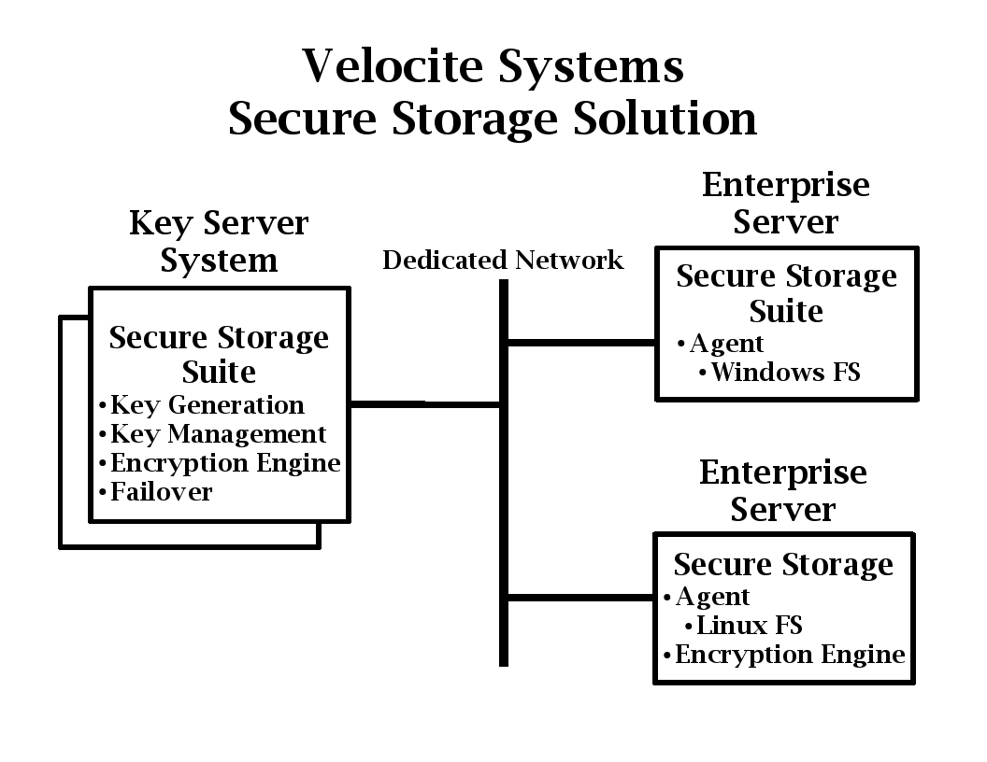Figure 1: Secure Storage Solution Configuration

Product Description
The Velocite Systems Secure Storage Solution consists of three components: the Key Server, one or more Encryption Engines, and an Agent for each enterprise server. These are described in the Components section. The configuration and data files are described in the Data Files section. The messages exchanged between components are described in the Control Messages section. The procedural and operating systems dependencies are described in the Dependencies section.

Components
The Velocite Systems Secure Storage Solution interfaces with operating system file systems. It maintains a key database that stores a unique encryption key for each file in the solution. When the file is accessed, the appropriate key is retrieved from the database and used to encrypt or decrypt the file.
There are five components within the Secure Storage Solution:
- Administration
- Initialization
- Key management
- File encryption/decryption
- Agent processing
- Disconnected mode

Administration
The administration process manages configuration files for application data that is described in the Data Files section. The application provides an interface for modifying these configuration files.
To provide a common look and feel, the application is capable of managing all data files. It automatically detects which components are installed on the host and only displays the interface to those data files.
The functions available to administrators are:
- User creation: There are two levels of access for authorized administrators. The second level includes the privileges of the first level. The restrictions on access are as follows:
  - Level 1: This is the lowest level of administration and allows for access to logging information only.
  - Level 2: This level of administration allows full access to modify configuration parameters and create new administration users.
- User validation: The administration application validates each user's authorized access before performing any function. In the user interface, unauthorized functions are not displayed.
- Key import/export: If a file is to be backed up or relocated to a different enterprise server, the encryption keys for the files may need to be exported and maintained in parallel with the file for it to be decrypted at a future time or a different location.
- Server authorization: The enterprise server Agents that are allowed to communicate with the Key Server and Encryption Engine are defined in configuration files that are managed in the administrator interface.
- Database audit: The Key Server database provides audit information, and the Key Server interface provides the capability to generate these reports. Authorized users may review the key database to validate it for various auditing purposes.

Initialization
The Key Server initialization consists of two steps:
- Key Server database initialization: The Key Server database, which stores the encryption keys for files, is accessed and validated. There are three steps in this process:
  - Verify that encryption keys in the Key Server database are accessible.
  - Verify that new encryption keys can be generated.
  - Validate keys that have been deregistered.
- Secure Storage network initialization: The Key Server listens for connection requests from Agents. When one is received, the following steps occur:
  - Verify the access of the requesting Agent host from a list of IP addresses in the configuration file.
  - If access is authorized, establish a secure connection with the Agent using the IPsec protocol.
The Encryption Engine initialization consists of one step:
- Establish secure connection with Agent: The Encryption Engine listens for connection requests from Agents. When one is received, the following steps occur:
  - Verify the access of the requesting Agent host from a list of IP addresses in the configuration file.
  - If the Agent is not on the same host as the Encryption Engine, a secure connection is established with it using the IPsec protocol.
The Agent initialization consists of three steps:
- Establish a connection with the Key Server: The Agent obtains the IP address of the Key Server from its configuration file and attempts to establish a secure connection with it, using the IPsec protocol.
- Establish a connection with the Encryption Engine: The Agent obtains the IP address of the Encryption Engine from its configuration file and attempts to establish a connection with it. If the Encryption Engine is not on the same host as the Agent, the connection is encrypted, using the IPsec protocol.
- Test file intercept and encryption: The Agent attempts to write and read the configuration file to a filespec that will be encrypted.

Key Management
Key management is handled automatically by the Key Server. There are four functions in the key management process:
- Key generation: The Key Server supports key generation by either software or hardware.
- Database key storage: The keys are stored in a database that includes the following information about the file with which the key is associated:
  - File name
  - File path: This is the fully qualified path, including the partition.
  - Key value
- Key retrieval: When the Get Key message is received from an Agent, the Key Server requests the key from the key database using the file name and file path. If the request does not return a key, a new one is generated and the key with its associated information is stored.
If the key is successfully retrieved, a Get Key Response message is sent to the Agent with the error flags set to zero and the key in the encryption key field. Otherwise, the Get Key Response message is sent to the Agent with the Error flag set, and all zeros in the encryption key field.
- Key deregistration: When the Delete File message is received for a file, its encryption key is deleted from the key database and the key is stored in the deregistration pool. The deregistration period is configurable, but must be a minimum of two weeks to allow for a backup copy of a file to be restored.

File Encryption/Decryption
There are six functions in the file encryption/decryption process:
- Agent intercept: When the File System Agent detects that data is being read or written, it tests the file partition, path, and name against the configured list of files to encrypt. If there is no match, the data is forwarded to the file system. Otherwise, a Get Key message is sent to the Key Server.
  - File ID
  - File path: This is the fully qualified path, including the partition.
- Key delivery: The Key Server queries the key database for the file. If the query returns the encryption key, it is sent to the requesting Agent. Otherwise, a new key is generated and saved in the database, with the associated file information, and the key is sent to the requesting Agent.
- File encryption/decryption: When the key is received, the Agent transfers the key and the data buffer to the Encryption Engine. The Encryption Engine returns the status and, if successful, a buffer with the encrypted/decrypted data.
- Agent data store: The File System Agent returns the data to the file system driver to be stored or forwarded to an application.
- Error handling: If there is an error at any point in the process, an error code is returned to the file system and a reason code, if appropriate.
- Special conditions: The Agent and Key Server handle the following special conditions:
  - File deletion: If a file is being deleted, the Agent sends a Delete File message to the Key Server, which deregisters the key for the file.
  - Key export: If a file is to be exported to long term backup media or another enterprise server, it must not be decrypted. The key must be maintained in parallel with the file. This is known as exporting the key. The Agent administration component is used to retrieve the file from storage without decrypting it. It then sends the Export Key message to the Key Server to retrieve the key which may be saved on a separate media to be maintained in parallel with the file.
Note: The key must be identified by a unique and portable value. This is the file name and as much of the path as is required to make it unique as compared to any other files in the key database with the same file name. This identifier is returned by the Key Server in the Export Response message.
  - Key import: If a file is to be imported from a long term backup or another enterprise server, the key must be imported using the Agent administration component. The file is stored on the enterprise server without requesting a key from the Key Server. The Agent sends the Import Key message to the Key Server to have the existing key added to the key database.
Note: Because the identifier for the key is the file name and some portion of the path, it may not be renamed during the import.

Agent Processing
The File System Agent consists of a File Handler Layer, that is common to all platforms, and a Plugin Interface, that is unique to each supported file system.
The File Handler Layer performs the following functions:
- Communicates with the Key Server and Encryption Engine
- Determines whether a file is to be encrypted based on the configuration file description of directories and files to be encrypted.
- Maintains the encryption key Most Recently Used (MRU) list (Note: See the Key Server Disconnected Mode section for details on the MRU.)
- Maintains state information and processes files accordingly
The Plugin Interface performs the following functions:
- Intercepts files being read or written
- Gets information about files from the file system and presents it to the File Handler Layer in a consistent format, including the following fields:
  - File name
  - File path
  - File creation status: The possible status values are:
    - New
    - Existing
    - Deleted
  - File size
- Returns a status code to the file system. If there is an error, it also returns a reason code where appropriate.
The figure, File System Agent, displays the relationship of the Agent to the operating system file system and applications.
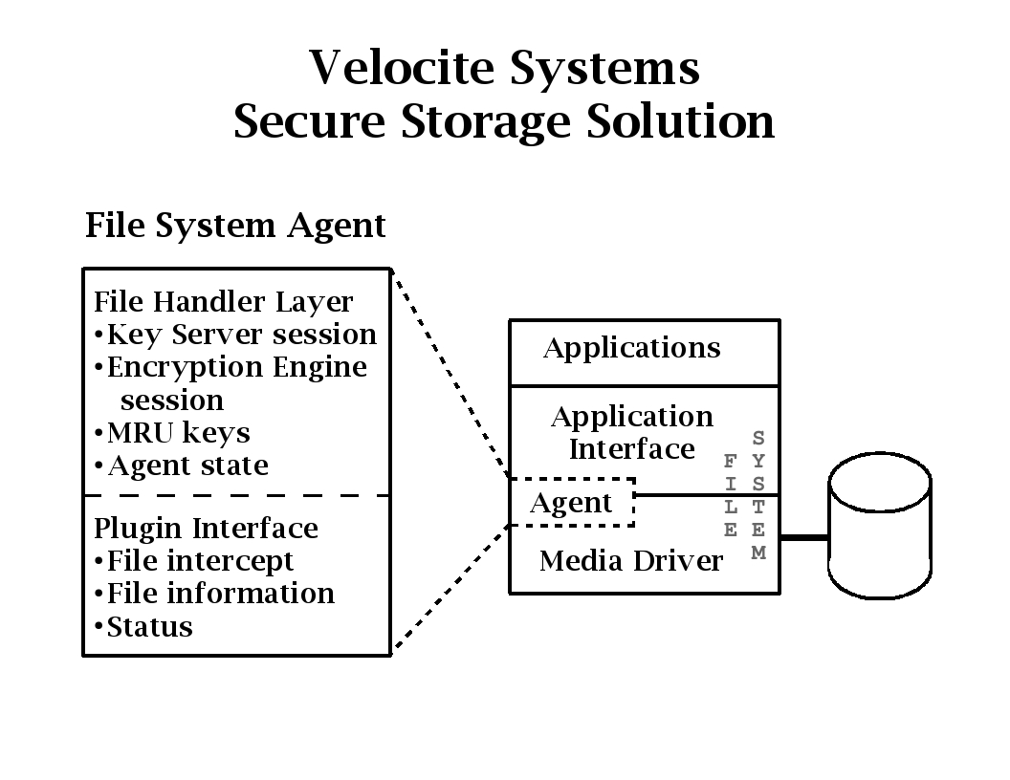Figure 2: File System Agent

Disconnected Mode
If either the Key Server or the Encryption Engine cannot be accessed by an Agent, it goes into Disconnected Mode state. This is handled differently for the Key Server and the Encryption Engine.

Key Server Disconnected Mode
Agents maintain a list of the most recently used (MRU) file encryption keys in memory. If access to the Key Server is lost, this list is used to handle key management temporarily, while Key Server recovery is performed.
The MRU list is a double linked list with a configurable maximum size where the default is 256. Each key in the list is also located in a Red Black tree to optimize searches for keys. The management of these structures is as follows:
- If a key is found in the tree, it is removed from the MRU list and put at the beginning.
- If a key is received from the Key Server, it is added to the tree and put at the beginning of the MRU list.
- If a key is received from the Key Server and the maximum number of keys are in the MRU list, the last key in the list is removed and then removed from the tree before adding the new key.
There are three steps in the Key Server Disconnect Mode process:
- Failure detection: The enterprise server Agent detects that the connection to the Key Server has failed. The Agent issues an error message and sets the internal state to Key Server Disconnect. The Agent determines that the connection has failed if it requests a key and does not receive a response within 2 seconds.
- File Encryption/Decryption: When a file is accessed, the tree is searched for the key. If the key is found, the process works normally. If the key is not found, an error code is returned to the file system and a reason code, if appropriate.
- Recovery: The Agent periodically attempts to re-establish a connection to the Key Server. When this is successful, it issues a message indicating the recovery and sets the internal state to Normal Key Server.

Encryption Engine Disconnected Mode
Agents include the Encryption Engine component, whether it is normally active on the enterprise server or not. If access to the Encryption Engine on another host is lost, the local Encryption Engine is used.
There are three steps in the Encryption Engine Disconnect Mode process:
- Failure detection: The enterprise server Agent detects that the connection to the Encryption Engine has failed. The Agent issues an error message and sets the internal state to Encryption Engine Disconnect. The Agent determines that the connection has failed if it requests that buffer be processed and does not receive a response within 2 seconds.
- File Encryption/Decryption: When a file is accessed, the local Encryption Engine processes it.
- Recovery: The Agent periodically attempts to re-establish a connection to the Encryption Engine. When this is successful, it issues a message indicating the recovery and sets the internal state to Normal Encryption.

Data files

Key Server
The following data files are maintained for the Key Server:
  - Initialization data: This data is encrypted, and the encryption keys are generated from Hashed Message Authentication Codes (HMAC) of passwords entered by an authorized administrator. The following configuration information is included:
    - The encryption keys for the database
    - The IP addresses of hosts authorized to make requests to the Key Server.
    - The length of time a key is to be deregistered before it is permanently deleted.
  - Key Database: The key database maintains the encryption keys for the files in the Secure Storage Solution. Each of the database files are encrypted with a unique key which is stored in an initialization data file.

Encryption Engine
The following data files are maintained for the Encryption Engine:
  - Initialization data: The data is not encrypted. The following configuration information is included:
    - The IP addresses of hosts authorized to make requests to the Encryption Engine.

Agents
The following data files are maintained for the Agents:
  - Initialization data: The data is not encrypted. The following configuration information is included:
    - The IP address of the Key Server.
    - The IP address of the Encryption Engine or LOCAL.
    - The maximum number of keys to maintain in the MRU list (default is 256).
    - The description of directories and files that are to be encrypted. The syntax of this configuration information is (Note: Fields in all capitals are keywords.):
ENCRYPT|NOENCRYPT,partition|ANY,path|ANY,filespec|ANY
[,expiration]
where the fields are:
      - ENCRYPT: The matching files are to be encrypted, which is the default.
      - NOENCRYPT: The matching files are not to be encrypted.
      - partition: The partition qualifier, such as “C:\” in Microsoft Windows or “/usr” in Linux/ Unix.
      - path: A fully qualified path that may use the “*” wildcard. If the last field is a directory, then every file and directory below it will obey the ENCRYPT/NOENCRYPT command.
      - filespec: The file specification, which may use the following symbols:
        - Text: Match on the exact filename characters.
        - “*”: Match on any combination of valid filename characters.
        - “[character_list]”: Match on any single character in the list (ie. “file[12]“ will match file1 or file2 but not file1a).
      - ANY: The field is not tested against the file. Note that at least one of partition, path, and filespec must be defined.
      - expiration: The length of time a key is maintained in the deregistered pool after its file has been deleted. If this field is not included, the default expiration period is two weeks.

Control Messages
Control Messages are the method by which the Velocite Systems Secure Storage Solution components interface with each other. The format of the Control Messages is:
| 4 octets | 1 octet | Variable length |
| Size | Command | Data |
where the fields are:
- Size: The total size of the message, including the size field itself
- Command: An 8-bit number
- Data: The data, if any, associated with the command
The supported Control Messages are defined below, with the command number in parentheses:
- Get Key (1): The Get Key data fields are:
| Variable length | Variable length | 4 octets |
| File Name | File Path | Expiration |
where the fields are :
  - File Name: The null-terminated name of the file to be encrypted or decrypted.
  - File Path: The null-terminated, fully qualified path to the file, which prevents files with the same name getting the same key.
  - Expiration: The length of time, in seconds, that the key is to be maintained in the deregistered pool after the file is deleted. If this field is zero, the default is used.
- Get Key Response (2): The Get Key Response data fields are:
| 1 octet | 12 Octets |
| Flags | Encryption Key |
where the fields are:
  - Flags: The flag field is a bit field in which success is indicated by zero errors. Otherwise, the following errors are defined:
1111 111. = Reserved (ignored)
.... ...1 = Error retrieving key from database
  - Encryption Key: The AES 256 key to be used for encryption.
- Encrypt Buffer (3): The Encrypt Buffer data fields are:
| 12 Octets | Variable length |
| Encryption Key | Data buffer |
where the fields are:
  - Encryption Key: The AES 256 key to be used for encryption.
  - Data Buffer: The data to be encrypted.
- Decrypt Buffer (4): The Decrypt Buffer data fields are:
| 12 Octets | Variable length |
| Encryption Key | Data buffer |
where the fields are:
  - Encryption Key: The AES 256 key to be used for decryption.
  - Data Buffer: The data to be decrypted.
- Encrypt/Decrypt Response (5): The Encrypt/Decrypt Response data fields are:
| 1 Octet |
| Flags |
where the fields are:
  - Flags: The flag field is a bit field in which success is indicated by zero errors. Otherwise, the following errors are defined:
1111 11.. = Reserved (ignored)
.... ..1. = Error decrypting data
.... ...1 = Error encrypting data
- Disconnect (6): The Disconnect data fields are:
| 1 Octet | Variable length |
| Flags | To be determined |
where the fields are:
  - Flags: The flag field is a bit field which indicates the source and destination of the command:
11.. .... = Reserved (ignored)
..1. .... = Command to Encryption Engine
...1 .... = Command to Key Server
.... 1... = Command to File System Agent
.... .1.. = Command from Encryption Engine
.... ..1. = Command from Key Server
.... ...1 = Command from File System Agent
- Delete File (7): The Delete File data fields are:
| Variable length | Variable length |
| File name | File Path |
  - File Name: The null-terminated name of the file to be encrypted or decrypted.
  - File Path: The null-terminated, fully qualified path to the file, which prevents files with the same name getting the same key.
- Export Key (8): The Export File data fields are:
| Variable length | Variable length |
| File name | File Path |
  - File Name: The null-terminated name of the file to be encrypted or decrypted.
  - File Path: The null-terminated, fully qualified path to the file, which prevents files with the same name getting the same key.
- Export Response (9): The Export Response data fields are:
| 1 Octet | 12 octets | Variable length |
| Flags | Encryption Key | Key identifier |
where the fields are:
  - Flags: The flag field is a bit field in which success is indicated by zero errors. Otherwise, the following errors are defined:
1111 11.. = Reserved (ignored)
.... ..1. = Error with file key
.... ...1 = File not found
  - Encryption Key: The AES 256 key to be used for encryption.
  - Key identifier: The file name and as much of the file path as is necessary to make it unique as compared to any other files in the key database with the same file name.
- Import Key (10): The Import File data fields are:
| 12 octets | Variable length | Variable length |
| Encryption Key | File name | File Path |
  - Encryption Key: The AES 256 key to be used for encryption.
  - File Name: The null-terminated name of the file to be encrypted or decrypted.
  - File Path: The null-terminated, fully qualified path to the file, which prevents files with the same name getting the same key.
- Import Response (11): The Import Response data fields are:
| 1 Octet |
| Flags |
where the fields are:
  - Flags: The flag field is a bit field in which success is indicated by zero errors. Otherwise, the following errors are defined:
1111 11.. = Reserved (ignored)
.... ..1. = Error with file key
.... ...1 = File not found

Dependencies

Procedural
The Velocite Systems Secure Storage Solution is designed to be used in an enterprise data center. This requires, at a minimum, the Velocite Systems platform applications supports the following standards:
- Data Storage: Support for SANS
- System access: Support for operating system user authorization and, optionally, Mandatory Access Control, such as SELinux
- Networking: Support for both IPv4 and IPv6 networks

System
The Velocite Systems Secure Storage File System Agents interface with the Microsoft Windows file systems, FAT32 and NTFS, and Linux file systems, EXT2/3, JFS, and ReiserFS. Other file systems may be added in the future.
The Key Server database presents challenges because the total number of file encryption keys across multiple enterprise servers may be very large. Access to the keys is critical, because encryption/decryption cannot begin until the key is retrieved. It may be possible to install enough memory to load the database indexes or even the entire database. However, it may be more economical to use high speed hard drives for the database, and Solid State Drives (SSD) for kernel swap space.

Messages
All failure messages issued by the Key Server include a reason code to assist administrators in troubleshooting or reporting the problem.
- Key database initialization successful
- Key database failure
- Key generation failure
- File encryption failure
- File decryption failure

Support

Testing

Hardware testing
The standard Velocite Systems hardware testing will be performed on each system built. This testing will include:
  - Verify correct hardware assembly
  - Ensure that the system POST's
  - Ensure all fans and cooling are working correctly
  - Validate the Hardware Configuration (BIOS, RAID... etc)
  - Validate the Operating System installation
  - Driver installation and hardware tests from inside the OS.

Key Server
The Key Server has the following tests performed prior to delivery:
  - Boot up
  - Key generation
  - Database storage and retrieval
  - Session establishment with enterprise hosts
  - Respond to requests from File System Agents
  - Access to keys in a very large database
  - Recovery scenarios

Encryption Engine
The Encryption Engine has the following tests performed prior to delivery:
  - Boot up, if appropriate
  - Session establishment with enterprise hosts
  - Respond to requests from File System Agents
  - File encryption and decryption
  - Recovery scenarios

File System Agent
The File System Agents have the following tests performed prior to delivery:
  - Verify interception of data writes
  - Verify interception of data reads
  - Session establishment with Key Server
  - Request keys from Key Server
  - Session establishment with Encryption Engine
  - Request encryption and decryption from Encryption Engine
  - Recovery scenarios

System Updates
The Velocite Systems Secure Storage Solution incorporates an update system that provides simple accessibility, testing, and application of software updates.

Standards Compliance
The Velocite Systems Secure Storage Solution conforms to the following security standards:
  - NIST FIPS 140-2 standard for encryption
  - CIPS certification for the Key Server software
Network encryption conforms to the following Internet Engineering Task Force (IETF) standards:
  - IP Security
    - RFC 4301: Security Architecture for the Internet Protocol
    - RFC 3554: On the Use of SCTP with IPsec
    - RFC 3723: Securing Block Storage Protocols over IP
  - ESP and AH Headers
    - RFC 4302: IP Authentication Header (AH)
    - RFC 4303: Encapsulating Security Payload (ESP)
    - RFC 4304: Extended Sequence Number Addendum to IPsec DOI for ISAKMP
    - RFC 4835: Cryptographic Algorithm Implementation Requirements For ESP And AH
  - Key Exchange
    - RFC 3547: Group Domain of Interpretation
    - RFC 4109: Algorithms for IKEv1
    - RFC 4306: Internet Key Exchange (IKEv2) Protocol
    - RFC 4307: Cryptographic Algorithms for Use in the Internet Key Exchange Version2 (IKEv2)
    - RFC 4308: Cryptographic Suites for IPsec
    - RFC 4718: IKEv2 Clarifications and Implementation Guidelines
    - RFC 4945: IPsec PKI Profile of IKEv1/ISAKMP, IKEv2, and PKIX
  - Cryptographic Algorithms
    - RFC 2410: NULL Encryption Algorithm and Its Use With IPsec
    - RFC 3173: IP Payload Compression Protocol (IPComp)
    - RFC 3526: More Modular Exponential (MODP) Diffie-Hellman groups for Internet Key Exchange (IKE)
    - RFC 3686: Using AES Counter Mode With IPsec ESP
    - RFC 4309: Using AES CCM Mode With IPsec ESP
    - RFC 4434: AES-XCBC-PRF-128 algorithm for IKE
    - RFC 4615: AES-CMAC-PRF-128 Algorithm for IKE
    - RFC 4754: IKE and IKEv2 Authentication Using ECDSA
    - RFC 5282: Using Authenticated Encryption Algorithms with the Encrypted Payload of IKEv2

Glossary
The following terms and abbreviations are used in this document.
Secure Storage Solution: The encryption of files used by enterprise servers, where each file is encrypted with a unique key.
Key Server: The server where encryption keys are generated and managed for all files in the Secure Storage Solution.
Encryption Engine: The application where encryption and decryption is handled in the Secure Storage Solution. This may reside on the same host as the Key Server, a separate host, or the same host as each Agent.
Agent: Software that resides on an enterprise server to intercept each file as it is being read or written. The Agent requests the encryption key for the file from the Key Server and sends the key and the data to the Encryption Engine to be processed.
Secure Storage Suite: The software available to configure a Secure Storage Solution. This may include the applications for a Key Server, an Encryption Engine, and one or more Agents.
IP Security Architecture (IPsec): A protocol suite for securing Internet Protocol (IP) communications by authenticating and encrypting each IP packet of a data stream. IPsec also includes protocols for establishing mutual authentication between Agents at the beginning of the session and negotiation of cryptographic keys to be used during the session.
Authentication Header (AH): This header and the associated protocol is used to provide connectionless integrity and data origin authentication for IP datagrams.
Encapsulating Security Payload header (ESP): This header and the associated protocol is used to provide confidentiality, data origin authentication, connectionless integrity, an anti-replay service, and limited traffic flow confidentiality.
Advanced Encryption Standard (AES): The encryption standard adopted by the US government. It includes three key ciphers: AES-128, AES-192, AES-256. Each cipher has a 128 block size, with key sizes of 128, 192, and 256, respectively.
Internet Key Exchange (IKE): This protocol performs mutual authentication between two parties and establishes an IKE security association (SA) that includes shared secret information that can be used to efficiently establish SAs for Encapsulating Security Payload (ESP) and/or Authentication Header (AH) and a set of cryptographic algorithms to be used by the SAs to protect the traffic that they carry.
Failover: A technique for providing the capability to automatically start using a redundant, backup computer in the event of the failure of the currently active computer. This requires most or all applications to continue processing without interruption.

