Feature Implementation Breakdown for Network Port Scanner
This document maps each required feature to the corresponding implementation in the provided codebase. Each section explains where the feature is implemented and how it is achieved.

1. Port Filtering (2 points)
Where:
- Implemented in parse_arguments() with the --display option.
- Used in save_as_csv() and save_as_txt() to filter results.
How:
- Users can specify --display all, --display open, or --display closed.
- The reporting functions check the state of each port and only include results that match the filter.
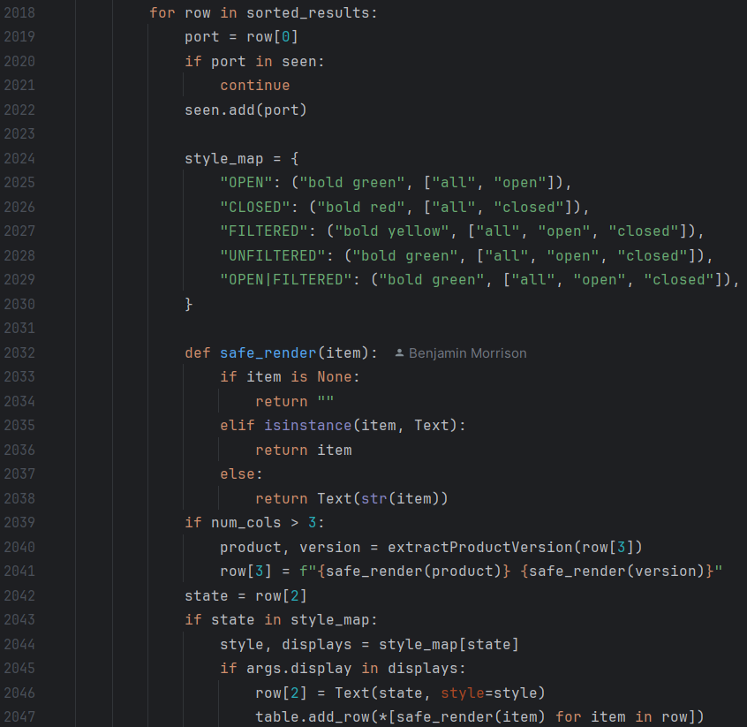

2. Scan Modes (1 point)
Where:
- Implemented in parse_arguments() with --portList choices (common, range, all, single, wellKnown, web, database, remoteAccess, fileShare, mail).
- Interactive mode (textual_interface()) also provides scan type selection.
How:
- Quick scans use predefined sets like common or web.
- Thorough scans use all (1–65535).
- Users can tailor scans by selecting the mode.

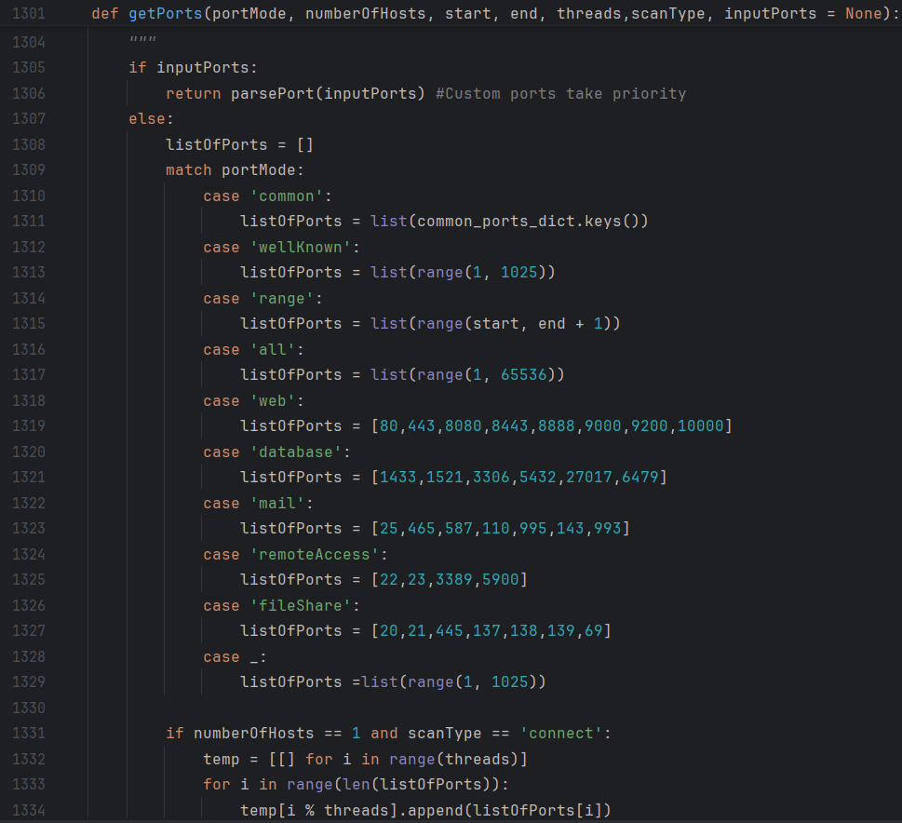

3. Custom Port Lists (1 point)
Where:
- Implemented in parsePort(input) function.
- CLI option -p, --port allows custom lists.
How:
- Users provide comma-separated ports.
- The function parses and validates them into integers for scanning.
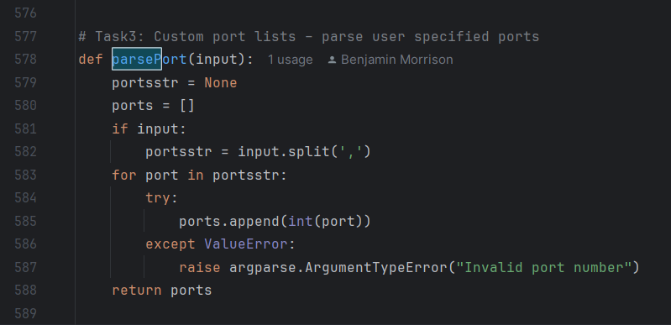

4. User-Friendly CLI (1 point)
Where:
- Implemented in parse_arguments() using argparse.
- Interactive mode in textual_interface() uses rich prompts and tables.
How:
- Provides clear options, defaults, and help messages.
- Interactive mode guides users step-by-step with visual tables.
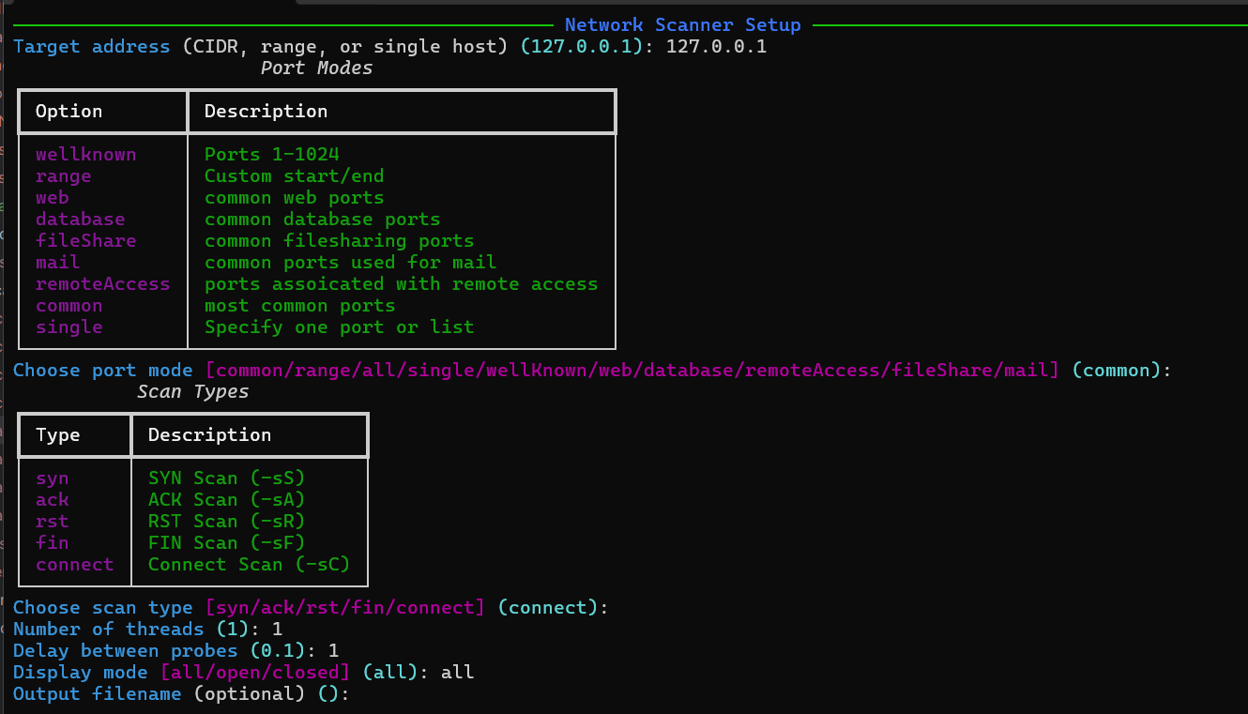

5. Support for Scanning Multiple Targets (2 points)
Where:
- Implemented in getIPaddresses(address, threads) for CIDR and ranges.
- Functions busybeeIFMultipleHosts() and busyBeeIFOneHost() handle threading across multiple hosts.
How:
- Expands CIDR or range notation into host lists.
- Distributes scanning tasks across threads for simultaneous scanning.

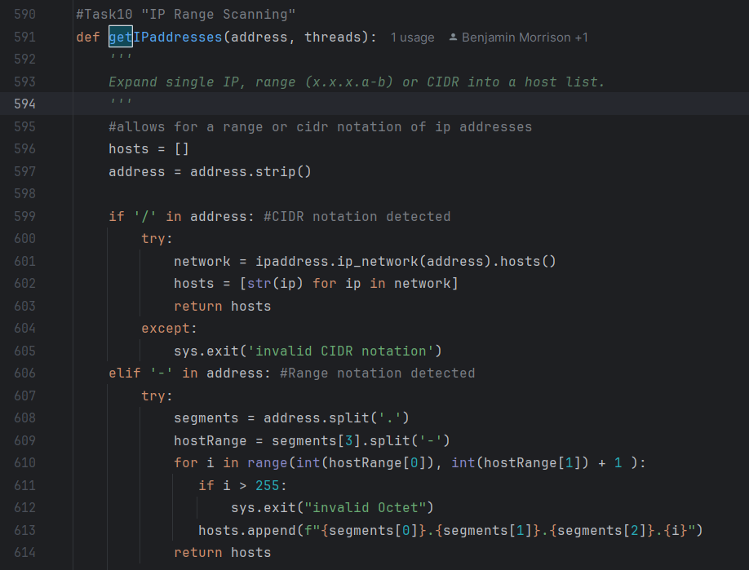

6. Logging and Reporting (2 points)
Where:
- Implemented in save_as_csv(), save_as_txt(), and outputFile().
How:
- Results are written to TXT or CSV files.
- Includes timestamp, target, port mode, and scan results.
- Provides persistent records for review.
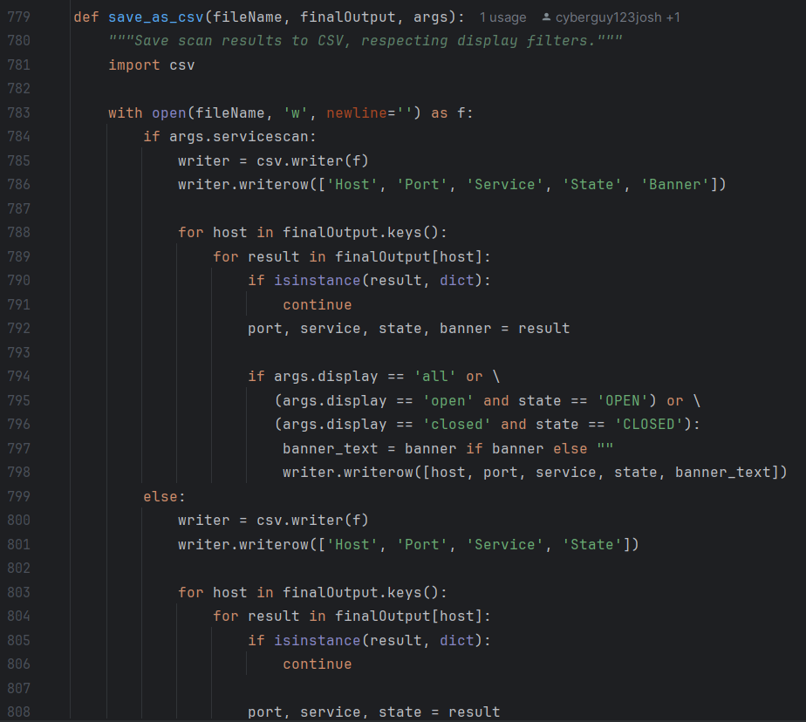

7. Output Customization (1 point)
Where:
- Controlled by CLI options -out, --output-to-file and -f, --output-format.
- Implemented in outputFile().
How:
- Users can choose TXT or CSV format.
- Filename can be specified or auto-generated.
- Reports include banners and vulnerabilities when enabled.

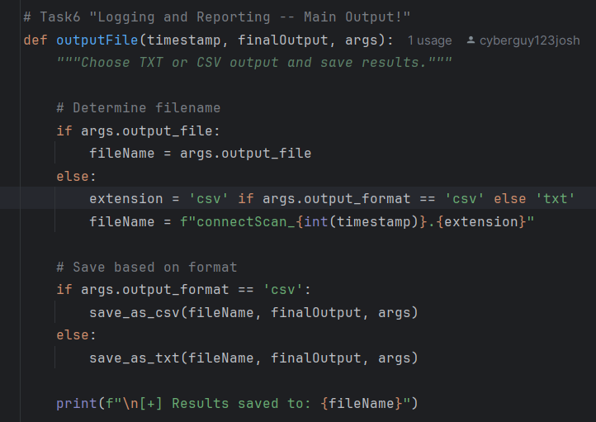

8. Port Range Validation (1 point)
Where:
- Implemented in getIPaddresses() for IP ranges.
- Port validation in parsePort() and through dictionaries common_ports_dict and wellKnownPorts.
How:
- Ensures valid ranges (e.g., octet ≤ 255).
- Reserved/well-known ports are mapped to services, providing warnings or context.
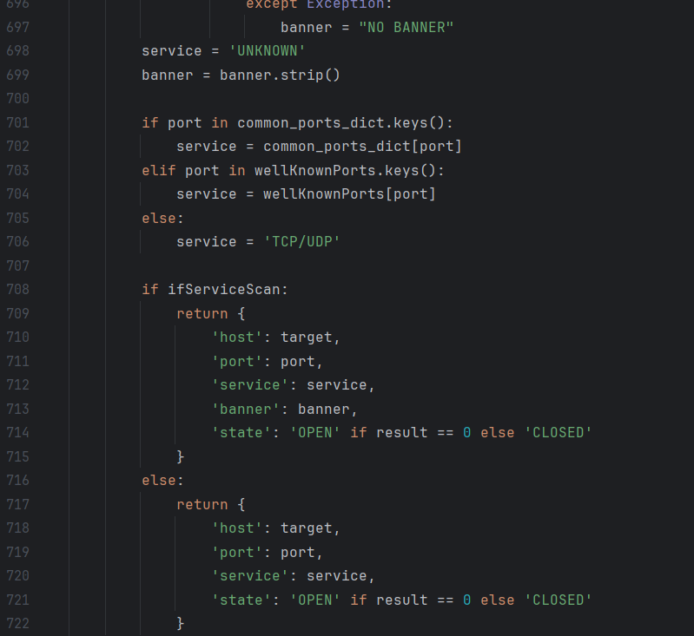

9. Service Detection (1 point)
Where:
- Implemented in scan_port_connect() with banner grabbing logic.
- Uses common_ports_dict and wellKnownPorts.
How:
- Attempts to read banners from services (FTP, SSH, SMTP, HTTP, etc.).
- Identifies services based on port dictionaries.
- Returns service name and banner in results.

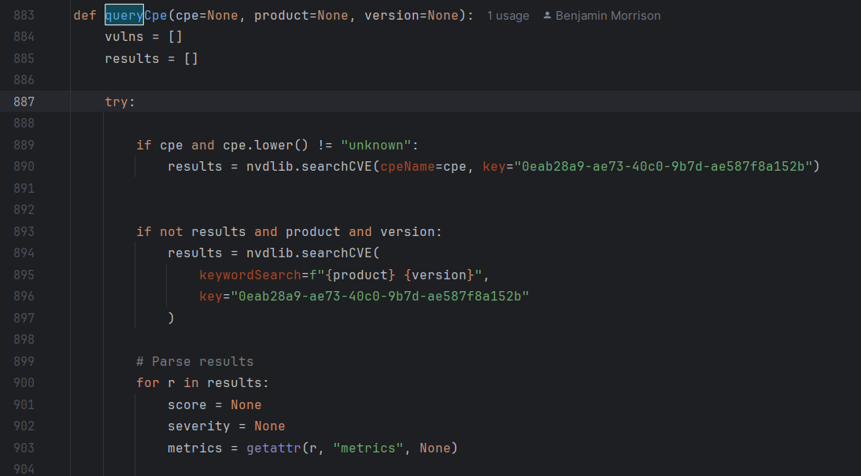

10. IP Range Scanning (1 point)
Where:
- Implemented in getIPaddresses(address, threads).
How:
- Supports CIDR notation (192.168.1.0/24).
- Supports range notation (192.168.1.1-50).
- Expands into host lists for scanning.

11. Security Scanning (2 points)
Where:
- Implemented in queryCpe() and rateVulnerabilities().
- Integrated with --servicescan and --show-vulns.
How:
- Queries NIST NVD via nvdlib using banners or service info.
- Retrieves CVEs with severity ratings (Low, Medium, High, Critical).
- Reports vulnerabilities alongside port/service results.
Example: scanning Telnet (port 23) with --show-vulns will highlight known CVEs. —
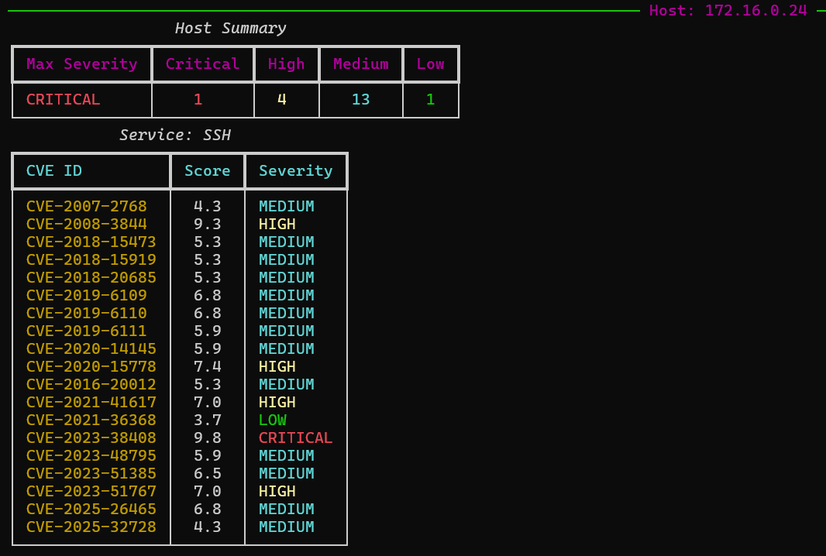

Summary
All required features are implemented in the codebase: - Filtering, modes, custom lists, CLI, multi-target scanning, logging, output customization, validation, service detection, IP range scanning, and security scanning are fully supported.
- The scanner provides a comprehensive, user-friendly, and security-focused tool for network assessments.

