Software Requirements Specification (SRS)
Project: Bank Management System
Version: 1.0
Authors: < Instructor / Student>
Status: Model Answer / Approved

Revision history
Version | Date | Author | Change summary | Approval
1.0 | 18-08-2025 | Instructor | SRS with diagrams embedded

Approvals
Role | Name | Signature / Email | Date
Course Coordinator

Table of Contents
1. Introduction
2. Overall description
3. External interface requirements
4. System features (detailed)
5. Non-functional requirements (detailed)
6. Quality attributes & Acceptance tests
7. UML Use-Case Diagram
8. Requirements Traceability Matrix (RTM)

1. Introduction

1.1 Purpose
This document is a Software Requirements Specification (SRS) for the Bank Management System. It defines the functional and non-functional requirements, interfaces, security objectives, verification criteria, and acceptance conditions for a C++-based application that supports common banking operations.

1.2 Scope
The system covers customer account creation and management, authentication, deposits, withdrawals, fund transfers, balance inquiry, transaction history, and administrative account management. Data shall be persisted locally using file-based storage. The project does not cover real-world banking infrastructure, payment-network integration, ATM hardware, inter-bank settlement, or production banking regulations.

1.3 Audience
The intended audience is the student development team and the instructor/course coordinator. The document is also intended to serve as a reference during design, implementation, testing, and demonstration.

1.4 Definitions
BMS – Bank Management System; Account – a customer banking record maintained by the system; Customer – a person who owns an account; Administrator – an authorized user who manages accounts; PIN – Personal Identification Number used for authentication; Transaction – a deposit, withdrawal, or transfer recorded by the system; UI – User Interface; SRS – Software Requirements Specification; RTM – Requirements Traceability Matrix.

2. Overall description

2.1 Product perspective
The Bank Management System is a standalone C++ application. It provides a menu-driven user interface and maintains customer, account, and transaction data through persistent local files. The system is organized into modules for authentication, account management, banking operations, transaction recording, and administration.

2.2 Major product functions (detailed)
• User authentication using account credentials/PIN.
• Customer account creation and unique account-number generation.
• Viewing and updating customer account details.
• Deposit and withdrawal of valid monetary amounts.
• Balance inquiry with current available balance.
• Transfer of funds between valid accounts.
• Recording of all successful banking transactions.
• Viewing transaction history for an account.
• Account deactivation/closure subject to validation.
• Administrator login, search, modification, and account monitoring.
• Persistent storage and retrieval of account and transaction records.
• Input validation and error messages for invalid operations.

2.3 User roles and characteristics (expanded)
• Customer: Basic computer and banking knowledge; can authenticate, view account information, and perform permitted banking operations.
• Administrator: Authorized project operator with additional privileges to search, view, modify, and deactivate customer accounts.
• Developer/Tester: Uses the system and test data to verify requirements and diagnose defects.

2.4 Operating environment
The application shall run on a standard desktop or laptop computer capable of compiling and executing C++ programs. A C++17-or-later compatible compiler is recommended. The system shall use the local file system for persistent storage and shall operate through a console-based interface.

2.5 Constraints
The project shall be implemented in C++. The initial version shall be standalone and shall not depend on external banking APIs. File storage shall be used for persistence. The system is an academic prototype and shall not be treated as production banking software. The implementation shall follow the requirements and interfaces defined in this SRS.

3. External interface requirements

3.1 User interfaces
The primary interface shall be a console/menu-driven interface. Menus shall present numbered options, request only the information necessary for an operation, display clear success or failure messages, and return the user to the appropriate menu after each completed operation. Sensitive input such as a PIN should not be displayed in plain text where the console environment permits masking.

3.2 Hardware interfaces
The system does not require specialized banking hardware. It requires a keyboard for input, a display for output, and local storage for application data files.

3.3 Software interfaces
• C++ standard library for input/output, strings, containers, file handling, and utility functions.
• Local data files for persistent storage of customer/account and transaction records.
• C++ compiler/build environment for compilation and execution.

3.4 Communications
The initial project version does not require network communication. All banking operations are performed within the standalone application using locally stored data.

4. System features (detailed)
Each requirement below includes acceptance criteria and a reference test case. IDs follow BMS-F-###.

4.1 Authentication
Description: Authenticate customers and administrators before allowing access to protected functions.
Req ID | Requirement (shall...) | Type | Priority | Source/Stakeholder | Acceptance criteria / Test case ref | Comments / Dependencies
BMS-F-001 | The system shall allow a customer to log in using a valid account number and PIN. | Functional | High | Customer/Security | Valid credentials lead to an authenticated customer session. Test: TC-AUTH-01 | Requires stored account credentials.
BMS-F-002 | The system shall reject an invalid account number or PIN and display an appropriate error message. | Functional | High | Customer/Security | Invalid credentials do not create a session. Test: TC-AUTH-02 | Must not reveal which credential was incorrect.
BMS-F-003 | The system shall limit repeated failed login attempts and temporarily block further attempts after the configured threshold. | Functional | High | Security | Account is blocked after threshold failures. Test: TC-AUTH-03 | Threshold shall be configurable in implementation.
BMS-F-004 | The system shall provide a separate administrator authentication path for administrative functions. | Functional | High | Administrator | Only valid admin credentials open the admin menu. Test: TC-AUTH-04 | Admin credentials shall not be exposed in normal customer menus.

4.2 Account Management
Description: Create, view, update, and deactivate customer accounts.
Req ID | Requirement (shall...) | Type | Priority | Source/Stakeholder | Acceptance criteria / Test case ref | Comments / Dependencies
BMS-F-005 | The system shall create a new customer account with a unique account number. | Functional | High | Customer/Admin | A new account receives a unique identifier and is persisted. Test: TC-ACC-01 | Account number must not duplicate an existing account.
BMS-F-006 | The system shall validate mandatory customer details before creating an account. | Functional | High | Business | Missing/invalid required fields prevent creation. Test: TC-ACC-02 | Fields include name and contact details.
BMS-F-007 | The system shall allow an authenticated customer to view their account details and current balance. | Functional | High | Customer | Correct account information is displayed. Test: TC-ACC-03 | Customer can view only their own account.
BMS-F-008 | The system shall allow authorized users to update permitted customer details. | Functional | Medium | Customer/Admin | Updated values are validated and persisted. Test: TC-ACC-04 | Account number and transaction records remain unchanged.

4.3 Deposit
Description: Add money to a valid active account and record the transaction.
Req ID | Requirement (shall...) | Type | Priority | Source/Stakeholder | Acceptance criteria / Test case ref | Comments / Dependencies
BMS-F-009 | The system shall accept a deposit amount only when it is greater than zero. | Functional | High | Customer | Zero/negative deposits are rejected. Test: TC-DEP-01 | Amount validation required.
BMS-F-010 | The system shall add a valid deposit amount to the account balance. | Functional | High | Customer/Business | New balance equals previous balance plus deposit. Test: TC-DEP-02 | Account must be active.
BMS-F-011 | The system shall record every successful deposit with transaction ID, account number, amount, type, and date/time. | Functional | High | Audit/Customer | A complete deposit record is created. Test: TC-DEP-03 | Depends on transaction storage.

4.4 Withdrawal
Description: Withdraw money from an active account while enforcing balance and validation rules.
Req ID | Requirement (shall...) | Type | Priority | Source/Stakeholder | Acceptance criteria / Test case ref | Comments / Dependencies
BMS-F-012 | The system shall reject withdrawals that are zero or negative. | Functional | High | Customer/Business | Invalid amount is rejected without balance change. Test: TC-WD-01 | Amount validation required.
BMS-F-013 | The system shall verify sufficient available balance before approving a withdrawal. | Functional | High | Customer/Business | Withdrawal succeeds only when balance >= amount. Test: TC-WD-02 | No overdraft permitted.
BMS-F-014 | The system shall subtract the approved withdrawal amount from the account balance. | Functional | High | Business | Balance is reduced by exactly the approved amount. Test: TC-WD-03 | Account must be active.
BMS-F-015 | The system shall record every successful withdrawal in the transaction history. | Functional | High | Audit/Customer | Withdrawal appears in history with correct amount and timestamp. Test: TC-WD-04 | Depends on transaction storage.

4.5 Funds Transfer and Transaction History
Description: Transfer funds between valid accounts and allow customers to review their own transaction history.
Req ID | Requirement (shall...) | Type | Priority | Source/Stakeholder | Acceptance criteria / Test case ref | Comments / Dependencies
BMS-F-016 | The system shall transfer funds only between valid active source and destination accounts. | Functional | High | Customer/Business | Invalid accounts cause the transfer to be rejected. Test: TC-TR-01 | Source and destination account numbers must differ.
BMS-F-017 | The system shall verify sufficient source-account balance before completing a transfer. | Functional | High | Business | Transfer fails when source balance is insufficient. Test: TC-TR-02 | No partial transfer permitted.
BMS-F-018 | The system shall debit the source account and credit the destination account atomically for a successful transfer. | Functional | High | Business | Both balances update correctly or neither changes. Test: TC-TR-03 | Requires consistent file update logic.
BMS-F-019 | The system shall record a successful transfer for audit and customer-history purposes. | Functional | High | Audit/Customer | Transfer record contains source, destination, amount, ID, and time. Test: TC-TR-04 | Transaction ID must be unique.
BMS-F-020 | The system shall display transaction history for an authenticated customer's account. | Functional | Medium | Customer | Only transactions belonging to the logged-in account are shown. Test: TC-HIS-01 | Read access must be restricted.

4.6 Administration and Persistence
Description: Provide authorized administrative controls and ensure data remains available between program executions.
Req ID | Requirement (shall...) | Type | Priority | Source/Stakeholder | Acceptance criteria / Test case ref | Comments / Dependencies
BMS-F-021 | The system shall allow an administrator to search for an account using account number. | Functional | Medium | Administrator | Correct matching account is displayed. Test: TC-ADM-01 | Admin authentication required.
BMS-F-022 | The system shall allow an administrator to deactivate an account after validating that the operation is permitted. | Functional | High | Administrator | Deactivated account cannot perform banking transactions. Test: TC-ADM-02 | Existing transaction history retained.
BMS-F-023 | The system shall persist account and transaction data when the application exits normally. | Functional | High | Business | Data remains available after restart. Test: TC-DATA-01 | Uses local files.
BMS-F-024 | The system shall load valid persisted account and transaction data when the application starts. | Functional | High | Business | Previously saved data is reconstructed correctly. Test: TC-DATA-02 | Invalid/corrupt records must be handled safely.

5. Non-functional requirements (detailed)
NFRs below are measurable and tied to test plans. IDs follow BMS-NF-###.
Req ID | Requirement | Category | Priority | Acceptance criteria / Measurement
BMS-NF-001 | For normal local operations, the system shall display the result of a transaction within 2 seconds after valid input is submitted. | Performance | High | At least 90% of repeated operations complete within 2s. Test: TC-PERF-01
BMS-NF-002 | The system shall maintain data consistency so that a successful transaction is reflected in both balance and transaction history. | Reliability | High | 100% of tested successful transactions show matching balance/history. Test: TC-REL-01
BMS-NF-003 | The system shall validate all user-entered numeric and textual fields and shall not terminate unexpectedly because of invalid input. | Usability/Robustness | High | Invalid-input test suite produces controlled errors and no crashes. Test: TC-ROB-01
BMS-NF-004 | The system shall preserve valid account and transaction records across normal application restarts. | Data Persistence | High | Records created before restart are retrievable afterward. Test: TC-DATA-03
BMS-NF-005 | The source code shall be modular and maintainable, with separate logical components for authentication, accounts, transactions, and persistence. | Maintainability | Medium | Code review confirms modules/classes have single, understandable responsibilities. Test: TC-MAINT-01

5.1 Security

5.1.1 Security Objectives
1. Confidentiality: Protect customer credentials and account information from unauthorized access and prevent users from viewing another customer's protected data.
2. Integrity: Ensure that balances and transaction records cannot be modified through unauthorized operations and that successful transactions leave consistent account records.

5.1.2 Security Requirements
Req ID | Requirement (shall...) | Type | Priority | Acceptance criteria / Test case ref
BMS-SR-001 | The system shall require authentication before allowing access to customer-specific or administrator-specific protected functions. | Security | High | Unauthenticated users are denied protected operations. Test: TC-SEC-01
BMS-SR-002 | The system shall not display or store a customer's PIN in plain text in transaction history or ordinary application output. | Security | High | PIN is absent from transaction records and normal output. Test: TC-SEC-02
BMS-SR-003 | The system shall prevent a customer from viewing or modifying another customer's account or transaction history. | Security | High | Cross-account access attempts are rejected. Test: TC-SEC-03
BMS-SR-004 | The system shall validate transaction amounts and account status before changing balances. | Security | High | Invalid amounts, inactive accounts, and insufficient balances do not modify data. Test: TC-SEC-04
BMS-SR-005 | The system shall preserve transaction integrity so that a transfer does not leave only one side of the balance update completed. | Security | High | Simulated failure during transfer does not produce an inconsistent final state. Test: TC-SEC-05

6. Quality attributes & Acceptance tests
The system shall be accepted when all high-priority functional and security requirements are implemented and verified, no critical defects remain in the demonstrated scope, persisted data survives normal restart, and the requirements traceability matrix shows corresponding test coverage.
Quality attributes: Performance – responsive local operations; Reliability – consistent balances and transaction records; Security – authenticated and authorized access; Usability – clear menu navigation and error messages; Maintainability – modular C++ classes/functions and readable code; Data integrity – successful transactions produce consistent persisted state.
Acceptance test suites: Authentication, Account Management, Deposit, Withdrawal, Transfer, Transaction History, Administration, Persistence, Performance, Robustness, and Security tests.
Test case | Scenario | Expected result
TC-AUTH-01 | Login with valid customer credentials | Customer menu is displayed.
TC-ACC-01 | Create account with valid data | Unique account is created and persisted.
TC-DEP-02 | Deposit valid amount | Balance increases by exact amount.
TC-WD-02 | Withdraw amount greater than balance | Operation rejected; balance unchanged.
TC-TR-03 | Transfer valid amount between two active accounts | Source decreases and destination increases consistently.
TC-HIS-01 | View customer transaction history | Only that customer's transactions are displayed.
TC-DATA-03 | Restart application after successful transactions | Saved accounts and transactions are restored.
TC-SEC-03 | Attempt cross-account access | Unauthorized access is denied.

7. UML Use-Case Diagram

7.1 UML Use-Case diagram – Customer

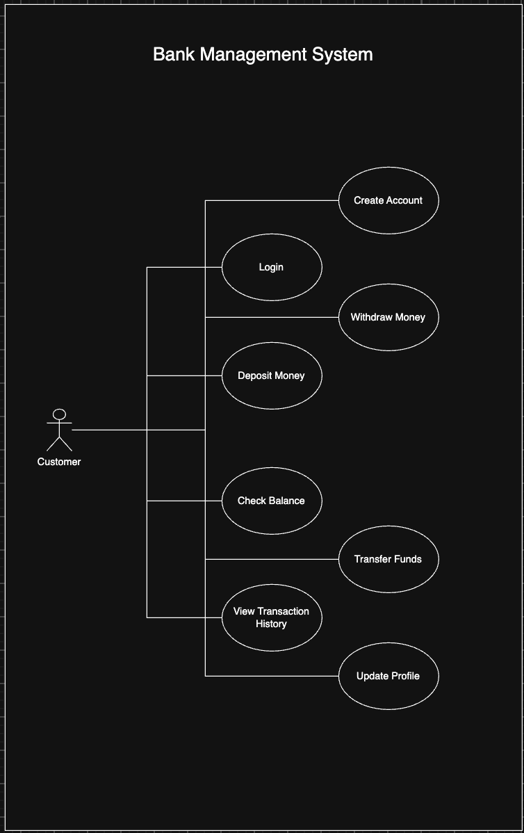
The customer use-case model shows the major functions available to an authenticated or prospective customer, including authentication, account creation, deposits, withdrawals, balance inquiry, transfers, profile updates, and transaction history.

7.2 UML Use-Case diagram – Administrator

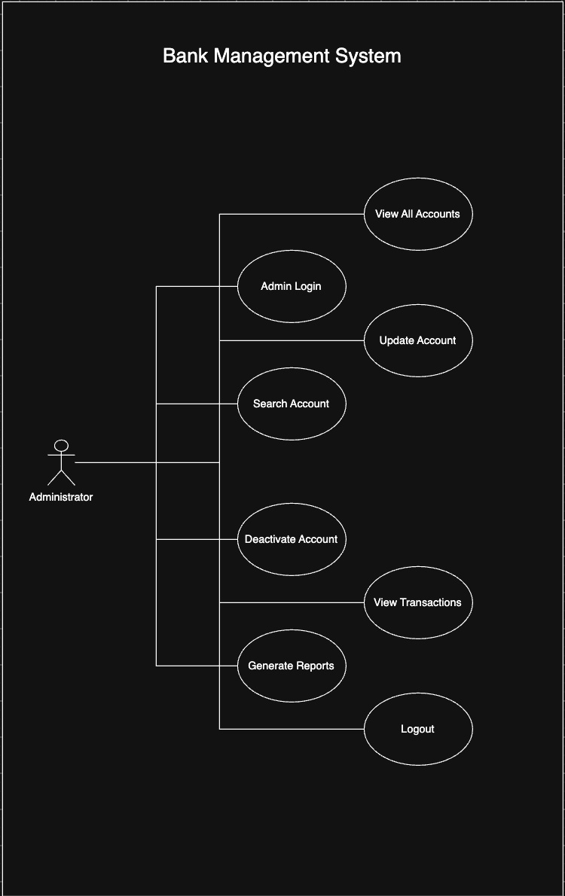
The administrator use-case model shows privileged functions such as administrator login, account search, viewing accounts and transactions, modifying permitted account details, deactivating accounts, and generating account summaries.

8. Requirements Traceability Matrix (RTM)
Req ID | Requirement short | Section ref / Design Spec | Module | Test case(s) | Status (N/P/A) | Comments
BMS-F-001 | Customer login | 4.1 / DS-AUTH-01 | Authentication | TC-AUTH-01 | N
BMS-F-005 | Create account | 4.2 / DS-ACC-01 | Account Module | TC-ACC-01 | N
BMS-F-010 | Deposit balance | 4.3 / DS-DEP-01 | Deposit Module | TC-DEP-02 | N
BMS-F-013 | Check withdrawal balance | 4.4 / DS-WD-01 | Withdrawal Module | TC-WD-02 | N
BMS-F-018 | Atomic transfer update | 4.5 / DS-TR-01 | Transfer Module | TC-TR-03 | N
BMS-F-020 | View transaction history | 4.5 / DS-HIS-01 | Transaction Module | TC-HIS-01 | N
BMS-F-023 | Persist data | 4.6 / DS-DATA-01 | Persistence Module | TC-DATA-01, TC-DATA-03 | N
BMS-NF-001 | Transaction response time | 5 / DS-PERF-01 | Application | TC-PERF-01 | N
BMS-NF-003 | Invalid-input robustness | 5 / DS-ROB-01 | Validation Module | TC-ROB-01 | N
BMS-SR-001 | Protected access | 5.1 / DS-SEC-01 | Authentication | TC-SEC-01 | N
BMS-SR-003 | Prevent cross-account access | 5.1 / DS-SEC-02 | Authorization | TC-SEC-03 | N
BMS-SR-005 | Transfer integrity | 5.1 / DS-SEC-03 | Transfer Module | TC-SEC-05 | N

