Software Architecture and Design Specification
Bank Management System
Project: Bank Management System
Version: 1.1
Implementation Language: C++17
Authors: Team 6
Date: 03-11-2026
Status: Final

Revision History
Version | Date | Author | Change Summary
1.0 | 04-10-2026 | Team 6 | Initial SAD draft
1.1 | 03-11-2026 | Team 6 | Traceability, security table, module descriptions and interfaces aligned with the approved SRS and the implemented design

Approvals
Role | Name | Signature/Date
Course Coordinator

1. Introduction
1.1 Purpose
This document specifies the software architecture and design of the Bank Management System (BMS), a console-based banking simulation application implemented in C++. It complements the project's Software Requirements Specification (SRS) by describing the internal component structure, interaction flows, interface design, and security architecture.
1.2 Scope
Covers the BMS internal module architecture (CLI, Auth, Account, Transaction, Admin, Audit, Storage), sequence flows for login and cash withdrawal, module-level interface design, error handling and logging, and a STRIDE-based threat model for the standalone application.
1.3 Audience
Developers, testers/evaluators, the course instructor, and future maintainers of the BMS codebase.
1.4 Definitions
BMS (Bank Management System), CLI (Command Line Interface), UML (Unified Modeling Language), STRIDE (Spoofing, Tampering, Repudiation, Information disclosure, Denial of service, Elevation of privilege), RTM (Requirements Traceability Matrix), I/O (Input/Output).

2. Document Overview
2.1 How to use this document
Provides the architectural deliverables for BMS: a component diagram, two UML sequence diagrams, module-level interface definitions, error handling, and a STRIDE threat model, all traced back to the requirement IDs defined in the approved SRS.
2.2 Related Documents
Software Requirements Specification (SRS) and its Requirements Traceability Matrix; Software Test Plan and Test Case Specification; DEVIATIONS.md in the repository.

3. Architecture
3.1 Goals & Constraints
Goals: a modular and maintainable codebase, preserved data integrity across all transactions, and portability across Windows and Linux build environments.
Constraints: implementation restricted to C or C++17; standalone single-machine deployment with no network dependency; local flat-file persistence; console-only I/O.
3.2 Stakeholders & Concerns
- Customer: transaction correctness, responsive CLI, clear prompts, protection of PIN and balance
- Administrator: account search and deactivation, clear audit trail
- Course Instructor/Evaluator: alignment with the SRS, code modularity, test coverage
- Development Team: maintainability, clear module boundaries, ease of extension

3.3 Component (UML) Diagram
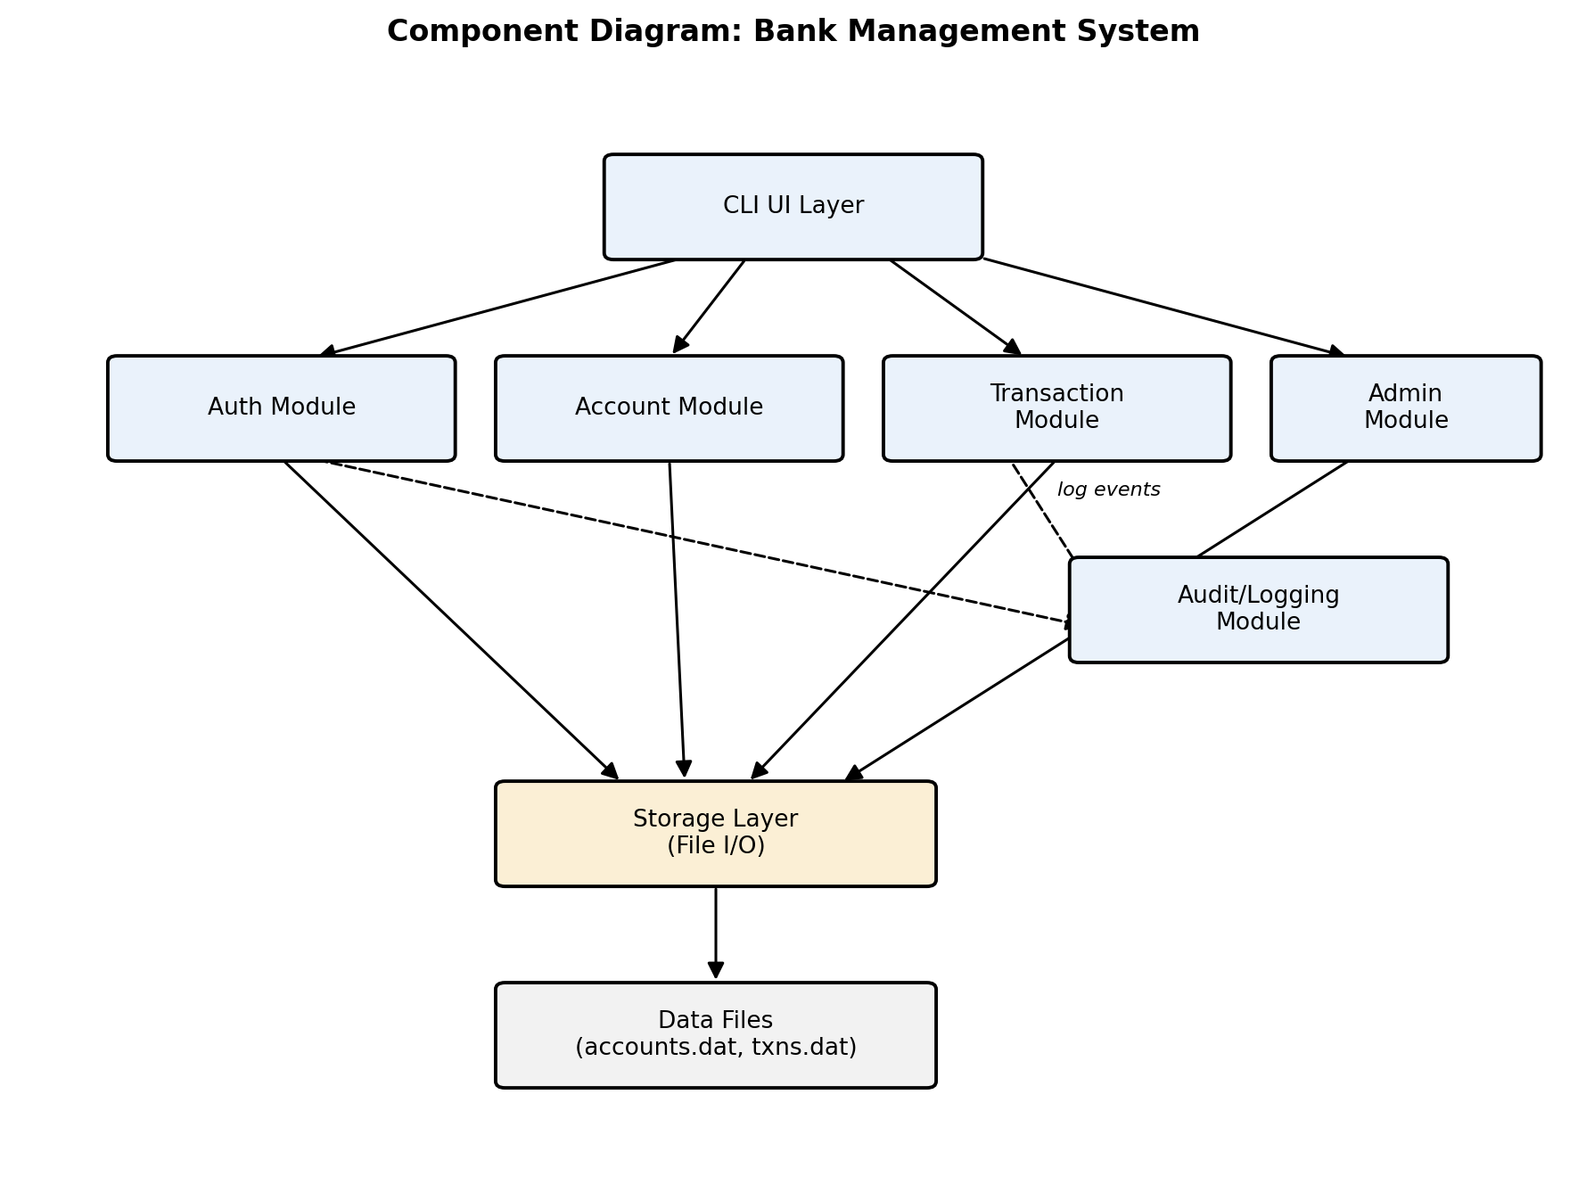
Figure 1: Component diagram showing the layered module structure of the Bank Management System.

3.4 Component Descriptions
- CLI UI Layer (ui, main): renders menus, captures input with masked PIN entry, formats receipts, histories and account details.
- Auth Module (auth, sha256): validates account number + PIN against a SHA-256 hash, applies the temporary block after 3 failed attempts (5 minutes, stored on disk so a restart does not bypass it), and provides the separate administrator login.
- Account Module (account): account creation with mandatory name, contact and PIN, unique account numbers, viewing and updating permitted details.
- Transaction Module (transaction, transfer, history): deposit, withdrawal, funds transfer with atomic debit and credit, balance inquiry and per-account transaction history.
- Admin Module (admin): administrator search by account number and account deactivation.
- Audit/Logging Module (audit): append-only log of security-relevant and transactional events, written by the other modules; it never records PINs or hashes.
- Storage Layer (storage): flat-file persistence of accounts and transactions; a save writes a temporary file and then renames it, so a crash cannot leave a half-written file; corrupted files are detected at start-up.
- Validation (validate): input rules for amounts, PINs, names and contact numbers, applied at the CLI boundary and again inside the business modules.

3.5 Chosen Architecture Pattern and Rationale
A layered architecture (CLI presentation layer -> business-logic modules -> storage layer) was chosen for clear separation of concerns, independent testability of each module's logic, and simplicity appropriate to a single-machine console application. A client-server or microservices architecture was considered and rejected as unnecessary complexity given the project's standalone, offline scope.

3.6 Technology Stack & Data Stores
C++17; GCC/G++ on Linux and MinGW/G++ on Windows; C++ Standard Library (iostream, fstream, filesystem, ctime); flat text files (accounts.dat, txns.dat, audit.log) as the data store; Make for the build; GitHub Actions for automated build and tests.

3.7 Risks & Mitigations
Risk | Mitigation
Unexpected termination corrupts a data file mid-write. | Write to a temporary file and atomically rename on successful save; both balances of a transfer are saved in one write (BMS-NF-002, BMS-SR-005).
Buffer overflows or invalid memory access from unchecked C/C++ input handling. | std::string and getline only, input validation at the CLI boundary, AddressSanitizer and UBSan in test builds (BMS-NF-003).
Scope creep beyond the C/C++, standalone constraint. | Architecture confined to the layered module set above, with no external network services.
Local file storage is a single point of failure. | Atomic saves and corrupt-file detection at start-up, with a clear error instead of a crash (BMS-F-023, BMS-F-024, BMS-NF-004).

3.8 Traceability to Requirements
Requirement ID(s) | Architectural Component
BMS-F-001 - BMS-F-003 (Customer authentication) | Auth Module
BMS-F-004 (Administrator login) | Auth Module + Admin Module
BMS-F-005 - BMS-F-008 (Account management) | Account Module
BMS-F-009 - BMS-F-011 (Deposit) | Transaction Module
BMS-F-012 - BMS-F-015 (Withdrawal) | Transaction Module
BMS-F-016 - BMS-F-019 (Funds transfer) | Transaction Module (transfer)
BMS-F-020 (Transaction history) | Transaction Module (history)
BMS-F-021 - BMS-F-022 (Administration) | Admin Module
BMS-F-023 - BMS-F-024, BMS-NF-004 (Persistence) | Storage Layer
BMS-NF-001 - BMS-NF-005 (Non-functional) | Cross-cutting: all modules + Storage Layer
BMS-SR-001 - BMS-SR-005 (Security) | Auth, Account, Transaction and Audit Modules

3.9 Security Architecture
Threat modeling (STRIDE):
Threat Category | Mitigation | Related Requirement
Spoofing | Account number + hashed PIN authentication before any protected function; identical error message for unknown account and wrong PIN | BMS-F-001, BMS-F-002, BMS-SR-001
Tampering | Atomic file saves; records validated when loaded; transfer updates both balances in a single write | BMS-F-018, BMS-F-024, BMS-SR-005
Repudiation | Transaction ledger with unique IDs and timestamps; audit log of logins, blocks and admin actions | BMS-F-011, BMS-F-019
Information Disclosure | PINs stored only as a SHA-256 hash, masked on entry, never written to logs or transaction records | BMS-SR-002
Denial of Service | Temporary block after 3 failed attempts; bounded input parsing prevents crash-based DoS | BMS-F-003, BMS-NF-003
Elevation of Privilege | Separate administrator credentials; a customer session is limited to its own account | BMS-F-004, BMS-SR-001, BMS-SR-003

4. Design

4.1 Design Overview
BMS follows a layered module design: the CLI presentation layer calls into the Auth, Account, Transaction, and Admin business-logic modules, each of which reads and writes exclusively through the Storage Layer. The Audit/Logging Module is a cross-cutting component called by the other modules. Each module is compiled as a separate translation unit with its own header file, so that modules can be unit-tested independently (BMS-NF-005).

4.2 UML Sequence Diagrams
Two sequence diagrams covering the login and withdrawal flows:
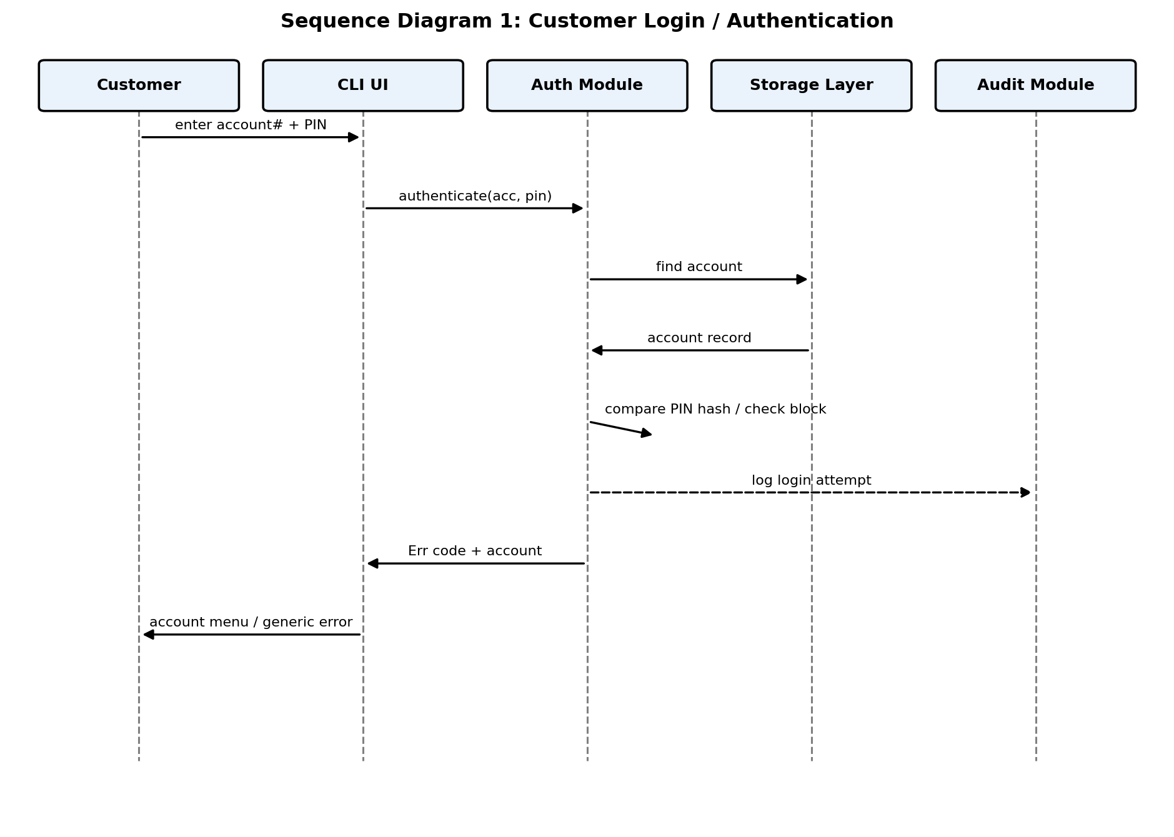
Figure 2: Sequence diagram for customer login / authentication.
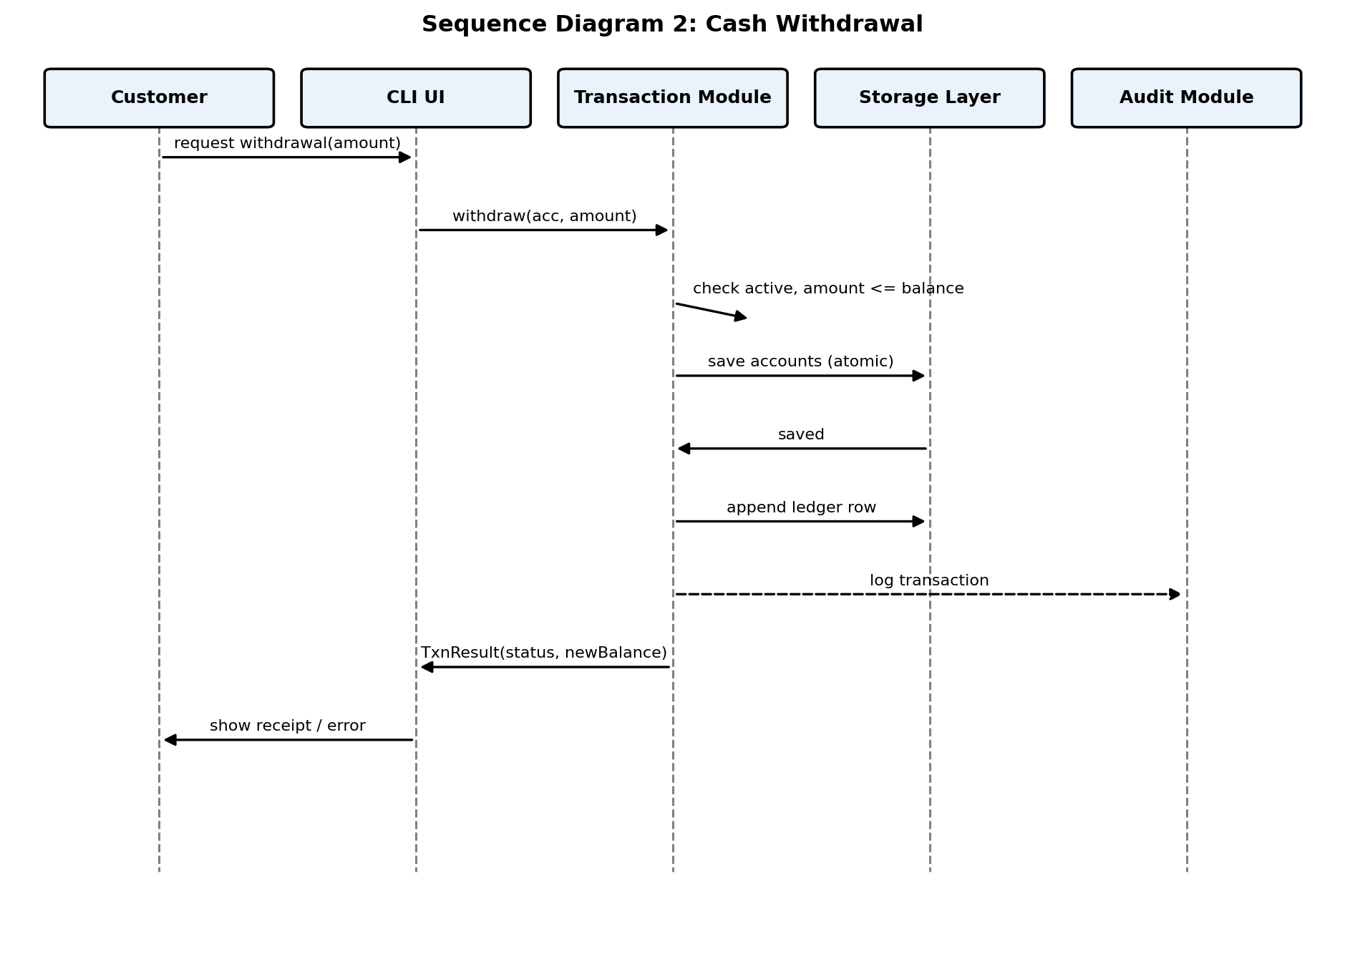
Figure 3: Sequence diagram for a cash withdrawal transaction.

4.3 API Design (module interfaces)
BMS is a console application rather than a networked service, so its API is the set of function-level module interfaces below instead of REST endpoints. Every function returns an error code and takes the account it acts on explicitly, so a customer session can only reach its own account (BMS-SR-003).
Auth Module - authenticate()
- Signature: Err authenticate(std::vector<Account>& accts, int accNo, const std::string& pin, Account*& outAcc)
- Returns: OK and a pointer to the account on success; otherwise an error code and a null pointer
- Side effects: counts failed attempts; after 3 failures sets a 5-minute block stored on disk; writes an audit-log entry; resets the counter on success
- Errors: ACCOUNT_NOT_FOUND, INVALID_PIN, ACCOUNT_LOCKED, ACCOUNT_INACTIVE (the CLI shows the same message for ACCOUNT_NOT_FOUND and INVALID_PIN)
Transaction Module - withdraw()
- Signature: TxnResult withdraw(std::vector<Account>& accts, int accNo, double amount)
- Preconditions: the caller is logged in as accNo; amount is positive with at most 2 decimals
- Returns: TxnResult { status, newBalance }; no overdraft, but withdrawing the exact balance is allowed
- Side effects: saves the new balance, appends a ledger row (ID, date/time, account, type, amount, balance after) and an audit-log entry
- Errors: INVALID_AMOUNT, ACCOUNT_NOT_FOUND, ACCOUNT_INACTIVE, INSUFFICIENT_FUNDS, IO_ERROR
Transaction Module - transfer()
- Signature: TxnResult transfer(std::vector<Account>& accts, int fromAcc, int toAcc, double amount)
- Preconditions: both accounts exist and are active; they differ; amount is valid and not above the source balance
- Side effects: both balances change in one save; if the save fails both are restored; two ledger rows (TRANSFER_OUT, TRANSFER_IN) and an audit entry are written after a successful save
- Errors: INVALID_INPUT, INVALID_AMOUNT, ACCOUNT_NOT_FOUND, ACCOUNT_INACTIVE, INSUFFICIENT_FUNDS, IO_ERROR

4.4 Error Handling, Logging & Monitoring
Module functions return a standard Err enumeration instead of throwing exceptions, which keeps the code simple and portable; the CLI layer maps each code to a user-facing message. A corrupted data file is detected at start-up and reported with a clear message instead of a crash. No PINs or hashes are written to logs: only event type, account number and timestamp. For evaluation, monitoring consists of the audit log and the transaction ledger, plus the automated test report from make test and the GitHub Actions run.

4.5 UX Design
A numbered-menu CLI that re-prompts on invalid input, masked PIN entry where the terminal supports it, consistent tabular formatting for histories, and an explicit confirmation prompt before irreversible actions such as transfers and account deactivation.

4.6 Design Decisions and Open Issues
- Decided: flat text files for persistence; 3 failed attempts cause a 5-minute block; no minimum balance and no overdraft.
- Decided: transfer and history are separate source files inside the Transaction Module, to keep each file small.
- Out of scope: a GUI or client-server extension.

5. Appendices
5.1 Glossary
BMS, CLI, UML, STRIDE, RTM - see Section 1.4 for expansions.
5.2 References
IEEE 42010 (architecture description practice); OWASP guidance on authentication and secrets handling; the project SRS, Test Plan and Test Case Specification.
5.3 Tools
draw.io / PlantUML-style diagramming, GCC/G++, Git and GitHub for version control and automation.

