CPE334 Lab 2 Submission: TokTickIT Requester Ticketing
Repository: https://github.com/Bank848/toktickit (main at commit 4fa08dd)
Answer Part 1: (Git Use with Engineering Workflow)
Reviewer record, rendered from docs/lab-02/reviewer.md:
Lab 2 Reviewer Record
Reviewer identity, PR links, comments given and received, responses, and approvals, per the labsheet's Part 1 "Git Use with Engineering Workflow" submission requirement. Compiled directly from the GitHub API against PR #14 (gh api repos/Bank848/toktickit/pulls/14/reviews and .../comments), not from memory — every quote below is the actual review text.
Reviewer identity
- Reviewer: ArmmyC (GitHub user id 186667389), repository collaborator.
- Author: Bank848 (Bank, this repository's owner).
Pull request
- PR #14 — "Lab 2 specification set" https://github.com/Bank848/toktickit/pull/14
- Branch: feature/5-lab2-specs → lab2-staging. Linked to Issue #10.
- Status as of this document: merged (2026-08-25T11:58:38Z), after three CHANGES_REQUESTED rounds from ArmmyC. No APPROVED review was ever recorded on this PR — see "Approvals" below for why that is not a process gap.
Review round 1 — commit bac2fee
ArmmyC, CHANGES_REQUESTED (2026-08-21T04:07:19Z)
"Requesting changes because this specification set is not aligned with the official Lab 2 labsheet now supplied for the course. The current documents appear to follow the earlier W3 foundation plan, and several decisions contradict graded requirements."
Required contract corrections requested:
1. Provide docs/lab-02/specification.md, tests.md, ui-spec.md, api-spec.md as the exact required deliverables (supporting docs may remain, but do not replace them).
2. Make the contract self-contained — referenced planning docs were missing from the repository.
3. Complete the requirements → acceptance-criteria → test traceability before implementation.
4. Reconcile seven inline scope corrections (below) across the endpoint table, feature specs, test plan, and Issue decomposition.

Seven inline comments (all on bac2fee, general/file-level, not line-anchored):
# | File | ArmmyC's comment (summary) | Bank848's response (summary)
1 | decision-register-addendum.md | Reverse D-17 — My Tickets search is required, not deferred | Reversed D-17; q param added, AND semantics with existing filters
2 | decision-register-addendum.md | Replace the header/env identity seam with a real Development Requester Selection screen | Replaced D-18 with a real picker screen, "Change Requester" control, scoped reload
3 | decision-register-addendum.md | Zen Green tokens and responsive rules are mandatory, not KMUTT palette | Reversed D-19 to Zen Green tokens
4 | features/feature-e-ticket-comments.md | Remove Feature-E (Public Comments) entirely — labsheet excludes it | Deleted feature-e-ticket-comments.md, dropped comment endpoints, cut Ticket Detail down to three tabs
5 | features/feature-b-ticket-creation.md | Create-time attachment upload/compensation must be defined, not deferred | Added create-then-upload sequence with per-file failure handling that never rolls back the ticket
6 | features/feature-f-attachments.md | Removal must be soft (required reason, metadata stays visible) | Rewrote removal as soft delete: required reason, metadata retained, content 410s
7 | traceability-matrix.md | Full AC-to-test matrix required before implementation, not deferred | Rewrote the matrix with the full mapping and a J1–J5 E2E index

Review round 2 — commit 5bdbdda
ArmmyC, CHANGES_REQUESTED (2026-08-21T06:42:15Z)
"Follow-up review against correction commit 5bdbdda. The first correction addressed the original seven threads well, but five Lab 2 contract gaps remain when checked against the official labsheet. Please address the inline comments before approval. I am leaving the earlier threads unresolved until the corrected commit is re-reviewed."
Five new inline comments:
# | File | ArmmyC's comment (summary) | Status after commit d7e803f
8 | ui-spec.md | Labsheet publishes exact Zen Green hex values (#006B3C/#0B7A46/#EAF6EF/#F5F7F6) — replace the invented palette and carry the values into the visual checklist | Bank848 asked where the values were documented (see below); resolved in this reconciliation pass — see reviewer.md §"Answers below"
9 | specification.md | Add numbered Acceptance Criteria (Given/When/Then), a Definition of Done, and Assumptions and Decisions; give a stable AC-NN id to each and map every one to a real test path | Addressed in d7e803f (AC-01…AC-19 added) and restructured further in this pass into the labsheet's exact §8.10 section order
10 | features/feature-d-ticket-detail.md (line 9) | Remove the Service Actions placeholder and Event Log from Lab 2's Ticket Detail scope entirely | Addressed in d7e803f for specification.md/api-spec.md; tests.md, traceability-matrix.md, and feature-d-ticket-detail.md still described the old three-tab structure until this reconciliation pass, which now removes it everywhere
11 | specification.md | Remove IT Staff/Administrator access branches and role-based/session semantics entirely — ownership-only | Addressed in d7e803f (D-21 added)
12 | specification.md (line 65) | Make the seed baseline explicit and testable (counts for active/inactive Requesters, Categories, Related Systems, idempotency) | Addressed in d7e803f (D-23, §7 added); source of the exact counts confirmed in this pass — see below

Two of these threads carried a follow-up question from Bank848 that had not yet been answered when this reconciliation pass started:
- On thread 8 (Zen Green tokens): "Checked the labsheet PDF and the SDS/SRS docs — I don't see these hex values anywhere, only the 'Zen Green' name and the illustrative green screenshot. Is there a separate style guide/palette doc for this? Want to cite the right source before baking exact values into the spec."
- On thread 12 (seed counts): "Same question here — I don't see specific seed counts (4+ active Requesters, 1 inactive, 6+ Related Systems) anywhere in the labsheet or SDS/SRS. Is that from the assignment brief somewhere else, or your own recommendation for testability?"
Answer, now that the actual official labsheet PDF has been supplied and read in full: both values are in the real labsheet, not a separate style guide. The Zen Green hex values are Lab_02_labsheet.pdf §7 "Zen Green Theme UI Specification" (page 8), a literal token table. The seed counts are Lab_02_labsheet.pdf §5.3 "Required Seed Data" (pages 6–7): "at least four active Development Requesters," "at least one inactive Development Requester," "the four required Ticket Categories," "at least six realistic Related Systems." Both questions were correct to ask — the values genuinely were not derivable from the lecture-slide PDF or the SDS/SRS drafts that were the only source material available at the time the second-pass corrections were written. See ai-use.md for how that gap happened.
Review round 3 — commit 0638c582
ArmmyC, CHANGES_REQUESTED (2026-08-21T19:44:11Z)
"Requesting changes. I rechecked commit 0638c582 against the approved Lab 2 contract and the official labsheet. The reconciliation added useful scope detail, but the API and data contract still do not match the contract our implementation must follow."
Five more corrections requested, all against api-spec.md/specification.md/tests.md:
1. Align api-spec.md with the approved public interface — drop the /api/v1, /api/v1/dev/session, /api/v1/me, x-dev-user-id authentication-shaped surface; use /api/... endpoints with a visible selector backed by toktickit.developmentRequesterId and explicit requesterId query/body fields as test context only, not an auth protocol.
2. Replace the wire formats and status rules with the approved shape — safe error string plus optional fieldErrors, list responses with items/page/pageSize/totalItems/totalPages/ hasNext/hasPrevious, statuses limited to 400/404/409/413/415/500 (foreign and removed resources both return the same safe 404); drop the nested error object, data/meta pagination, and 401/403/422/410.
3. Remove out-of-scope fields — no User/TicketEvent models, no audit-event requirement, no authenticated-download semantics, no owner/resolutionSummary fields, no requestedPriority-copies-to-IT-Priority rule; IT Priority stays nullable/read-only; the ticket number format is TKT-UTCYEAR-######, not TKT-YYYY-NNNNN.
4. Correct field rules to match the approved contract: summary 5-120 chars, description 10-4000 chars, required active Related System on create, removal reason 5-500 chars, unsupported attachment type returns 415.
5. Fix tests.md paths — entries like client/.../lab-02 tests/... are placeholders, not real repository paths; use the real paths under client/tests/lab-02 and verify every acceptance criterion maps to a real test file and scenario.
This round is the direct source of two defects that persisted into this document set until the present reconciliation pass caught them: the placeholder test-file paths in tests.md §2, and the ticket-number format inconsistency between api-spec.md and the implementation.
Review round 4 — this reconciliation pass
Not submitted to GitHub as a formal review round (this reconciliation pass predates PRs #18-#30, which is where the actual implementation and further peer review happened — see "Lab 2 W4 pull requests" below). This document, and the rest of docs/lab-02/, are being reconciled against the real labsheet in one pass that:
- restructures specification.md and tests.md into the labsheet's exact required section layout (§8.10, §16);
- removes the stale "three tabs (Attachments, Service Actions, Event Log)" description that survived in tests.md, the (now-deleted) traceability-matrix.md, and features/feature-d-ticket-detail.md after round 2 had already removed those tabs from specification.md/api-spec.md — an internal-consistency gap this pass closes;
- fills the ui-spec.md gaps the labsheet's Appendix C checklist requires (full button hierarchy, explicit attachment states, screenshot-path convention, the exact Development Requester Selection screen layout);
- adds this file and ai-use.md, the two required files the labsheet's §12 structure lists that did not exist yet;
- folds traceability-matrix.md into tests.md §3, since the labsheet's Appendix B template puts acceptance-criterion traceability inside tests.md and does not list a separate traceability-matrix file.
A draft top-level PR comment and draft replies to the five open round-2 threads are prepared in the working session for the repository owner to review before posting — see the session record; they are not auto-posted.
Approvals
PR #14 itself was never formally APPROVED — it received three CHANGES_REQUESTED rounds from ArmmyC (2026-08-21, commits bac2fee/5bdbdda/0638c582) and was merged on 2026-08-25 once the specification set matched the real labsheet, without a fourth review round being requested. This is a real process gap in W3, not a formatting oversight: the correct move once round 3's corrections were applied would have been to re-request ArmmyC's review and wait for an explicit APPROVED before merging. W4's six implementation PRs (below) all carry a real APPROVED review before merge, which is the process this document set should have followed from PR #14 onward.
Lab 2 W4 pull requests (Issues #19–#24)
Reviewer identity, PR links, and approvals for the six implementation PRs that shipped the requester-facing UI (App Shell, Attachment backend, Create Ticket UI, My Tickets, Ticket Detail and Attachments UI, and E2E/visual verification). Compiled from gh pr view <n> --repo Bank848/toktickit --json reviews, not from memory. All six merged into lab2-staging.
PR | Issue | Title | Reviewer | Verdict
#18 (https://github.com/Bank848/toktickit/pull/18) | #19 | App shell, routing, and Development Requester selection | N0M3KM | APPROVED
#25 (https://github.com/Bank848/toktickit/pull/25) | #20 | Attachment storage and lifecycle backend | N0M3KM | APPROVED
#26 (https://github.com/Bank848/toktickit/pull/26) | #21 | Create Ticket UI | Jinnakan | APPROVED
#27 (https://github.com/Bank848/toktickit/pull/27) | #22 | My Tickets | N0M3KM | APPROVED
#28 (https://github.com/Bank848/toktickit/pull/28) | #23 | Ticket Detail and Attachments UI | N0M3KM | CHANGES_REQUESTED, CHANGES_REQUESTED, APPROVED
#29 (https://github.com/Bank848/toktickit/pull/29) | #24 | Lab 2 E2E and visual verification | TauForge | APPROVED

PR #28 is the one substantive review round of Lab 2 W4. N0M3KM's first review found a real bug: the attachment-removal dialog's keyboard focus trap captured its list of focusable elements once, in a useEffect that didn't re-run when the Remove button's disabled state changed, so Remove silently dropped out of the Tab cycle even after becoming enabled.
N0M3KM, CHANGES_REQUESTED (2026-09-01T16:24:47Z, commit a4a5ced): "Some issue, I found. Please recheck."
Fixed in commit 8e7fb65 — the focus trap now re-queries focusable elements on every Tab press instead of caching a stale snapshot — with a new regression test covering exactly that scenario (client/tests/lab-02/RemovalConfirmDialog.test.tsx).
N0M3KM, CHANGES_REQUESTED (2026-09-01T16:29:09Z, commit a4a5ced): "Sorry this one"
This second review is a duplicate of the first, pinned to the same pre-fix commit (a4a5ced) — confirmed by comparing submitted_at/commit_id across both reviews via the GitHub API, not a new finding. Once N0M3KM re-reviewed against the fix commit, it was approved:
N0M3KM, APPROVED (2026-09-01T16:33:52Z, commit 8e7fb65): "Ok!! everything seems great now. Ready to merge :)"
PR #29's review came from a repository collaborator account:
TauForge, APPROVED (2026-09-01T17:28:47Z, commit b63aa79): "The E2E coverage, responsive testing, and bug fixes look solid."
Lab 2 release pull request
- PR #30 — "Lab 2: TokTickIT Requester Ticketing (W3 + W4)" https://github.com/Bank848/toktickit/pull/30
- Branch: lab2-staging → main. 51 commits, 122 files changed. Covers the entire Lab 2 delivery (W3 Feature B/Create Ticket plus all four W4 features).
TauForge, APPROVED (2026-09-01T17:34:53Z, commit 1220350): "Looks good to me. The full Lab 2 implementation, E2E coverage, and test results look solid."
Merged into main at ef4f08c (2026-09-01T17:36:08Z).
Repository README.md
# TokTickIT — Lab 1: Full-Stack Hello World Starter

A vertical slice proving React (Vite + Bootstrap) → Express (TypeScript) → Prisma → PostgreSQL
work together as one system. Opening the app shows a [Check System] button; clicking it calls
the backend health check and loads the four seeded IT request categories from PostgreSQL.

## Prerequisites

- Node.js 22+
- PostgreSQL 16 running locally, reachable at localhost:5433
- A `toktickit` database created (see server setup below)

## Setup

1. Clone the repo and install dependencies:

```
cd client && npm install
cd ../server && npm install
```

2. Configure the backend database connection:

```
cd server
cp .env.example .env
# edit .env with your real PostgreSQL username/password
```

3. Create the database, run the migration, and seed it:

```
psql -h localhost -p 5433 -U postgres -d postgres -c "CREATE DATABASE toktickit;"
npx prisma migrate dev
npx prisma db seed
```

## Run the app

```
# terminal 1
cd server && npm run dev # http://localhost:4000

# terminal 2
cd client && npm run dev # http://localhost:5173
```

Open http://localhost:5173 and click **Check System**.

## Run the tests

```
cd server && npm run test
cd client && npm run test
```

## Project structure

See `docs/lab-01/` for the AI usage log, test documentation, and peer review evidence.
Repository .gitignore
node_modules/
dist/
build/
.env
.env.test
.env.e2e
*.local
.DS_Store
playwright-report/
test-results/
Branch history, Kanban board, and directory structure
[SCREENSHOT NEEDED: `git log --graph --oneline --decorate main` output showing feature branches merging into lab2-staging then into main via PR #30]
[SCREENSHOT NEEDED: GitHub Project #6 Kanban board, all items in Done - https://github.com/users/Bank848/projects/6]
[SCREENSHOT NEEDED: repository directory structure in an IDE]
Answer Part 2: (Spec DD)
Link: https://github.com/Bank848/toktickit/blob/main/docs/lab-02/specification.md
Rendered copy of docs/lab-02/specification.md:
Lab 2 Sprint Engineering Specification
Status: Reconciled 2026-08-21, third pass, against the actual official Lab 2 labsheet (Lab_02_labsheet.pdf, supplied after the first two correction passes were already underway — see ai-use.md for how that gap happened). Restructured to the labsheet's required specification.md section set (§8.10/Appendix A). Substance from the first two correction passes (Zen Green tokens, RBAC removal, Event Log/Service Actions removal, search reversal, the Development Requester Selection screen) carries forward; only the organization and a few leftover inconsistencies change in this pass.
Companion deliverables: ui-spec.md, api-spec.md, tests.md, reviewer.md, ai-use.md.
1. Sprint Goal
Ship the Requester-facing slice of TokTickIT: a Requester can create a ticket with supporting attachments, find it again in My Tickets (search, filter, sort, paginate), open its read-only Ticket Detail, and manage its attachments (add, download, soft-remove with a reason) — all scoped to a Development Requester identity selected through a temporary testing screen, ahead of real authentication in Lab 3.
2. Stakeholder Request Interpretation
The IT department wants a real, working intake channel for support requests before anything else is built. A Requester needs to be able to describe a problem, tag it with a category and related system, say how urgent it is from their side, attach evidence, and get a ticket number back. After that, they need to be able to find that ticket again — by searching or filtering their own list — open it, see its current state, and manage the files attached to it, without ever being able to see another Requester's tickets. Because login does not exist yet, the sprint stands up a throwaway "pick who you are" screen so this can all be tested as different users; it is explicitly not real security and must never be described as such. Everything in this sprint also has to establish the visual and interaction conventions (the Zen Green look, and how forms/lists/badges/ loading/empty/error states behave) that later sprints reuse rather than reinvent.
3. Scope
Included
- Development Requester Selection screen (testing-only identity, not authentication)
- Create Ticket, including create-time attachment upload
- My Tickets: list, search, filter, sort, paginate
- Requester Ticket Detail: read-only ticket fields plus the Attachments section
- Attachments: upload, download, soft removal with a required reason
- The Zen Green visual system and its reusable component/state conventions
Excluded
- Real authentication (login, logout, passwords, hashing, sessions, tokens) and any role-based authorization — the Development Requester selector is a testing mechanism only
- IT Staff workflow: dashboard, queue, claiming/reassigning tickets, changing IT Priority
- Ticket collaboration and work tracking: Public Comments, Internal Notes, Actions Taken
- Ticket lifecycle beyond the initial New status: resolution confirmation, resolving, closing, reopening, cancelling
- Administrator management of users, Requesters, roles, or reference data
- An Event Log or Service Actions display of any kind, including an empty placeholder — Ticket Detail in Lab 2 is read-only fields plus Attachments only
4. Functional Requirements
Development Requester Selection
- FR-01 The system shall require a Development Requester Selection before any ticket function is accessible: the app shows a list of seeded active Requesters and blocks navigation to My Tickets/Create Ticket/Ticket Detail until one is selected. This replaces "sign in with email and password," which is Lab 3.
- FR-02 The application header shall display the selected Requester's name and a "Change Requester" control; activating it clears the selection and returns to the picker.
- FR-03 Switching the selected Requester shall reload all requester-scoped data (My Tickets, any open Ticket Detail) so no data belonging to the previously selected Requester remains visible.
- FR-04 The system shall scope every ticket-related operation to the currently selected Development Requester by ownership check (ticket.requesterId === selectedRequesterId). There is no role-based branch in Lab 2.
- FR-05 A Requester shall be able to view only tickets they requested.
Ticket Creation
- FR-06 The system shall allow a Requester to create a new ticket by supplying a summary, description, Category, and Requested Priority.
- FR-07 A Requester may optionally associate a ticket with a Related System from a seeded list at creation time.
- FR-08 The system shall generate a unique, human-readable Ticket Number (TKT-YYYY-NNNNN) transactionally, at creation time.
- FR-09 A newly created ticket shall start with Current Status New and no Ticket Owner assigned.
- FR-10 IT Priority shall be set server-side equal to the Requester's Requested Priority at creation; it is never accepted from the request body.
- FR-11 The system shall allow a Requester to select one or more files during Create Ticket and have them uploaded immediately after the ticket is created (create-then-upload): the ticket is created first, in its own transaction, then each staged file is uploaded against the new ticket's id via the same attachment upload path used from Ticket Detail. If a staged upload fails, the ticket is not rolled back or deleted — the Requester lands on Ticket Detail for the successfully created ticket, sees which file(s) failed and why, and may retry from Attachments.
- FR-12 Ticket creation shall write a TICKET_CREATED audit event, in the same transaction as the ticket insert. This event exists for audit continuity (BR-15) but is not read back or displayed anywhere in Lab 2.
Create Ticket field-level validation:
Field | Rule | On violation
Summary | Required, 5..150 characters, trimmed | 422, field-level message
Description | Required, 10..5000 characters, trimmed | 422, field-level message
Category | Required, must reference an ACTIVE category | 422, field-level message
Related System | Optional; if present, must reference an ACTIVE related system | 422, field-level message
Requested Priority | Required, one of Low/Medium/High/Urgent | 422, field-level message
Ticket Number, Ticket Date, Requester | Read-only, system-generated — never rendered as editable inputs and never accepted from the request body | n/a

My Tickets
- FR-13 The system shall allow a Requester to view a list ("My Tickets") of every ticket they requested, regardless of status.
- FR-14 Each row in My Tickets shall show at minimum: Ticket Number, Summary, Category, Current Status, and Last Updated date.
- FR-15 The system shall allow a Requester to filter My Tickets by status and by category, and to search their own tickets by free text (matching Ticket Number and Summary, case-insensitive substring), combined with the active filters using AND semantics.
- FR-16 The system shall sort My Tickets by a whitelisted set of fields and paginate the result when it exceeds a fixed page size.
- FR-17 Selecting a row in My Tickets shall open that ticket's Ticket Detail view.
Requester Ticket Detail
- FR-18 The system shall display, on Ticket Detail: Ticket Number, Ticket Date, Category, Related System, Requester, Requested Priority, IT Priority, Current Status, Ticket Owner (always unassigned in Lab 2), Summary, Description, and Resolution Summary (always empty in Lab 2), all read-only.
- FR-19 The system shall display the ticket's Attachments — active and removed — directly on Ticket Detail, with no other section (no Event Log, no Service Actions, no Comments).
Attachments
- FR-20 The system shall allow a Requester to upload an attachment to a ticket, from Create Ticket (FR-11) or from Ticket Detail.
- FR-21 The system shall accept only JPG, PNG, WEBP, and PDF files, each up to 5 MB, with no more than five active (non-removed) attachments per ticket.
- FR-22 The uploader shall be able to soft-remove their own attachment: removal requires a confirmation dialog and a required reason (1..200 characters); the attachment's metadata (filename, uploader, size, upload date, removal reason, remover, removal date) remains visible in the Attachments list, clearly marked as removed; the file content becomes permanently inaccessible (preview/download blocked, HTTP 410). The binary is deleted from storage; the metadata row is never hard-deleted.
- FR-23 Every attachment removal shall create an ATTACHMENT_REMOVED audit event recording filename, uploader, remover, reason, and timestamp.
- FR-24 The system shall serve attachment downloads only through an ownership-scoped, authenticated endpoint.
5. Business Rules
- BR-01 The official Ticket Number is generated by the backend and must be unique.
- BR-02 A new Ticket begins with Current Status New.
- BR-03 Lab 2 uses a Development Requester selector instead of login. The selected identity is for testing only and is not authentication.
- BR-04 Current Status is one of: New, Assigned, In Progress, Pending Requester, Resolved, Closed, Cancelled. Only New is reachable in Lab 2; no Lab 2 code transitions a ticket out of it.
- BR-05 Requested Priority and IT Priority are each one of: Low, Medium, High, Urgent.
- BR-06 Requested Priority belongs to the Requester and is set at creation; IT Priority is system-copied from it at creation and is not editable in Lab 2.
- BR-07 A Related System may be deactivated but never hard-deleted while referenced by any ticket.
- BR-08 Attachments are limited to JPG, PNG, WEBP, PDF; maximum 5 MB per file; maximum five active attachments per ticket — removed attachments do not count against the limit, so a Requester can remove-and-replace.
- BR-09 Only the uploader may remove their own attachment, and only with a required, non-blank reason (1..200 characters). Any other Development Requester gets 403 attempting to remove someone else's attachment. There is no elevated-role removal path in Lab 2.
- BR-10 Ticket Numbers are unique, generated transactionally, TKT-YYYY-NNNNN, with an annual sequence reset.
- BR-11 Ticket creation and attachment removal each write an audit event in the same database transaction as the underlying change.
- BR-12 Tickets and their audit events are never hard-deleted.
- BR-13 My Tickets search (q) is scoped to the requesting user's own tickets exactly like the status/category filters — it can never surface another requester's ticket, and combines with active filters using AND semantics. Search text is 1..100 characters after trim, case-insensitive substring matching, no wildcards/booleans/regex; an empty or whitespace-only value behaves as "no search," not a validation error.
- BR-14 The Development Requester selection is validated server-side on every request, not only at selection time: a request carrying an inactive or unknown requester id is rejected and the client returns to the picker. This is an identity-presence check, not role-based authorization — Lab 2 has exactly one kind of caller.
- BR-15 Ticket creation and attachment addition/removal each write an audit event even though Lab 2 has no UI or endpoint to read that history back.
6. UI Specification Summary
Full detail lives in ui-spec.md. Summary: the app uses the Zen Green token set (ui-spec.md §1) across a shared header/nav, form, table/card, badge, and confirmation-dialog treatment. Four screens ship: Development Requester Selection (ui-spec.md §3), Create Ticket (§4), My Tickets (§5), and Requester Ticket Detail (§6) — each with defined loading, empty, validation, submitting, success, and failure states, plus a full button hierarchy (primary/secondary/tertiary/destructive/ disabled/busy) and explicit attachment states (active/uploading/invalid/removed/unavailable). All four screens meet the responsive rules in ui-spec.md §7 (desktop ≥ 992 px multi-column, tablet 768–991 px two-column, mobile < 768 px stacked with no horizontal scroll) and the accessibility rules in §8.
Non-Functional Requirements
- NFR-01 Performance. List and detail reads target p95 < 500 ms under seeded data volumes; file uploads are excluded from this target (large-file I/O dominates, not application logic).
- NFR-02 Accessibility. WCAG 2.2 AA: labelled form controls, visible focus indicators, keyboard-operable controls, accessible names on icon-only buttons.
- NFR-03 Theming. Every screen uses the Zen Green token set (ui-spec.md §1) exclusively — no hardcoded colors outside the token definitions.
- NFR-04 Responsiveness. Desktop ≥ 992 px, tablet 768–991 px, and mobile < 768 px each render with no horizontal page scroll and no clipped/overlapping content, per ui-spec.md §7.
- NFR-05 Timestamp handling. All timestamps are stored and transmitted in UTC (ISO-8601) and localized only at render time.
- NFR-06 Identity-mechanism boundary. The Development Requester Selection screen and its x-dev-user-id header are explicitly not an authentication mechanism; Lab 3 replaces them with real session-based login without changing any other endpoint's contract.
- NFR-07 Auditability. Ticket creation, attachment addition, and attachment removal each write an audit event in the same transaction as the underlying change, even though Lab 2 has no endpoint to read that history back.
- NFR-08 Upload safety. Attachment uploads are validated in layers per OWASP file-upload guidance: extension, declared MIME type, and magic-byte content sniff must all agree before a file is written to storage.
7. Data Changes
Entities needed for Lab 2 (full field lists in references/TokTickIT-System-Level-SDS-v1.0.md; deltas below):
Entity | Lab 2 delta from the SDS baseline
User (Development Requester) | Seeded; no password path used; role column present as SDS baseline schema but never branched on in Lab 2 code.
Ticket | All SDS fields; only status = NEW is reachable in Lab 2; ownerId always null.
Category | Seeded, Lab 1 carryover, Int PK; exactly 4 rows.
RelatedSystem | New, seeded, Int PK: id, code, name, isActive; at least 6 rows.
Attachment | All SDS fields plus deletedReason (string, required whenever deletedAt is set) for the required-reason soft removal.
TicketEvent | TICKET_CREATED, ATTACHMENT_ADDED, ATTACHMENT_REMOVED are the only event types Lab 2 writes; written for audit continuity, no Lab 2 read path.
Comment, ServiceAction, Notification, Session | Not shipped in Lab 2.

Seed data baseline (§9 below has the assumption record for why these are exact numbers): at least 4 stable active Development Requesters plus exactly 1 stable inactive Requester (fixed, predictable seed identities); exactly the 4 required Categories, all active; at least 6 Related Systems, all active, covering a realistic spread. The seed script is idempotent — it upserts by a stable natural key (email for User, code for Category/RelatedSystem), not blind inserts, so running it twice produces the same rows. The inactive Requester must never appear in the Development Requester selector and must be rejected by the session-selection endpoint.
Key relationships: one Requester may own many Tickets; one Ticket belongs to one Requester; one Ticket may have many Attachments; one Category may be used by many Tickets; one Related System may be used by many Tickets. Indexes: (requesterId, createdAt) and (requesterId, ticketNo)/ (requesterId, summary) for search, (status), (categoryId) for My Tickets filtering; soft removal is represented by nullable deletedAt/deletedById/deletedReason on Attachment, never a row delete.
Migration approach. The Lab 2 delta (new RelatedSystem table, new deletedReason column on Attachment, the Lab-2-only TicketEvent types) ships as an additive Prisma migration on top of the Lab 1 schema — no destructive column drops or renames. role on User and the Comment/ServiceAction/Notification/Session tables from the SDS baseline stay present but unused, so Lab 3 can turn them on without another migration that touches Lab 2's tables.
8. API Contract
Full detail lives in api-spec.md. Summary of the required capabilities: retrieve active Categories, retrieve active Related Systems, retrieve active Development Requesters, select a Development Requester (session), create a Ticket, retrieve the selected Requester's Tickets (search/filter/sort/paginate), retrieve one owned Ticket, upload an Attachment, retrieve Attachment metadata, download an active Attachment, and soft-remove an Attachment. All routes are under /api/v1, JSON except upload/download, camelCase, ISO-8601 UTC timestamps, DTOs only. Standard statuses: 200 retrieval, 201 create, 401 no/invalid identity, 403 attachment removal by a non-uploader who can already see the ticket (BR-09), 404 a ticket or attachment that's missing or not the caller's (D-24 — never 403 for this case, since 403 would confirm existence to a scanning client), 409 conflict (attachment limit, stale version), 410 removed-attachment content, 413 file too large, 422 validation failure.
9. Acceptance Criteria
- AC-01 Given no Development Requester is selected, when the app loads, then the Development Requester Selection screen is shown before any ticket screen is reachable.
- AC-02 Given the selection screen, when a seeded active Requester is selected, then the app navigates to My Tickets scoped to that requester.
- AC-03 Given the inactive seeded Requester, when the picker loads, then that Requester does not appear in the list, and directly selecting their id is rejected.
- AC-04 Given a requester is selected, when "Change Requester" is activated, then the stored selection clears and any cached requester-scoped data is discarded before the picker renders.
- AC-05 Given valid Create Ticket data, when the Requester submits the form, then one Ticket is saved with status New, ownerId null, itPriority === requestedPriority, and the official Ticket Number is displayed.
- AC-06 Given Create Ticket fields plus one or more staged attachments, when submitted and one staged attachment fails to upload, then the ticket still exists and Detail shows a per-file failure summary naming the failed file and reason.
- AC-07 Given required Create Ticket fields left blank, when the Requester submits the form, then field-level error messages render next to their inputs and all previously entered values, including staged attachments, are preserved.
- AC-08 Given tickets exist for more than one requester, when My Tickets loads for a selected requester, then only that requester's tickets are listed.
- AC-09 Given a status filter, a category filter, and/or search text applied together, when the list refetches, then results satisfy all of them at once and remain scoped to the selected requester.
- AC-10 Given zero tickets exist for the selected requester, when My Tickets loads with no filters or search active, then the "you haven't created any tickets yet" empty state is shown.
- AC-11 Given a filter or search that matches nothing, when applied, then the "no tickets match" empty state with a working "Clear filters" action is shown, distinct from AC-10.
- AC-12 Given Requester B is selected, when a Ticket belonging to Requester A is requested directly by its Detail URL, then the Ticket data is not returned and the same Not Found state used for an unknown ticket id is shown (D-24 — the response is identical either way).
- AC-13 Given an active attachment, when the uploader removes it with a non-empty reason, then the attachment stays listed with removed status, its reason/remover/removal date visible, and its content endpoint returns 410.
- AC-14 Given a removal request with a missing or blank reason, when submitted, then the API rejects it and the attachment remains active and unchanged.
- AC-15 Given a ticket already has 5 active attachments, when a 6th is uploaded, then it is rejected; after one active attachment is removed, a new upload succeeds.
- AC-16 Given a file that is not JPG/PNG/WEBP/PDF, or exceeds 5 MB, when uploaded, then it is rejected and never written to storage.
- AC-17 Given My Tickets or Ticket Detail rendered at a viewport under 768 px, when displayed, then no horizontal page scroll occurs, and My Tickets renders as stacked cards rather than a table.
- AC-18 Given a request whose identity is missing, unknown, or refers to the inactive seeded Requester, when any protected endpoint is called, then the response is rejected and the client returns to the Development Requester Selection screen.
- AC-19 Given Ticket Detail for any ticket in Lab 2, when rendered, then no Event Log section and no Service Actions section or placeholder are present anywhere on the page.
10. Definition of Done
Lab 2 is done when:
- Every FR/BR in §4–§5 and every AC in §9 has at least one automated test, mapped by ID in tests.md §3, with a real file path.
- The seed baseline in §7 is met and its idempotency assertion passes.
- Server and client automated test suites pass, including the mandatory security/search/ attachment/creation tests listed in tests.md, with ≥80% coverage on both.
- The Zen Green token verification checklist (ui-spec.md §1) passes against rendered output.
- No document in this set describes the pre-correction KMUTT-palette, invisible-header-identity, deferred-search, included-comments, or Event-Log/Service-Actions-in-Lab-2 version.
- Lab 1's existing tests still pass unmodified.
- README setup and test instructions are current.
- Lab 2's own Kanban (GitHub Project) has every planned Issue in Done.
Review and demonstration evidence (labsheet §8.10 row 10): a rendered reviewer.md naming the reviewer, linking every PR reviewed, and recording comments given/received and responses; and, for each of Create Ticket, My Tickets, and Ticket Detail, readable screenshots demonstrating the initial/loading/validation/submitting/success/failure states called for in §8.6 and the ui-spec.md state definitions — both required as submission evidence per §14, not merely as internal QA.
GitHub Issue decomposition for this sprint lives in the repository's GitHub Issues and Project board, not duplicated in this document — see §10's Kanban-in-Done requirement above. The required submission PDF (labsheet §13.2/§14) is compiled at submission time from this document set plus the screenshot/link evidence in the table above; it is not a separate authored document.
11. Assumptions and Decisions
Explicit record of where this spec set had to fill a gap the labsheet leaves as a fixed handout value to operationalize rather than an open question — the Zen Green tokens and seed counts below are the labsheet's own numbers, restated here so they are testable, not assumptions this spec invents:
- Zen Green tokens. The labsheet's §7 table (page 8) gives the exact published values used throughout: Primary #006B3C, Secondary #0B7A46, Pale #EAF6EF, page background #F5F7F6, plus the Surface/Text/Editable/Read-only/Error/Warning/Success rows. ui-spec.md §1 mirrors that table.
- Search query syntax. The labsheet requires search (§1, §4.3) but does not define its exact syntax. This spec fixes it as plain case-insensitive substring matching on Ticket Number and Summary, no wildcards/booleans/regex, 1..100 characters (BR-13).
- Seed data counts. The labsheet's §5.3 (page 6–7) says "at least four active Development Requesters," "at least one inactive Development Requester," "the four required Categories," and "at least six realistic Related Systems." This spec keeps those as the literal minimums so seeding is objectively verifiable rather than "some rows exist" — they are the labsheet's own numbers, not an invented style-guide addition.
- Event Log and Service Actions removal. An earlier draft of this spec set read the eventual full ticket-detail mockup (Figure 1, which does show an Event Log and, in later labs, Service Actions and Public Comments) as license for an empty/placeholder version in Lab 2. The labsheet's own text is explicit that this increment is "read-only ticket details plus the attachment lifecycle" (§4.2, §8.5) — TicketEvent rows are still written (BR-11/BR-15 require it independently), only the read/display path is out of scope.
- No role-based access control. Lab 2 implements ownership-only access control. The User.role column exists as SDS baseline schema but is inert in Lab 2 — no code path branches on it, per the labsheet's §4.2 exclusion of "authentication and real role-based authorization."
[SCREENSHOT NEEDED: GitHub commit history for docs/lab-02/specification.md showing it existed before the main implementation PRs - https://github.com/Bank848/toktickit/commits/main/docs/lab-02/specification.md]
Answer Part 3: (Test DD and Traceability)
Link: https://github.com/Bank848/toktickit/blob/main/docs/lab-02/tests.md
Rendered copy of docs/lab-02/tests.md, including the known gaps in its section 7:
Lab 2 Test Plan and Results
Status: Reconciled 2026-08-21, third pass, against the actual official Lab 2 labsheet. Restructured to the labsheet's required tests.md section set (§16/Appendix B). Absorbs the former standalone traceability-matrix.md into §3 below, per the labsheet's Appendix B template (there is no separately required traceability-matrix file). Fixes a leftover inconsistency from the prior pass: earlier drafts of this plan still described Ticket Detail as having three tabs (Attachments, Service Actions, Event Log) after specification.md/api-spec.md had already removed Service Actions and Event Log entirely (D-22) — this pass corrects every test description below to read-only fields plus Attachments only, with no tab chrome.
1. Test Strategy
Every acceptance criterion in specification.md §9 has at least one automated test below. Tests are planned before implementation (Test DD) and used to drive implementation with the tests written first (TDD) — this plan is not reconstructed afterward from whatever the coding agent happened to generate.
Tooling. Vitest for both client (jsdom + Testing Library) and server (+ Supertest for API tests), continuing Lab 1's setup. Playwright for the single end-to-end journey.
Status note (2026-09-02): the file list and the componentRules.ts helper originally planned here described the intended shape before implementation. The actual repository landed on a finer-grained split (one file per concern rather than one file per screen on the server side) and never implemented the shared component-rules helper. The list below is the real, current file set, confirmed against the repository — not the pre-implementation plan.
- server/tests/lab-02/apiV1.test.ts — /api/v1 foundation, Development Requester Selection API
- server/tests/lab-02/attachmentStorage.test.ts — local disk storage adapter (unit)
- server/tests/lab-02/attachmentValidation.test.ts — attachment type/MIME/magic-byte policy (unit)
- server/tests/lab-02/attachments.api.test.ts — attachment upload/download/removal API
- server/tests/lab-02/createTicketRequest.validator.test.ts — create-ticket request validator (unit)
- server/tests/lab-02/currentUser.test.ts — identity resolution and dev-identity boot guard
- server/tests/lab-02/errorEnvelope.test.ts — error envelope middleware
- server/tests/lab-02/listTicketsQuery.test.ts — My Tickets query parser (unit)
- server/tests/lab-02/migration.test.ts — Lab 2 schema migration
- server/tests/lab-02/referenceData.test.ts — categories/related-systems reference endpoints
- server/tests/lab-02/ticketCreation.test.ts — POST /api/v1/tickets
- server/tests/lab-02/ticketDetail.api.test.ts — GET /api/v1/tickets/:id
- server/tests/lab-02/ticketNumber.test.ts — Ticket Number formatting and generation (unit)
- server/tests/lab-02/ticketsList.api.test.ts — GET /api/v1/tickets
- client/tests/lab-02/AttachmentSection.test.tsx — attachment list, upload, removal UI
- client/tests/lab-02/CreateTicket.test.tsx — Create Ticket page
- client/tests/lab-02/MyTickets.test.tsx — My Tickets page
- client/tests/lab-02/RemovalConfirmDialog.test.tsx — removal-confirmation dialog and focus trap
- client/tests/lab-02/RequesterContext.test.tsx — Development Requester context/session storage
- client/tests/lab-02/SelectRequesterPage.test.tsx — Development Requester Selection page
- client/tests/lab-02/TicketDetail.test.tsx — Requester Ticket Detail page
- client/tests/lab-02/routeGuard.test.tsx — requester-selection route guard
- e2e/lab-02/requester-ticket-flow.spec.ts — full responsive requester journey
Harness fixes needed before writing tests (all applied):
1. client/vite.config.ts includes .ts unit tests, not only .tsx.
2. Server tests run against an isolated toktickit_test database, with migration + seed in global setup. Requires a local server/.env.test (gitignored, not committed) pointing at that database — see server/.env.example for the connection-string shape.
3. Coverage tooling (@vitest/coverage-v8) is installed on both client and server.
4. The E2E suite additionally requires server/.env.e2e and client/.env.e2e (both gitignored; .example copies are committed) pointing the E2E server and client at a dedicated toktickit_e2e database and matching port. Real bug found and fixed in this pass: client/.env.e2e did not exist and there was no client/.env.e2e.example documenting it, so the E2E client silently fell back to its default VITE_API_BASE_URL (port 4000) while the E2E server actually listens on port 4001 — every E2E run failed at the very first screen (the Development Requester dropdown never populated) until client/.env.e2e was added.
2. Planned Tests
Test ID | Type | Requirement/AC | What It Tests | Expected Result | Automated Test File | Final
UNIT-01 | Unit | BR-01, BR-10 | Ticket Number generator padding/year boundary | Correct TKT-YYYY-NNNNN format, annual reset | server/tests/lab-02/ticketNumber.test.ts | Pass
UNIT-02 | Unit | FR-06, BR-05 | Create-ticket request validator boundaries (summary/description length, blank-after-trim, unknown enum, inactive category/related system) | 422 with field errors for each boundary case | server/tests/lab-02/createTicketRequest.validator.test.ts | Pass
UNIT-03 | Unit | FR-15, FR-16, BR-13 | List-query parser (pageSize clamp, negative page, unknown sort, q trim/length/blank-as-omitted) | Parser normalizes or rejects each case per BR-13 | server/tests/lab-02/listTicketsQuery.test.ts | Pass
UNIT-04 | Unit | FR-21, BR-08 | Attachment policy matrix (extension/MIME/magic-byte agreement, 5-active-file limit not counting removed) | Each boundary accepted/rejected correctly | server/tests/lab-02/attachmentValidation.test.ts (type/MIME/magic bytes); server/tests/lab-02/attachments.api.test.ts (413 size boundary, 5-file limit at the API layer) | Pass
UNIT-05 | Unit | FR-22, BR-09 | Removal-request reason validation | 422 for a missing/empty reason | server/tests/lab-02/attachments.api.test.ts | Pass — narrower than planned; see §7
API-01 | API | AC-05 | Create valid ticket | 201; one saved Ticket; status New; itPriority = requestedPriority; unique number returned | server/tests/lab-02/ticketCreation.test.ts | Pass
API-02 | API | AC-06, AC-07 | Create with invalid field | 422 with field errors and preserved input | server/tests/lab-02/ticketCreation.test.ts | Pass — see §7 for the failing-attachment half
API-03 | API | AC-05 (concurrency) | 10 parallel POST /tickets | 10 distinct Ticket Numbers, no gaps or duplicates | server/tests/lab-02/ticketCreation.test.ts | Pass
API-04 | API | AC-08, AC-09 | List, filter, search My Tickets | Only the selected requester's tickets; AND semantics across filters and q | server/tests/lab-02/ticketsList.api.test.ts | Pass
API-05 | API | AC-10, AC-11 | Empty My Tickets / no-match My Tickets | Distinct empty-state payload shape for each case (zero total vs. zero after filtering) | server/tests/lab-02/ticketsList.api.test.ts | Pass
API-06 | API | AC-18 | Protected endpoint with missing/unknown/inactive requester identity | 401, and ?requesterId= on the list endpoint is ignored, never honoured as a scope override | server/tests/lab-02/currentUser.test.ts (401 cases); server/tests/lab-02/ticketsList.api.test.ts (requesterId override ignored) | Pass
API-07 | API | FR-18, FR-19 | Retrieve owned Ticket Detail | 200 with all specified fields plus attachments (active and removed) | server/tests/lab-02/ticketDetail.api.test.ts | Pass
API-08 | API | AC-12 | Retrieve another requester's Ticket Detail | 404, no ticket data present in the response, byte-identical to the response for an unknown ticket id | server/tests/lab-02/ticketDetail.api.test.ts | Pass
API-09 | API | AC-19 | Ticket Detail response and route surface | No events/service-actions/comments field or endpoint exists anywhere in the response or router | — | Not implemented as a dedicated test; see §7
API-10 | API | AC-16 | Upload wrong type / oversized file | 422 type mismatch or 413 size; nothing written to storage | server/tests/lab-02/attachments.api.test.ts | Pass
API-11 | API | AC-15 | 6th active attachment upload, then upload after one removal | 409 on the 6th; success after a removal frees a slot | server/tests/lab-02/attachments.api.test.ts | Pass
API-12 | API | AC-13, AC-14 | Remove attachment with reason / with missing reason | 200 removed-state DTO with reason/remover/date visible and 410 on content; 422 when reason missing | server/tests/lab-02/attachments.api.test.ts | Pass
API-13 | API | FR-24 | Download headers and removed-attachment access | Content-Disposition/nosniff/stored mimeType present; storageKey never in any response body | server/tests/lab-02/attachments.api.test.ts | Pass
UI-01 | UI | AC-01, AC-02, AC-03 | Development Requester Selection renders/selects/excludes inactive | Picker blocks navigation until selection; inactive requester absent | client/tests/lab-02/SelectRequesterPage.test.tsx; client/tests/lab-02/routeGuard.test.tsx | Pass
UI-02 | UI | AC-07 | Submit Create Ticket without Summary | Field message renders next to the input; API not called | client/tests/lab-02/CreateTicket.test.tsx | Pass
UI-03 | UI | AC-06 | Post-create per-file upload failure | Failure summary renders without hiding the created ticket | client/tests/lab-02/CreateTicket.test.tsx | Pass
UI-04 | UI | AC-09, AC-10, AC-11 | My Tickets filters/search/pagination and both empty states | Refetch resets to page 1; correct empty state per scenario | client/tests/lab-02/MyTickets.test.tsx | Pass
UI-05 | UI | AC-17 | My Tickets at a sub-768px viewport | Renders as stacked cards, no horizontal scroll | — | Not a dedicated component test; covered by E2E-01's mobile project instead
UI-06 | UI | FR-18, AC-19 | Ticket Detail header render | All specified fields present; no Event Log/Service Actions/Comments section anywhere in the DOM | client/tests/lab-02/TicketDetail.test.tsx | Pass
UI-07 | UI | AC-12 | Ticket Detail for a non-owned ticket | Not Found state rendered (same view as an unknown id), no field data present | client/tests/lab-02/TicketDetail.test.tsx | Pass
UI-08 | UI | AC-13 | Attachment removal dialog | Submit disabled until a non-empty reason is entered; confirmed removal shows removed metadata, disabled download | client/tests/lab-02/AttachmentSection.test.tsx; client/tests/lab-02/RemovalConfirmDialog.test.tsx | Pass
UI-09 | UI | AC-15, AC-16 | Attachment list at the 5-active limit / with an invalid staged file | Upload control disabled at 5; invalid file rejected client-side with a visible message | client/tests/lab-02/AttachmentSection.test.tsx | Pass
UI-10 | UI | FR-02, FR-03, AC-04 | Header identity display and "Change Requester" reload | Header shows selected Requester's name; activating Change Requester clears the stored selection and discards cached requester-scoped data before the picker renders | client/tests/lab-02/RequesterContext.test.tsx; client/tests/lab-02/TicketDetail.test.tsx (cache-discard regression cases) | Pass
UI-11 | UI | ui-spec.md §2, §4, §8 (component rules) | Create Ticket component rules (asterisk/aria-describedby, read-only tokens, button hierarchy) | — | — | Not implemented — the planned shared componentRules.ts helper was never built; see §7
UI-12 | UI | ui-spec.md §2, §6, §8 (component rules) | Ticket Detail component rules, same helper | — | — | Not implemented; see §7
UI-13 | UI | ui-spec.md §2, §6, §8 (component rules) | Attachment removal dialog and upload control component rules, same helper | — | — | Not implemented; see §7
UI-14 | UI | ui-spec.md §2, §5, §8 (component rules) | My Tickets filter-bar component rules, same helper | — | — | Not implemented; see §7
E2E-01 | E2E | AC-01, AC-02, AC-05, AC-09, AC-13, AC-17 | Complete responsive requester journey: select requester, create ticket with one valid attachment, find it via search in My Tickets, open Detail, remove the attachment with a reason, verify at a mobile viewport | Every step succeeds; confirmation shows the official Ticket Number; removed attachment shows blocked content | e2e/lab-02/requester-ticket-flow.spec.ts | Pass (desktop, tablet, mobile)
API-14 | API | FR-12, BR-11 | TICKET_CREATED audit event on ticket creation | Event row exists with correct ticketId, type, and timestamp inside the same transaction as the ticket insert | server/tests/lab-02/ticketCreation.test.ts | Pass
API-15 | API | FR-23, BR-15 | ATTACHMENT_REMOVED audit event on soft removal | Event row exists recording the removal | server/tests/lab-02/attachments.api.test.ts | Pass — asserted as part of the removal happy-path test, not a standalone case
UNIT-06 | Unit | BR-07 | Related System deactivation path | Deactivating sets isActive = false; no code path hard-deletes a Related System referenced by any ticket | server/tests/lab-02/referenceData.test.ts | Pass
UNIT-07 | Unit | BR-12 | Ticket/TicketEvent hard-delete guard | No route or service function performs a hard delete on Ticket or TicketEvent — asserted by absence (no such handler reachable) | — | Not implemented as a dedicated test; true by code-review, not by an automated assertion — see §7

3. Acceptance-Criterion Traceability
Every criterion in specification.md §9 maps to at least one planned test above.
Requirement / Feature | AC(s) | Test(s)
Development Requester Selection (FR-01–FR-05) | AC-01, AC-02, AC-03, AC-04 | UI-01, UI-10, E2E-01 (AC-01, AC-02 only)
BR-03, BR-14 (selector is testing-only, server-validated every request) | AC-18 | API-06
Ticket Creation (FR-06–FR-12) | AC-05, AC-06, AC-07 | UNIT-01, UNIT-02, API-01, API-02, API-03, API-14, UI-02, UI-03, UI-11, E2E-01 (AC-05 only)
BR-01, BR-02, BR-04, BR-06, BR-10 | AC-05 | API-01
BR-11 (create/removal audit event, same transaction) | — (folded into FR-12/FR-23 tests) | API-14, API-15
My Tickets (FR-13–FR-17) | AC-08, AC-09, AC-10, AC-11 | UNIT-03, API-04, API-05, UI-04, E2E-01 (AC-09 only)
BR-13 (search scope and AND semantics) | AC-09 | API-04, UNIT-03
Ownership scope, IDOR guard | AC-12, AC-18 | API-06, API-08, UI-07
Requester Ticket Detail (FR-18–FR-19) | AC-12, AC-19 | API-07, API-08, API-09, UI-06, UI-07
Attachments (FR-20–FR-24) | AC-13, AC-14, AC-15, AC-16 | UNIT-04, UNIT-05, API-10, API-11, API-12, API-13, API-15, UI-08, UI-09, E2E-01 (AC-13 only)
BR-07, BR-08, BR-09, BR-11, BR-12, BR-15 | AC-13, AC-14, AC-15, AC-16 | UNIT-04, UNIT-05, UNIT-06, UNIT-07, API-10, API-11, API-12, API-15
Responsive (§7 breakpoints) | AC-17 | UI-05, E2E-01 (AC-17 only)
Zen Green tokens (ui-spec.md §1) | — (visual, not a numbered AC) | manual checklist, §4 below
Component rules (ui-spec.md §2, §8) — asterisk/aria-describedby, read-only vs editable, button hierarchy | — (component contract, not a numbered AC) | UI-11 (Create Ticket), UI-12 (Ticket Detail), UI-13 (Attachments), UI-14 (My Tickets) — none of the four were implemented, see §7
Seed baseline (specification.md §7) | AC-03, AC-18 | migration/seed check, folded into API-06 setup and UI-01 fixture data

4. Responsive and Visual Checklist
Manual + Playwright-screenshot verification, at desktop (≥ 992 px), tablet (768–991 px), and mobile (< 768 px) viewports, for Create Ticket, My Tickets, and Ticket Detail:
- No clipped labels, overlapping messages, hidden buttons, or unreadable attachment names at any size.
- No horizontal page scrolling at any breakpoint.
- Desktop: multi-column layout, content centered with a sensible maximum width. Tablet: two-column layout where practical, Summary/Description receive enough width. Mobile: fields stack vertically, buttons remain touch-friendly (≥ 44×44 CSS px).
- Zen Green token verification: app header and primary buttons render #006B3C; secondary actions, active nav indicator, and the visible focus ring render #0B7A46; hover/selected rows and info banners render #EAF6EF; the page background renders #F5F7F6.
- Badge consistency for Requested Priority, IT Priority, and Current Status (text + icon, never color alone).
- Filters, pagination, attachment controls, and empty states remain usable at all viewport sizes.
- Screenshot paths follow artifacts/lab-02/screenshots/{create-ticket,my-tickets,ticket-detail}/.
5. Test Commands
# server (requires server/.env.test — see server/.env.example for the connection-string shape)
cd server && npm test
cd server && npm run test:coverage

# client
cd client && npm test

# e2e (requires server/.env.e2e and client/.env.e2e — see the .env.e2e.example files in each)
npm run test:e2e
6. Final Results
Final measurement on main at ef4f08c (2026-09-02, this reconciliation pass — supersedes every measurement below it):
- server — npm test: 17/17 test files, 109/109 tests passing. npm run test:coverage: 79.55% statements / 87.81% branch / 84.61% functions / 79.55% lines overall; every Lab 2 source file itself is 84.6–100% covered (ticketNumber.ts, errorEnvelope.ts, attachmentStorage.ts at 100%; tickets.ts 93.56%; attachments.ts 92%; currentUser.ts 93.33%) — the overall percentage is pulled down by seed.ts/server.ts/prisma/*-seed*.ts, boot and ops scripts with no tests by design, same pattern as the W3 measurement below.
- client — npm test: 10/10 test files, 47/47 tests passing.
- e2e — npm run test:e2e: 3/3 passing (desktop, tablet, mobile projects) against e2e/lab-02/requester-ticket-flow.spec.ts, covering the full journey described in E2E-01.
- Two real environment bugs were found and fixed to get this measurement, not worked around: server/client had drifted from package.json (multer, file-type, @playwright/test, dotenv were declared but not installed — npm install had never been re-run after they were added), and client/.env.e2e never existed, so the E2E client silently pointed at the wrong API port until this pass added it. See ai-use.md for the diagnosis.
- Coverage percentages above are for server only — client/package.json has no test:coverage script, so client coverage is not measured in this Lab.
W3 interim measurement (Issues 5–8 only, recorded 2026-08-18, historical, pre-dates this docs-reconciliation pass): server — 47/47 tests passing, npm run test:coverage reports 68.6% statements / 79.16% branch / 71.42% functions overall; every W3 source file itself is 85–100% covered (ticketNumber.ts, createTicketRequest.ts, errorEnvelope.ts at 100%; tickets.ts 88.4%; currentUser.ts 93.5%) — the overall percentage is pulled down by seed.ts/ verify-seed*.ts/server.ts, boot/ops scripts with no tests by design. client — 3/3 existing tests passing (no new client code in W3). This measurement predates every correction in this document and will change once search, the dev selector, soft-removal-with-reason, and Zen Green UI code land; it is retained only as a historical checkpoint, not as evidence toward the ≥80% Lab 2 target, which is measured again at Lab 2 completion.
Lab 2 W4 measurement (Issues #19–#24, requester-facing UI, recorded 2026-09-02):
- client — npx vitest run in client/: 47/47 tests passing across 10 files.
- E2E — npx playwright test against e2e/lab-02/requester-ticket-flow.spec.ts: 3/3 passing (desktop, tablet, mobile projects), covering select requester → create ticket with an initial attachment → find it in My Tickets → open detail → upload a second attachment → remove it with a reason → switch requester → confirm the new requester sees neither the ticket nor the removed attachment's reason, and that direct navigation to another requester's ticket returns the generic "Ticket not found." message (not a 403-style message, per D-24).
- 24 real screenshots captured to artifacts/lab-02/screenshots/{select-requester,create-ticket, my-tickets,ticket-detail}/, one set per viewport per flow step.
- server vitest suite was not re-run for this Issue — no server code changed in W4-6, and the local toktickit_test Postgres database this machine's tests/globalSetup.ts expects is not currently provisioned (a pre-existing local-environment gap, not a W4 regression).
7. Known Limitations or Deferred Tests
- Load/perf testing beyond the p95 smoke assertion is out of scope for Lab 2.
- Cross-browser E2E (Playwright currently targets Chromium only) is not required by the labsheet for Lab 2 and is deferred.
- Visual regression is manual-checklist only (§4); no pixel-diff tooling is introduced in Lab 2.
- UI-11 to UI-14 were never implemented. §1 originally planned a shared client/tests/lab-02/componentRules.ts helper asserting the ui-spec.md component contract (required-field asterisk, aria-describedby wiring, read-only vs. editable token classes, button-hierarchy classes) once and reusing it across all four screens. That helper does not exist in the repository, and no equivalent assertions exist elsewhere. The component rules themselves are followed in the implementation (visible in the E2E screenshots and manual checklist, §4/§9), but they are not covered by an automated test. This is the single largest real gap in this test plan.
- UNIT-05 is narrower than planned. Only the missing/empty-reason boundary is tested (inside attachments.api.test.ts, at the API layer); there is no dedicated removal-request validator unit test and no 201-character upper-boundary case.
- API-02's "ticket retained despite a failed attachment" half is not a server test. Ticket creation and attachment upload are separate endpoints by design, so a failed upload cannot roll back the ticket at the server layer — this is verified at the UI/E2E layer instead (UI-03, E2E-01), not duplicated as a server API test.
- API-09 and UNIT-07 are true by absence, not by an automated assertion. No route or Prisma model for events/service-actions/comments exists (confirmed by reading src/routes/v1/), and no code path performs a hard delete on Ticket/TicketEvent (confirmed by reading src/routes/v1/attachments.ts and tickets.ts) — but neither fact is asserted by a test that would fail if a future change reintroduced them.
- UI-05's mobile-viewport rendering is covered only by E2E-01's mobile project, not by a dedicated MyTickets.test.tsx viewport test.
Test Output
Results from a fresh run on main at commit 4fa08dd. Summaries below are transcribed from the run, not reformatted terminal captures.
server: npm test
Test files : 17 passed / 17 total
Tests : 109 passed / 109 total
server: npm run test:coverage (overall)
Statements : 79.55%
Branches : 87.81%
Functions : 84.61%
Lines : 79.55%
Overall figure is pulled down by seed.ts / server.ts / prisma seed scripts,
which have no tests by design. Lab 2 source files themselves: 84.6% to 100%.
client: npm test
Test files : 10 passed / 10 total
Tests : 47 passed / 47 total
root: npm run test:e2e
Playwright projects: desktop, tablet, mobile
Specs : 3 passed / 3 total
Spec file : e2e/lab-02/requester-ticket-flow.spec.ts
[SCREENSHOT NEEDED: terminal screenshots of each of the three test runs above]
Answer Part 4: (AI Use with Reflection)
Link: https://github.com/Bank848/toktickit/blob/main/docs/lab-02/ai-use.md
Rendered copy of docs/lab-02/ai-use.md:
Lab 2 AI Use
LLM used: Claude (Claude Code), via the terminal-based agent CLI, across the whole Lab 2 lifecycle — specification/test-planning (Issues 5-8, the labsheet reconciliation), implementation (Issues 19-23), and E2E/visual verification (Issue 24).
Key prompts
# | Prompt (paraphrased) | Purpose
1 | "Draft specification.md, ui-spec.md, api-spec.md, and tests.md for Lab 2 from the SDS decision register and the SRS feature inventory, covering Requester ticket creation, My Tickets, Ticket Detail, and Attachments." | Initial spec-set creation (commits 19914c0–e7e593a), before the real labsheet had been supplied to the session.
2 | "Record the W3 interim coverage measurement in the test plan's Definition-of-Done section." | Capturing a real, dated test-run snapshot rather than an invented coverage number.
3 | "ArmmyC requested changes on PR #14 citing an official labsheet, first against a lecture-slide PDF mistaken for the full labsheet and then, after five more inline comments, against the same incomplete source again — reconcile specification.md, ui-spec.md, api-spec.md, and the feature docs against all twelve review comments across both passes (search scope, Development Requester Selection screen, Zen Green tokens, comments removal, create-time attachments, soft-removal reason, full traceability matrix, RBAC removal, Service Actions/Event Log removal, numbered Acceptance Criteria and Definition of Done, explicit seed baseline, cited Zen Green hex source)." | Two correction passes (commits 5bdbdda, d7e803f) against the wrong source document — this is the pass where two of Bank's own review replies had to ask "where does this number come from?" because the lecture deck genuinely didn't contain the answer.
4 | "Here's the actual official labsheet PDF I forgot to upload earlier — read it in full and reconcile the whole docs/lab-02/ set against it as the authoritative source, including two new required files (reviewer.md, ai-use.md) and the exact required file/section structure it specifies." | The task this document is part of: discovering the real source and redoing the reconciliation properly against it, rather than against the lecture deck.
5 | "List every required section for specification.md and tests.md per the labsheet's Appendix A/B templates, and check the current drafts against that exact structure." | Structural gap analysis before rewriting — confirmed the existing content was substantively correct but organized differently, plus surfaced a real bug: tests.md and traceability-matrix.md still described Ticket Detail as having three tabs after specification.md had already removed two of them.
6 | "Pull the full PR #14 review history via the GitHub API — every review, every inline comment, every reply — and build reviewer.md from the actual data, not from memory of the conversation." | Ensuring reviewer.md is a factual record rather than a reconstruction, per the labsheet's requirement that it show "reviewer identity, PR links, comments given and received, responses, and approvals."
7 | "Fold traceability-matrix.md into tests.md §3 rather than keeping both, since the labsheet's Appendix B template puts AC traceability inside tests.md and doesn't list a separate matrix file — but don't delete anything until it's confirmed everything is carried over." | Deciding a structural question (keep vs. consolidate) against the source template rather than by habit.
8 | "Implement Issue #24, Lab 2's E2E and visual verification: a dedicated Playwright config plus one spec covering the full requester flow, real screenshots, and honest doc updates." | W4-6 implementation. The background agent that started this Issue hung and never reported back; the work was resumed and finished directly against its worktree.
9 | "The E2E suite times out waiting for the client dev server every single run — diagnose why, don't just retry." | Root-cause debugging rather than raising the timeout or restarting blindly. Found that Vite's --mode e2e bound to localhost, which resolves to the IPv6 loopback ::1 on this machine, while Playwright's webServer health check hit http://127.0.0.1:5183 (IPv4) — the two never met, so every boot attempt spun for the full 120s. Fixed by pinning Vite to --host 127.0.0.1.
10 | "Now that the servers boot, the spec itself fails three different ways per viewport — fix the real cause each time, not the symptom." | Three genuine bugs surfaced once the suite could actually run: (1) AttachmentPicker rendered a picked filename as a bare text node sibling to its Remove button, so no element's own text was ever exactly the filename and Playwright's exact-text match could never find it — fixed by wrapping the filename in its own <span>; (2) the spec's "Create Ticket" link locator matched both the persistent nav link and the My Tickets empty-state link, a strict-mode collision — fixed by scoping the locator to the nav landmark; (3) the spec assumed ticket detail URLs end in a numeric ID (/\d+$/) when the app actually routes on the ticket's UUID — fixed the regex to match a UUID instead of guessing the app was wrong.

My Reflection
The real lesson from this PR wasn't about writing specs — it was about source discipline. Two correction passes (5bdbdda, d7e803f) were done entirely against Lecture 3 - Lab 2.pdf, the lecture slide deck, because that was the only PDF available in the session at the time and it looked authoritative enough (it has the Zen Green screenshot, the role table, the general shape of the assignment). It wasn't the actual labsheet, and it was missing entire sections — the exact Zen Green hex values, the exact seed-data counts, the required file structure, the exact specification.md/tests.md templates, and the reviewer.md/ai-use.md requirement didn't exist in it at all. The reviewer's questions in round 2 ("where does this number come from?") were answered honestly at the time ("I don't see it in the source I have — is there another document?") instead of inventing a plausible-sounding citation, which in hindsight was the right call: it left a clean paper trail showing exactly where the gap was, so when the real labsheet showed up it was straightforward to go back and answer both questions for real instead of quietly overwriting a fabricated source.
The working pattern that held up well across all three passes was treating the labsheet (once it existed) as strictly authoritative and re-reading it in full before touching any file, rather than patching individual review comments in isolation — that's what caught the stale "three tabs" description that had survived two correction passes inside tests.md and the old traceability-matrix.md even after specification.md and api-spec.md had already dropped Service Actions and Event Log. A comment-by-comment patch loop would very plausibly have left that inconsistency in place indefinitely, since no single review comment pointed at tests.md specifically for that issue.
Answer Part 5: (Development Requester Select Screen)
Evidence for this screen is in Answer Part 6 below, since this part carries no points on its own.
Answer Part 6: (Working Ticket Screen: Create Mode)
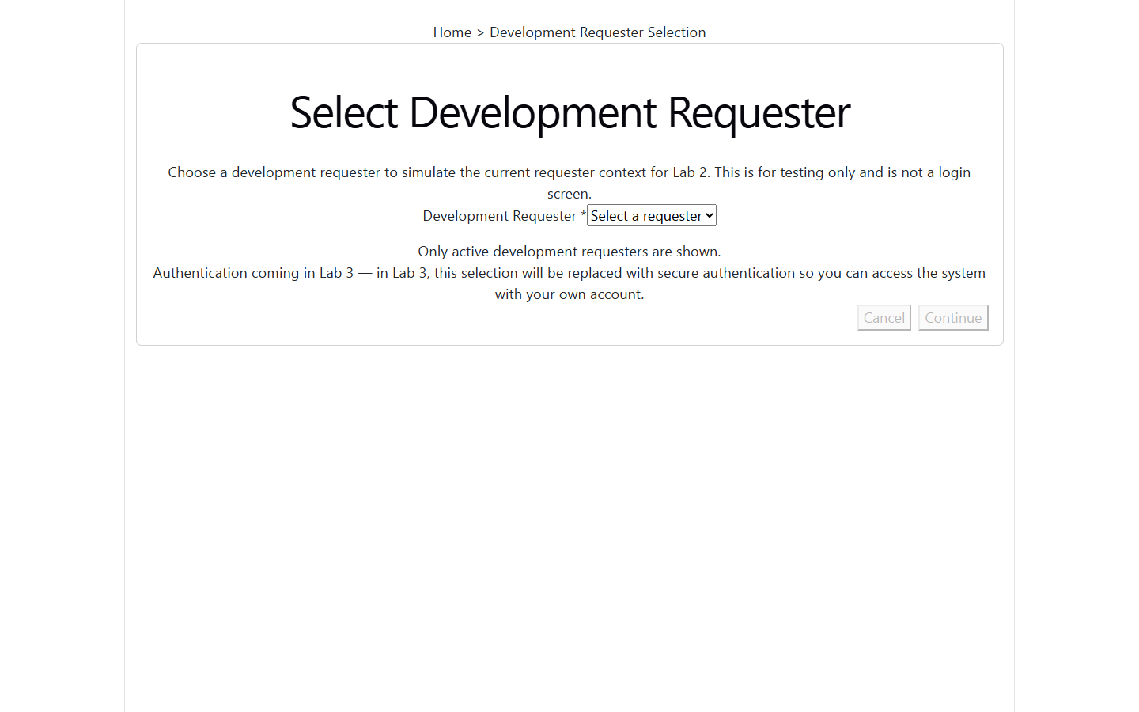
Development Requester Selection screen, initial load (select-requester/desktop-initial.png)
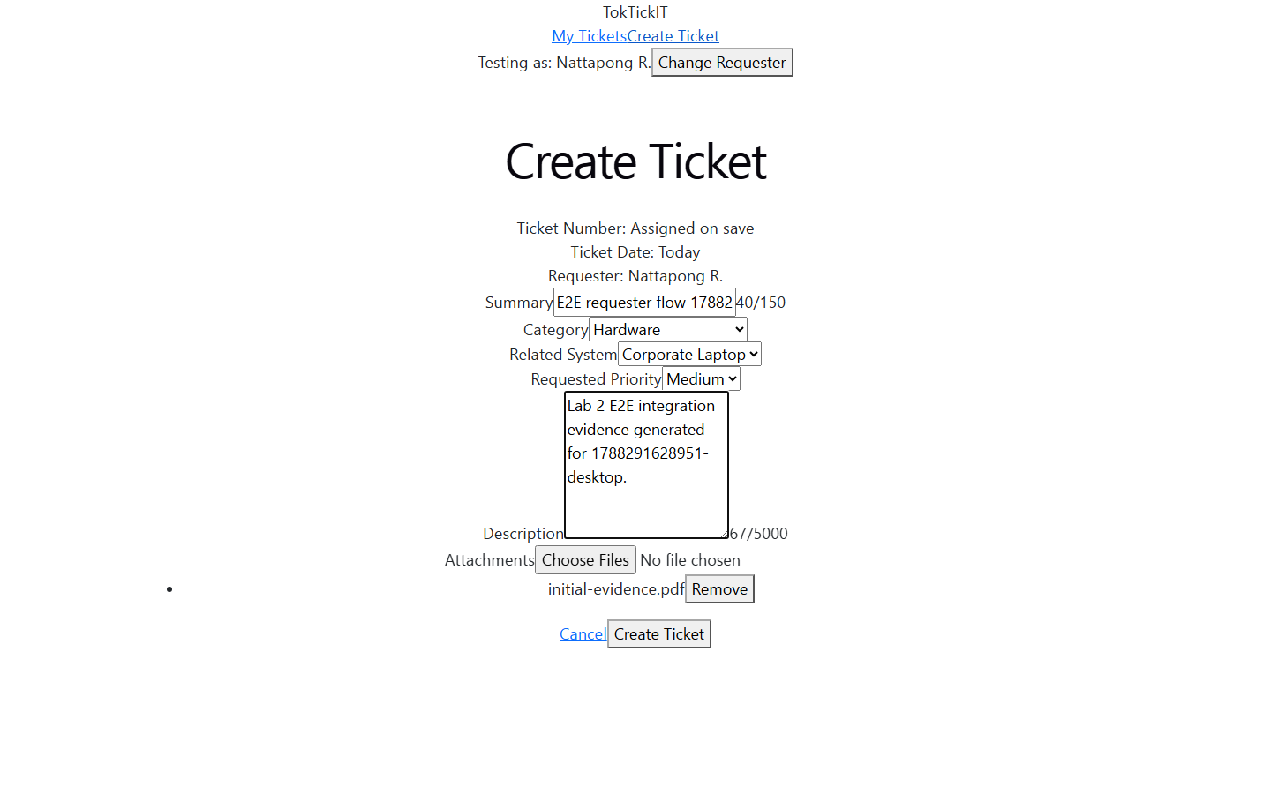
Create Ticket form filled, Requester field populated from the selected Development Requester (create-ticket/desktop-filled.png)
States not yet captured:
[SCREENSHOT NEEDED: Development Requester dropdown open]
[SCREENSHOT NEEDED: Change Requester action / selected-user display banner]
[SCREENSHOT NEEDED: Development Requester list loading state and failure state]
[SCREENSHOT NEEDED: Create Ticket invalid submission showing field-level validation messages]
[SCREENSHOT NEEDED: Create Ticket submitting/busy state]
[SCREENSHOT NEEDED: Create Ticket success state showing the official TKT- ticket number]
[SCREENSHOT NEEDED: saved ticket's requesterId matching the selected requester, e.g. an API response or DB row]
[SCREENSHOT NEEDED: one valid + one invalid attachment on the create form, with the invalid one's rejection message]
[SCREENSHOT NEEDED: backend/API failure on submit with form values preserved]
Answer Part 7: (Working My Tickets Screen)
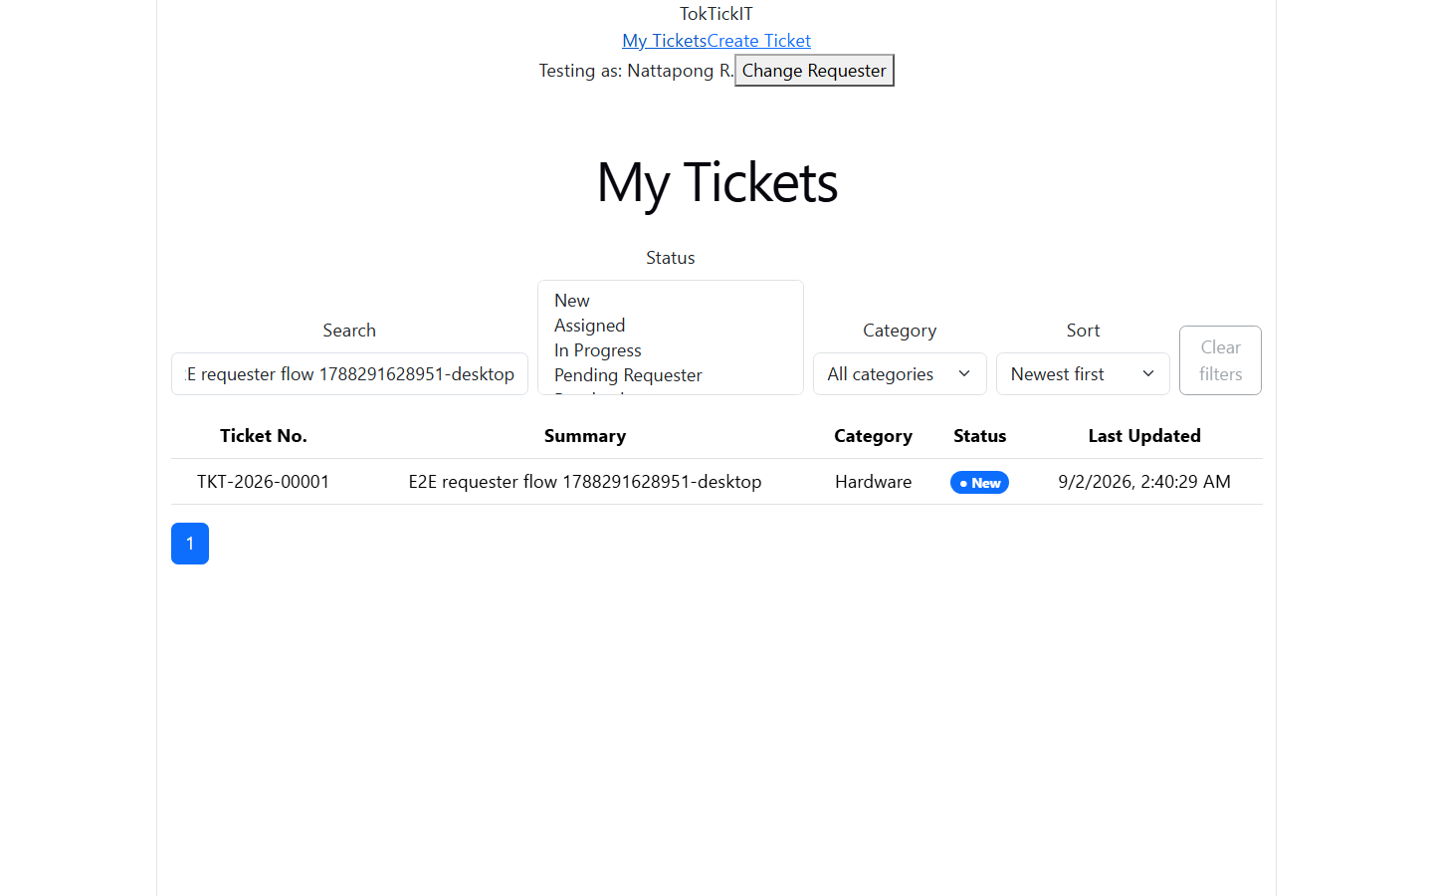
My Tickets list with filters applied (my-tickets/desktop-filtered.png)
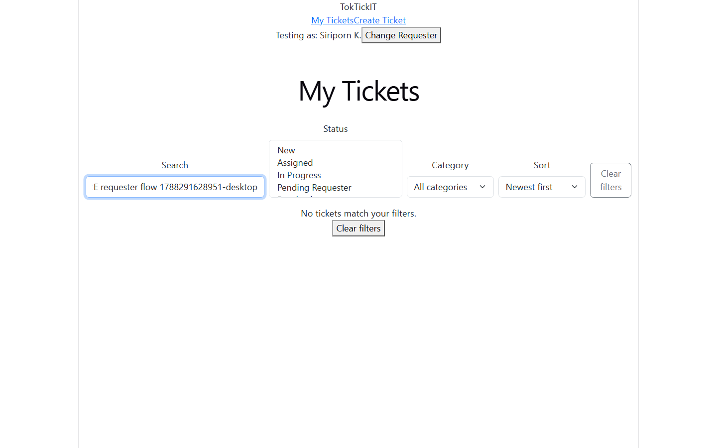
My Tickets after switching to a different Development Requester: the prior requester's tickets are gone (my-tickets/desktop-isolated-empty.png)
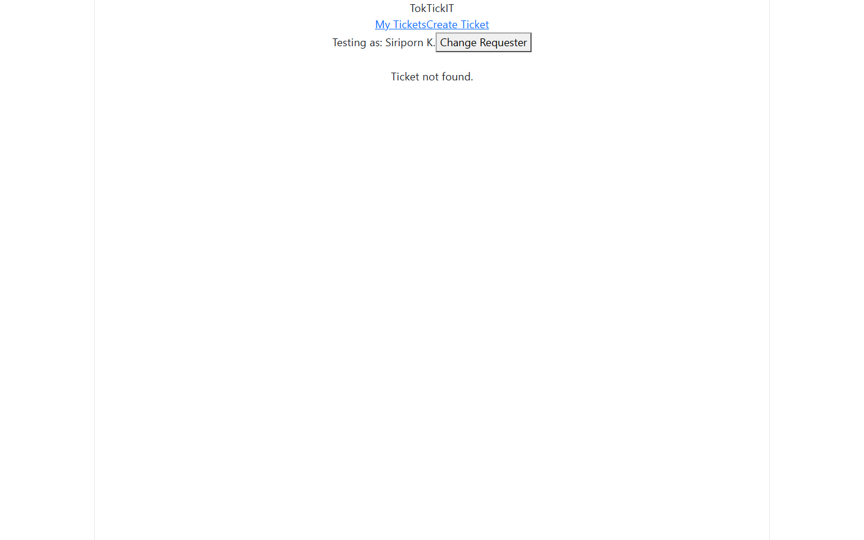
Direct navigation to another requester's ticket returns a generic Ticket not found message (ticket-detail/desktop-foreign-not-found.png)
States not yet captured:
[SCREENSHOT NEEDED: My Tickets unfiltered full list for one requester]
[SCREENSHOT NEEDED: search box in use]
[SCREENSHOT NEEDED: sort control changed and resulting order]
[SCREENSHOT NEEDED: pagination controls with more than one page of results]
[SCREENSHOT NEEDED: true empty state (zero tickets ever) versus no-results-for-filters state, if the app distinguishes the two - check client/src/pages/MyTicketsPage.tsx for the exact wording of each]
Answer Part 8: (Working Ticket Screen: View Mode and Attachments)
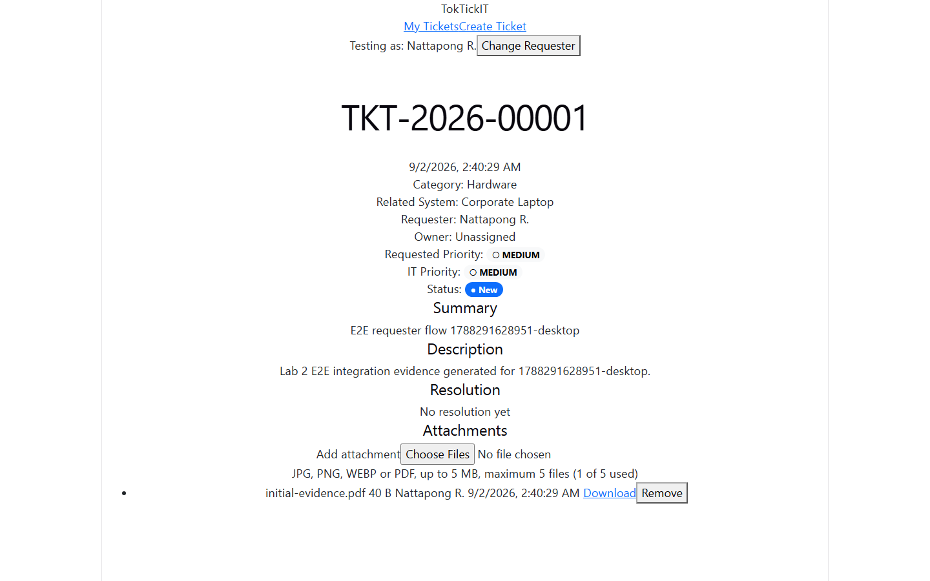
Owned Ticket Detail, read-only fields plus Attachments section (ticket-detail/desktop-initial.png)
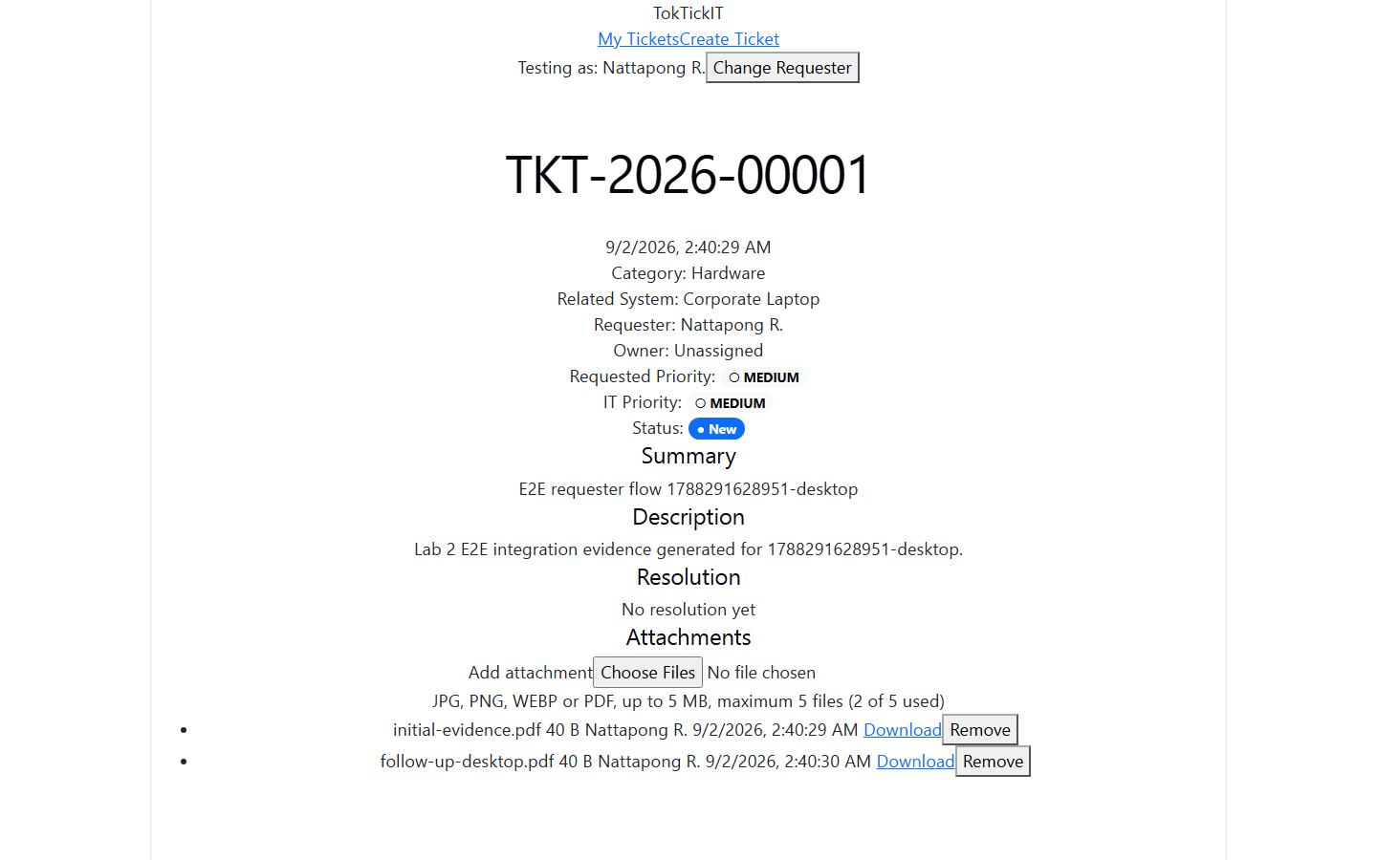
Attachment added and active (ticket-detail/desktop-active-attachment.png)
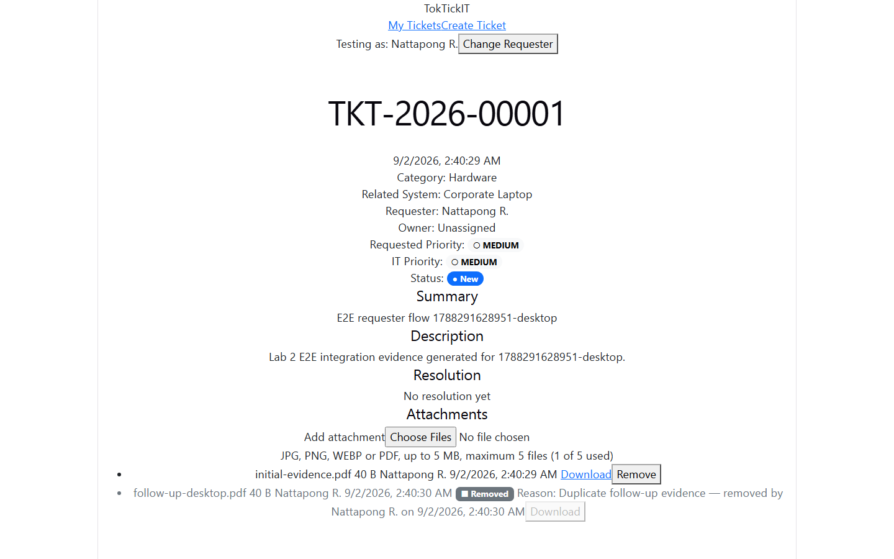
Attachment soft-removed with reason, metadata retained (ticket-detail/desktop-removed-attachment.png)
States not yet captured:
[SCREENSHOT NEEDED: downloading an active attachment]
[SCREENSHOT NEEDED: the removal-confirmation dialog itself, before confirming]
[SCREENSHOT NEEDED: blocked download of a removed attachment, e.g. the 410 API response]
[SCREENSHOT NEEDED: unauthorized access to a different requester's attachment, e.g. the 404 API response]
Answer Part 9: (Zen Green UI and Responsive Evidence)
Link: https://github.com/Bank848/toktickit/blob/main/docs/lab-02/ui-spec.md
Rendered copy of docs/lab-02/ui-spec.md, in full:
TokTickIT — Lab 2 UI Specification
Status: Reconciled 2026-08-21, third pass, against the actual official Lab 2 labsheet (§7 "Zen Green Theme UI Specification" and §17 "Appendix C. Suggested ui-spec.md Checklist"). Implements the labsheet's mandatory Zen Green design tokens, full component-state set, and responsive presentation rules. Extends the SDS System-Wide UI Standards (references/TokTickIT-System-Level-SDS-v1.0.md) — shared component treatment, form labelling, focus visibility, WCAG 2.2 AA target — with Lab 2's concrete tokens and screens.
1. Zen Green Design Tokens
Table below matches the labsheet's §7 token table exactly (page 8), including the rows the earlier draft of this spec omitted (Surface/cards, Editable field, Read-only field, Warning).
Token / Element | Value | Required Style (per labsheet) | Contrast note
Primary green | #006B3C | App header, primary actions, strong emphasis | White text on #006B3C ≈ 6.6:1 (AA)
Secondary green | #0B7A46 | Active tabs, focus accents, links, hover states | On page background ≈ 5.4:1 (AA)
Pale green | #EAF6EF | Selected, success, and subtle section emphasis | Paired only with the Text token — high contrast
Page background | #F5F7F6 | Application background (or similarly quiet near-white) | Text on it ≈ 15:1
Surface / cards | White (#FFFFFF) | White with subtle border and restrained shadow | Cards sit above the page background
Text | #1F2937 | Dark charcoal-green, not pure black, for comfortable reading | On page background ≈ 15:1
Editable field | White background, #7A8B80 border | White background with clear neutral border | Distinct from read-only fields
Read-only field | #F0F3F1 background | Soft gray-green shading, clearly distinct but still readable | Never the same fill as an editable input
Error | #B3261E | Dark red text and border; message appears immediately below the field | On page background ≈ 6.0:1 (AA)
Warning | #8A6D1B on #FFF6DA | Amber callout or badge; never used as ordinary decoration | On page background ≈ 5.0:1 (AA)
Success | #1E7D34 | Green confirmation with readable text, never color alone | On page background ≈ 4.6:1 (AA)
Muted (supplementary) | #5B6573 | Secondary labels, metadata, timestamps | On page background ≈ 5.1:1 (AA)
Border/icon (supplementary) | #7A8B80 | Borders, dividers, non-text decorative icons | Non-text; no AA text requirement

Status and priority badges use text + an icon, never color alone (SDS System-Wide UI Standards). Badge background tints use Zen Green Pale or the neutral/warning/danger surfaces above with the corresponding dark text color, not raw Primary/Secondary (those are reserved for header/ primary-action chrome so the palette does not read as "everything is a button").
Verification checklist (screenshot/computed-style check, per review request): app header and primary buttons render #006B3C; secondary actions, the active nav indicator, and the visible focus ring render #0B7A46; hover/selected rows and info banners render #EAF6EF; the page background (<body>/app shell, not individual cards) renders #F5F7F6. See tests.md for the test that asserts these computed values.
2. Global Layout
- App header (Zen Green Primary background, white text): product name "TokTickIT" (left), primary nav — My Tickets, Create Ticket (center/left-aligned per Bootstrap navbar), and the selected-requester display + "Change Requester" control (right, see §3). The active nav item is indicated with the Secondary green underline/pill, never color alone (also carries an aria-current="page").
- Content area: Bootstrap container, responsive grid, system font stack, Bootstrap spacing scale.
- Shared components (per SDS): one treatment each for forms, buttons, tables, badges, confirmation dialogs, loading/empty/error states, used identically across Create Ticket, My Tickets, and Ticket Detail.
- Mobile navigation: below the md (768 px) breakpoint, the primary nav (My Tickets, Create Ticket) collapses behind a Bootstrap navbar-toggler (hamburger) button in the header; the selected-requester display and "Change Requester" control stay visible in the collapsed header bar rather than moving into the collapsed menu. Expanding the toggler shows the nav items stacked full-width; it closes on item selection or on a second toggle press. This satisfies the labsheet's §8 "responsive mobile navigation" requirement.
Typography and Spacing
- Font stack: system font stack (-apple-system, "Segoe UI", Roboto, Helvetica, Arial, sans-serif) — no custom web font is loaded in Lab 2.
- Type scale: page/section headings 1.25rem/600 weight; field labels and table headers 0.875rem/600; body text and input values 1rem/400; helper/muted text and timestamps 0.8125rem/400 using the Muted token.
- Spacing: Bootstrap's default spacing scale (0.25rem increments) throughout; form fields use 1rem vertical gap between rows, 0.5rem between a label and its control; cards use 1.5rem internal padding on desktop, 1rem on mobile.
Button hierarchy (labsheet §17)
Style | Visual | Use
Primary | Solid Zen Green Primary fill, white text | The one main action per screen (Create Ticket submit, Continue on the selector)
Secondary | White fill, Zen Green Secondary border and text | Supporting actions alongside a primary (e.g. "Clear filters" next to search)
Tertiary | No fill, no border, Zen Green Secondary text, underline on hover | Low-emphasis actions (e.g. "Cancel" links back to a list)
Destructive | White fill, Danger border and text; solid Danger fill on confirm-dialog submit | Attachment removal confirm
Disabled | Muted gray fill/border/text, cursor: not-allowed, aria-disabled="true" | Any button whose action cannot currently be taken (e.g. Continue with nothing selected)
Busy | Primary/Destructive styling plus an inline spinner, text unchanged, aria-busy="true", click-disabled | Submit while the request is in flight

Icon-only controls (e.g. a table-row remove icon) always carry a visible text label via aria-label and a hover tooltip — an icon never replaces the required visible text on a button.
3. Development Requester Selection (D-18, labsheet §8.1)
Route: /dev/select-requester (also the fallback the app redirects to whenever no valid requester is currently selected).
Layout (matches the labsheet's §8.1 illustration): a centered card below the app header and a "Home > Development Requester Selection" breadcrumb, containing, top to bottom:
1. An icon and the title "Select Development Requester."
2. One line of explanatory text: "Choose a development requester to simulate the current requester context for Lab 2. This is for testing only and is not a login screen."
3. A labelled Development Requester dropdown (required, red asterisk), populated from GET /api/v1/dev/requesters (active Requesters only).
4. An info line, Zen Green Pale surface with an info icon: "Only active development requesters are shown."
5. A secondary note, neutral surface with a shield icon: "Authentication coming in Lab 3 — in Lab 3, this selection will be replaced with secure authentication so you can access the system with your own account."
6. Two buttons, right-aligned: Cancel (tertiary — no-ops back to the header/home when a prior selection exists, disabled with no effect when this is the first-load fallback) and Continue (primary; disabled until a Requester is chosen).
Choosing a Requester and activating Continue calls POST /api/v1/dev/session with the selected user id; on success the app navigates to My Tickets. The dropdown and both buttons are fully keyboard-operable (Tab to focus, Enter/Space/arrow keys per native <select> and <button> semantics — no custom widget that breaks native keyboard behavior).
States: loading (dropdown shows a disabled "Loading requesters…" placeholder while the fetch is in flight), empty (no active Requesters seeded — a labelled error state with guidance, not a silent empty dropdown, since the app is unusable without at least one), API-failure (the fetch itself failed — an inline error banner with a Retry action, Continue stays disabled).
Header integration: once a requester is selected, the app header shows "Testing as: <display name>" and a "Change Requester" button. Activating it clears the stored selection (sessionStorage, not a cookie) and navigates to /dev/select-requester. Any in-flight or cached requester-scoped data (My Tickets list, an open Ticket Detail) is discarded on switch — the next screen always re-fetches fresh, scoped to the newly selected requester. This is asserted directly in E2E (see tests.md).
4. Create Ticket
Route: /tickets/new.
Single-column card. Fields, in order:
1. Ticket Number, Ticket Date, Requester — read-only display fields (Read-only-field token background, #F0F3F1), shown near the top per the labsheet's §8.2 "system-generated fields near the top" arrangement. Ticket Number and Ticket Date show placeholder text ("Assigned on save" / "Today") until the ticket is created; Requester shows the currently selected Development Requester's display name. None of the three is ever rendered as an editable input or accepted from the request body.
2. Summary — text input, required, live character counter to 150.
3. Category — select, required, active categories only, placeholder "Select a category".
4. Related System — select, optional, "Not applicable" default, active related systems only.
5. Requested Priority — select, required, default Medium.
6. Description — textarea, 6 rows, required, character counter to 5000.
7. Attachments — file picker (multi-select), accepting .jpg .jpeg .png .webp .pdf, client- side pre-check of extension and size (advisory only — server re-validates everything, per api-spec.md). Staged files are listed with a remove-before-submit control; nothing uploads until the ticket itself is created.
Actions: Create Ticket (primary, Zen Green Primary) and Cancel (link back to My Tickets).
Submit sequence (FR-11): POST /tickets first; on success, for each staged file, upload via POST /tickets/:id/attachments in sequence; navigate to the new Ticket Detail regardless of individual upload outcomes, with a per-file success/failure summary shown as a dismissible alert on Ticket Detail if any upload failed ("2 of 3 files attached. 1 failed: invoice.exe — file type not allowed. Retry from Attachments below."). The ticket itself is never rolled back or hidden because an attachment upload failed.
States: loading (initial categories/related-systems fetch), empty (no active categories — form disabled with guidance, since a ticket cannot be created without one), submitting (double-submit disabled, spinner on the button), field errors (validation messages associated with their inputs via aria-describedby, all entered input preserved, first invalid field receives focus), global error with retry (network/server failure on submit), success (navigate to Detail with a success alert carrying the new ticket number).
5. My Tickets
Route: /tickets.
Filter bar (above the table/cards): search input (placeholder "Search by ticket number or summary"), status multi-select, category select, a Sort control (whitelist per api-spec.md #7: Newest first (default), Oldest first, Recently updated, Ticket No.), and a secondary "Clear filters" button that resets search/filters/sort to their defaults and is disabled when nothing is active — all combined with AND semantics (D-17/BR-13). Changing any filter, the sort, or the search box (debounced ~300 ms) refetches and resets to page 1.
Desktop (≥ md, 768 px): table — columns Ticket No., Summary, Category, Status, Last Updated. Status shown as a text+icon badge, never color alone.
Mobile (< md): the same rows render as stacked cards (label: value pairs), per the SDS "card layout" responsive requirement — never a horizontally scrolling table.
Row selection: clicking a row/card navigates to that ticket's Detail (FR-17).
Pagination: page-size-aware controls below the list, standard Bootstrap pagination component.
States: loading (skeleton rows/cards), two distinct empty states — "You haven't created any tickets yet" (no filters/search active, zero total tickets) versus "No tickets match your filters" (filters/search active, zero results) with a "Clear filters" action on the latter, error with retry.
6. Ticket Detail
Route: /tickets/:id.
Header block: ticket number, date, category, related system ("Not applicable" when none was selected), requester, owner ("Unassigned" — always, in Lab 2), Requested Priority badge, IT Priority badge, current status badge, summary, description, resolution summary ("No resolution yet" — always, in Lab 2) — matching specification.md FR-18's full field list.
Attachments section (corrected 2026-08-21: no tab chrome, no Service Actions placeholder, no Event Log — Lab 2 Ticket Detail is read-only fields plus the attachment lifecycle only, per review). Renders directly below the header block: upload control (constraints stated in visible text: "JPG, PNG, WEBP or PDF, up to 5 MB, maximum 5 files", count shown as "3 of 5 used", disabled at 5 active). List rows: filename, size, uploader, upload date, Download (active attachments only), Remove (own uploads only, while ticket is not Closed). Removed attachments remain in the list, visually de-emphasized (muted text, a "Removed" badge with icon), showing filename, uploader, original upload date, removal reason, remover, and removal date — Download/preview is replaced with a disabled control (never a working link to the deleted binary). Removing an attachment opens a confirmation dialog requiring a reason (required text field, 1..200 characters, submit disabled until non-empty) before the request is sent. Empty state (zero attachments ever, not even removed ones): "No attachments yet."
Attachment states (labsheet §17 checklist):
State | Presentation
Active | Normal row: filename, size, uploader, date, working Download, Remove shown only for the current requester's own uploads
Uploading | Row shows the staged filename with a progress/busy indicator in place of Download/Remove; not yet persisted
Invalid | Client-side pre-check (wrong extension or over 5 MB) renders an inline error next to the staged file and blocks it from being included in the upload request; the server re-validates independently and returns the same class of error if a client check is bypassed
Removed | De-emphasized (muted text, "Removed" badge with icon), shows reason/remover/removal date, Download replaced with a disabled control — never a working link to the deleted binary
Unavailable | If a fetch for the attachment list itself fails, the whole section shows an inline error with Retry rather than a partial/broken list

Not part of Lab 2 (removed 2026-08-21): a Service Actions tab/placeholder and an Event Log tab. TICKET_CREATED/ATTACHMENT_ADDED/ATTACHMENT_REMOVED events are still written for audit continuity (BR-11/BR-15) but are not read back or displayed anywhere in Lab 2 — no events endpoint, no Event Log UI. Public Comments remain out of scope per D-15.
States: loading, not-found/not-accessible (404, corrected 2026-08-22 PR #14 peer review, D-24 — a generic "Ticket not found" message, never revealing whether the ticket exists; 403 would have confirmed existence, so it's never used here), error with retry.
7. Responsive Rules (D-19/NFR-04, labsheet §8.7)
Viewport | Required Behavior
Desktop ≥ 992 px | Multi-column layout as specified in §4/§5/§6; content centered with a sensible maximum width
Tablet 768–991 px | Two-column layout where practical; Summary and Description receive enough width
Mobile < 768 px | Fields stack vertically; buttons remain touch-friendly (≥ 44×44 CSS px); no horizontal page scrolling
All sizes | No clipped labels, overlapping messages, hidden buttons, or unreadable attachment names

My Tickets switches table → stacked-card layout at the 768 px boundary (§5). Verified in E2E at a sub-768px viewport (see tests.md E2E-01) and by the manual/screenshot checklist in tests.md §4.
Screenshot path convention: artifacts/lab-02/screenshots/create-ticket/, .../my-tickets/, .../ticket-detail/, one subfolder per screen, filenames stating the viewport and state (e.g. create-ticket/mobile-validation-failure.png).
8. Accessibility (WCAG 2.2 AA)
- Every form control has a programmatic label; validation messages are associated with their field via aria-describedby and announced to assistive tech on submit failure.
- Keyboard focus is visible (a Zen Green Secondary focus ring, never suppressed) and follows a logical tab order; the confirmation dialog (attachment removal) traps focus and returns it to the control that opened it on close.
- Status/priority/removed-attachment states communicate via text and icon, never color alone.
- The Development Requester Selection list and My Tickets rows/cards are fully operable by keyboard (Tab to focus, Enter/Space to activate).
Responsive screenshots (desktop / tablet / mobile)
 | 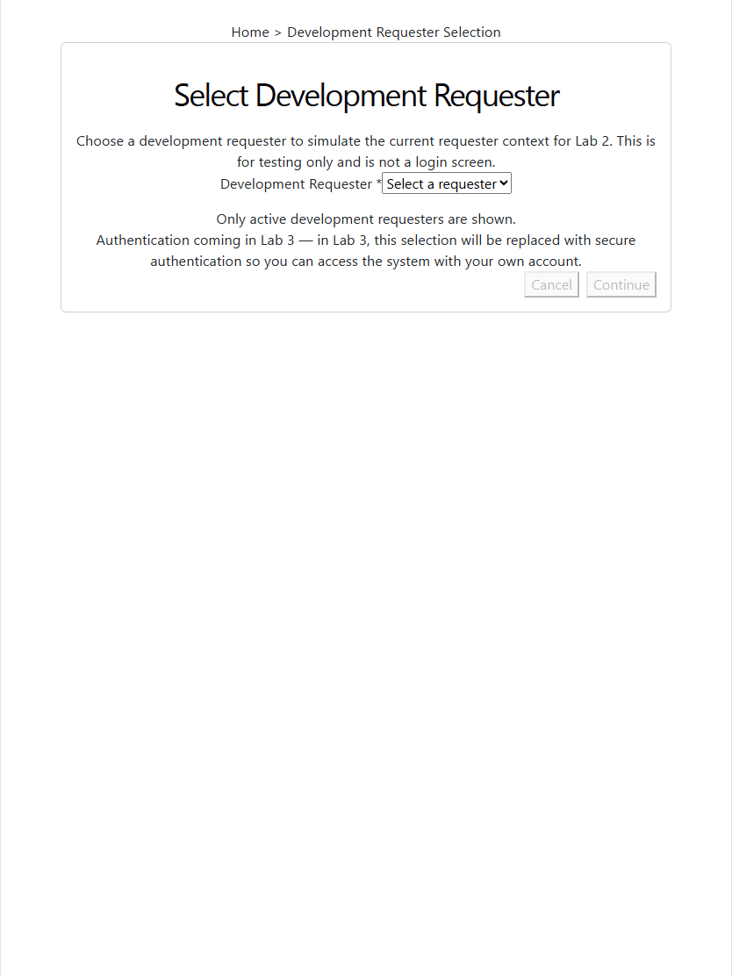 | 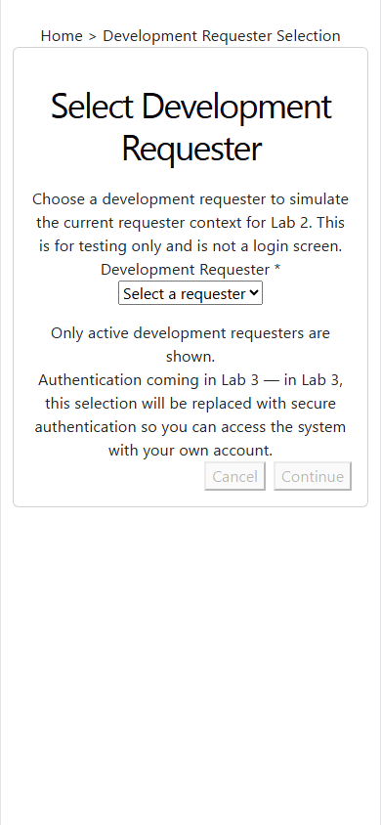
Desktop: select-requester/desktop-initial.png | Tablet: select-requester/tablet-initial.png | Mobile: select-requester/mobile-initial.png
Development Requester Selection at desktop 1440 px, tablet 834 px, and mobile 390 px widths
 | 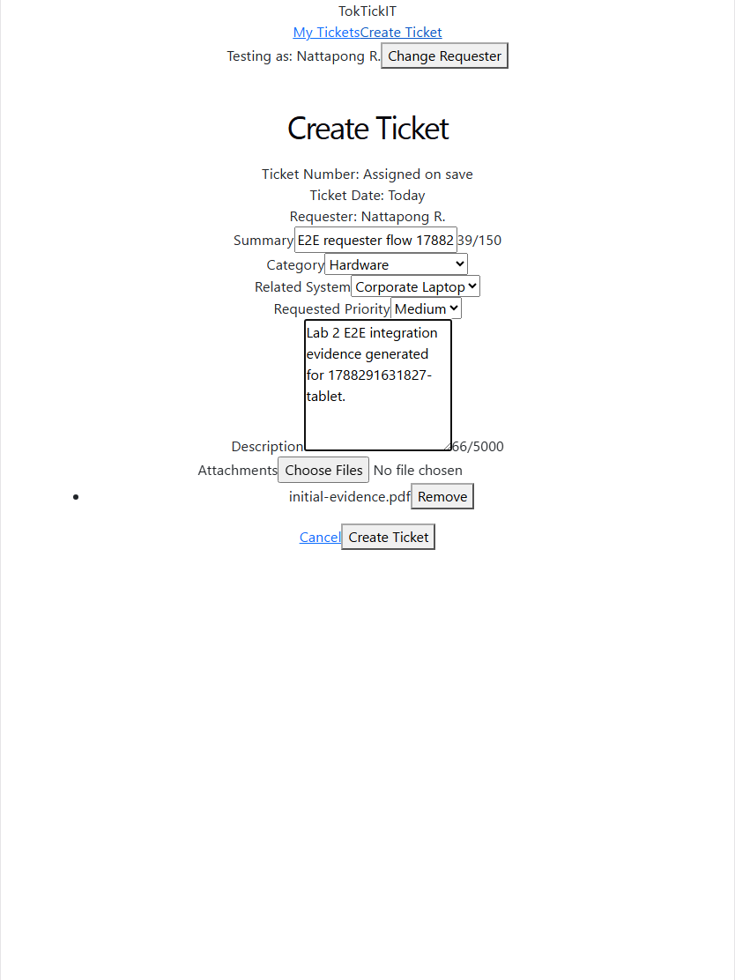 | 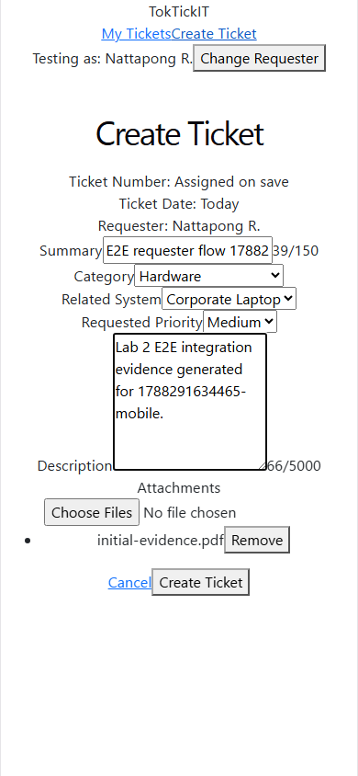
Desktop: create-ticket/desktop-filled.png | Tablet: create-ticket/tablet-filled.png | Mobile: create-ticket/mobile-filled.png
Create Ticket, form filled with one staged attachment, at the three widths
 | 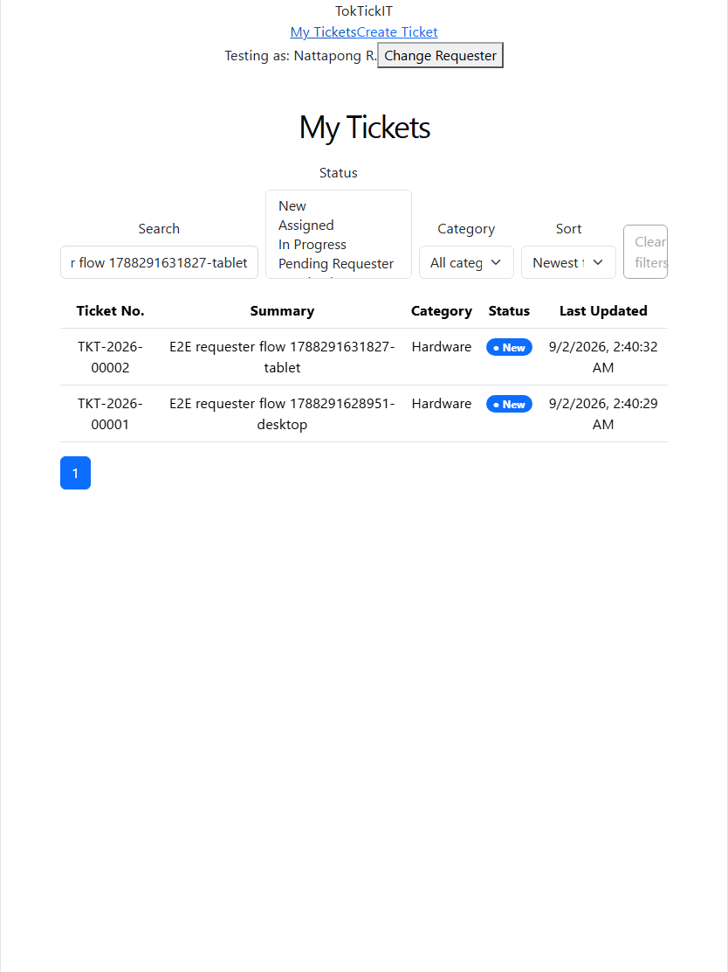 | 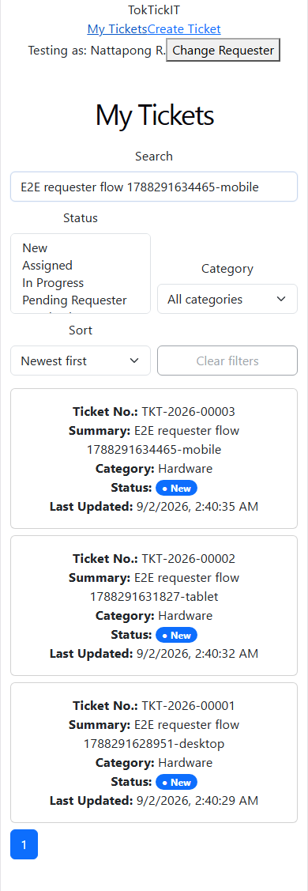
Desktop: my-tickets/desktop-filtered.png | Tablet: my-tickets/tablet-filtered.png | Mobile: my-tickets/mobile-filtered.png
My Tickets with search text applied; table on desktop and tablet, stacked cards on mobile
 | 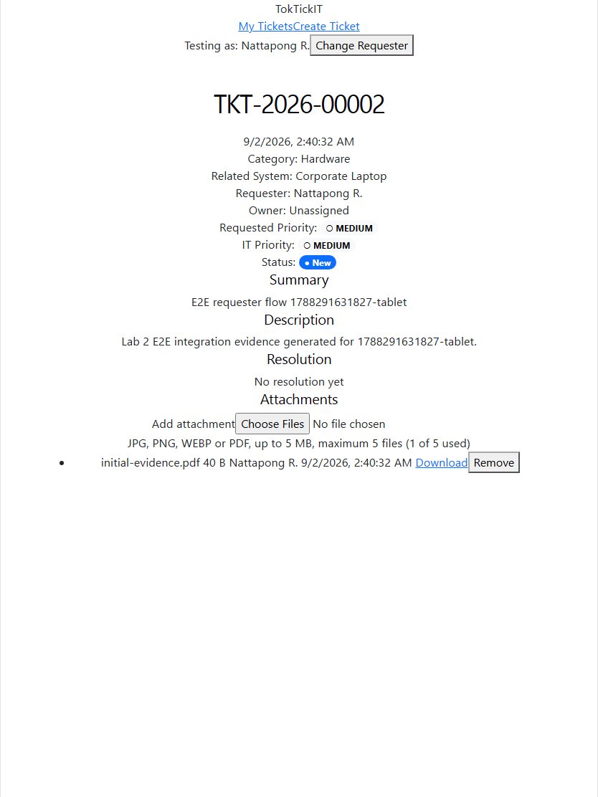 | 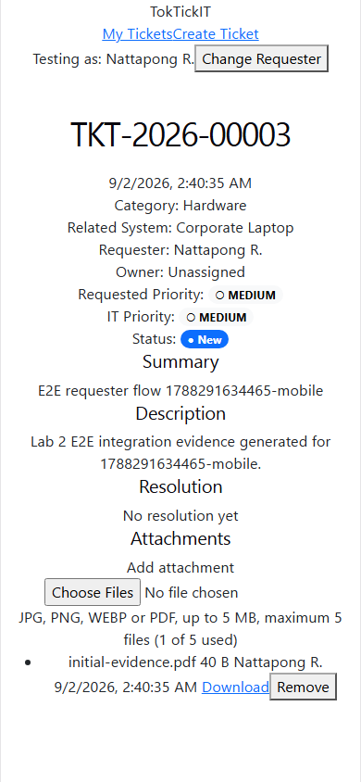
Desktop: ticket-detail/desktop-initial.png | Tablet: ticket-detail/tablet-initial.png | Mobile: ticket-detail/mobile-initial.png
Ticket Detail with one active attachment at the three widths
Visual checklist
Each cell records what the embedded screenshot actually shows. Where a screenshot cannot settle an item, the cell says so instead of claiming a pass.
Item | Desktop | Tablet | Mobile
Colors (Zen Green tokens: #006B3C header and primary buttons, #F5F7F6 page background) | Not met in screenshot: header renders as plain text on white, buttons use default browser styling, status badge is Bootstrap blue (create-ticket/desktop-filled.png, my-tickets/desktop-filtered.png) | Not met in screenshot: same default styling (create-ticket/tablet-filled.png, my-tickets/tablet-filtered.png) | Not met in screenshot: same default styling (create-ticket/mobile-filled.png, my-tickets/mobile-filtered.png)
Editable vs read-only fields | Partial: read-only Ticket Number / Ticket Date / Requester render as plain text lines and editable fields as inputs, so the two are distinguishable, but the #F0F3F1 read-only shading is not visible (create-ticket/desktop-filled.png) | Partial, same as desktop (create-ticket/tablet-filled.png) | Partial, same as desktop (create-ticket/mobile-filled.png)
Validation placement | Not verifiable from screenshot (no validation-failure capture exists) | Not verifiable from screenshot | Not verifiable from screenshot
Button hierarchy (primary / secondary / tertiary / disabled) | Partial: Cancel is a link and Create Ticket a button, Clear filters and Continue show a disabled state, but no primary fill colour distinguishes the main action (create-ticket/desktop-filled.png, select-requester/desktop-initial.png) | Partial, same as desktop (create-ticket/tablet-filled.png, select-requester/tablet-initial.png) | Partial, same as desktop (create-ticket/mobile-filled.png, select-requester/mobile-initial.png)
Clipping | Pass: no clipped labels or buttons (my-tickets/desktop-filtered.png, ticket-detail/desktop-initial.png) | Not met in screenshot: the Clear filters button text is cut at the right edge of the filter bar (my-tickets/tablet-filtered.png) | Pass: no clipped labels or buttons (my-tickets/mobile-filtered.png, ticket-detail/mobile-initial.png)
Overlap | Not met in screenshot: the Description textarea covers part of its character counter (create-ticket/desktop-filled.png) | Not met in screenshot: same Description counter overlap (create-ticket/tablet-filled.png) | Not met in screenshot: same Description counter overlap (create-ticket/mobile-filled.png)
Horizontal overflow | Pass: content fits inside the 1440 px viewport (all four desktop screenshots) | Pass: content fits inside the 834 px viewport (all four tablet screenshots) | Pass: content fits inside the 390 px viewport and My Tickets switches to stacked cards (my-tickets/mobile-filtered.png)

