Game Ready 3D Hair Model from Small Set of Images

# Nuttapon Vanakittistien1 Attawith Sudsang1 Nuttapong Chentanez1,2

## 1Department of Computer Engineering, Faculty of Engineering, Chulalongkorn University

## 2NVIDIA

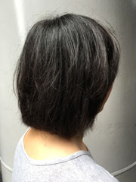 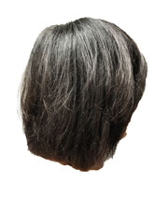 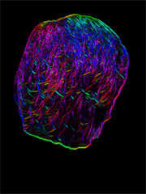 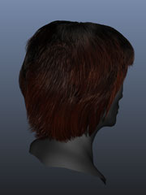 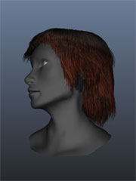 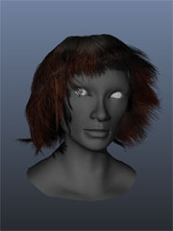

Project Materials:

[Executable Files Demo](http://isl2-dev.cp.eng.chula.ac.th/~dae/bank/demo.zip)

[Camera Web App](http://isl2-dev.cp.eng.chula.ac.th/~dae/bank/cam_test/main.html)

Supplementary Video

Demo Video

Code (Coming soon…)