PlateBack Lite: Predicting Food Demand and Simulating Food Waste Reduction Using Machine Learning

2. Abstract
Multi-centre meal-delivery and commercial catering operations must determine meal preparation quantities ahead of realized weekly customer demand. Forecast inaccuracies impose asymmetric operational costs: over-prediction generates excess prepared meals, whereas under-prediction causes stockouts and unserved customer demand. This paper presents PlateBack Lite, a reproducible machine learning pipeline that forecasts weekly meal demand (num_orders) across fulfilment centres and evaluates the operational consequences of prediction-guided meal preparation through a policy simulation. We evaluate our framework on the public Genpact Food Demand Forecasting dataset, which comprises 456,548 weekly order records spanning 145 weeks across 77 fulfilment centres and 51 distinct meals (14 categories and 4 cuisines). To prevent look-ahead bias and target leakage, we enforce a strict chronological split—training on Weeks 1–116 (361,348 observations) and evaluating on held-out Weeks 117–145 (95,200 observations)—and construct causal historical demand features that rely strictly on past observations prior to each prediction week (with a zero-history constant fallback of 0.0 in Week 1 to eliminate contemporaneous target leakage). We compare a training-period Historical Average Baseline against Linear Regression, Random Forest Regressor, and Gradient Boosting Regressor pipelines incorporating pricing discounts, promotional exposure flags, categorical metadata, cyclical seasonality, and causal historical demand summaries. On the held-out test set, the Gradient Boosting Regressor achieved the best statistical forecasting performance across all point-prediction metrics (MAE = 80.8407, RMSE = 172.8451, R² = 0.7760), followed by the Random Forest Regressor (MAE = 82.5332, RMSE = 178.1692, R² = 0.7620) and Linear Regression (MAE = 104.9161, RMSE = 220.4739, R² = 0.6356), all improving over the Historical Average Baseline (MAE = 109.7701, RMSE = 248.9597, R² = 0.5353). We then simulate a weekly meal-preparation policy with a +5.0\% safety buffer across the 23,618,862 total test-period meal orders, revealing a clear distinction between the optimal model for simulated surplus minimization and the optimal model for service-level maximization. Relative to the historical-average preparation policy (6,693,322 simulated surplus units; 4,234,976 simulated shortage units; 82.07\% demand served), Gradient Boosting achieved the lowest simulated surplus (4,350,038 units, a -35.01\% relative change vs. baseline, while serving 85.11\% of demand with 3,517,907 shortage units), whereas Random Forest achieved the lowest simulated shortage (3,333,045 units) and highest percentage of demand served (85.89\%, while reducing simulated surplus by -28.99\% to 4,753,258 units). Because the underlying dataset records fulfilled order counts rather than physical kitchen leftovers, all surplus and shortage metrics represent simulated operational proxies under explicit policy assumptions rather than empirically measured or real-world food waste reduction.

3. Keywords
Food demand forecasting; machine learning; gradient boosting; random forest; perishable inventory simulation; meal preparation policy; chronological validation; leakage prevention.

4. Introduction
Commercial food preparation and meal-delivery fulfilment centres operate under strict perishability and lead-time constraints. Culinary teams and fulfilment managers must procure ingredients and prepare meal batches before observing actual customer order volumes. When weekly preparation quantities are set using static rules of thumb or unadjusted historical averages, sudden demand fluctuations driven by promotional campaigns or price discounts produce substantial operational inefficiencies. Specifically, preparing more meal units than customers order creates excess prepared inventory (operational surplus), whereas preparing fewer units than demanded results in stockouts (unmet demand), lost revenue, and diminished customer trust.
While machine learning (ML) methods have been widely studied for retail and hospitality demand forecasting (Rodrigues et al., 2024; Hübner et al., 2024), two methodological challenges frequently complicate empirical evaluations in student and applied research projects. First, random train/test splitting or global target-encoding across time series introduces temporal data leakage, artificially inflating test-set accuracy by allowing future demand signals to inform past predictions. Second, evaluating forecasting models solely through symmetric statistical error metrics—such as Mean Absolute Error (MAE) or Root Mean Squared Error (RMSE)—does not directly reveal how forecast errors translate into operational trade-offs between over-preparation surplus and customer service levels under a buffered preparation policy.
In this study, we design, audit, and evaluate PlateBack Lite, a lightweight and reproducible machine learning system built on the public Genpact Food Demand Forecasting dataset (456,548 records across 77 fulfilment centres and 51 meals over 145 weeks). Our work addresses both methodological rigour and operational interpretability:
1. We implement a strictly chronological train/test split (training on Weeks 1–116; testing on Weeks 117–145) paired with a causal feature engineering pipeline that eliminates both future look-ahead leakage and Week 1 contemporaneous target leakage.
2. We benchmark four lightweight models suitable for standard CPU execution—a Historical Average Baseline, Linear Regression, Random Forest Regressor, and Gradient Boosting Regressor—using unified scikit-learn preprocessing pipelines.
3. We couple the held-out test forecasts with an explicit, auditable meal-preparation simulation incorporating a +5.0\% safety buffer, quantifying how each forecasting model affects simulated surplus, simulated shortage, and percentage of customer demand served.
4. We maintain a strict conceptual and reporting distinction between statistical prediction accuracy on order counts (num_orders) and simulated preparation outcomes, explicitly documenting why simulated surplus on order data is an operational proxy rather than measured physical kitchen waste.

5. Related Work

5.1 Machine Learning for Food and Catering Demand Forecasting
Short-horizon demand forecasting in food service and catering operations requires modelling both baseline item popularity and exogenous demand shifters such as pricing and marketing promotions. Rodrigues et al. (2024) evaluated machine learning models for short-term demand forecasting in food catering services, showing that data-driven demand predictions can inform meal production planning to mitigate overproduction. Similarly, Hübner et al. (2024) examined machine-learning-based demand forecasting in a bakery case study, linking improved demand forecasts to reductions in overbaked surplus and associated life-cycle environmental impacts. On the Genpact Food Demand Forecasting benchmark specifically, Panda and Mohanty (2023) analyzed time-series and regression approaches for supply chain demand modelling, highlighting the importance of centre-level and meal-level attributes alongside promotional indicators.

5.2 Classical Regression Ensembles on Tabular Demand Data
For structured tabular datasets with heterogeneous numerical and categorical features, tree-based ensemble methods remain strong, computationally tractable baselines. Random Forests (Breiman, 2001) reduce variance by averaging predictions across bootstrap-aggregated decision trees trained on random feature subsets, capturing non-linear interactions without extensive hyperparameter tuning. Gradient Boosting Machines (Friedman, 2001) sequentially fit shallow regression trees to the negative gradient of the loss function, reducing both bias and variance. Unlike deep neural networks, classical linear and tree-based models implemented in scikit-learn (Pedregosa et al., 2011) run reproducibly on standard desktop hardware and allow straightforward inspection of preprocessing pipelines.

5.3 Perishable Preparation Policies and Safety Buffers
Translating point demand forecasts into production quantities is a classical problem in perishable inventory management (Arrow et al., 1951). When demand is uncertain and unserved orders cannot be backlogged across weeks, kitchens typically apply a proportional safety buffer α > 0 above the point forecast D̂ to protect service levels against upward demand variance. In such settings, forecast errors manifest asymmetrically: static historical averages fail to anticipate promotional surges (causing large stockouts during promoted weeks) while over-preparing during unpromoted weeks when prices return to baseline.

6. Research Questions and Contributions
This study investigates three empirical research questions:
- RQ1 (Forecasting Accuracy): Under a strict chronological train/test split free of target leakage, to what extent do supervised regression models (Linear Regression, Random Forest Regressor, and Gradient Boosting Regressor) utilizing pricing, promotional, metadata, and causal historical features reduce held-out test error (MAE, RMSE, and R²) compared with a training-period Historical Average Baseline?
- RQ2 (Simulated Surplus Reduction): When weekly meal preparation quantities are set using a +5.0\% safety buffer (Q_{c,m,t} = round(1.05 × D̂_{c,m,t})) without access to test-period actual demand, how do prediction-guided policies change total simulated surplus relative to a historical-average preparation policy?
- RQ3 (Service-Level Trade-off): Does reducing simulated surplus via machine learning predictions degrade customer demand fulfilment (increase simulated shortages), or does dynamic responsiveness to price and promotion signals improve both surplus and the percentage of demand served?

Summary of Contributions
1. Verified Leak-Free Feature Engineering: We implement and unit-test a vectorized causal feature pipeline ensuring that training features at week t depend solely on weeks < t (using a strict 0.0 constant fallback at Week 1) and test features depend solely on Weeks 1–116.
2. Empirical Model Benchmarking: Across 95,200 held-out test records, we establish that Gradient Boosting (RMSE = 172.8451, R² = 0.7760) and Random Forest (RMSE = 178.1692, R² = 0.7620) reduce test RMSE by 30.57% and 28.43% relative to the Historical Average Baseline (RMSE = 248.9597, R² = 0.5353).
3. Operational Policy Simulation: We demonstrate that while Linear Regression reduces simulated surplus by 10.78% with a slight reduction in demand served (81.65\% vs. 82.07\% baseline), non-linear tree ensembles (Random Forest and Gradient Boosting) reduce simulated surplus by 28.99% and 35.01% while simultaneously increasing total demand served to 85.89% and 85.11%.

7. Dataset Description

7.1 Relational Schema and Completeness
We use the public Genpact Food Demand Forecasting dataset (accessed via Kaggle), which contains three relational CSV files with zero missing values across all columns:
1. `train.csv` (456,548 rows × 9 columns):
- id (int64): Unique transaction record identifier.
- week (int64): Sequential week index ranging from 1 to 145.
- center_id (int64): Fulfilment centre identifier (77 unique centres).
- meal_id (int64): Meal identifier (51 unique meals).
- checkout_price (float64): Final price paid by the customer (including discounts/taxes).
- base_price (float64): Baseline menu price of the meal.
- emailer_for_promotion (int64): Binary indicator (0 or 1) for email promotional campaigns.
- homepage_featured (int64): Binary indicator (0 or 1) for homepage placement.
- num_orders (int64): Target variable representing total weekly orders fulfilled for (center_id, meal_id, week).
2. `meal_info.csv` (51 rows × 3 columns):
- Maps each meal_id (int64) to its food category (str, 14 unique categories such as Beverages, Rice Bowl, Sandwich) and cuisine (str, 4 unique cuisines: Thai, Indian, Italian, Continental).
3. `fulfilment_center_info.csv` (77 rows × 5 columns):
- Maps each center_id (int64) to city_code (int64), region_code (int64), center_type (str: TYPE_A, TYPE_B, TYPE_C), and operational area op_area (float64, in km²).

7.2 Exploratory Statistics of Merged Data
Merging train.csv with meal_info.csv (on meal_id) and fulfilment_center_info.csv (on center_id) yields 456,548 complete observations with zero duplicate (center_id, meal_id, week) keys. The target variable num_orders is right-skewed:
- Mean: 261.87 orders/week (SD = 395.92)
- Quartiles: 25th percentile = 54.0, Median (50th percentile) = 136.0, 75th percentile = 324.0
- Range: Minimum = 13 orders/week; Maximum = 24,299 orders/week
- Pricing: Mean checkout_price = 332.24 (SD = 152.94); Mean base_price = 354.16 (SD = 160.72).

8. Methodology

8.1 Chronological Train/Test Partitioning
To evaluate forecasting generalization on future unseen weeks without temporal leakage, we sort the merged dataset chronologically by (week, center_id, meal_id) and reserve the final 20\% of unique weeks (29 weeks) as the held-out test period:
- Training Period (D_{train}): Weeks 1 ≤ t ≤ 116 (361,348 observations; 79.15\% of rows).
- Held-Out Test Period (D_{test}): Weeks 117 ≤ t ≤ 145 (95,200 observations; 20.85\% of rows).
This enforces the strict chronological boundary \max_{i \in D_{train}} week_i = 116 < \min_{j \in D_{test}} week_j = 117.

8.2 Leak-Free Feature Engineering
For each observation (c, m, t), we construct 17 numerical features and 5 categorical features:
1. Deterministic Price, Promotion, and Seasonality Features (Known at Prediction Time):
- Absolute price discount: price_diff_{c,m,t} = base_price_{c,m,t} - checkout_price_{c,m,t}.
- Relative discount ratio: discount_ratio_{c,m,t} = \frac{price_diff_{c,m,t}}{\max(base_price_{c,m,t}, 10^{-6})}.
- Discount indicator: is_discounted_{c,m,t} = I(checkout_price_{c,m,t} < base_price_{c,m,t}).
- Combined promotion count: promo_count_{c,m,t} = emailer_for_promotion_{c,m,t} + homepage_featured_{c,m,t}.
- Cyclical annual seasonality (52-week period):
week_sin_t = \sin≤ft(\frac{2π (t mod 52)}{52}), week_cos_t = \cos≤ft(\frac{2π (t mod 52)}{52})
- Fulfilment centre operational area: op_area_c and raw time index week_t.
2. Strictly Causal Historical Demand Features (Zero Contemporaneous or Future Leakage):
- Within the Training Set (1 ≤ t ≤ 116): For any week t, all historical demand features are computed exclusively from observations in strictly prior weeks t' < t:
- prior_global_mean: Cumulative sum of num_orders across all training records in weeks 1 \dots t-1 divided by the cumulative count in weeks 1 \dots t-1. For the initial training week (t = 1), where zero prior observations exist (prior_global_cnt = 0), we assign a strict past-only constant fallback of 0.0 so that Week 1 target values are never used to construct Week 1 features.
- hist_meal_mean and hist_center_mean: Cumulative mean of num_orders for meal m (or centre c) across weeks 1 \dots t-1, falling back to prior_global_mean when a meal or centre has not yet appeared prior to week t.
- hist_pair_mean, hist_pair_roll4_mean, and hist_pair_std: Within each (center_id, meal_id) series sorted by week, the expanding mean, 4-observation rolling mean (from shifted lags 1 \dots 4), and sample standard deviation over strictly prior weeks < t. When a (center_id, meal_id) pair appears for the first time in training, hist_pair_mean falls back to 0.5 × (hist_meal_mean + hist_center_mean), hist_pair_roll4_mean falls back to hist_pair_mean, and hist_pair_std defaults to 0.0.
- Within the Held-Out Test Set (117 ≤ t ≤ 145): To ensure that neither feature engineering nor the preparation simulation uses actual test-period demand, all historical features for test observations are computed exclusively from D_{train} (Weeks 1–116). Specifically, hist_pair_mean and hist_pair_std are the full training-period mean and standard deviation per (center_id, meal_id), and hist_pair_roll4_mean is the mean of the final up-to-4 training observations per pair prior to Week 117.
3. Preprocessing Pipeline (`ColumnTransformer`):
- Numerical features (17 columns): Median imputation (SimpleImputer(strategy="median")) followed by zero-mean, unit-variance standardization (StandardScaler()).
- Categorical features (5 columns: `category`, `cuisine`, `center_type`, `city_code`, `region_code`): Most-frequent imputation (SimpleImputer(strategy="most_frequent")) followed by one-hot encoding (OneHotEncoder(handle_unknown="ignore", sparse_output=False)).

8.3 Forecasting Models
We implement four models with non-negative prediction clipping (D̂_{c,m,t} = \max(0, ŷ_{c,m,t})):
1. Historical Average Baseline (`HistoricalAverageBaseline`): A custom scikit-learn regressor that memorizes the training-period mean demand D̄^{train}_{c,m} for each (center_id, meal_id) pair over Weeks 1–116, with hierarchical fallback to 0.5(D̄^{train}_m + D̄^{train}_c) and the global training mean for unseen pairs.
2. Linear Regression (`LinearRegression`): Ordinary least squares regression wrapped in a scikit-learn Pipeline with the ColumnTransformer, fitted on all 361,348 training records.
3. Random Forest Regressor (`RandomForestRegressor`): An ensemble of 100 decision trees (n_estimators=100, max_depth=16, min_samples_leaf=5, random_state=42, n_jobs=-1).
4. Gradient Boosting Regressor (`GradientBoostingRegressor`): A boosted ensemble of 150 regression trees (n_estimators=150, learning_rate=0.1, max_depth=5, random_state=42).
To maintain lightweight execution on a local workstation CPU, the two tree-ensemble models fit on the most recent 120,000 chronological training records (max_train_samples_tree=120000, corresponding to the most recent training weeks leading up to Week 116), while their input historical features retain full cumulative information from Week 1.

8.4 Food Preparation Surplus and Shortage Simulation
To evaluate how demand forecasts perform when guiding operational meal preparation, we simulate a weekly preparation rule across all N_{test} = 95,200 held-out test records (c, m, t) \in D_{test}. Let D_{c,m,t} = num_orders_{c,m,t} denote realized test demand and D̂_{c,m,t} ≥ 0 denote the point forecast produced by a given model using only pre-test demand history.
Under a proportional safety buffer α = 0.05 (+5.0\%), the prepared quantity Q_{c,m,t} is:
Q_{c,m,t} = round((1 + α)D̂_{c,m,t}) = round(1.05 × D̂_{c,m,t})
Assuming prepared meals are perishable within the weekly planning window and cannot be carried over as fresh meals to week t + 1, each observation yields:
- Simulated Surplus (Over-Preparation):
S^{+}_{c,m,t} = \max(0, Q_{c,m,t} - D_{c,m,t})
- Simulated Shortage (Unmet Demand):
S^{-}_{c,m,t} = \max(0, D_{c,m,t} - Q_{c,m,t})
- Served Demand:
Served_{c,m,t} = \min(Q_{c,m,t}, D_{c,m,t}) = Q_{c,m,t} - S^{+}_{c,m,t} = D_{c,m,t} - S^{-}_{c,m,t}
Aggregating across all (c, m, t) \in D_{test}, we compute:
Total Simulated Surplus = ∑_{c,m,t} S^{+}_{c,m,t}, Total Simulated Shortage = ∑_{c,m,t} S^{-}_{c,m,t}
Demand Served (%) = 100 × \frac{∑_{c,m,t} Served_{c,m,t}}{∑_{c,m,t} D_{c,m,t}}
Relative Surplus Change vs. Baseline (%) = 100 × \frac{Total Simulated Surplus_{policy} - Total Simulated Surplus_{baseline}}{Total Simulated Surplus_{baseline}}

9. Experimental Setup
- Software Environment: Python 3.14.7, numpy 2.5.3, pandas 3.0.6, scikit-learn 1.9.1, matplotlib 3.11.2, and streamlit 1.65.0.
- Evaluation Metrics: All models are evaluated on the exact same held-out test set (D_{test}, N = 95,200) using:
MAE = \frac{1}{N}∑_{i=1}^{N} |y_i - ŷ_i|, RMSE = √{\frac{1}{N}∑_{i=1}^{N} (y_i - ŷ_i)^2}, R² = 1 - \frac{∑_{i=1}^{N} (y_i - ŷ_i)^2}{∑_{i=1}^{N} (y_i - ȳ)^2}
- Automated Verification Suite (`tests/test_pipeline.py`): Five unit and integration tests verify (1) missing-dataset error handling, (2) strict chronological splitting and zero test-target leakage, (3) zero contemporaneous target leakage in Week 1 and subsequent training weeks, (4) baseline policy invariance to test actuals, and (5) exact mathematical agreement between results/predictions.csv, results/model_comparison.csv, and results/waste_simulation.csv.

10. Results

10.1 Held-Out Test Set Forecasting Accuracy (RQ1)
Table 1 reports the forecasting performance of all four models on the held-out test period (Weeks 117–145, N = 95,200), corresponding directly to results/model_comparison.csv. Visual comparisons of the metrics, weekly demand trajectories, and residual distributions are saved in results/figures/model_comparison.png, results/figures/actual_vs_predicted.png, and results/figures/residual_analysis.png.
Table 1: Held-Out Test Set Forecasting Evaluation (Weeks 117–145, N = 95,200)
Model | MAE ↓ | RMSE ↓ | R² ↑ | MAE Change vs. Baseline | RMSE Change vs. Baseline
Historical Average Baseline | 109.7701 | 248.9597 | 0.5353 | 0.00% | 0.00%
Linear Regression | 104.9161 | 220.4739 | 0.6356 | -4.42% | -11.44%
Random Forest Regressor | 82.5332 | 178.1692 | 0.7620 | -24.81% | -28.43%
Gradient Boosting Regressor | `80.8407` | `172.8451` | `0.7760` | `-26.35%` | `-30.57%`

Key empirical findings from Table 1:
1. The Historical Average Baseline explains slightly more than half of the variance in weekly test demand (R² = 0.5353, MAE = 109.7701, RMSE = 248.9597), reflecting persistent baseline differences in popularity across (center_id, meal_id) combinations.
2. Linear Regression reduces MAE by 4.42\% (to 104.9161) and RMSE by 11.44\% (to 220.4739), lifting R² to 0.6356. This confirms that incorporating linear terms for price discounts, promotional campaigns, and rolling historical averages improves upon static historical means.
3. The non-linear tree ensembles achieve substantial error reductions: Random Forest Regressor lowers MAE by 24.81\% (MAE = 82.5332, RMSE = 178.1692, R² = 0.7620), and Gradient Boosting Regressor achieves the best statistical forecasting performance across all three metrics, lowering MAE by 26.35% (to 80.8407), lowering RMSE by 30.57% (to 172.8451), and achieving R² = 0.7760.
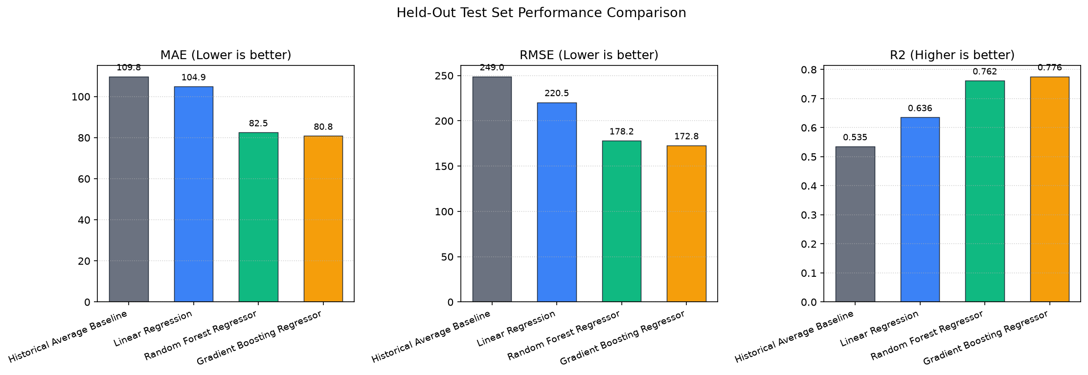
Figure 1 (`results/figures/model_comparison.png`): Comparison of Mean Absolute Error (MAE), Root Mean Squared Error (RMSE), and Coefficient of Determination (R²) across the four evaluated models on the held-out chronological test set (Weeks 117–145, N = 95,200).
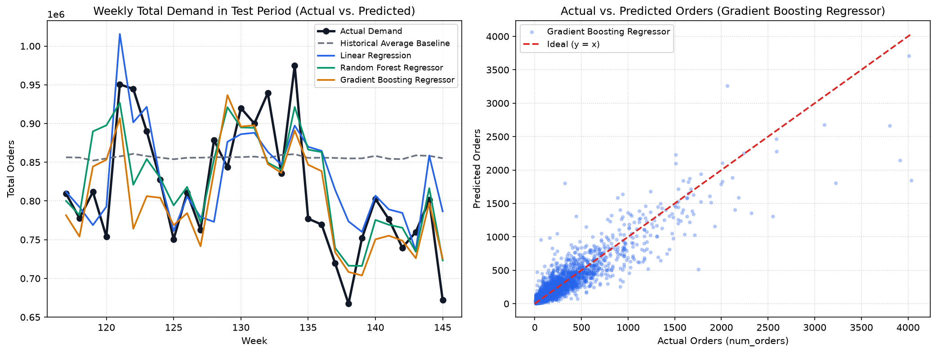
Figure 2 (`results/figures/actual_vs_predicted.png`): Left: Weekly aggregated actual vs. predicted meal demand across test weeks 117–145. Right: Sample-level actual vs. predicted order scatter plot for the Gradient Boosting Regressor against the y = x identity line.
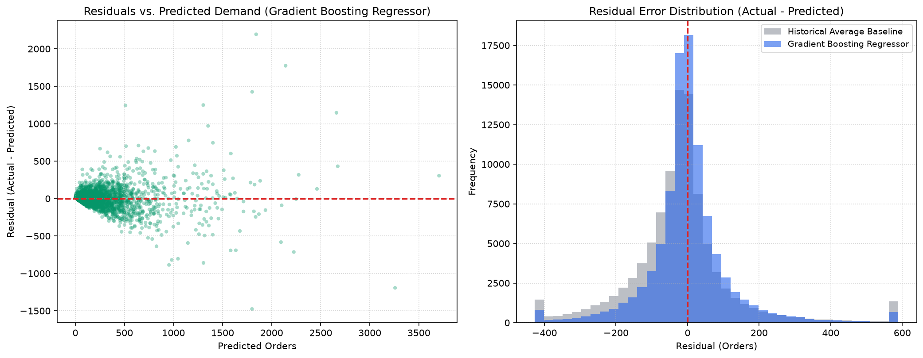
Figure 3 (`results/figures/residual_analysis.png`): Left: Residuals (y - ŷ) vs. predicted demand for the Gradient Boosting Regressor. Right: Residual error distribution comparing the Gradient Boosting Regressor against the Historical Average Baseline.

10.2 Food Preparation Simulation Results (RQ2 & RQ3)
Table 2 presents the operational simulation outputs across Weeks 117–145 (results/waste_simulation.csv), illustrated in results/figures/waste_simulation.png. Total realized customer demand across the 95,200 test records is 23,618,862.0 meal orders, and every policy applies the identical +5.0\% safety buffer (α = 0.05).
Table 2: Simulated Meal Preparation Policy Comparison (α = 5.0\% Safety Buffer, Weeks 117–145)
Preparation Policy | Model Source | Safety Buffer (%) | Total Actual Demand | Total Prepared Units | Total Simulated Surplus | Total Simulated Shortage | Demand Served (%) | Relative Surplus Change vs. Baseline (%)
Baseline Policy (Historical Average) | Historical Average Baseline | 5.0% | 23,618,862.0 | 26,077,208.0 | 6,693,322.0 | 4,234,976.0 | 82.07% | 0.00%
Prediction Policy (Linear Regression) | Linear Regression | 5.0% | 23,618,862.0 | 25,256,017.0 | 5,971,543.0 | 4,334,388.0 | 81.65% | -10.78%
Prediction Policy (Random Forest Regressor) | Random Forest Regressor | 5.0% | 23,618,862.0 | 25,039,075.0 | 4,753,258.0 | `3,333,045.0` | `85.89%` | -28.99%
Prediction Policy (Gradient Boosting Regressor) | Gradient Boosting Regressor | 5.0% | 23,618,862.0 | 24,450,993.0 | `4,350,038.0` | 3,517,907.0 | 85.11% | `-35.01%`

Key simulation findings from Table 2:
1. Baseline Policy Inefficiency: Preparing 1.05 × the training-period historical average generates 26,077,208 prepared meal units, resulting in 6,693,322 simulated surplus units and 4,234,976 simulated shortage units (82.07\% of total demand served).
2. Linear Regression Policy Trade-off: Guiding preparation with Linear Regression reduces total prepared units to 25,256,017, lowering simulated surplus by 10.78% (to 5,971,543 units), but slightly increases simulated shortages from 4,234,976 to 4,334,388 units (reducing demand served by 0.42 percentage points to 81.65\%).
3. Pareto Improvement by Tree Ensembles: Both Random Forest and Gradient Boosting improve upon the Baseline Policy on both dimensions simultaneously:
- Random Forest Policy reduces simulated surplus by 28.99% (saving 1,940,064 excess prepared units) while reducing simulated shortages by 21.30% (from 4,234,976 to 3,333,045 units), achieving the highest customer service level of 85.89% demand served (+3.82 percentage points above baseline).
- Gradient Boosting Policy (Best for Minimizing Simulated Surplus): Achieves the largest reduction in simulated surplus—cutting surplus by 35.01% (to 4,350,038 units, saving 2,343,284 excess prepared units relative to baseline)—while also reducing simulated shortages by 16.93% (to 3,517,907 units) and serving 85.11% of total demand (+3.04 percentage points above baseline).
- Random Forest Policy (Best for Minimizing Simulated Shortage and Maximizing Demand Served): Achieves the lowest simulated shortage (3,333,045 units, a 21.30% reduction in unmet demand vs. baseline) and the highest service level (85.89% of demand served, +3.82 percentage points above baseline), while simultaneously reducing simulated surplus by 28.99% (to 4,753,258 units).
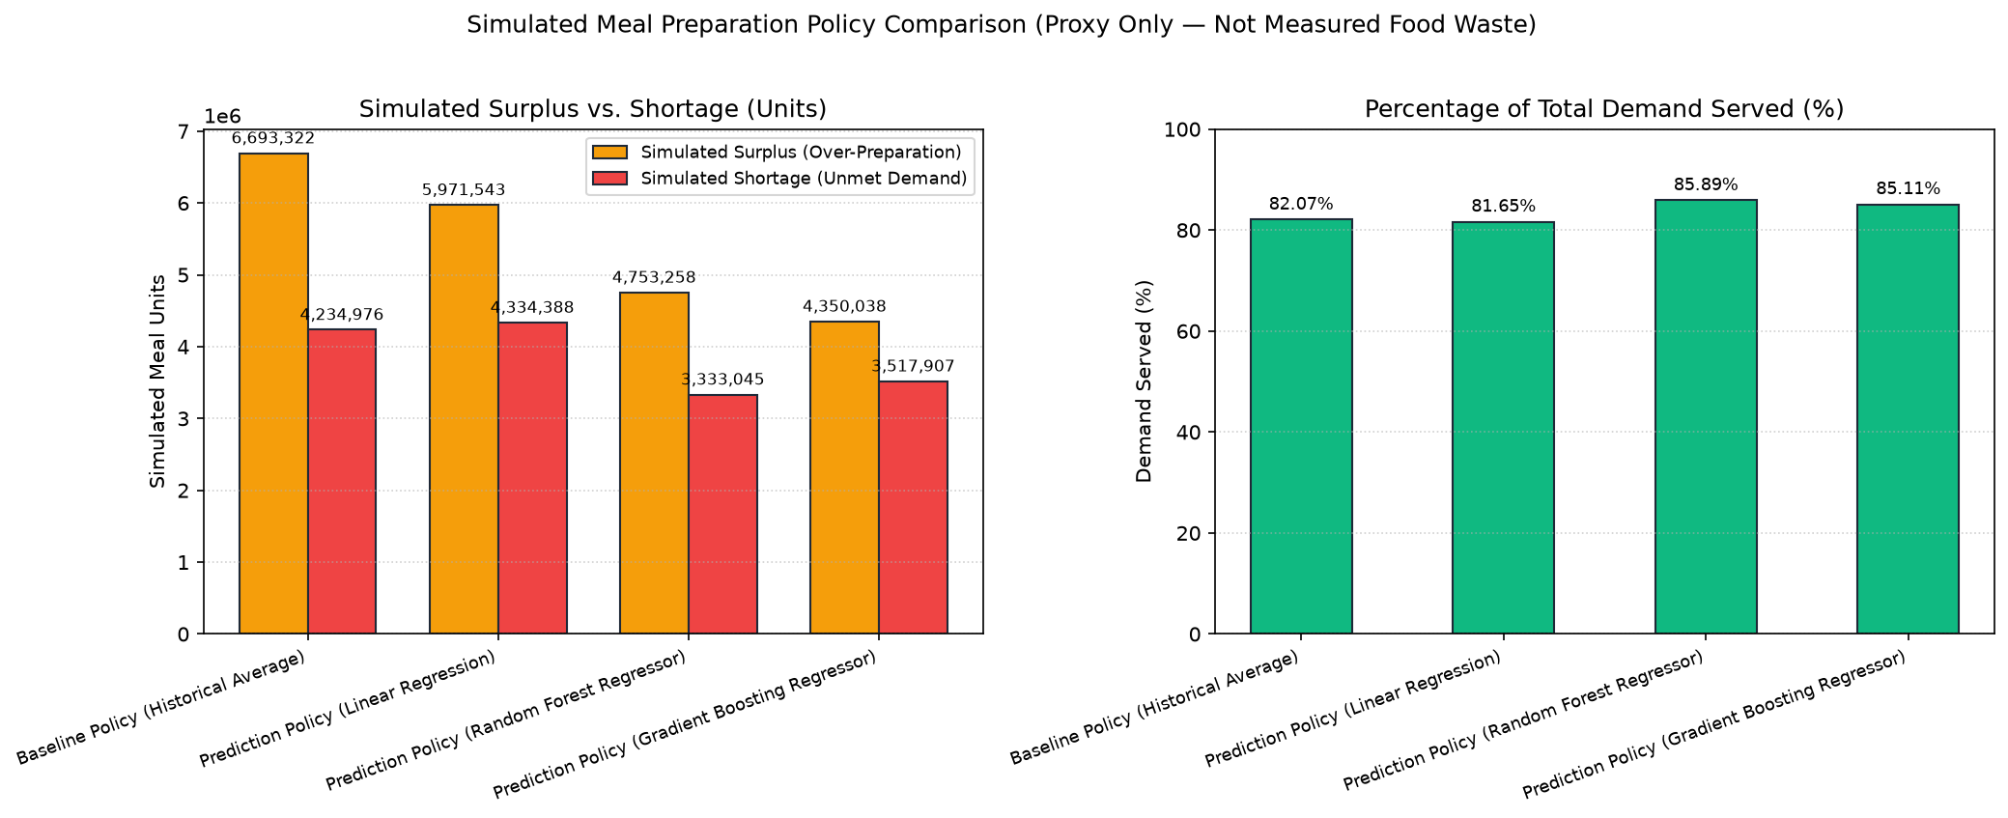
Figure 4 (`results/figures/waste_simulation.png`): Left: Total simulated surplus (over-preparation) and simulated shortage (unmet demand) across the four preparation policies (α = 5.0\% buffer). Right: Percentage of total test-period demand served by each policy. Note: Figures represent simulated operational proxies on order data, not measured physical food waste.

10.3 Summary of Best Model by Evaluation Criterion
To clearly distinguish statistical point-forecast accuracy from each simulated operational metric, Table 3 summarizes the top-performing model under each criterion on the held-out test set.
Table 3: Best-Performing Model by Statistical and Simulated Operational Criterion
Criterion Category | Evaluation Metric | Best Model / Policy | Verified Value | Comparison to Historical Baseline
Statistical Forecasting | Lowest MAE ↓ | Gradient Boosting Regressor | 80.8407 | -26.35% (vs. 109.7701)
Statistical Forecasting | Lowest RMSE ↓ | Gradient Boosting Regressor | 172.8451 | -30.57% (vs. 248.9597)
Statistical Forecasting | Highest R² ↑ | Gradient Boosting Regressor | 0.7760 | +0.2407 (vs. 0.5353)
Operational Simulation (α = 5\%) | Lowest Simulated Surplus ↓ | Prediction Policy (Gradient Boosting Regressor) | 4,350,038.0 units | -35.01% (vs. 6,693,322.0)
Operational Simulation (α = 5\%) | Lowest Simulated Shortage ↓ | Prediction Policy (Random Forest Regressor) | 3,333,045.0 units | -21.30% (vs. 4,234,976.0)
Operational Simulation (α = 5\%) | Highest Demand Served (%) ↑ | Prediction Policy (Random Forest Regressor) | 85.89% | +3.82 pp (vs. 82.07%)

11. Discussion

11.1 Why Non-Linear Models Simultaneously Reduce Simulated Surplus and Shortage
At first glance, reducing total prepared units (from 26.08M under the baseline to 24.45M under Gradient Boosting) while increasing the percentage of customer demand served (from 82.07\% to 85.11\%) might appear counterintuitive. However, comparing the weekly trajectories in results/figures/actual_vs_predicted.png reveals the mechanism:
- Meal demand in the Genpact dataset exhibits pronounced spikes when a meal is featured on the homepage (homepage_featured = 1), promoted via email (emailer_for_promotion = 1), and offered at a discounted checkout price (checkout_price < base_price).
- The Historical Average Baseline spreads those promotional demand spikes across all weeks in the training period. Consequently, during normal unpromoted weeks in the test period, the historical average systematically over-predicts demand (creating large simulated surplus), whereas during promoted weeks it severely under-predicts demand (creating large simulated shortages).
- Linear Regression captures additive main effects of promotions and discounts (R² = 0.6356), but because promotional elasticity scales multiplicatively with a meal's baseline popularity and centre size, an additive linear model under-predicts high-volume promotional surges, explaining why its demand served (81.65\%) lags slightly behind the baseline (82.07\%) despite lower overall RMSE.
- Random Forest and Gradient Boosting capture the multiplicative interaction between baseline (center_id, meal_id) demand (hist_pair_mean, hist_pair_roll4_mean) and promotional/discount indicators. They allocate more prepared units specifically to promoted item-weeks (reducing stockouts) and scale back preparation during unpromoted item-weeks (reducing over-preparation surplus).

11.2 Distinction Between Prediction Accuracy and Simulated Operational Outcomes
Our findings illustrate why evaluating forecasting models alongside an operational policy simulation provides richer insight than point-prediction metrics alone:
- Although Gradient Boosting achieves a slightly lower RMSE (172.8451) and MAE (80.8407) than Random Forest (RMSE = 178.1692, MAE = 82.5332), Random Forest prepares slightly more aggregate units (25.04M vs. 24.45M) and achieves a slightly higher demand-served percentage (85.89\% vs. 85.11\%), whereas Gradient Boosting achieves a larger reduction in simulated surplus (-35.01\% vs. -28.99\%).
- Depending on whether a fulfilment centre places a higher marginal penalty on unserved customer orders or on excess prepared inventory, operations managers can select between the Random Forest policy (higher service level) and the Gradient Boosting policy (lower simulated surplus) or tune the safety buffer α.

12. Limitations and Threats to Validity
To ensure honest and transparent academic reporting, several methodological and dataset limitations must be emphasized:
1. Simulated Surplus Is an Operational Proxy, Not Measured Physical Food Waste:
The Genpact Food Demand Forecasting dataset records fulfilled weekly customer order quantities (num_orders). It does not contain physical kitchen production logs, batch-cooking sizes, unplated bulk ingredients, shelf-life reuse across consecutive days, or post-consumer plate waste. Therefore, Surplus_{c,m,t} = \max(0, Q_{c,m,t} - D_{c,m,t}) represents simulated over-preparation under the assumed preparation policy, and must not be interpreted as empirically measured physical food waste reduction.
2. Right-Censored Historical Demand:
Because num_orders records completed customer orders rather than unconstrained demand intent, any historical stockouts during Weeks 1–145 would right-censor the observed target values.
3. Static Historical Features Across the 29-Week Test Horizon:
To enforce a strict pre-test information boundary so that actual test-period demand (Weeks 117–145) never leaks into test predictions or preparation quantities, the historical demand features (hist_pair_mean, hist_pair_roll4_mean, hist_pair_std, hist_meal_mean, hist_center_mean) are frozen at the end of the training period (Week 116) across all 29 test weeks. In a rolling one-step-ahead production deployment where Week t-1 realized orders become known before preparing for Week t, updating hist_pair_roll4_mean weekly would likely yield further accuracy gains.
4. Chronological Subsampling for Tree Ensembles:
While HistoricalAverageBaseline and LinearRegression fit on all 361,348 training rows, RandomForestRegressor and GradientBoostingRegressor fit on the most recent 120,000 chronological training rows (max_train_samples_tree=120000) to keep single-machine CPU training under five minutes. Although the historical features passed into those trees summarize all 116 training weeks, training tree splits on a subset of rows is a computational trade-off.
5. Absence of Statistical Significance Testing and Hyperparameter Optimization:
Each model was trained with fixed, documented hyperparameters (random_state=42) on a single chronological split. We do not claim formal statistical significance across multiple rolling origins or claim algorithmic novelty over state-of-the-art boosting libraries.

13. Conclusion and Future Work
This study presented PlateBack Lite, a reproducible machine learning pipeline for forecasting weekly meal demand and simulating meal-preparation policies on the 456,548-row Genpact Food Demand Forecasting dataset. Under a strictly leak-free chronological evaluation protocol (training on Weeks 1–116; testing on Weeks 117–145), Gradient Boosting Regressor (MAE = 80.8407, RMSE = 172.8451, R² = 0.7760) and Random Forest Regressor (MAE = 82.5332, RMSE = 178.1692, R² = 0.7620) substantially outperformed both Linear Regression (MAE = 104.9161, RMSE = 220.4739, R² = 0.6356) and the Historical Average Baseline (MAE = 109.7701, RMSE = 248.9597, R² = 0.5353). When evaluated in a weekly meal-preparation simulation with a +5.0\% safety buffer, the Gradient Boosting and Random Forest policies reduced simulated surplus by 35.01% and 28.99%, respectively, while increasing the percentage of customer demand served from 82.07% (baseline) to 85.11% and 85.89%.
Future extensions of this work include: (1) training quantile regression models under asymmetric pinball loss so that the safety buffer is learned directly from the conditional demand distribution rather than applied as a uniform +5.0\% multiplier; (2) evaluating rolling walk-forward retraining across the test horizon; and (3) validating preparation policies on kitchen datasets that pair order logs with physical batch-production and leftover weight measurements.

14. References
1. Arrow, K. J., Harris, T., & Marschak, J. (1951). Optimal inventory policy. Econometrica, 19(3), 250–272. https://doi.org/10.2307/1906813
2. Breiman, L. (2001). Random forests. Machine Learning, 45(1), 5–32. https://doi.org/10.1023/A:1010933404324
3. Friedman, J. H. (2001). Greedy function approximation: A gradient boosting machine. The Annals of Statistics, 29(5), 1189–1232. https://doi.org/10.1214/aos/1013203451
4. Hübner, N., Caspers, J., Coroamă, V. C., & Finkbeiner, M. (2024). Machine-learning-based demand forecasting against food waste: Life cycle environmental impacts and benefits of a bakery case study. Journal of Industrial Ecology, 28(5), 1118–1131. https://doi.org/10.1111/jiec.13528
5. Panda, S. K., & Mohanty, S. N. (2023). Time series forecasting and modeling of food demand supply chain based on regressors analysis. IEEE Access, 11, 42679–42700. https://doi.org/10.1109/ACCESS.2023.3271159
6. Pedregosa, F., Varoquaux, G., Gramfort, A., Michel, V., Thirion, B., Grisel, O., Blondel, M., Prettenhofer, P., Weiss, R., Dubourg, V., Vanderplas, J., Passos, A., Cournapeau, D., Brucher, M., Perrot, M., & Duchesnay, E. (2011). Scikit-learn: Machine learning in Python. Journal of Machine Learning Research, 12, 2825–2830.
7. Rodrigues, M., Migueis, V., Freitas, S., & Machado, T. (2024). Machine learning models for short-term demand forecasting in food catering services: A solution to reduce food waste. Journal of Cleaner Production, 435, 140265. https://doi.org/10.1016/j.jclepro.2023.140265

