Auto Banker

Solution Architect Document

Version: 0.1 DRAFT 01

**Published**:

## 

## Revision History

[Required. List changes between each release. Increment Release Number by 1 only between published versions.]

| Version # | Date | Revised By | Description of Changes |
| --- | --- | --- | --- |
| 0.1 DRAFT 01 |  | Lokeshwaran | First draft |
|  |  |  |  |
|  |  |  |  |
|  |  |  |  |
|  |  |  |  |
|  |  |  |  |
|  |  |  |  |
|  |  |  |  |
|  |  |  |  |
|  |  |  |  |
|  |  |  |  |

TABLE OF CONTENTS

1

1.1 Revision History 2

1 Scope 4

1.2 Identification 4

1.2.1 Problem Statement 4

1.3 Solution Overview 4

2 Solution Architecture: 5

3 Solution Specifications 7

3.1 BANK UI: 7

3.2 Core Engine 13

3.3 Mongo DB 15

3.4 Analytics view 16

4 Model Deployment 17

# 1 Scope

## Identification

This document provides the solution level design for the Auto banker solution. This document also provides low level code implementation for the described solution

### Problem Statement

Banking process such as Bank Account opening, Cheque transactions, Document verification and Loan process currently involve manual human intervention and are time consuming:

1) Bank Account opening needs customer to fill up the form manually and the operator manually verifying the document and entering the details to create a new account for the customer.

2) Cheque processing requires the customer to deposit the cheque at bank, which is then sent to the cheque clearing house for verification and transfer of funds between banks. The current process can take upto 3 working days

It is therefore required to automate the process which can reduce the workload and to complete the process in a matter of seconds

## Solution Overview

This Solution is aimed at automating the process of Bank Account opening by capturing the details of the customer such as Customer’s Name, DOB, Signature and other mandatory details directly from the Aadhar Card and PAN card scanned copy. This will cut short the manual intervention of the operator and also prevent the need of customer to travel to bank for opening an account. Customer can open an account for the bank from the convenience of his home.

This solution also aims at automating the process of Cheque clearance by just needing the customer to upload the photo of the Cheque. The solution automatically detects the Payor, Payee, Amount and also verifies the signature for authenticity. This solution will drastically reduce the current processing time and the cheque transactions can be completed in few seconds.

# 2 Solution Architecture:

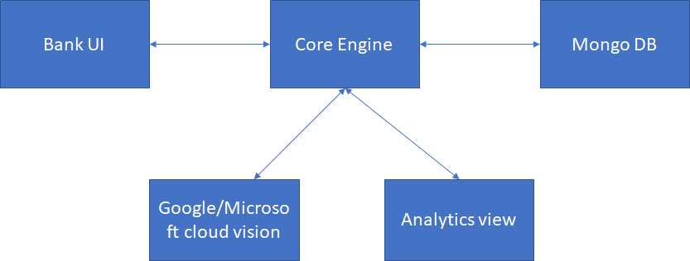

**Bank UI:**

This is a webpage which the customer uses to upload documents such as Aadhar, Pan card to create a new bank account. Customer can also upload Cheque to process it. This is a simple UI which acts as a medium between the customer and bank. The UI consists of 3 functionalities

a) Create new account

b) Process Cheque

c) Review form to provide feedback

**Core Engine:**

This is the core system of Auto Banker application. This system acts as an orchestration engine to maintain the integrity of the Auto Banker application. The functionalities of the Core Engine are:

a) To collect the Customer’s document images from Bank UI and interact with Google/Microsoft cloud vision for entity extraction and to create a new bank account for the customer.

b) To collect Customer’s cheque image from Bank UI and interact with Google/Microsoft cloud vision to process the cheque

c) To maintain the customers account and statement balance by updating all the transaction details in MongoDB

b) To collect every customer’s feedback and perform sentimental analysis to arrive at overall ease of use factor for the customer

e) To perform reporting as and when required by the Analytics view application

**Google/Microsoft cloud vision:**

This is a Over the Cloud solution being provided by Google/Microsoft. The system is the key to extract the customer details from the images sent by the Core Engine. As this is a ready to use solution, there is no seperate AI model required to be built from scratch and the solution can be directly used by using APIs.

**MongoDB:**

Database to store all the account meta data. This DB is used to store customer details, account balance, reviews and the log of all the transactions.

**Analytics view:**

An Analytics tool to summarize the activities on a real time basis. The tool reports on the bank accounts being created, cheque transactions, money inflow and outflow, revenue generated, fraud and customer sentiments

# 3 Solution Specifications

## **3.1 BANK UI:**

Page 1: Welcome to Auto Banker page

This page is the Home page of ‘Auto Banker’ application. Customer can perform three actions on this page:

a) Open a New Bank Account

b) Cheque Payment

c) Submit Feedback

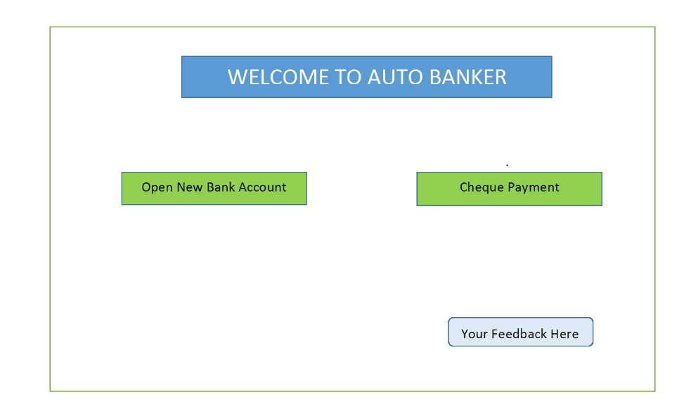

Page 2: New Account Creation page

This page is used to upload Customer’s PAN card and Aadhar card to create new bank account. User is navigated to this page upon clicking ‘Open New Bank Account’ on Home page. Cutomer can perform following actions on this page:

a) Submit PAN: Customer can upload PAN image and the image is sent to the Core Engine on clicking ‘Submit PAN’

b) Submit Aadhar: Customer can upload Aadhar image and the image is sent to the Core Engine on clicking ‘Submit Aadhar’

Upon clicking on ‘Create My Account’, both the images are sent to Google/Microsoft ocr and customer details are retrived. Customer will be navigated to ‘Verify Your Account details’ page

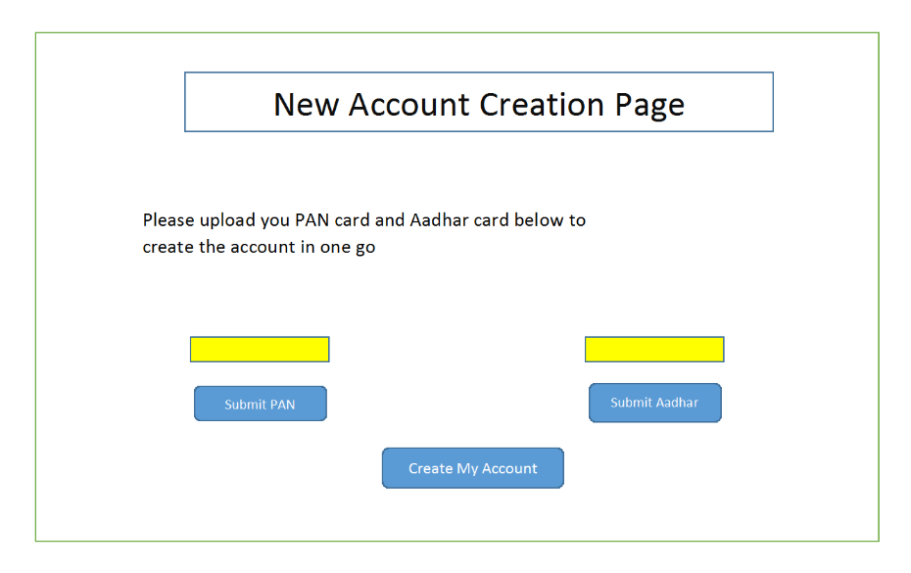

Page 3: Verify your Account Details page

Customer is redirected to this page after clicking on ‘Create My Account’ on ‘Account Creation page’. This page is used to confirm the customer details extracted from the PAN and Aadhar images uploaded by the customer. The fields are populated with default extracted values and is editable. If the customer makes any changes here, the changes can be considered.

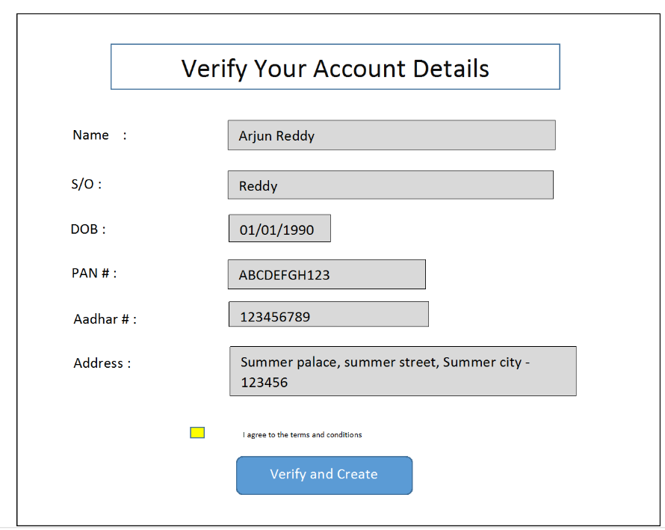

Upon clicking on ‘Verify and Create’, customer will be taken back to Homepage and will be presented with Account number and Opening Balance

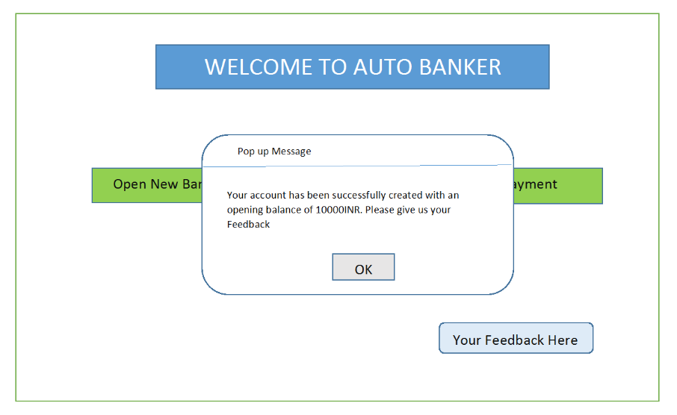

Page 4: Cheque Processing page

Customer is redirected to this page on clicking ‘Cheque Payment’ option on the Home page. Customer is allowed to upload the scanned image of the cheque and submit it. On clicking ‘Submit Cheque’, the image is sent to Core Engine and then to Google/Microsoft ocr to extract the payor, payee and amount details.

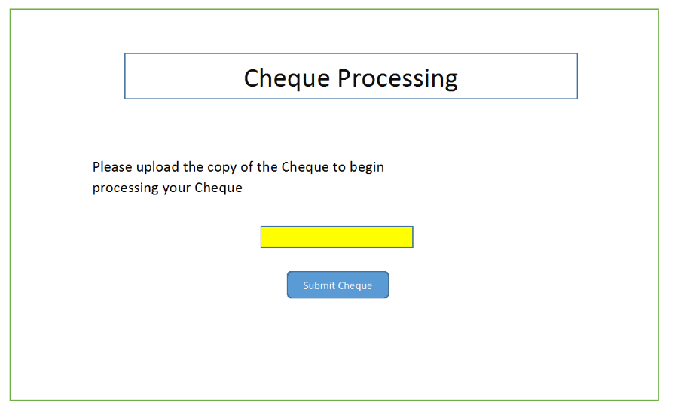

Once the cheque is processed successfully, customer is redirected to homepage and is presented with a new statement balance

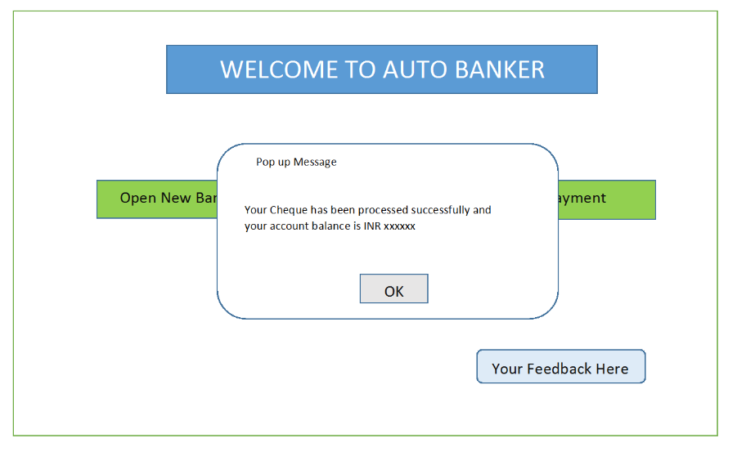

## 3.2 Core Engine

The Core Engine is the brain of Auto Banker and consists of the following modules:

**1) Extract Text from Image Module** – This module will be involked whenever customer uploads the images such as PAN, Aadhar and Cheque in the BANK UI. The modules responsibility is to,

- wrap the input image into REST API and call Google/Microsoft for character recognition

- verify the received JSON response to extract customer details from it

Module inputs:

a) PAN card Image

b) Aadhar card Image

c) Cheque image

Module outputs:

a) JSON message received from cloud OCR engine

**2) JSON parser**  - This module will analyse the JSON message to extract the relevant customer details required to create a bank account or to process a cheque

Module inputs:

a) JSON message outputted from ‘Extract Text from Image Module’

b) Type of image(whether PAN/Aadhar/Cheque)

Module outputs:

a) ‘Name’, ‘S/o’, ‘DOB’, ‘PAN number’, ‘Signature’ details for PAN card image

b) ‘Name’, ‘S/o’, ‘Aadhar number’, ‘DOB’, ‘Sex’, ‘Address’, ‘Phone number’, ‘Photo’ details for Aadhar card image

c) ‘Payee’, ‘Amount in words’, ‘Amount’, ‘ISFC code’, ‘Account number’, ‘Signature’ details for the Cheque image

**3) Create Account module** – This module will create a new customer record into the bank database after getting the customer details from ‘JSON parser’. This module generates a unique account number or the customer and deposits a sample 1000 INR

Module inputs:

a) Verified customer details from ‘Verify your Account Details’ page

Module outputs:

a) Create a new customer record in Mongo DB with unique account number(schema described in MongoDB section)

b) Display the account number and initial balance to the customer

**4)** **Process Cheque module –** This module will process the cheque by verifying its authenticity and transferring the mentioned amount from payor to payee’s account

Module inputs:

a) Cheque details inputted by the ‘JSON Parser’

Module functionalities:

a) Deduct the payors account with the mentioned amount

b) Credit the payee account with the mentioned amount

Module output:

a) Display the new account balance to the customer in Home page

**5)** **Signature Authenticator module** – AI based model to verify the authenticity of the customer’s signature presented in cheque. The signature is compared with the signature that was captured during account creation from PAN and aadhar copy.

Module inputs:

a) Customer’s signature presented in Cheque

Module outputs:

a) TRUE is signature is genuine, FALSE otherwise

**6) Feedback analysis module** – This is a sentiment analysis module to analyse the feedbacks given by the customer. Score is generated to measure customer’s happiness with the application usage.

Module inputs:

a) Feedback comments given by customer in ‘Home page’ UI(Basically a Google form)

Module outputs:

a) Sentiment score from 1-10

## 3.3 Mongo DB

Database used to store all the customer records and transactions occuring in ‘Auto Banker’ application

Database name: AutoBanker

Collection 1: Customer_record

Document keys: Account number, Created date, Name, Age, DOB, sex, S/o, Statement Balance, Pan number, Aadhar number, Address, Phonenumber, Photo, Signature

Collection 2: Customer_trans

Document keys: Account number, Transaction ID, Cheque number, Amount_credited, Amount_debited

Note: Two records will exist, one for payee and another for payor

Collection 3: Uploaded_docs

Document keys: Account number, Image, Image type, Uploaded_time

Collection 4: Cust_feedback

Document Keys: Feedback_ID, Feedback_comments, Feedback_score

## 3.4 Analytics view

TBD

# 4 Model Deployment

Model will be deployed into AWS cloud. Server details are TBD