ELASTIC Fleet
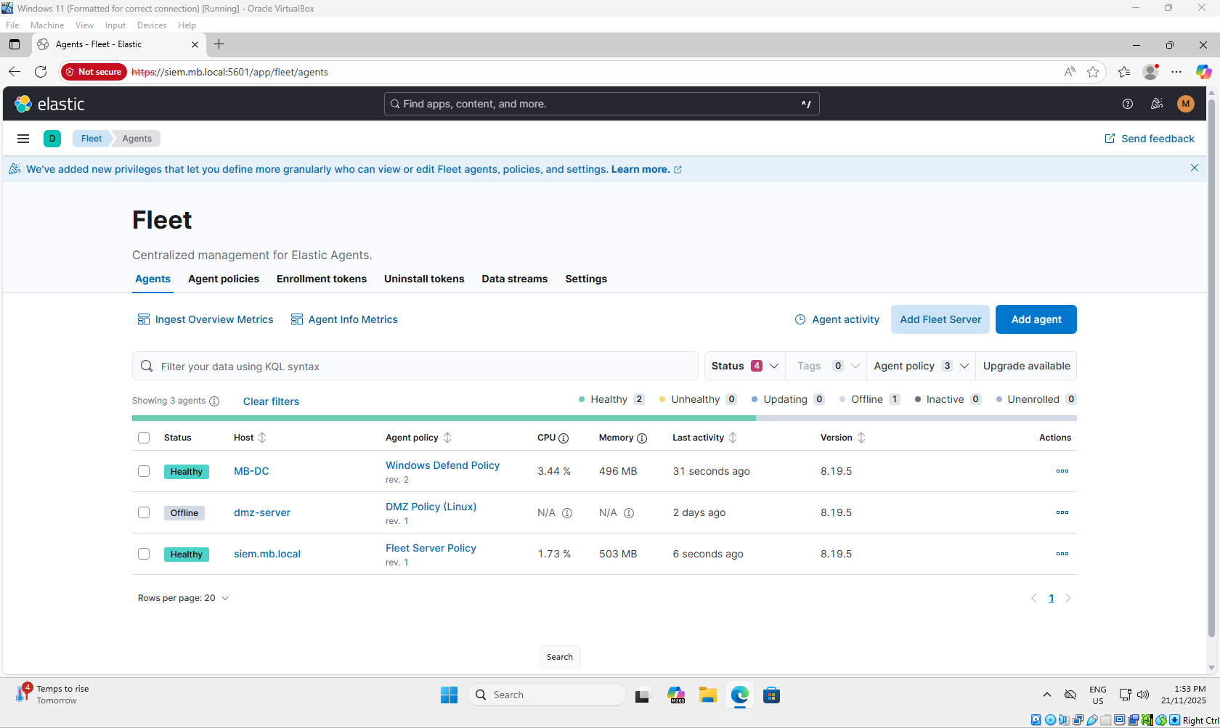
This shows the entire fleet currently managed by Elastic. The DMZ is offline, despite the screenshots as this version of the DMZ is an older version taken prior to the installation of Elastic.
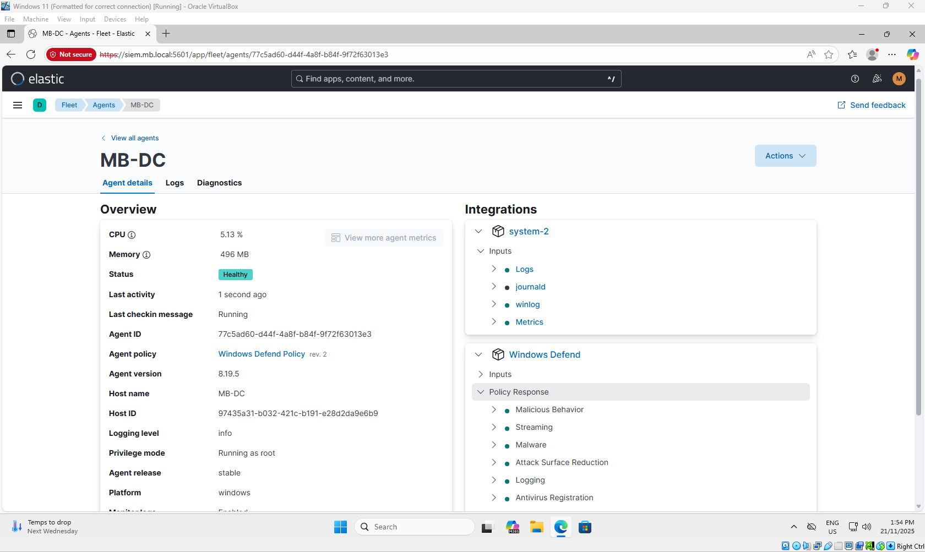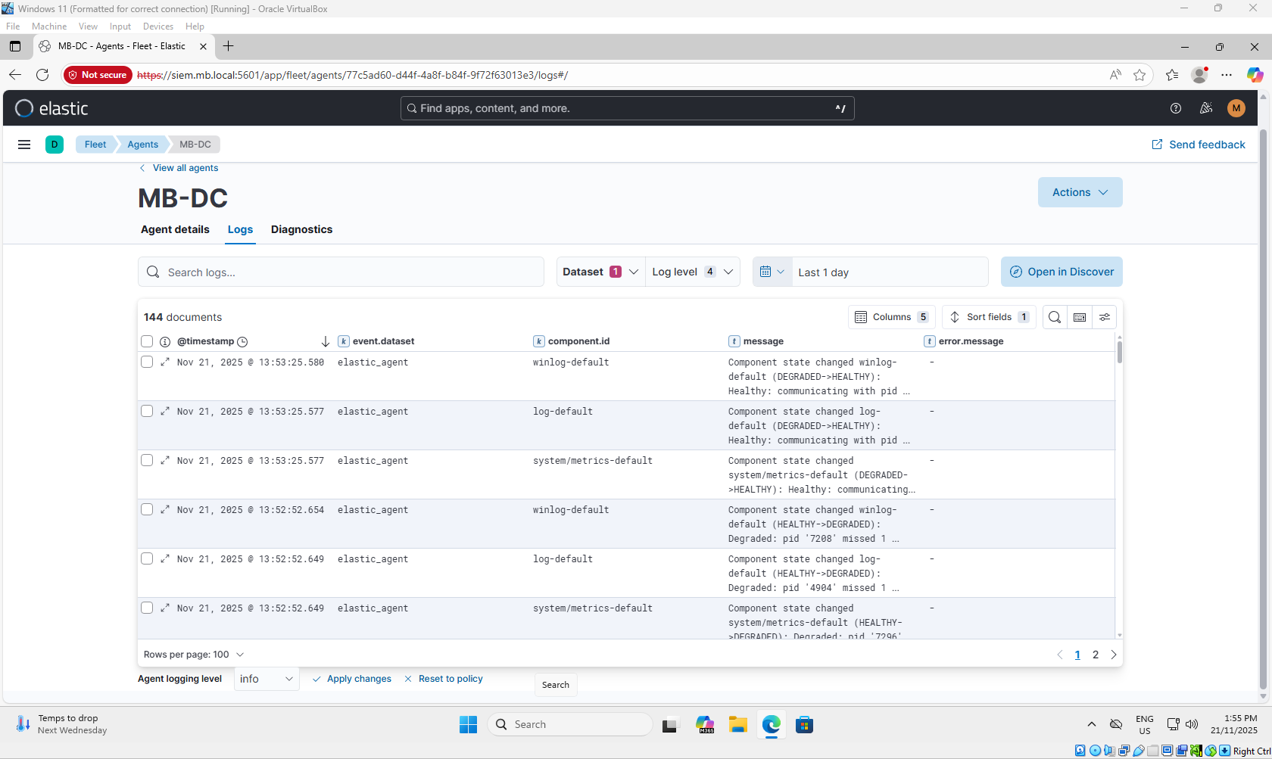
More specifics of the MB-DC server.

WINDOWS SERVER
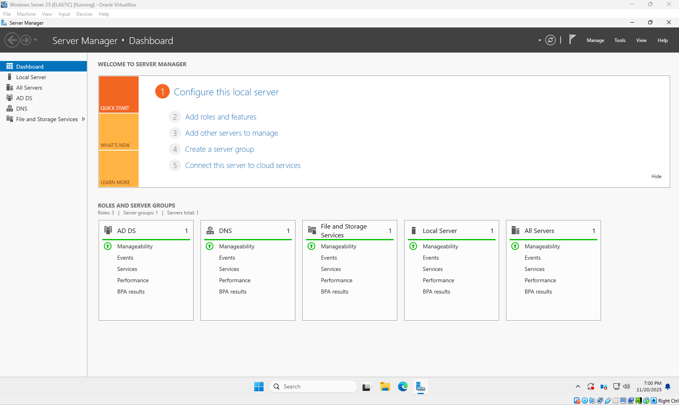
The server was configured to be the network’s DNS server, with the address 192.168.100.100. The only user on this is the user for the Windows 11 client.
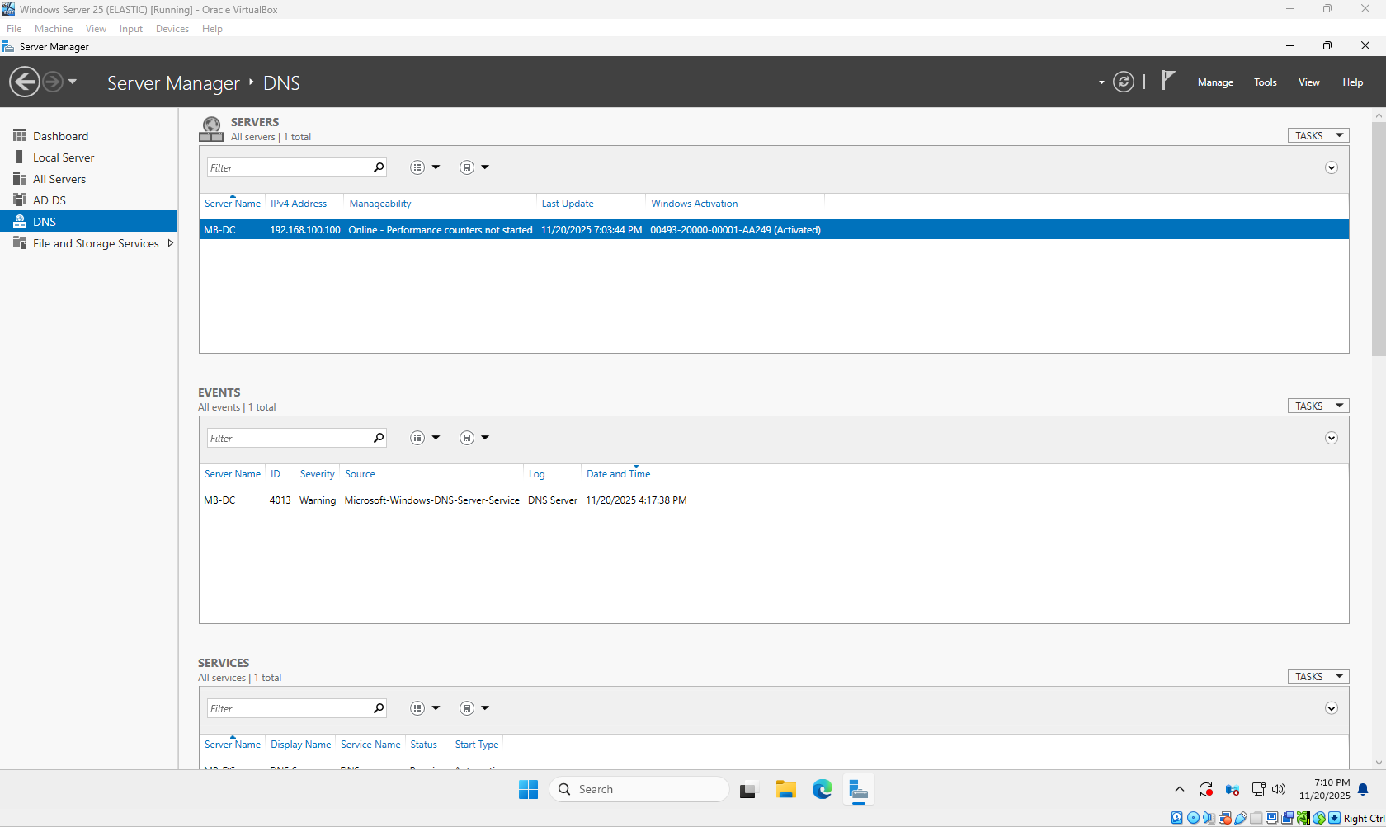

Below are the configured DNS options to allow for access to the DVWA and Juice-Shop hosts. 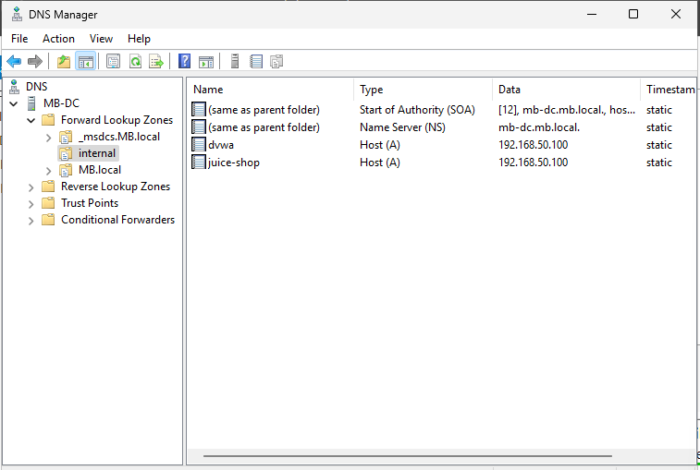

This is the network settings for the server. The Default Gateway is directed to the firewall.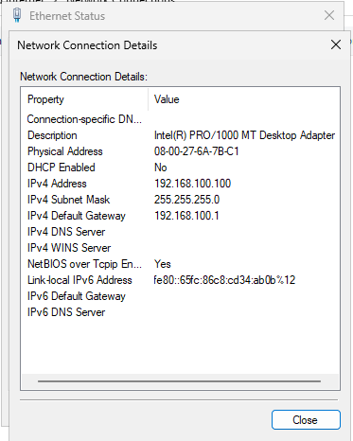

DMZ
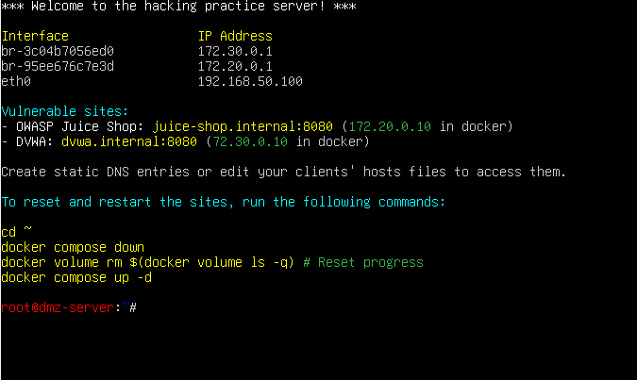
Above is the basic information for the DMZ. Seen here is the two web servers that have been linked to this server, the DVWA and the OWASP Juice Shop. Unfortunately due to last minute issues, we were unable to grab screenshots of these pages.
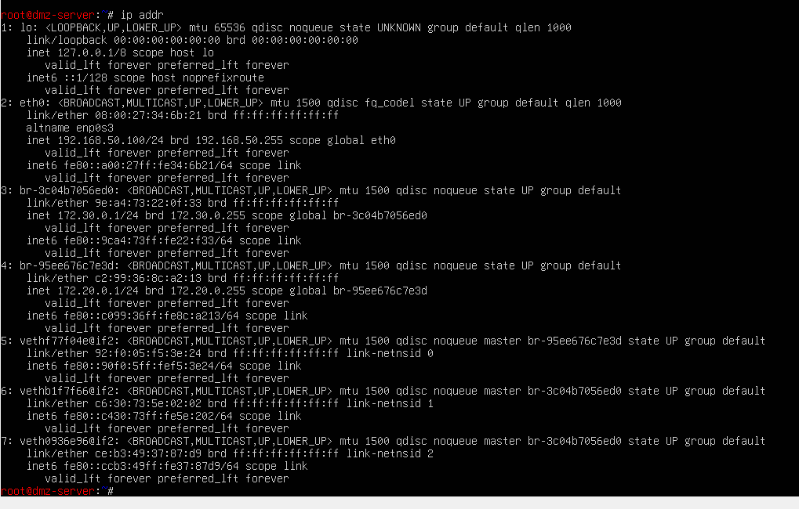
This is an extended look at the IP settings of the DMZ.
As this version of the DMZ doesn’t have Elastic configured, there is no processes to show Elastic running.
SIEM
Below is the IP settings of the SIEM machine.
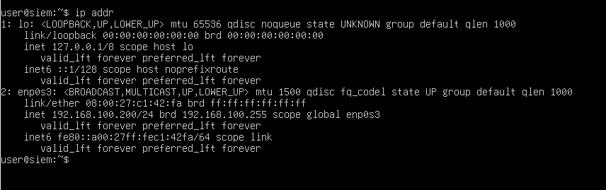
This shows some of the running processes on the SIEM, notably the inclusion of the Kibana and Elastic+ processes.