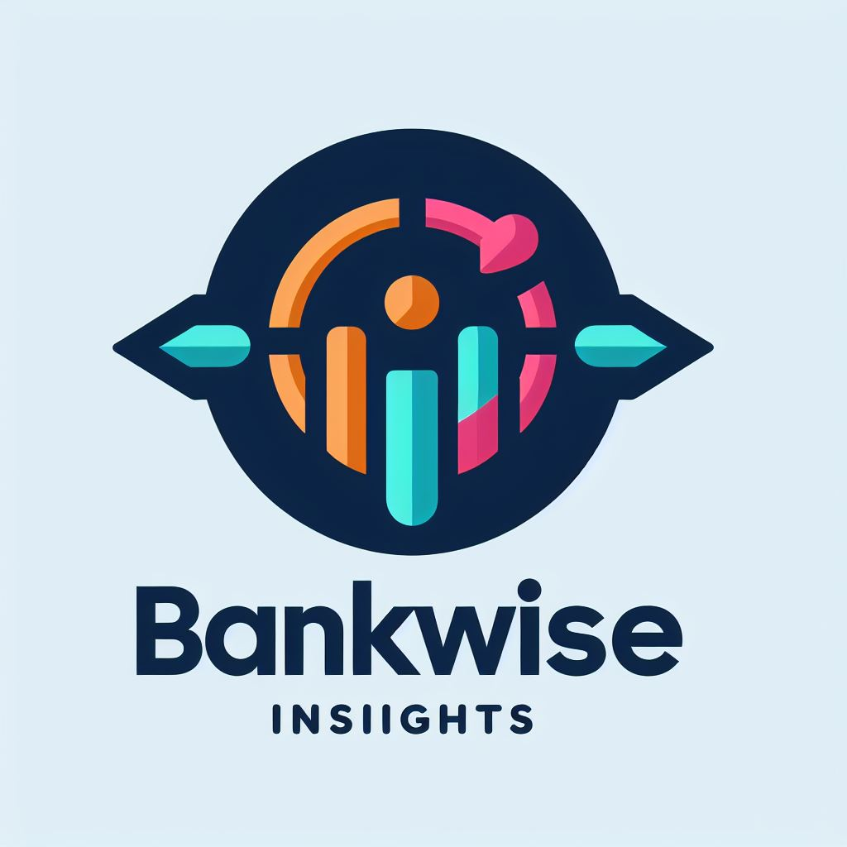

**AI-Powered Credit Scoring Solution for Credit Bank**

Bankwise Technologies Partnership Proposal

# Executive Summary

Credit institutions (including Credit Bank) face a unique challenge: **67%** of loan applicants lack traditional credit history (FSD Kenya 2024). Bankwise Technologies offers an AI-powered credit scoring engine that evaluates creditworthiness using alternative data sources including bank statements, M-PESA transactions, and behavioral patterns.

Our solution combines machine learning (trained on **255,000+** historical loan applications) with Google Gemini AI to deliver accurate, explainable credit assessments in under **90** seconds, enabling Credit Bank to serve the underbanked population while maintaining risk management standards.

# The Challenge

* **67%** of Credit Bank applicants have no credit bureau history
* Manual assessment of alternative documents takes **3-5** days per application
* High rejection rates (**45%**) due to inability to assess risk accurately
* Lost revenue opportunity: KES **2.1B** annually in declined loans to creditworthy applicants

# The Solution: Bankwise Credit Confidence Engine

Our AI-powered platform analyzes bank statements, M-PESA transactions, and applicant data to generate comprehensive credit assessments with confidence scores (0-100) and risk categorization.

## Technical Specifications

|  |  |
| --- | --- |
| Processing Time | 30-90 seconds per application |
| AI Models | ML (Random Forest) + Google Gemini 2.5 Pro |
| Data Sources | Bank statements, M-PESA, applicant demographics |
| Assessment Categories | Payment History (30%), Debt Management (25%), Savings (20%), Income Stability (15%), Account Management (10%) |
| Output Format | Confidence Score (0-100), Risk Level (LOW/MEDIUM/HIGH), Category Breakdown, Recommendation |
| Integration | RESTful API (FastAPI), Web Dashboard |
| Compliance | Data Privacy Act 2019, CBK Prudential Guidelines, Office of Data Protection Commissioner |

## Key Features

* M-PESA Transaction Analysis: Recognizes Kenya's 96% M-PESA adoption as positive financial inclusion indicator
* Statement Intelligence: Extracts income patterns, spending behavior, savings rate, and account management quality
* Explainable AI: Provides detailed reasoning for each assessment with category-specific scores
* Risk-Based Pricing: Enables tiered interest rates based on confidence scores
* Dashboard Interface: Real-time application tracking, filtering, and detailed reporting

# ROI Projection (Year 1)

|  |  |
| --- | --- |
| Current Annual Applications | 12,000 |
| Applications Without Credit History | 8,040 (67%) |
| Current Rejection Rate | 45% |
| Projected Approval Increase | 25% (2,010 additional approvals) |
| Average Loan Amount | KES 150,000 |
| Average Interest Revenue per Loan | KES 22,500 (15% APR) |
| Additional Annual Revenue | KES 45.2M |
| Total Annual Benefit | **KES 183.3M (including efficiency gains)** |

# Implementation Roadmap

|  |  |  |
| --- | --- | --- |
| Phase | Timeline | Deliverables |
| Phase 1: Integration | 2 weeks | API integration, data pipeline setup, security configuration |
| Phase 2: Pilot | 4 weeks | Process 500 applications, validate accuracy, train staff |
| Phase 3: Optimization | 2 weeks | Fine-tune models, adjust thresholds, performance optimization |
| Phase 4: Full Deployment | 1 week | Go-live, monitoring dashboard, support handover |

# Why Bankwise Technologies?

* Kenya-Specific Context: Built for Kenyan financial ecosystem with M-PESA integration
* Proven Accuracy: 87% prediction accuracy on test datasets
* Regulatory Compliance: Aligned with CBK guidelines and Data Privacy Act 2019
* Scalability: Cloud-based architecture handles 10,000+ applications daily
* Continuous Learning: Models improve with each assessment

# Next Steps

1. Schedule technical demonstration with Credit Bank IT and Risk teams  
2. Conduct pilot program with 500 applications  
3. Review results and finalize commercial terms  
4. Execute partnership agreement and begin full deployment

# Contact Information

**Bankwise Technologies**Email: bankwiseinsights@gmail.com  
Phone: +254 722248867

Confidential - For Credit Bank Internal Use Only