**“STAIR CLIMBING TROLLEY”**

**ABSTRACT:**

The projects aims to develop a mechanism for easy transportation of heavy load over stairs. The need of such system have raised from day to day requirement in our society. Local goods transportation generally depends on manual Trolleys which are used in warehouses, construction sites, malls, residential relocations etc. Mostly hand trolleys are manufactured with the main aim of transporting goods on flat surface or at ground level. However, when it comes to shifting the goods above the ground level there are limitations where a hand trolley cannot be brought to, such as rough surfaces or any up level from ground is not an easy job, especially where there are no lifting facilities (elevator, conveyer, etc). Therefore, limiting the aspect of transportations from lower ground to higher levels or vice versa. The hand trolley could be tried to handle through the staircase but there are higher chance of failure occurring during the lifting on staircase, such as falling of hand trolley when it gets out of control and causing accidents as well as injuries. Apart from that, smaller and circular objects have the highest tendency of falling as it doesn’t fit the trolley area. In shifting and moving heavy load above ground, Human labours are considered to be the solitary

This mechanism of stair climbing trolley allows for efficient stair climbing functionality. This functionality allows for easy movement of goods across stair cases. The project aims to develop a mechanism for easy transportation of heavy load over stairs. The need of such system have raised from day to day requirement in our society. Using of this vehicle the labour cost can be reduce as well as large amount of load can be transfer uniformly with less power consumption thus our project introduces the new alternative for transportation of load over the stairs. It has designed in such a way that it can be climb a stepped path with its modified wheel structure.

**INTRODUCTION:**

Nowadays, mechanical artifacts are commonly found in our daily life. They are currently used in many fields of applications such as office, hospital operation, industrial automation, military tasks and security systems. It is not difficult to observe that mechanical designs play an important role in assisting human tasks. Stairs are one of the most commonly faced mobility challenges for daily life applications. Whenever it comes to shifting the goods above the ground level there are limitations where a hard trolley cannot be brought to, such as rough surface or any up level from ground is an easy job. So, our group has been involved in a project to design and develop a mechanical STAIR-CLIMBER that can climb up and down the stairs in a stepwise and safe manner. After studying various options it was decided to build a trolley that could be carry load across stair and also it can work on even surfaces whenever it is needed. Thus we have decided to make a stair climbing trolley which is affordable to everyone with low cost. This will enable efficient handling of goods across stairs with less human energy.

**WORKING PRINCIPLE:**

Stair climbing trolley consists of three wheels, two wheels are arranged in corners and one wheel is fixed in the middle in the form of equilateral triangle. While moving on the flat surface the wheels are parallel to the ground. While climbing on the stairs with the help of handle we can carry load on the stairs with this we can reduce the human effort and do the work in the better way. It is used to transport load from one place to another place this is used in the places where lift & elevators are not present.

**BLOCK DIAGRAM:**

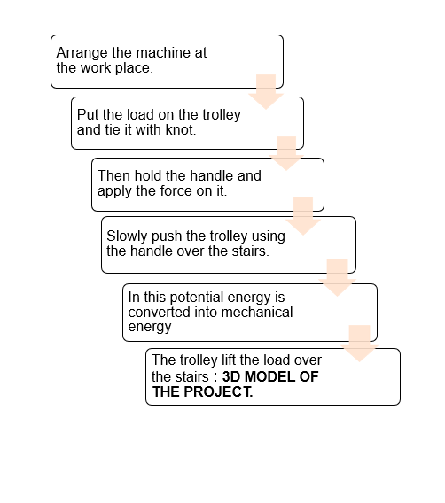

**MODEL DIAGRAMS:**

**FRONT VIEW:**

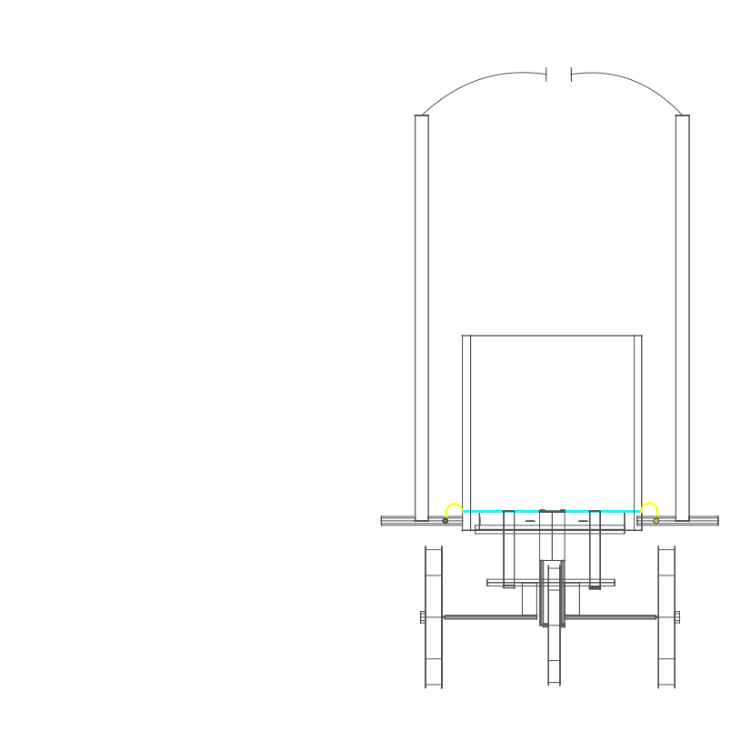

**TOP VIEW:**

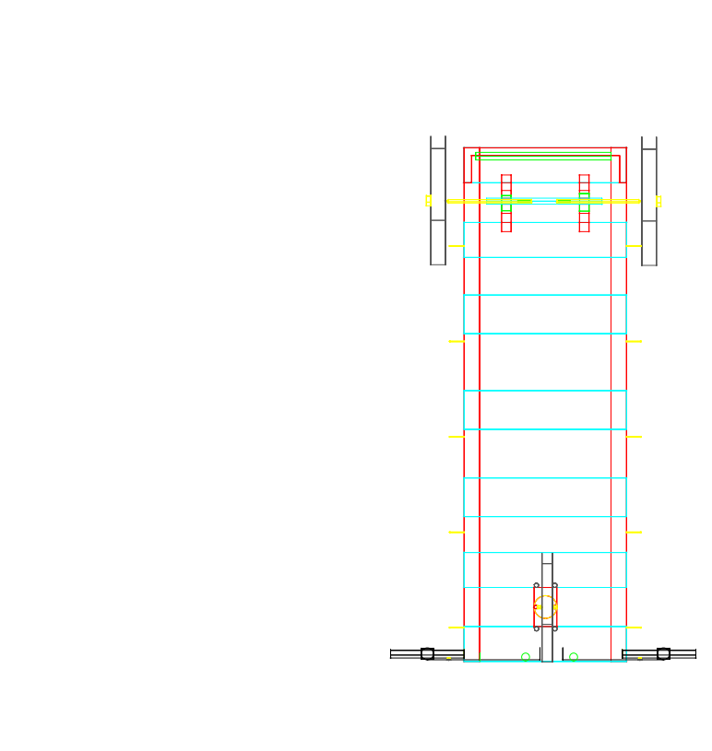

**SIDE VIEW:**

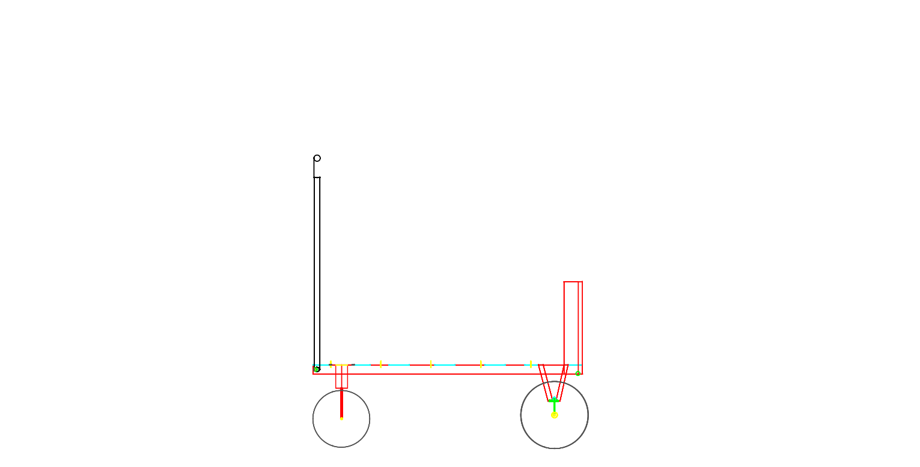

**RESULT:**

Seed bagging machine useful for collecting grains from the floor and a conceptual model was implemented and fabricated successfully. It has considerable potential to greatly increase the efficiency of collecting seeds with comparison of other traditional available techniques. The main task now is to promote this technology and have available to users at an affordable price. The seed bagging machine is made up of local components in workshop. This can be sourced at an inexpensive price from local traders. By using local materials, collecting of grains can be achieved.

**CONCLUSION:**

The main aim of the project is stair climbing mechanism for load carrier with decreasing effort. The stair climbing trolley has been designed in such way that it can carry the heavy loads as well as bulky loads over stairs and also used for carrying loads on flat surfaces from one place to another place without many efforts from the user. Accordingly, to the tests conducted, the stair climbing trolley has a capacity of carrying a load of 70-80 kgs on the flat surfaces. It has the ability to ascend a flight of stairs of 30 degree elevation carrying a load capacity of 40 kg.

* Thus, our better work with lessor effort has been the main objectives of human beings in any field.
* The main project as platform we try to present mechanized stair climbing load carrier with reducing effort.
* Stair climbing mechanism in stair case load carrier which helps to carry the loads with help to carry the loads with stair case.

Hence, we completed our project to our best with lot of efforts.

**TEAM DETAILS:**

BANOTH GANESH - 20H51A05D6 – 8466869185 - [20h51a05d6@cmrcet.ac.in](mailto:20h51a05d6@cmrcet.ac.in)

SANTHOSH REDDY JAKKIDI – 20H51A05E1 – 9133142281 – [20h51a05e1@cmrcet.ac.in](mailto:20h51a05e1@cmrcet.ac.in)

SARASWARHI PATIL - 21H55A0518 – 8008547500 - [21h55a0518@cmrcet.ac.in](mailto:21h55a0518@cmrcet.ac.in)

**\*\*\*\*\*THE END\*\*\*\*\***