Final Year B. Tech. CSE Augmented Reality and Virtual Reality

Assignment No. 4

# Submitted by:

|  |  |
| --- | --- |
| **PRN** | **1032211329** |
| **Student Name** | **Aryan Bansal** |

**Title:** Develop a scene in Unity that includes game objects such as a cube, sphere and plane. Apply transformations on these 3 game objects, add a video and audio source and apply Rigid body component, Material and Box collider to the game objects. Write a program to control game objects.

**Aim:** To understand the features of Unity to develop a scene and apply Rigid body component, Material and Box collider to the game objects.

# Theory:

**<<Explain following points>>**

|  |  |
| --- | --- |
| ● | Key Features used for scene creation   1. Hierarchy: Organizes game objects in a tree structure. 2. Scene View: Allows visualizing and navigating the game world. 3. Game View: Displays the game as it will appear to players. 4. Inspector: Provides details and properties of selected game objects. 5. Assets: Manages resources like models, textures, and sounds. 6. Prefab System: Enables the creation of reusable object templates. 7. Terrain System: Constructs and modifies virtual landscapes. 8. Lighting: Controls the illumination of the scene. 9. Cameras: Defines perspectives for rendering the scene. 10. Particle System: Creates various visual effects like fire or smoke. 11. Audio Source: Integrates sound into the scene. 12. Physics System: Simulates realistic object interactions. 13. Navigation System:Supports character movement and pathfinding. 14. Animation System: Facilitates the creation and control of animations. 15. Post-Processing Effects: Enhances visuals with effects like blur or color correction. |

* Rigid body component, Material and Box collider:

Rigidbody Component:

Function: Adds physics behavior to a GameObject.

Purpose: Enables realistic movement, collision, and interaction with forces. Attributes: Mass, drag, angular drag, gravity, and interpolation.

Material (Physics Material):

Function: Defines surface properties for physics interactions. Purpose: Modifies friction and bounciness during collisions.

Attributes: Friction (static and dynamic), bounciness, and friction combine.

Box Collider:

Function: Defines a collision shape as a box around a GameObject. Purpose: Determines the physical boundaries for collision detection. Attributes: Size (dimensions of the box), center, and material (optional).

Output:

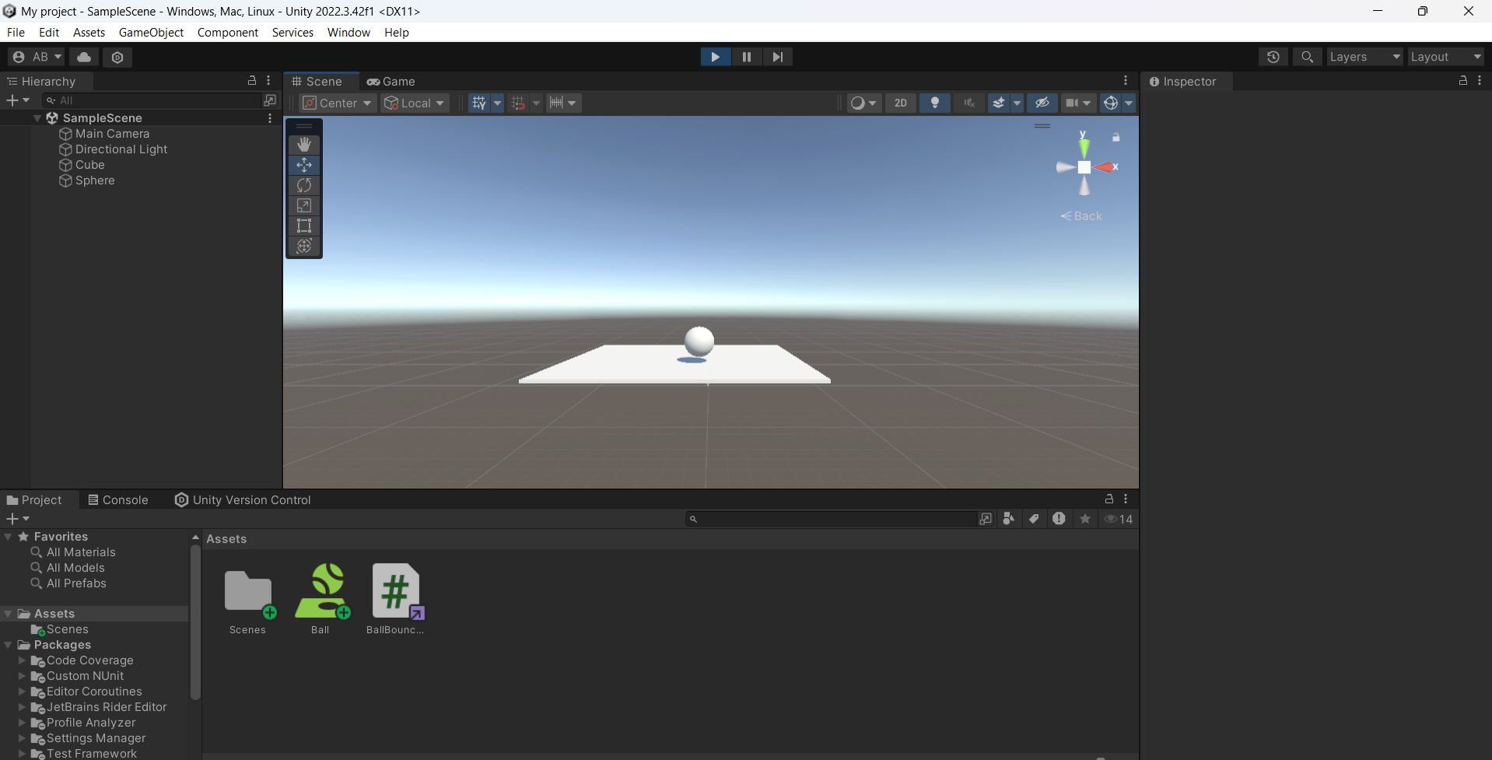

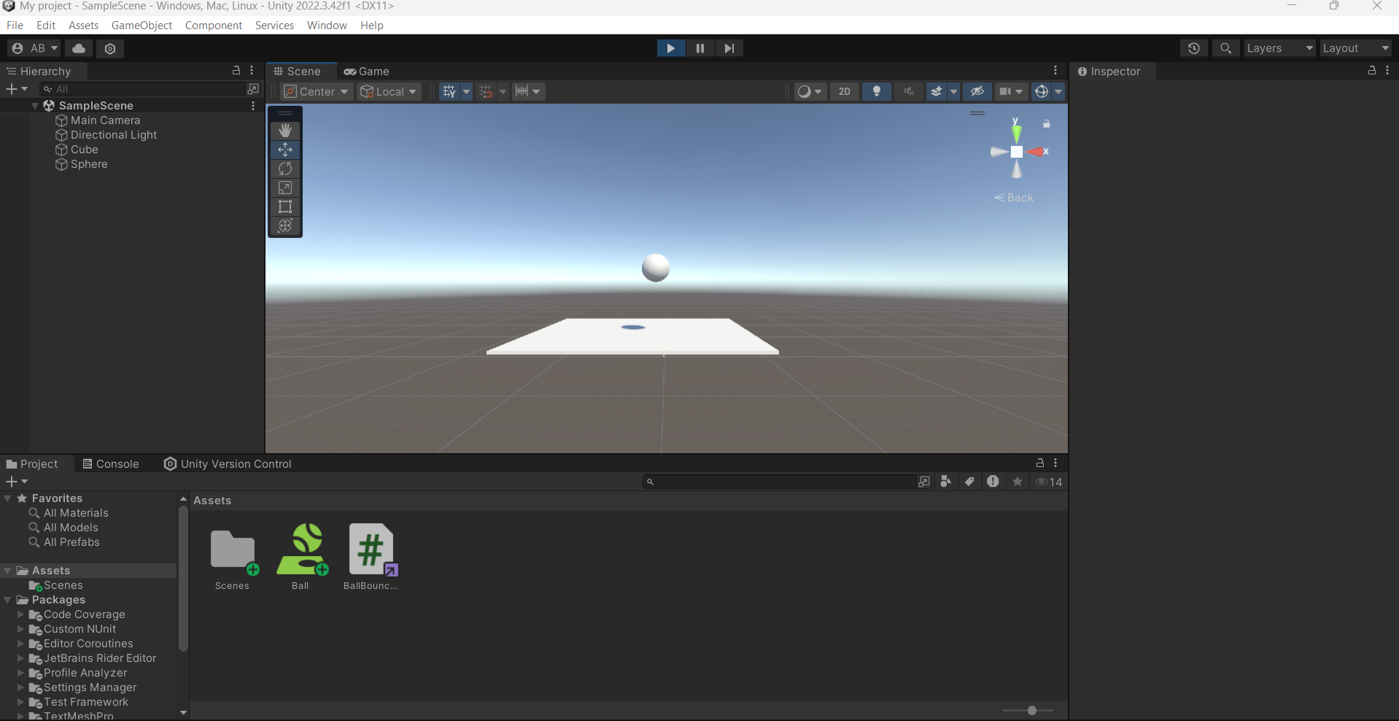

**Conclusion:** Thus, we have understood the features of Unity to develop a scene and applied Rigid body component, Material and Box collider to the game objects and controlled game objects through script.

# FAQs:

1. What is the rigid body component?
2. What is the use of rigid body and box Collider?
3. How can you control game objects in Unity?