Final Year B. Tech. CSE Augmented Reality and Virtual Reality

Assignment No. 5

# Submitted by:

|  |  |
| --- | --- |
| **PRN** | **1032211329** |
| **Roll No** | **PB-25** |
| **Student Name** | **Aryan Bansal** |

**Title:** Create an immersive environment for Virtual Reality (living room/terrain/basketball court) with only static game objects. 3D objects can be created using Blender or use available 3D models.

**Aim:** To understand the steps for creating Terrain in Unity.

# Theory:

**<<Explain following points>>**

|  |  |
| --- | --- |
| ● | Describe Unity Asset Store  The Unity Asset Store is a digital marketplace integrated into the Unity game development platform. It offers a vast collection of pre-made assets, including 3D models, textures, scripts, plugins, and tools. Game developers and creators can browse, purchase, and easily integrate these assets into their Unity projects, accelerating development and enhancing the overall quality of their games or applications. |
| ● | Steps to add and paint terrain  1. Create Terrain:  - Go to "GameObject" > "3D Object" > "Terrain."  2. Adjust Size:  - Set terrain resolution and size in the Inspector.  3. Shape Terrain:  - Use tools like "Raise or Lower" for elevation adjustments.  4. Paint Textures:  - Select "Paint Texture" tool to add textures.  5. Add Layers:  - Edit terrain layers in the "Terrain Layers" section.  6. Detail and Trees (Optional): |

- Add details, trees, and grass using respective tools.

7. Configure Settings:

- Adjust lighting, shadows, and other settings in the Inspector.

8. Save Your Scene:

- Save your work to preserve changes.

* Steps to add trees and grass for creating terrain:

1. Terrain Settings:
   * Click on terrain, open settings, and select "Tree" tab.
2. Add Trees:
   * Click "Edit Trees," add tree prefabs, and paint them onto the terrain.
3. Adjust Placement:
   * Fine-tune tree density and height for realism.
4. Switch to "Grass" Tab:

- In settings, switch to "Details" tab for grass.

1. Add Grass Texture:
   * Click "Edit Details" to add grass textures.
2. Paint Grass:

- Use "Paint Texture" tool to add grass to the terrain.

1. Adjust Settings:
   * Fine-tune grass density and configure settings in the Inspector.
2. Save Scene:

- Save your work to keep tree and grass placements.

# Output:

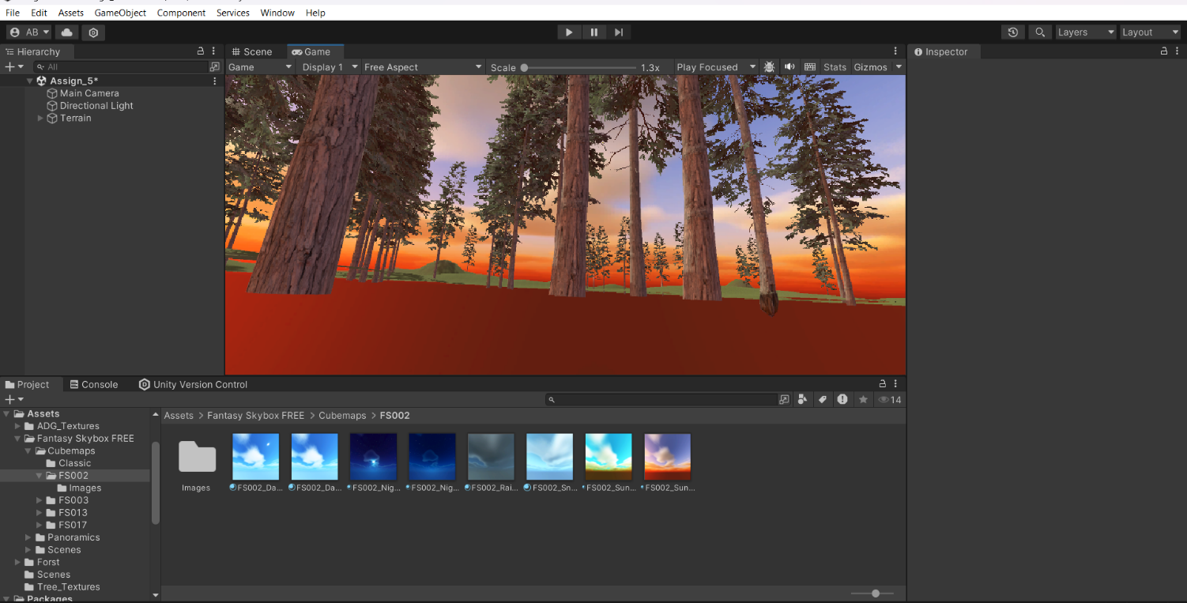

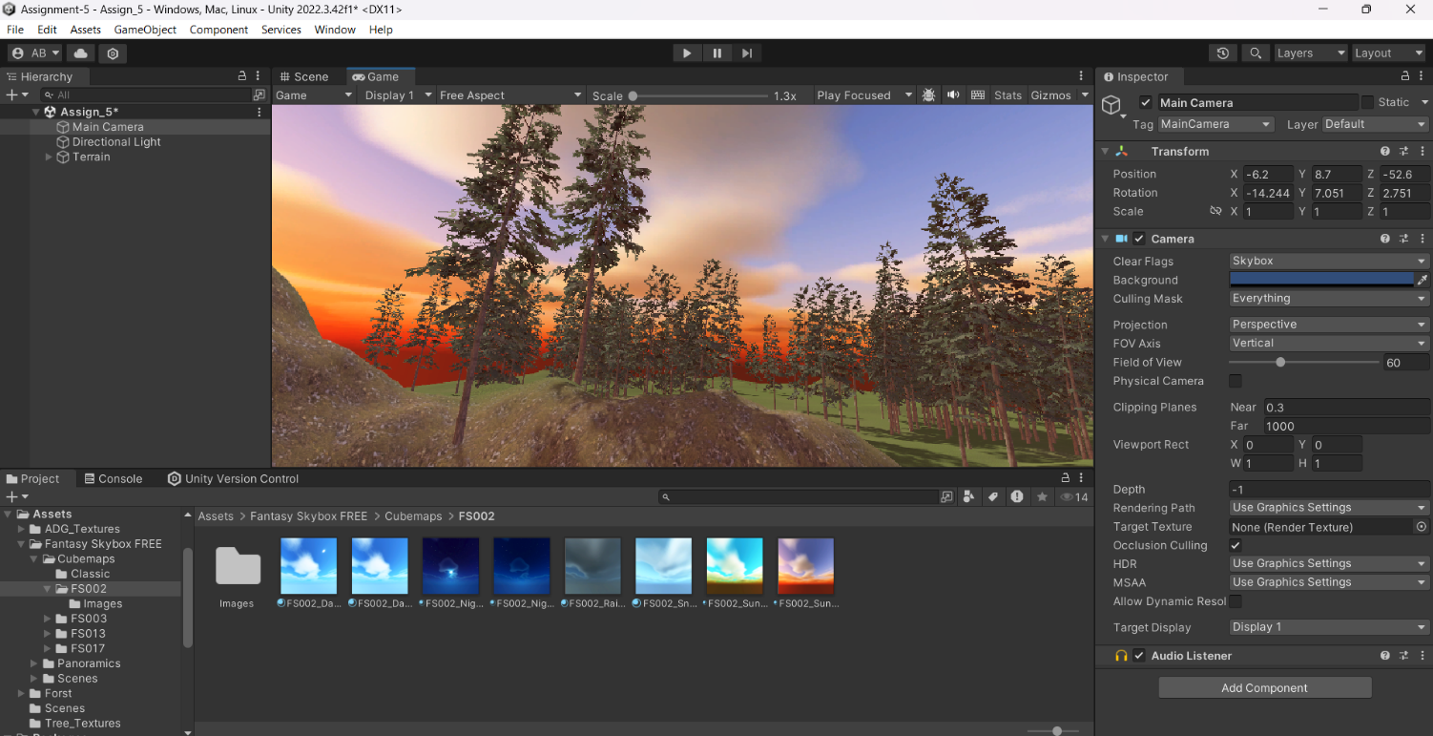

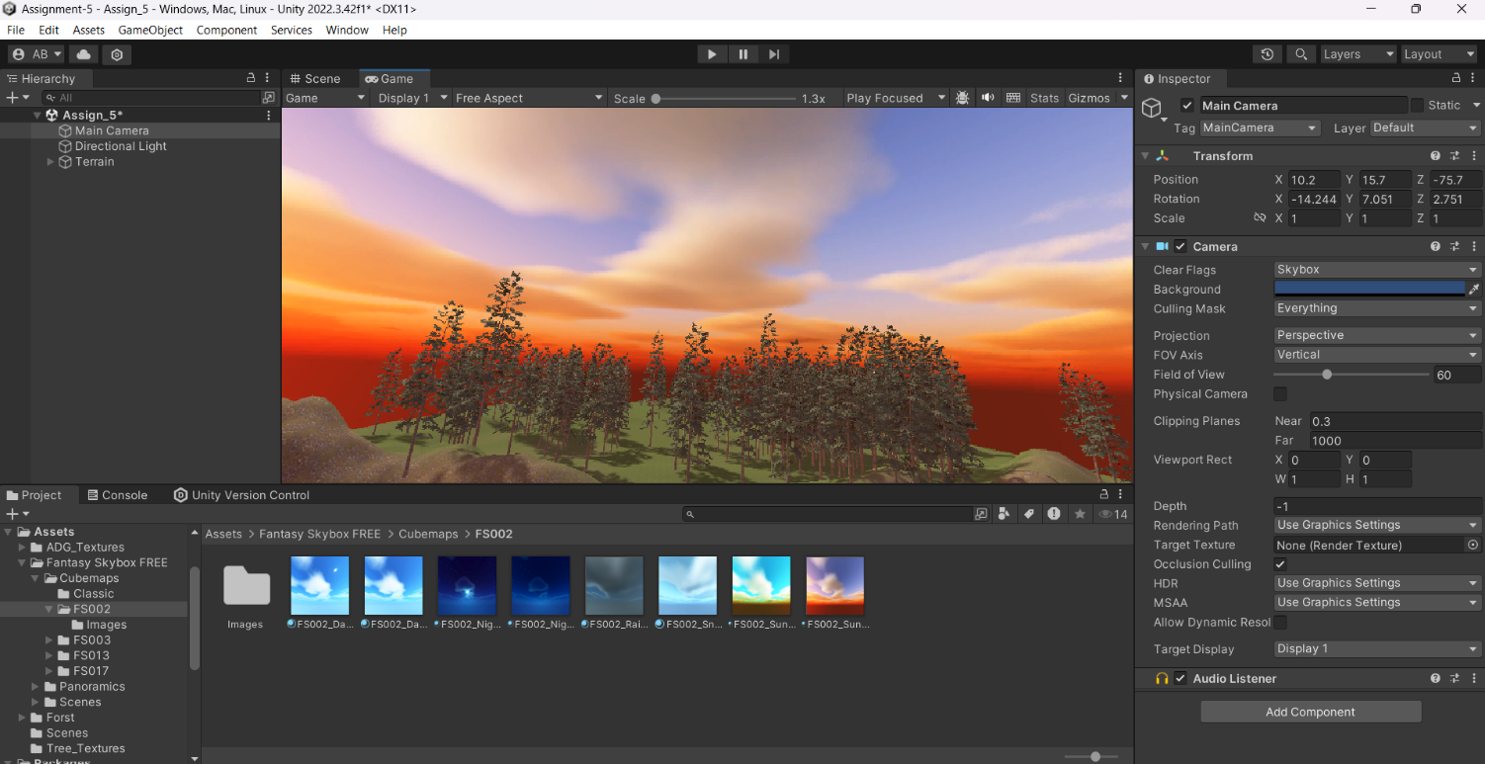

**Conclusion:** Thus, we have understood the steps for creating Terrain in Unity.

# FAQs:

1. What is Unity Asset Store?
2. How do we add Assets in Unity?
3. What is a package manager in Unity?

School of CET, MITWPU, Pune