**CS-213 Assignment 3**

**Photos**

Bansari Mehta(bm844) and Anvay Patel(acp205)

Start the application

Login screen appears:

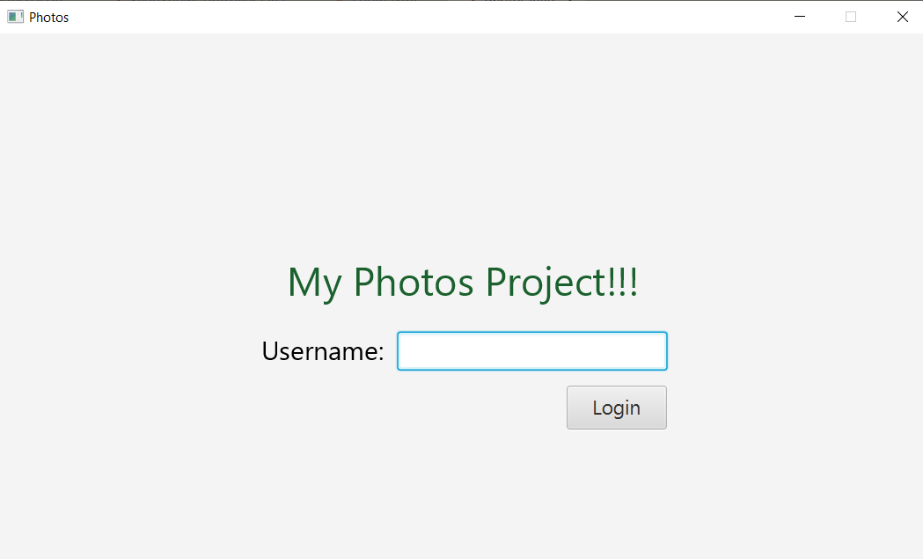

If user logs in as Admin, following screen will appear.

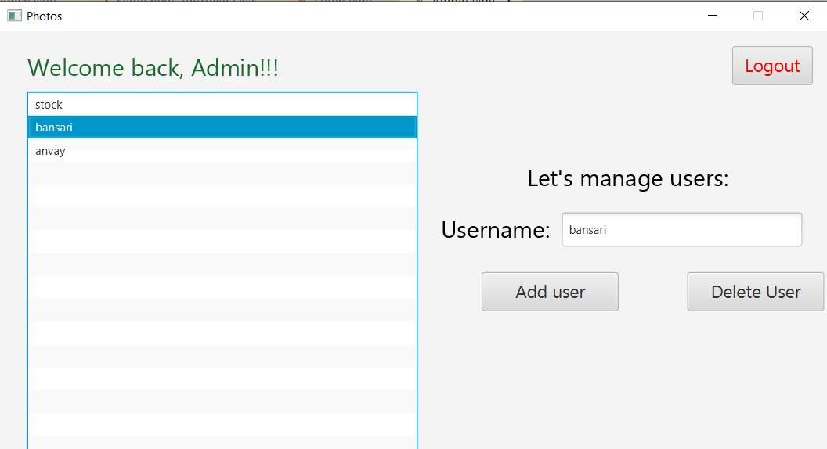

The list of all users will be displayed in the List View.

- Create – Clicking Create button adds new user.

- Delete – Clicking Delete button deletes existing user.

- Logout – Clicking Logout button will log out the admin following the confirmation popup

- If a user is logged in as non admin user then, they will be directed to View All Albums page; after that page, at any point a scene changes a user can use back button to go to previous scene.

**All Albums Page:**

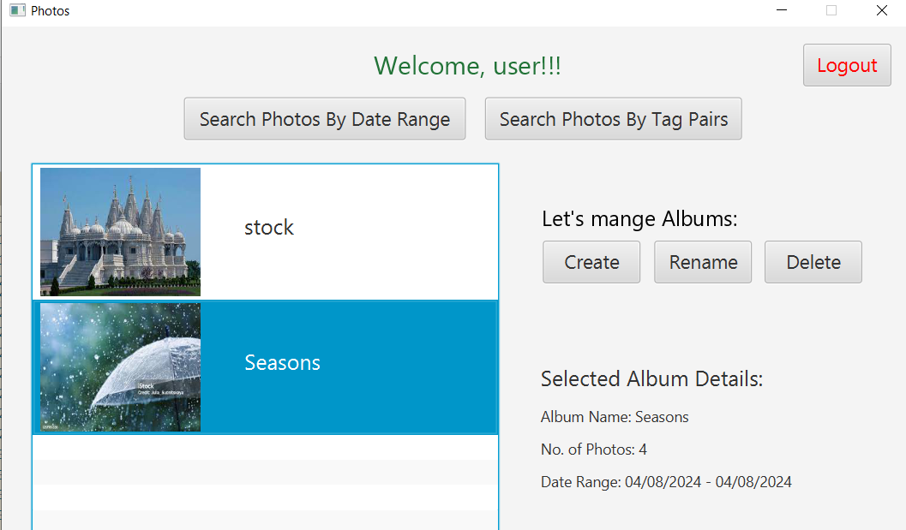

Event Details:

- The list of all albums will be displayed in the List View.

- Double clicking on album name in List View opens the album.

- Create – Clicking Create button creates new album.

- Rename – Clicking Rename button gives a popup of text entry with a Save button to rename that album.

- Delete – Clicking Delete button deletes an existing album.

- When the user clicks on any album in list view, Album Details such as its name, number of photos, and date range will be displayed.

- Search Photos By Date Range – Clicking that button gives a popup where a user inputs Date Range. The Search Results Page will open followed by the popup.

- Search Photos By Tag Pairs – Clicking that button gives a popup where a user inputs text entry. The Search Results Page will open followed by the popup.

- Logout – Clicking Logout button will log out the admin following the confirmation popup.

**Open Album Page:**

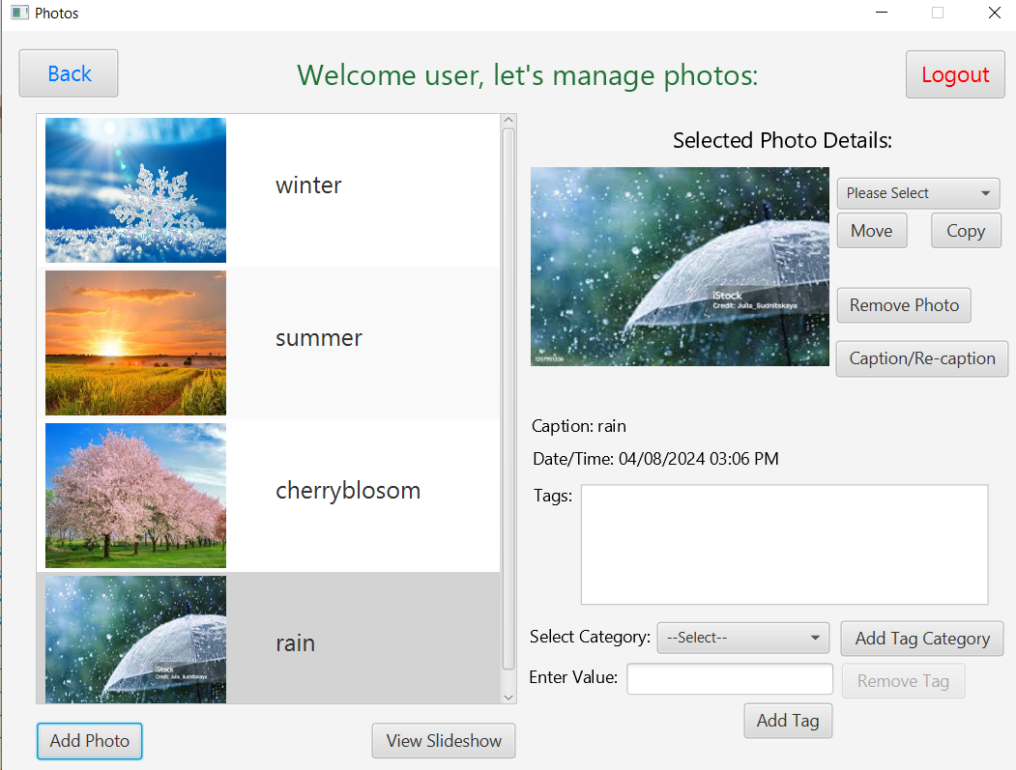

Event Details:

- The Thumbnail images of all photos in the opened album will be displayed in the List View.

- Add Photo – Clicking Add Photo button opens a popup where a user can add a new photo, set its caption, and add/remove tags.

- View Slideshow – Clicking View Slideshow buttons displays all images of that album.

- Move Photo – Selecting the album from dropdown and clicking Move Photo button moves the photo followed by confirmation popup.

- Copy Photo – Selecting the album from dropdown and clicking Copy Photo button copies the photo followed by confirmation popup.

- Remove Photo – Clicking Remove Photo button removes the photo followed by a confirmation popup.

- Caption/Re-caption – Clicking Caption/Re-caption button allows user to enter a text entry in a popup that updates the Caption of that photo.

- Selecting a photo will display photo, caption, date/time, and tags for that photo.

- All the current tags for a photo will be displayed in the List View.

- Add Category – Clicking Add Category button allows user to enter a text entry in a popup that adds new tag category.

- Add Tag – Selecting a Category from the drop down and entering its value allows user to add a tag in the list view.

- Remove Tag – Selecting a Tag from List View and clicking Remove Tag button removes the tag from the list view followed by a confirmation popup.

- Back – Clicking Back buttons takes a user to their all-albums page.

- Logout – Clicking Logout button will log out the admin following the confirmation popup.

**View Slideshow Page:**

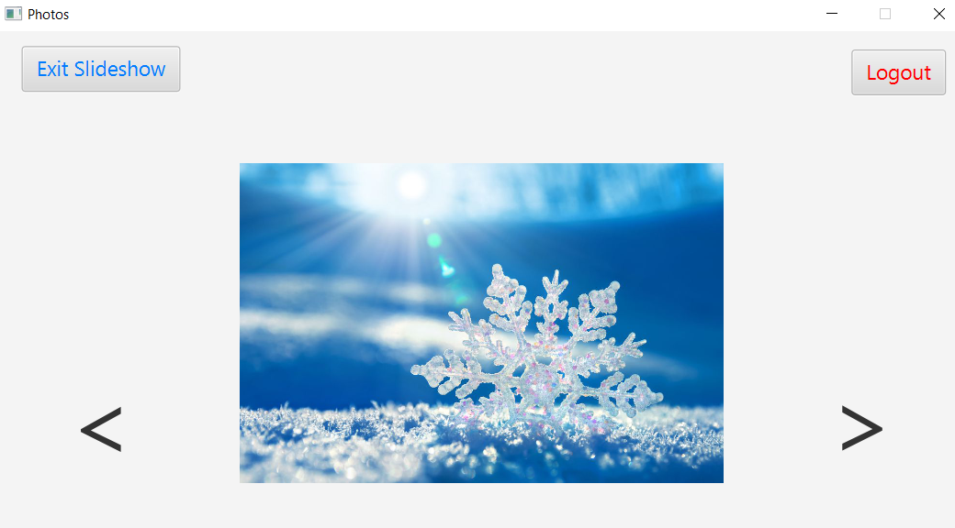

Event Details:

- Exit Slideshow – Clicking that button exits the slideshow and takes back to Open Album

Page.

- “<” – Clicking “<” button displays previous image of that album.

- “>” – Clicking “>” button displays next image of that album.

**Search Results Page:**

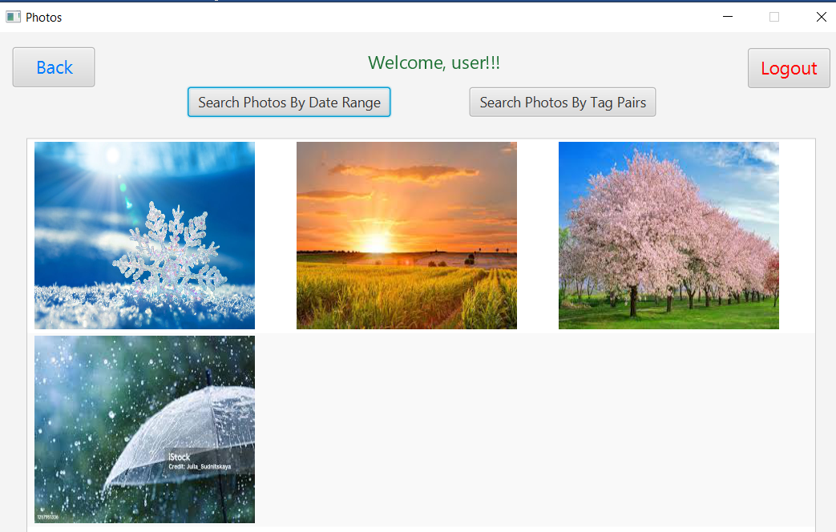

Event Details:

- Search Photos By Date Range – Clicking that button gives a popup where a user inputs Date Range. The Search Results Page will open followed by the popup.

- Search Photos By Tag Pairs – Clicking that button gives a popup where a user inputs text entry. The Search Results Page will open followed by the popup.

- The list of all photos that match the search entry will be displayed in the middle of the page.

- Back – Clicking Back buttons takes a user to their all-albums page.

- Logout – Clicking Logout button will log out the admin following the confirmation popup.

**Notes**:

- At any point in time in the application if the user decides to logout, then the logout button is provided, and all the work will be saved.

- At any point in time in the application a user can close the application directly and they will be logged out automatically.