**STUDENT BLACKBOARD**

-Bansari Patel

**1.0 PROJECT PROPOSAL**

Any student whether he’s new or returning has a long “To-Do List” prior to beginning the school year. They need to complete several steps such as selecting courses, getting familiar with the subjects if in case they don’t belong to the same background, find out where classes take place and at what time and dates, the library, bookstore, department offices, knowing their faculty and much more. Students also need access to submit assignments and get their grades, they need to work with other students on projects, and they need to update their student profile. A student portal is such a system that contains this interaction at the same location. Basically, this kind of portal is very popular in the United States but back when I was an undergrad student, we didn’t have this kind of facility at our school. So, I truly think developing such a portal will be helpful to the students back there.

As in Today’s Digitalized world, every paper-based Information Management system is moving online. From Hospitals to Schools, everyone should be using some software which makes their tasks easy and efficient. My Project is one such software that will make so many tasks easy and more manageable for lots of people. Users Include Students, Professors of the College. Student Blackboard is a college portal that allows cutting edge online interaction between the college system, Faculty, and Students.

I want to provide students with tools that help them easily find the information they need under one roof rather than asking updates about assignments, books to other fellow students. Moreover, they can get information about their grades online. This system would benefit a professor in terms of managing course contents and accessing information of any student within that portal.

# 2.0 PROJECT REQUIREMENTS

## **A. IDENTIFY A LIST OF POTENTIAL USERS**

## 

**A1. LIST OF USER INTERVIEWS**

**USER 1: AGE-22, GENDER-FEMALE, OCCUPATION-STUDENT**

An undergraduate student.

Back in my country I contacted an undergrad student and asked her how she got to know about due dates for submission of the assignments and she told me that she would usually ask her classmates or message in class’s group and enquire about that. But there are times when people might be busy and didn’t reply to her. So, in that case, the constraint is she might miss the due dates relying on another person to answer her.

**USER 2: AGE-19, GENDER-FEMALE, OCCUPATION-STUDENT**

An undergraduate student.

Talking with user-2 I asked her how she decides the course for the upcoming semester. She replied that she will just wait for the college system to make the courses available to them and search for it in google for what the course contents will be and then decide whether that course is suitable for her or not. Basically, they depend on the online course content which is generic and not particularly meant for their field or university.

**USER 3: AGE-37, GENDER-MALE, OCCUPATION-FACULTY**

An assistant professor.

While interacting with the faulty and questioning him about he assigns assignments and tasks to students, he told me that, they generally would contact the class head and send her the assignment and further it will be the responsibility of that student to forward the assignment to everyone in the class.

**USER 4: AGE-30, GENDER-MALE, OCCUPATION-FACULTY**

An assistant professor.

Another conversation with my professor was regarding study materials, how do they distribute them to the students, and he told me that there was a print station near our university so the students can get their copies by themselves by visiting that store.

**A2. LIST OF INITIAL TASKS**

**TASK 1: ASSIGNMENT DISTRIBUTION**

The first functionality of my system will cover is Assignment Distribution, this functionality will have two interfaces: one for the student and another for the faculty. For the student, the credentials will be that they can view, download and upload the assignment that their professor has assigned. For the faculty, they will be given the authority to upload the assignments and delete the assignments. The faculty can also update the due dates so that students can know the deadlines.

**TASK 2: ENROLLMENT OF ELECTIVE COURSES**

This module will eliminate the need for a paper-based form filling process that requires students to fill out forms in person to enroll in elective and courses. In this module Professors can create custom forms that can be distributed to students and students can fill out those forms to enroll in the course. The information filled by students will be available to the professor’s UI so that they can handle the rest of the Enrollment process to GTU. This module will also allow professors to provide a brief Description of listed/available courses so that students can decide better.

**TASK 3: COURSE LIBRARY**

In this module, Professors will be able to upload PDFs and DOCs about Course Curriculum including notes, answer sheets, tips, etc. for students to see on the go. Students can view and download the documents. It will help the professor to reach out to students in a better way providing them with the best academic experience.

**TASK 4: ASSIGNMENT SUBMISSION**

The functionality of this module would be performed by students. After viewing the assignments allotted by the faculty, students can upload their completed assignments on that same tab or page so that they don’t have to go submit the documents physically. There might be some cases where students due to some circumstances cannot make it to school on the day of submission so this task will be helpful at that time.

## **B. TASK LIST VALIDATION**

**B1. LIST OF USER DISCUSSIONS ON THE TASKS**

**USER 1: AGE-42, GENDER-MALE, OCCUPATION-FACULTY**

I explained my project to the professor and asked if the functionalities that I am providing will be helpful to them and he said that yes, there should be a system performing these tasks to ease their life. An additional idea that he provided me with was that I can add a module for attendance in the project. So, it could be easy for students to check on their attendance.

**USER 2: AGE-36, GENDER-FEMALE, OCCUPATION-FACULTY**

Interacting with another professor and explaining my project, she suggested to me the platforms and the languages that I can work on. She also told me that I can design the interface in a way that looks good and compatible with all kinds of electronic devices.

**USER 3: AGE-22, GENDER-MALE, OCCUPATION-STUDENT**

Discussing the project with my friend, he told me that you should implement such kind of projects so that it could be really beneficial for students. He referred me to some universities that are having these sorts of portals so I can get more ideas from that.

**USER 4: AGE-22, GENDER-FEMALE, OCCUPATION-STUDENT**

While talking to about the project with an undergraduate student she suggested to me the functionality that I can add for the college calendar which will view the events, holidays, placements ongoing. So that they can be active in the events and don’t have to rely on another person to pass the information about ongoing activities on the campus.

**B2. LISTS OF REVISED TASKS**

**TASK 1:**

I would like to add a college calendar module and link that with assignments and submissions so that students can get deadlines for each subject. I can connect the dates that the professor has mentioned into the event table and that will reflect in the college calendar.

**TASK 2:**

The functionality of adding an attendance hub is also a great idea! It can be implemented in a way that; the professor needs to manually add the attendance into the excel sheet and it would directly generate the percentage of each student’s presence. But according to me its not a feasible solution so I might not consider adding this functionality.

**TASK 3:**

A task that is added can also be of publishing students’ grades into the module of assignments so that the students can have easy access to their grades from anywhere. The professor shall upload the grades after checking the grades in a way a student can have an acknowledgment that their assignments are processed by the faculty.

**B3. REVISED LIST OF USERS**

After finishing the process of identifying the tasks and interacting with the users I didn’t find any major change in the list of users because my project focuses on the communication between faculty and user so they would be the only users. But I can add another user which is admin.

**REVISED USER 1: ADMIN**

The role of admin in my system will be to provide authentication for the users. Admin will also have control access distribution. They will also handle the college calendar module as the faculties cannot have time to update the system every day and, in some cases, they also might not aware of events happening in college, but the admin must know everything about the events.

**C. THE LITERATURE SYNOPSIS:**

1. <https://www.ijarbest.com/conference/spcl15/670>

This is a paper published by some students of Tamilnadu, basically, they have developed a similar system of what I want to design and the ideas that they had also related to rectifying the issues that are encountered by the students in day to day basis. In their document, they have also stated the benefits of having intranet systems in universities.

2. <https://ris.utwente.nl/ws/portalfiles/portal/6623596/concourse.pdf#page=46>

This research paper provides very detailed specifications of why this kind of educational portal should exist. They focused on the general objectives and expected benefits from the project. Moreover, they have mentioned the diagram depicting the whole structure of the project.

3. <https://www.educause.edu/ir/library/pdf/pub5006g.pdf>

Reading this research paper, I came to know everything I needed to know about what a web portal is, how web portal should be. Additionally, I learned many terms that are related to a portal like HEP (Horizontal Enterprise Portals), VEP (Vertical Enterprise Portal), CPAD (Customized, Personalized, Adaptive Desktop). On top of that, they also showed how to proceed with the development of a web portal (things that one should keep in mind).

4. <https://ieeexplore.ieee.org/document/7233087/references#references>

This Document guides on the common features of the general portal structure. They also compared the traditional portal framework and how the latest student portal is. Furthermore, they also discussed how to divide the components of the portal and how to efficiently work on each of them.

# 3.0 Project Prototype

**3.1 DESIGN:**

The login page of the system will have email and username. Once you have that entered you can enter the system.

The image on the right is the enrollment page for students. A student needs to enter his name and select an option from the drop-down menu for elective courses. After they have made the decision, click on Enroll to Submit their form.

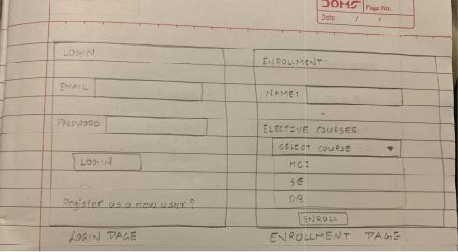

Login Page for the system and Enrollment page for Students

The image on the left shows Create Course module which is for Faculty to add new Course. They will have fields such as Course Number, Title, Credits and Department. Once they click on the Create button, a new course will be added.

On the right side, the faculty can see the view of the list of students enrolled for his Course.

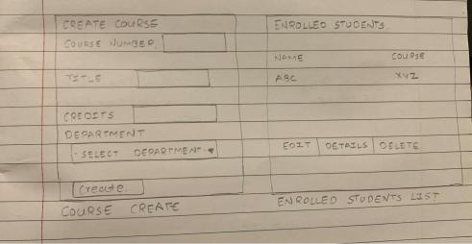

Create a Course and Faculty’s page to see Enrolled Students List

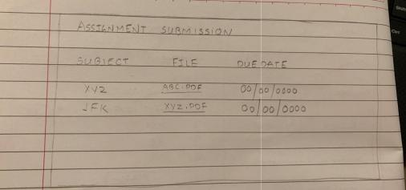The below image is of Assignment Submission in which the students can check the assignments due dates, view the file.

Assignment Distribution

Book Library will have all the study materials, books that are uploaded by the faculty for students to either view or download it.

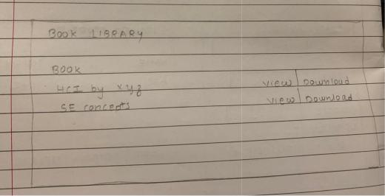

Book Library

On this page, the students can upload their completed assignments in the form of a word or pdf file.

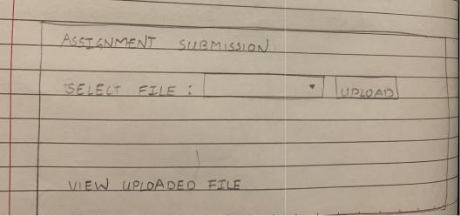

Assignment Submission

College Calendar is the home page of the system that will have all the links that can navigate the user to different pages.

It will also have the list of events happening on campus including placements, holidays, college fest and etc.

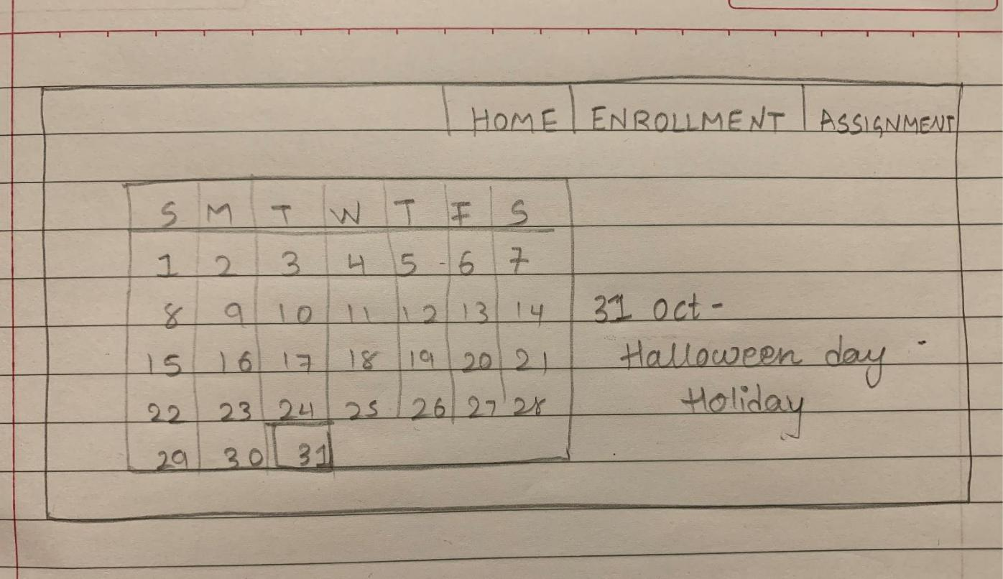

College Calendar

**STORY-BOARD PROTOTYPE:**

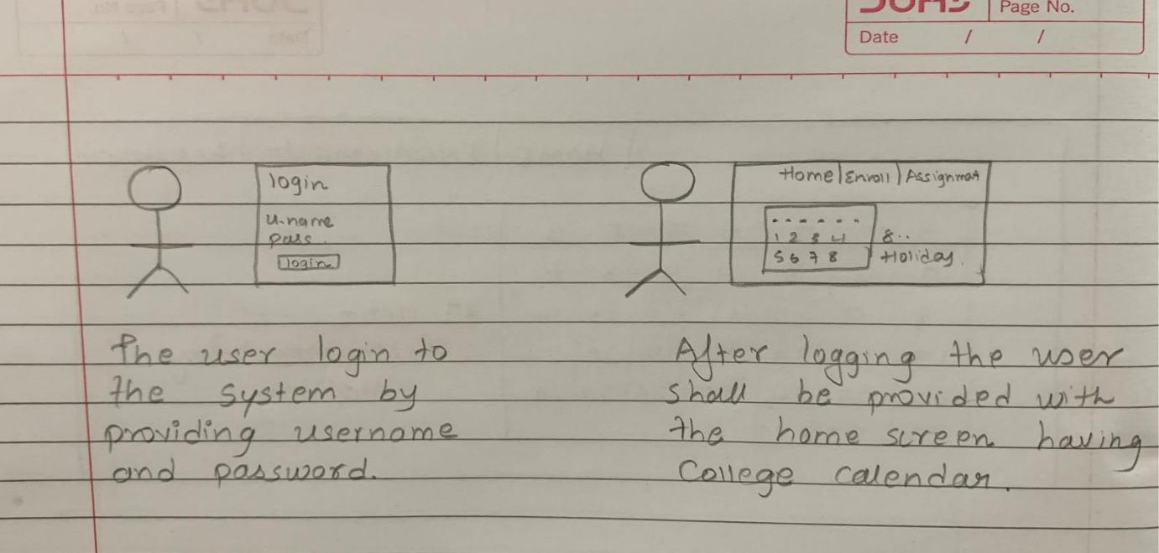

**USER EXPERIENCE MAP:**

An experience map is a representation of the customer's experience in different interactions with the software/system. The representation can be in the form of a series of sticky notes or flow diagrams. The experience map that I came up with for the application which I am planning to design is shown in the above figure. This consists of the Design ideas, Comments, Questions, and Instructions.

**3.2 EVALUATION:**

For the evaluation phase, I have a walkthrough for all tasks that the systems will perform.

|  |  |  |
| --- | --- | --- |
| Description of Step | Does the user have the knowledge/training | Is it believable that they would do |
|  | to do this? | it? Are they motivated? |
| Enrollment into | Yes, the user will be having the | They will use the task as it will |
| Elective Courses | knowledge to which course to select from | give the information for the |
|  | the given options as the details for each | courses and platform under one |
|  | the subject will be given. | page. |
| Enrolled Students | The Faculty can view the students that are | They will use this module to |
|  | registered for the courses. | know the number of students |
|  |  | enrolled. |
| Assignment | It’s not that they will need to be familiar | Yes, they will use this for their |
| Submission | with the module because it’s too simple to | ease. |
|  | understand. |  |
| Book Library | No such kind of training will be required | Rather than asking for materials |
|  | as the user will just click the download button | to everyone, it is better to get it on |
|  | if he wants that book. | your own. |

**3.3 Choice and Refinement:**

For future development I will use the story-board prototype as it is easy to understand by any user as to how to do and what do to will be mentioned in the images. So, with the help of Storyboard prototyping, the user will get ideas for the input and what output they must get. The tasks that will be affected are view, download, and upload for different users. The prototype was modified in the way that it provides some basic guidelines for the users to interact with the system. The User base was the same for both the paper-type protocol and story-board prototyping. The only changes that are made in the interfaces are the authorities that will be given to the user on the basis of their login credentials.

**3.4 Finalized Design:**

The interaction starts with the user that will log-in to the system. The login step will be simple as the user just needs to enter username and password and if not registered, they can click on the New User and that link will navigate to the registration page.

After that, the user can see the Home Page. The homepage itself will be the college calendar page viewing the events happening on campus. By default, it will show the events for the current date and if you want to know upcoming events than the user simply needs to click on the date and the events registered will be shown.

There will be three options available to the users to navigate, Assignment, Library, and Enrollment. The user can select that according to the need.

Let’s say they selected Assignment,

Assignment page for Faculty: If a faculty is a user then they will be having the option to upload an assignment and view the uploaded assignment.

If the user is a Student than they can download the assignment uploaded by the faculty and upload their completed work.

Next up, the Library page: The faculty can upload any study material that wishes to provide the students and the students can have the option to view and download that material.

For the Enrollment page:

The faculty will be creating a course and the details of that course will be also provided by him. The course detail will include the description of the subject, course credits and the name of faculty.

The student can have the authority to select the courses that are being provided by the faculty and the details so that they can choose from the number of courses that will be the most appropriate for them.

**3.5 Lessons Learned:**

For this project prototype, I learned different types of paper-prototyping available and for what is used for. I designed the user-interfaces for the system with the help of paper prototyping. I created them in a flow in which my system would perform.

Prototyping any project is crucial as it allows the designers to present the designs and actions performed. We can also know at a very early stage if the designs or prototypes are having any errors.

**4.0 PROJECT IMPLEMENTATION**

Student Dashboard is a project to provide students with tools that help them easily find the information they need under one roof rather than asking updates about assignments, books to other fellow students. Moreover, they can get information about their grades online. This system would benefit a professor in terms of managing course contents and accessing information of any student within that portal.

The first screen that will appear will be the login page. In the login page, the user needs to enter their email address and password.

If the user is new to the system they have the link to register as a new user but for that, they will need admin’s help to provide the credentials.

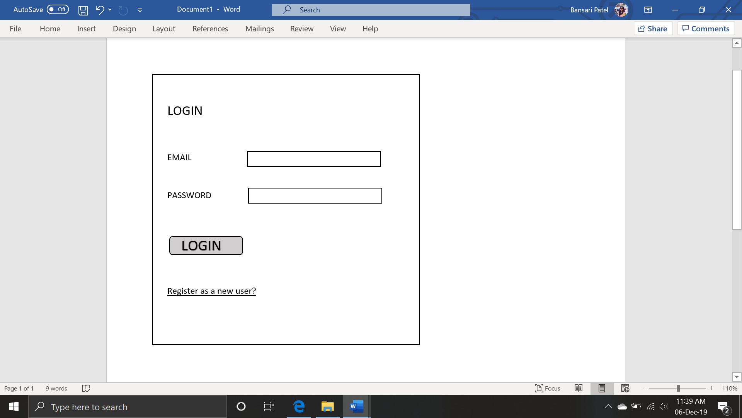

LOGIN PAGE

The next page after login will be the home page. The home page will have a college calender as its display screen and it shows the events happening on the selected date.

The home page will also have tabs to redirect them to another page.

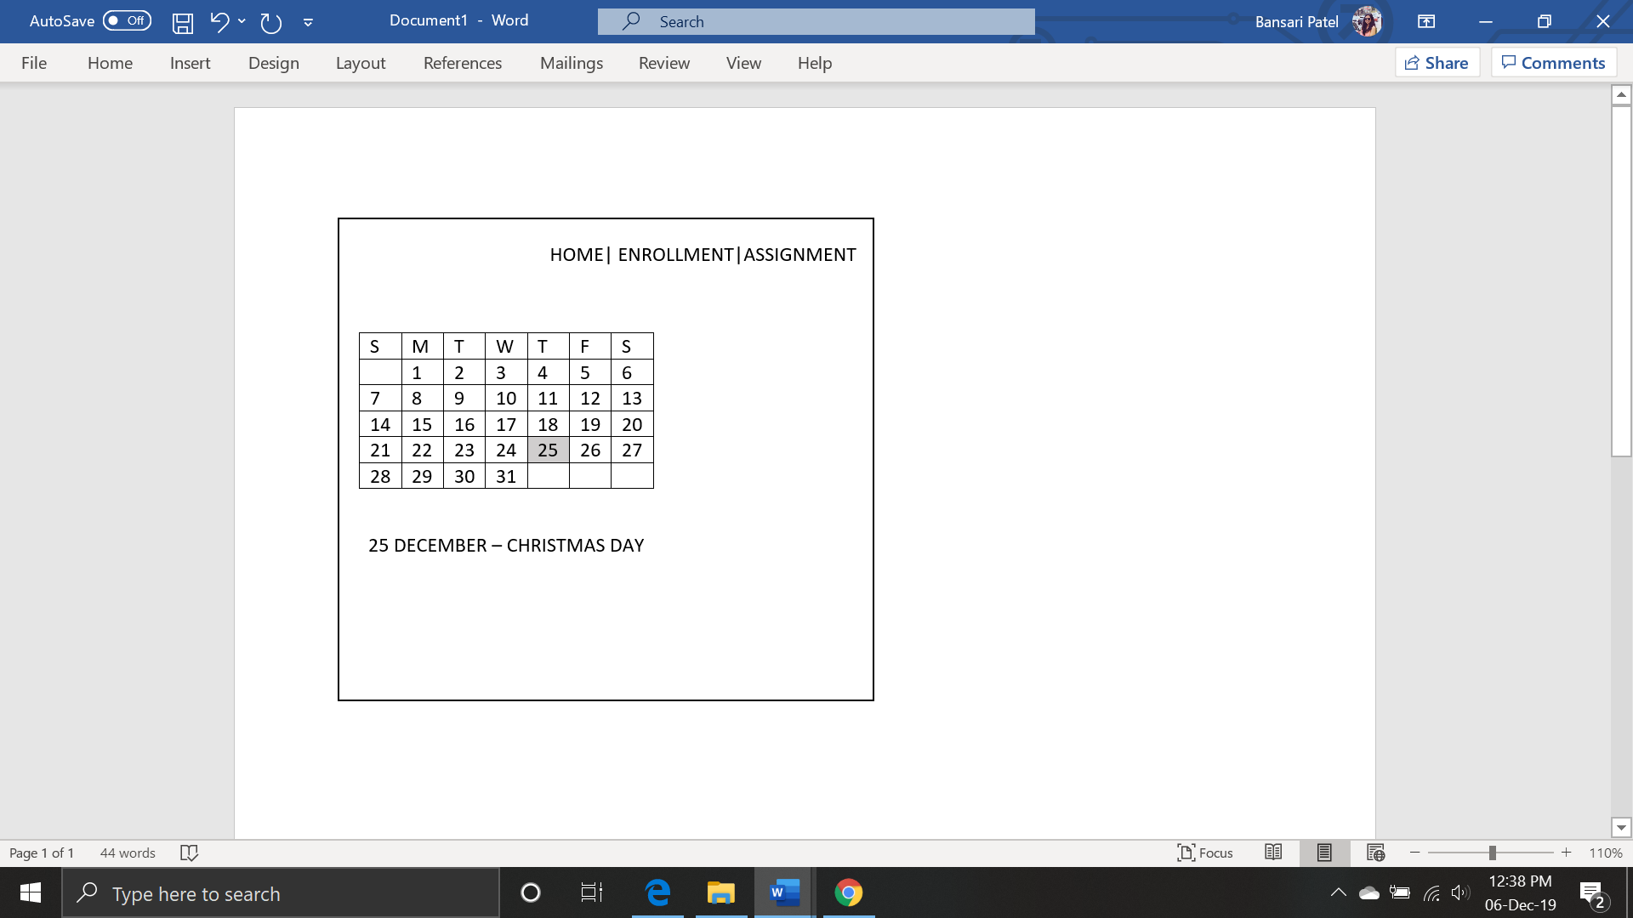

HOME PAGE

Below is the screenshot of the Course creation module which will be done by the faculty. They can add the course number, title, credits and select the department for that course. Once the faculty has created a course it will show those subjects to students for enrollment.

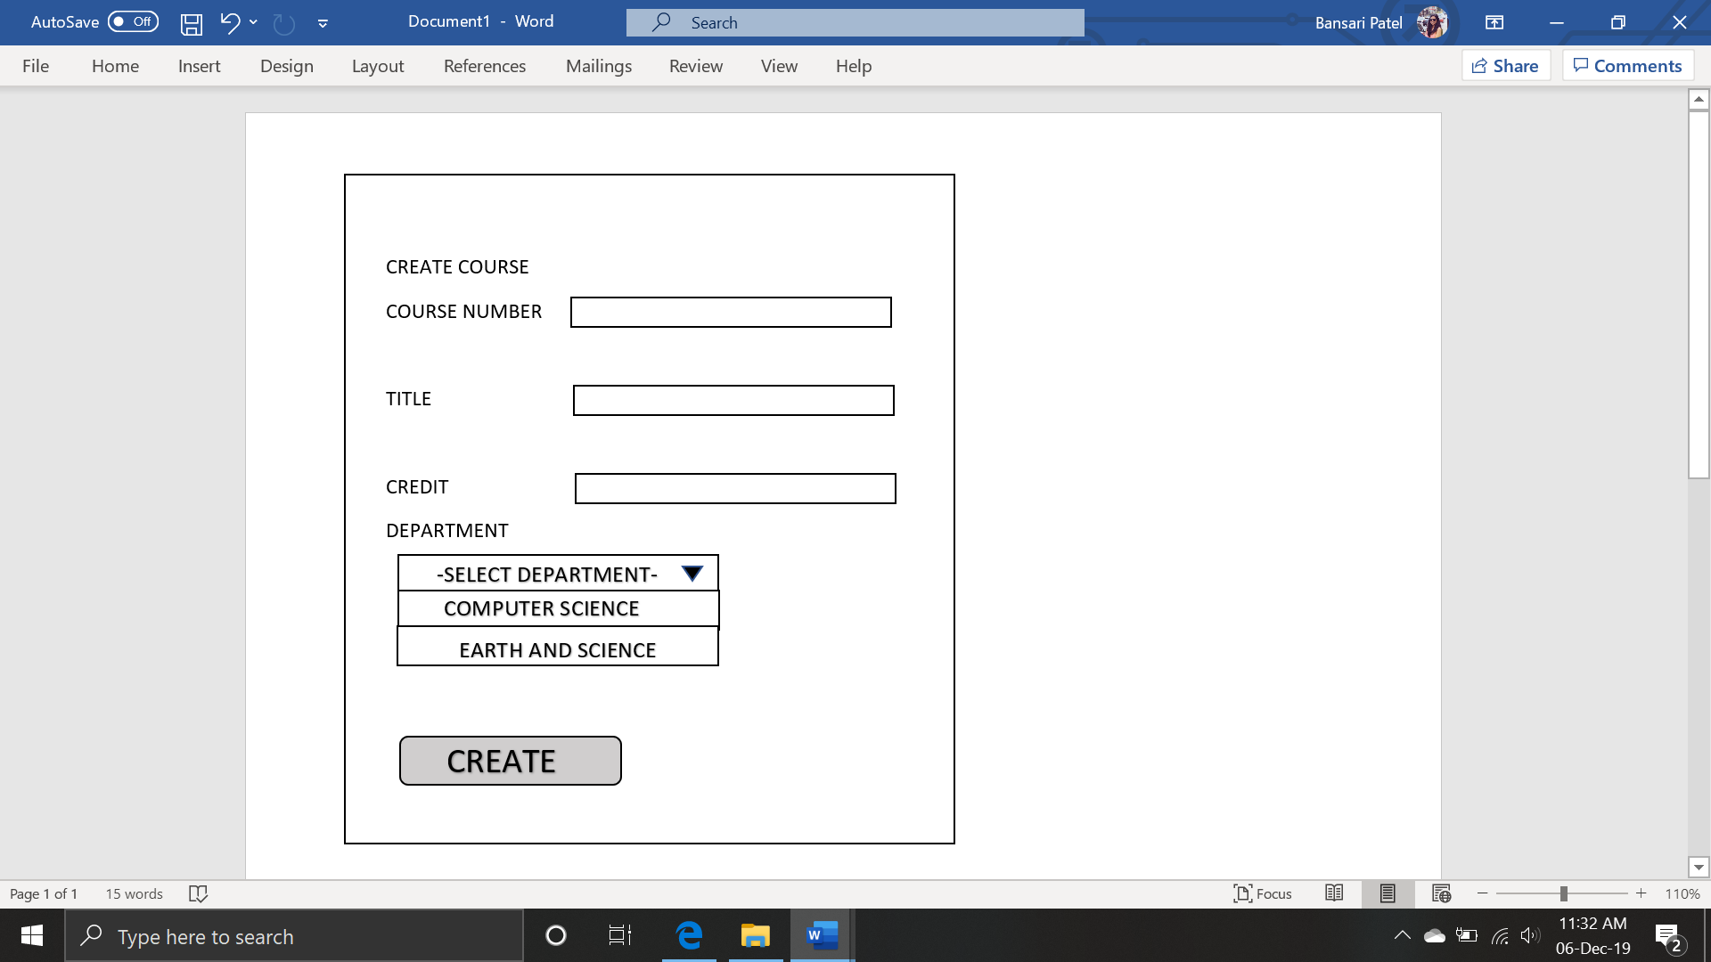

CREATE COURSE

Faculties can have access to view the list of students that are enrolled in their subjects. The following screenshot shows the list of students participated in some course.

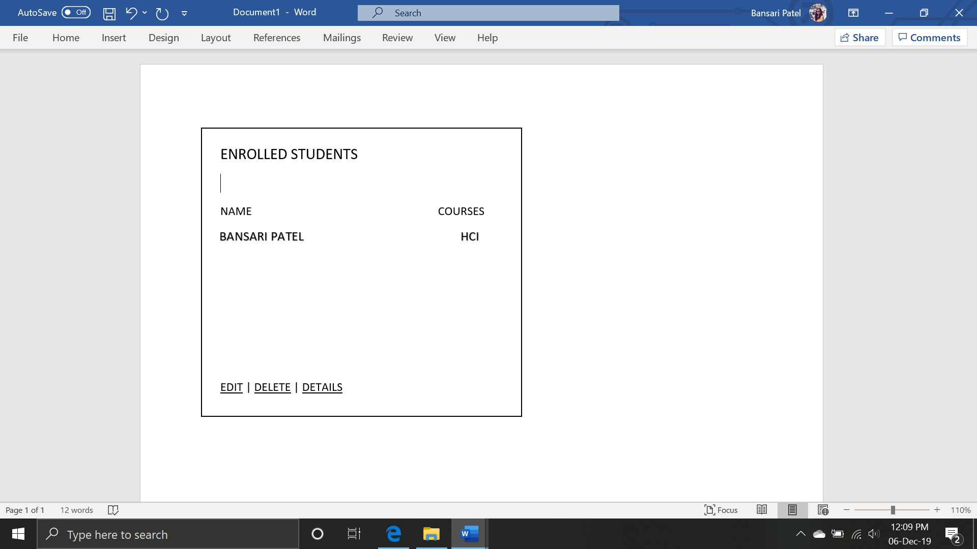

ENROLLED STUDENTS LIST

The following page is for students who want to enroll in some courses. They can view names first and select the elective courses available from the drop-down menu and after the selection is done, they can click on the Enroll button to register themselves for that subject.

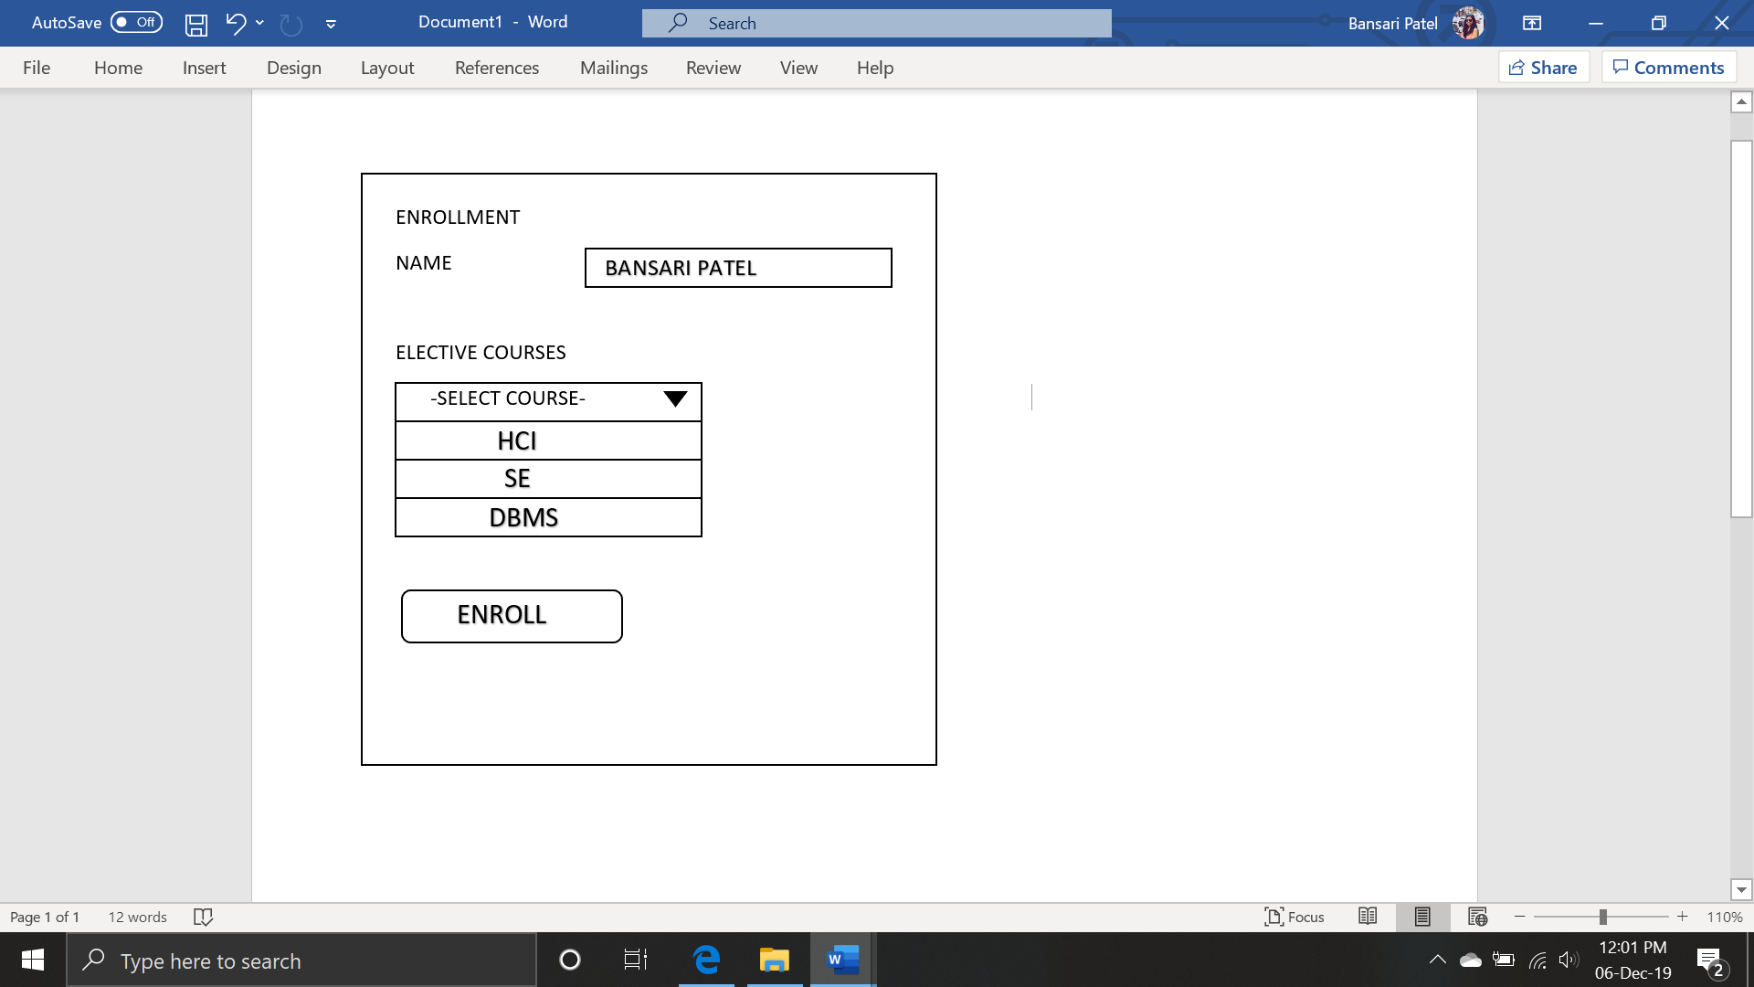

STUDENT ENROLLMENT

Assignment submission is the module in which the faculty will create the students who will be able to see due dates along with the assignment file. The file can be any word or pdf file, or it can be an image as well.

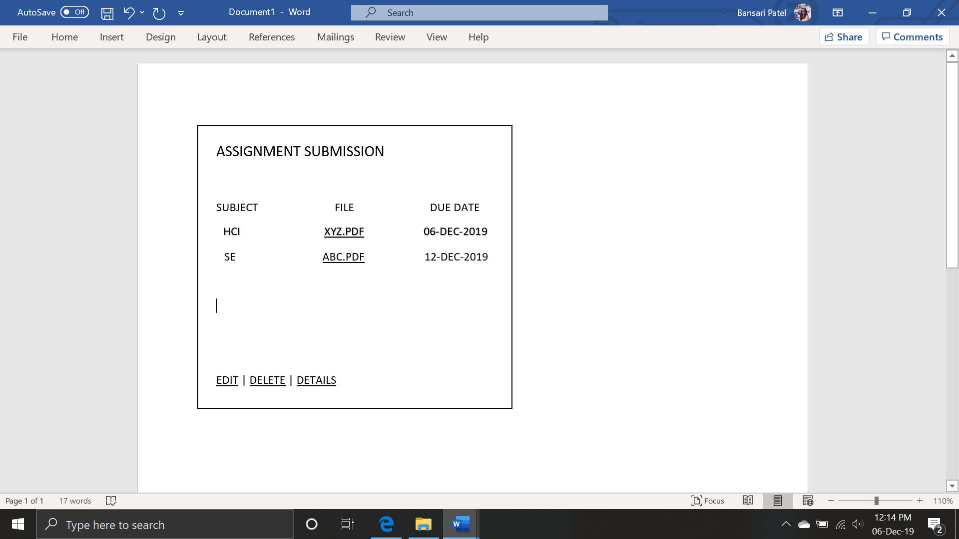

ASSIGNMENT PAGE

For the students, this page will allow them to submit the completed assignments. They just have to select the file and click on the upload button to complete the task.

They will also be able to view the uploaded documents.

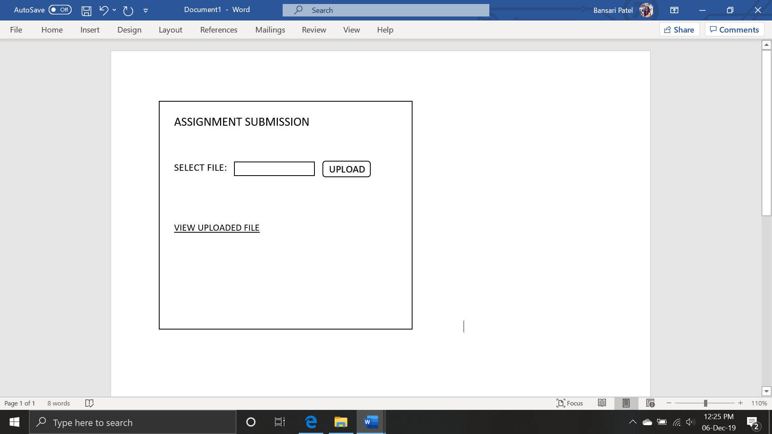

ASSIGNMENT SUBMISSION

The last page/module is a book library in which the professor can upload documents or study materials and the students will be able to view or download it.

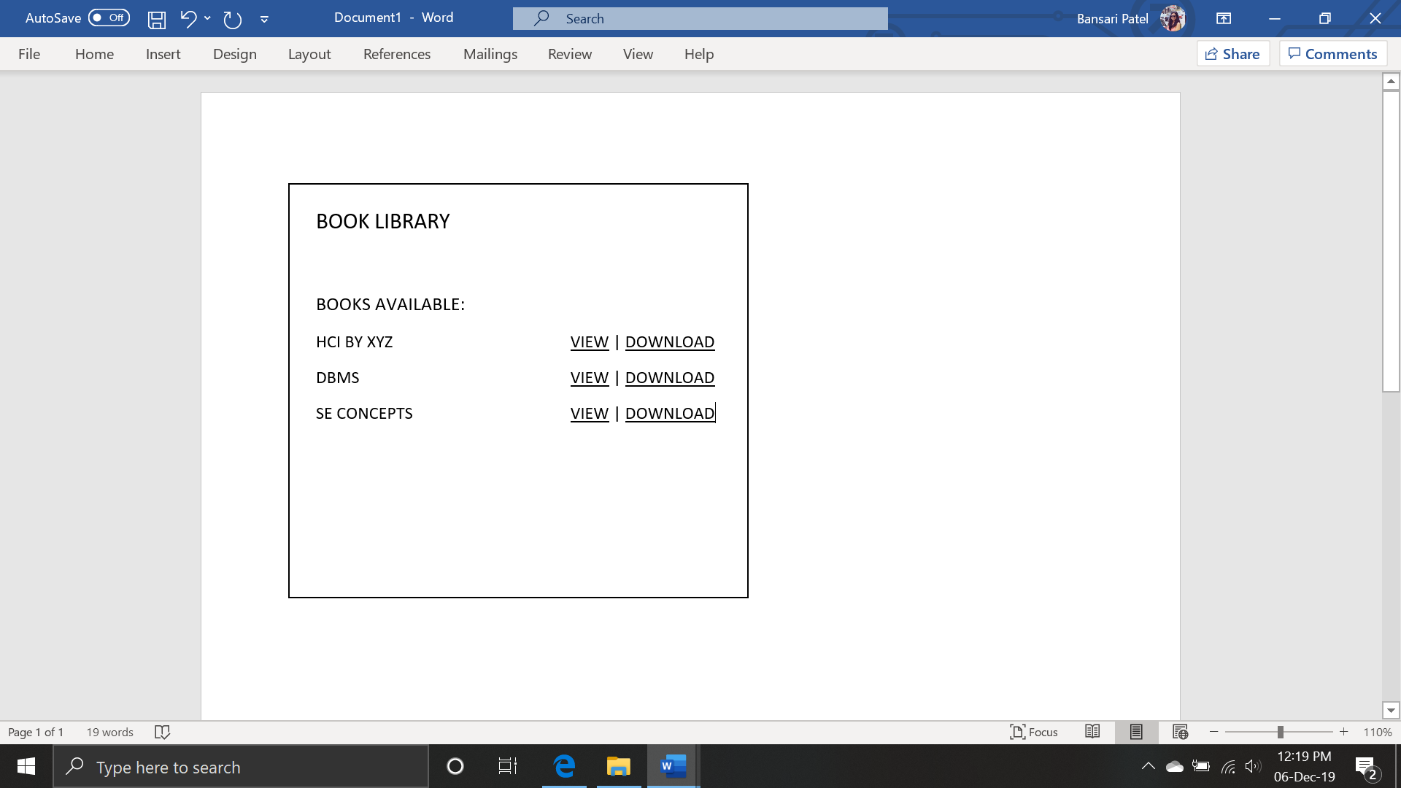

BOOK LIBRARY