IBM Bob Usage in CareBridge
Hackathon Project Documentation

1. Overview
CareBridge is an AI-powered healthcare awareness and access assistant designed to help users understand healthcare information in simple language, access preventive-health information, and discover relevant healthcare resources.
The application is designed as an awareness and navigation assistant and does not attempt to diagnose diseases or prescribe medication.

2. Role of IBM Bob
IBM Bob was used as an AI-powered development partner during the development of the CareBridge prototype.
Our primary use of IBM Bob was in frontend-backend integration. Bob helped us connect the frontend with the backend API, troubleshoot integration issues, and refine the overall application workflow.
IBM Bob was also used for debugging and code refinement where required.
The final implementation, testing, integration, and product decisions were performed and reviewed by the development team.

3. Development Tasks Supported by IBM Bob

3.1 Frontend–Backend Integration
One of the main uses of IBM Bob was integrating the CareBridge frontend with the Python backend.
The integration involved connecting the frontend chat interface to the backend API so that:
- User
- Frontend Chat Interface
- Backend API
- AI Agent
- AI Response
- Frontend
IBM Bob assisted us in:
- Connecting frontend requests to the backend API
- Structuring API requests and responses
- Debugging frontend-backend communication issues
- Handling backend responses in the frontend
- Ensuring user messages were correctly passed to the AI agent
- Displaying AI-generated responses in the chat interface
- Refining the communication flow between frontend and backend

3.2 AI Agent Development
The CareBridge backend uses LangChain/LangGraph with a Groq-powered language model and exposes healthcare-related tools to the agent.
IBM Bob was used mainly to support the surrounding application development, debugging, and integration rather than replacing the AI architecture itself.
The agent was designed to:
- Understand natural-language healthcare questions
- Respond in the user's language
- Provide simplified healthcare information
- Promote preventive healthcare
- Search for healthcare resources when appropriate
- Escalate potentially urgent situations
- Avoid diagnosis and prescription behavior

3.3 Healthcare Safety Logic
CareBridge includes safety-oriented instructions designed to prevent the assistant from:
- Diagnosing diseases
- Prescribing medication
- Inventing medication doses
- Inventing healthcare facilities or emergency numbers
- Providing fabricated medical information
Potential emergency situations are instead directed toward professional medical care.
The development team reviewed and tested this behavior as part of the application validation process.

3.4 Tool Integration
CareBridge includes tools for:
- Healthcare information/resource search
- Saving relevant responses
These tools are exposed to the AI agent so that it can retrieve information when required rather than relying entirely on generated knowledge.
IBM Bob assisted primarily with the application-side integration and debugging required to make these components work with the frontend and backend.

3.5 Debugging and Code Refinement
IBM Bob was used during iterative development to help identify and resolve implementation issues, particularly those involving the frontend, backend API, and their integration.
The generated suggestions were reviewed and tested by the development team before being incorporated into the project.

4. Human Oversight
IBM Bob did not autonomously make final product or healthcare decisions.
The development team was responsible for:
- Reviewing generated code
- Testing functionality
- Validating frontend-backend communication
- Validating AI behavior
- Reviewing healthcare safety behavior
- Selecting which suggestions to implement
- Making final product and technical decisions
Healthcare-related behavior was specifically reviewed to ensure that CareBridge remains an awareness and resource-navigation assistant rather than a replacement for medical professionals.

5. Technology Architecture
The current prototype follows this high-level architecture:
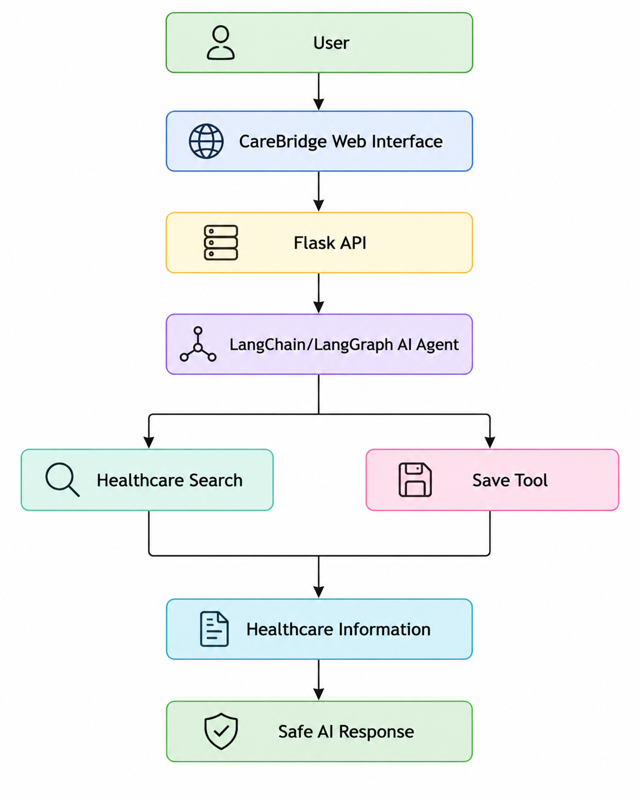
IBM Bob was primarily used during the development of the integration between the frontend and backend components, including API communication and debugging.

6. Example Development Workflow
- Identify a frontend-backend integration requirement or technical issue.
- Provide the relevant code or development context to IBM Bob.
- Ask Bob for an implementation approach or debugging assistance.
- Implement or modify the suggested code.
- Run and test the application.
- Debug any remaining issues.
- Review the implementation as a team.
- Validate the final functionality.

7. Responsible Use of AI Development Tools
IBM Bob was treated as a development assistant rather than an autonomous software engineer.
All important implementation decisions remained under human control.
For the healthcare domain, additional attention was given to safety, accuracy, transparency, and avoiding unsupported medical claims.

8. Outcome
Using IBM Bob helped the team accelerate the development of the CareBridge prototype, particularly in:
- Frontend-backend integration
- API communication
- Debugging
- Code refinement
- User-interface iteration
This helped us rapidly move from individual application components to a working end-to-end prototype.
The resulting CareBridge prototype demonstrates AI-assisted healthcare awareness, multilingual interaction, healthcare-resource discovery, and responsible-AI behavior.

