
FINA 6203: Investment Analysis
Mutual Fund Report: Vanguard 500 Index Fund Admiral Shares (VFIAX)

TEam 2: duc nghia (michael) phan, bansi nirav thakkar, fadi frem boustani, ohene boahen, zhe chen, wenxi liu
Presented to Professor paul chiou

Table of contents
1. Portfolio Objectives 3
2. Security Holdings 7
3. Investment horizon and Performance 9
4. Risk management 12
5. Investor suitability analysis 13
6. Benchmark Performance Comparison 14
7. Conclusion 16

Table of figures
Figure 1: VFIAX's investment style 5
Figure 2: VFIAX's holdings 8
Figure 3: VFIAX's historical performance 10
Figure 4: VFIAX's return compared to the average large blend fund 11
Figure 5: Historical volatility measures of benchmark indexes 12
Figure 6: VFIAX's performance statistics 14
Figure 7: VFIAX's performance compared to average large blend funds 15

- Portfolio Objectives
Vanguard 500 Index Fund Admiral Shares (VFIAX):
The U.S. index fund VFIAX became available to investors when it launched in November 2000. The Admiral share class of VFIAX offers a 0.04% expense ratio but investors must deposit at least $3,000 to access this fund.
Investment objective:
The fund operates with a single purpose to duplicate the performance of the S&P 500 Index. The fund achieves its goal by maintaining identical stock holdings at index weights which provides investors with U.S. market exposure through established companies without market prediction attempts.
Benchmark:
The fund tracks the S&P 500 Index which contains approximately 500 of the biggest publicly traded U.S. companies. The S&P 500 Index which S&P Dow Jones Indices maintains serves as the main performance indicator for large-cap U.S. equity investments because it represents 80% of the total U.S. stock market value.
Why this benchmark makes sense:
The S&P 500 serves as the suitable benchmark for VFIAX because the fund exists to duplicate this index exactly. The fund and index use market-capitalization weighting which results in larger companies holding greater weight in the investment portfolio. The fund achieves its purpose when its performance matches the S&P 500 Index because this indicates successful execution of its investment strategy.

Strategy:
The fund invests in all S&P 500 component stocks through market value-based stock acquisitions. The fund operates with a strategy that avoids market timing and stock selection for individual companies. It tries to maintain identical returns to the index through the reduction of tracking error which represents the difference between fund performance and benchmark performance.
The investment portfolio distributes its assets across all essential business sectors including technology and healthcare and financials and consumer goods and industrials and additional sectors. The fund performs periodic updates to its holdings when the index experiences changes through additions or removals of companies. The fund performs portfolio updates only occasionally which results in a 2-3% annual turnover rate. The fund maintains low trading activity which results in reduced expenses and lower tax liabilities for investors.
Investment Policy Statement (IPS):
The IPS for VFIAX remains unavailable from Vanguard although investors can understand the fund's operational framework through its prospectus and investment strategy. The fund exists to serve investors who want to invest in U.S. large-cap stocks without focusing on particular market segments or investment approaches. It operates through full replication by holding all S&P 500 Index components at their corresponding weights. The Admiral share class of VFIAX demands a $3,000 initial investment while offering a 0.04% expense ratio to demonstrate Vanguard's dedication to cost reduction. The fund maintains low portfolio turnover at 2-3% per year which helps minimize trading expenses and generates better tax performance for shareholders.
Investment style:
VFIAX follows a passive investment approach focused on large-cap U.S. equities. As shown in the
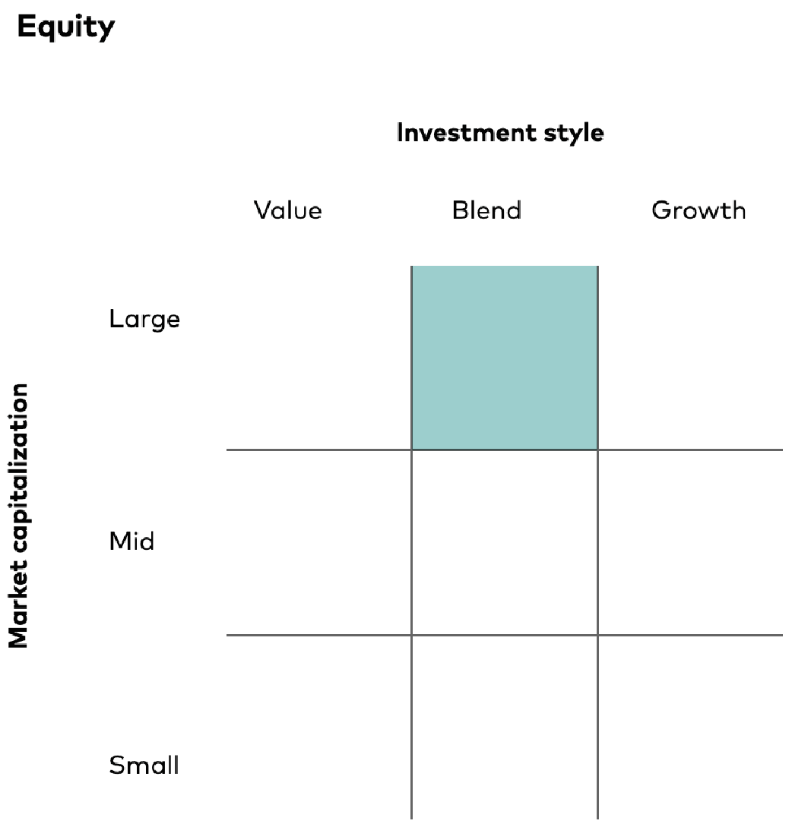
Morningstar style box above, the fund falls squarely in the "large blend" category, meaning it holds a mix of both growth-oriented and value-oriented stocks without favoring either style.
Figure 1: VFIAX's investment style
The fund's growth exposure comes from companies like Apple, NVIDIA, and Amazon firms characterized by high earnings growth and premium valuations. On the value side, the portfolio includes established companies such as Johnson & Johnson, Procter & Gamble, and Exxon Mobil, which typically trade at lower price multiples and pay consistent dividends. Because the S&P 500 naturally includes both types of stocks weighted by market value, VFIAX captures this blend automatically without any distinct positions..
Investment process: Identifying, Selecting, and Monitoring securities
VFIAX doesn't pick stocks, it follows a rules-based process determined entirely by the S&P Dow Jones Index Committee. The Committee decides which companies qualify for the S&P 500 based on specific criteria:
- The company must be based in the U.S. and have its primary listing on a U.S. exchange
- Market capitalization must exceed approximately $13 billion (the exact threshold adjusts with market conditions)
- The company must report positive GAAP earnings in both the most recent quarter and over the past four quarters
- At least 50% of shares must be available for public trading (adequate liquidity and float)
Once the index composition is set, Vanguard's job is simply to replicate it. The fund holds all 500 stocks in proportion to their float-adjusted market values, with no discretionary decisions by portfolio managers. Consistent monitoring tracks any changes in index weights due to price movements, corporate actions, or share issuances, and the fund adjusts accordingly.
Buy/Sell discipline:
VFIAX's trading decisions follow mechanical rules tied entirely to S&P 500 index changes, with no room for manager judgment or market timing.
A BUY occurs when companies join the index. The fund also buys shares when reinvesting dividends or deploying new cash from investor contributions, spreading these purchases proportionally across all holdings.
A SELL happens when companies exit the index through mergers, bankruptcies, privatizations, or shrinking market caps. The fund also makes small adjustments during quarterly rebalancing to keep portfolio weights aligned with any market cap shifts.
- Security Holdings
As a market-cap weighted index fund, VFIAX's largest holdings reflect the biggest companies in the S&P 500. The top 10 positions account for 38.73% of the portfolio, with technology stocks dominating due to their substantial market valuations. The table below shows these holdings as of October 31, 2025:
Rank | Company | Ticker | Weight | Sector
1 | NVIDIA Corporation | NVDA | 7.95% | Technology
2 | Microsoft Corporation | MSFT | 6.72% | Technology
3 | Apple Inc. | AAPL | 6.60% | Technology
4 | Amazon.com,  Inc. | AMZN | 3.72% | Consumer Cyclical
5 | Meta Platforms Inc. | META | 2.78% | Communication Services
6 | Broadcom Inc. | AVGO | 2.71% | Technology
7 | Alphabet Inc. (Class A) | GOOGL | 2.47% | Communication Services
8 | Tesla, Inc. | TSLA | 2.18% | Consumer Cyclical
9 | Alphabet Inc. (Class C) | GOOG | 1.99% | Communication Services
10 | Berkshire Hathaway Inc. (Class B) | BRK-B | 1.61% | Financial Services
Figure 2: VFIAX's holdings
The concentration in technology with NVIDIA, Microsoft, Apple, and Broadcom together representing over 23% of the fund reflects the sector's dominance in the U.S. equity market. However, the portfolio also includes representation from consumer cyclicals (Amazon, Tesla), communication services (Meta, Alphabet), and financials (Berkshire Hathaway), providing some diversification even within the top holdings.
- Investment horizon and Performance
VFIAX is designed for long-term investors with a time horizon exceeding five years. As a core large-cap holding, the fund provides broad exposure to the U.S. equity market without attempting to time market movements or rotate between sectors.
Performance analysis:
The table below shows VFIAX's historical performance across multiple timeframes as of October 31, 2025:
Period | Date | Price | Annualized  Return (Before  Fees) | Annualized  Return (After  Fees)
Current | 10/31/2025 | 631.72
1 Year Ago | 10/31/2024 | 520.3376 | 17.60% | 17.55%
3 Years Ago | 10/31/2022 | 342.5843 | 24.88% | 24.45%
5 years ago | 10/31/2020 | 280.9879 | 16.42% | 16.02%
Since inception | 11/13/2000 | 77.69 | 8.63% | 8.21%
Expense ratio | 0.04%
Inception years | 24.97
Figure 3: VFIAX's historical performance
The fund has delivered strong returns across all periods. The 1-year return of 17.55% (after fees) reflects the market rally through late 2024 and 2025. The 3-year annualized return of 24.45% captures the sharp recovery from the 2022 market correction, when inflation concerns and rising interest rates pressured equity valuations.
Over five years, the fund returned 16.02% annually, a period that includes the COVID-19 pandemic crash in March 2020 and the subsequent recovery. The since-inception annualized return of 8.21% over nearly 25 years demonstrates the fund's ability to deliver consistent long-term performance despite major market disruptions, including the dot-com crash, the 2008 financial crisis, and the pandemic.
Comparison to peer average:
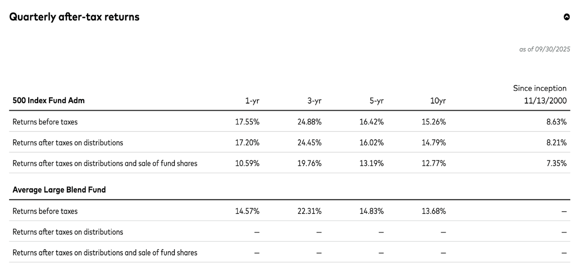
Figure 4: VFIAX's return compared to the average large blend fund
VFIAX consistently outperforms the average large blend fund across all timeframes. As shown in Figure 4, the fund's 3-year return of 24.88% (before taxes) exceeds the peer average of 22.31% by 2.57 percentage points. This outperformance stems primarily from VFIAX's rock-bottom expense ratio of 0.04%, compared to the category average which typically ranges from 0.50% to 1.00%.
Expected return goal:
VFIAX aims to deliver long-term capital appreciation by matching the performance of the S&P 500 Index rather than trying to beat it. The fund's return expectations align with historical S&P 500 performance, which has averaged 7-10% annually over extended periods. By holding a diversified portfolio of roughly 500 large-cap U.S. companies weighted by market value, the fund participates in the growth of America's largest corporations without the costs and risks associated with active stock selection.
- Risk management
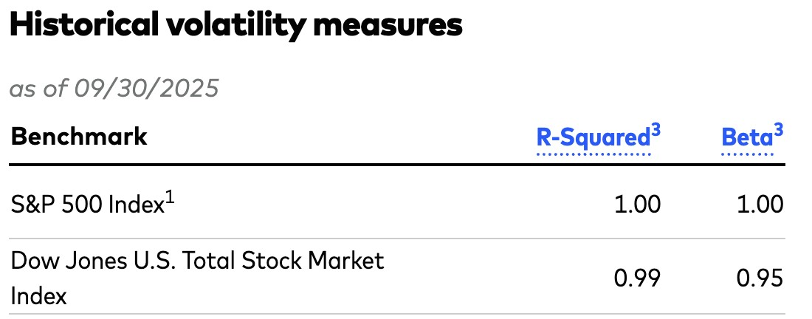
The fund manages risk through diversification rather than active risk mitigation. Holding 504 stocks across eleven economic sectors reduces the impact of any single company's performance on the overall portfolio. However, as a passive fund that mirrors the S&P 500, VFIAX accepts full market risk when the index falls, the fund falls with it.
Figure 5: Historical volatility measures of benchmark indexes
The fund's risk profile can be understood through several key metrics. With a median market capitalization of $403 billion, the portfolio focuses exclusively on large, established companies rather than smaller, potentially more volatile firms. The portfolio's price-to-earnings ratio of 28.9x and price-to-book ratio of 5.2x reflect current market valuations. The fund's return on equity of 27.0% indicates the profitability of its underlying holdings, while the earnings growth rate of 23.6% suggests strong forward momentum in corporate profits.
Fund size and scale:
As of September 30, 2025, VFIAX holds total net assets of approximately $1.4 trillion across all share classes, with the Admiral Shares class accounting for $626 billion. This enormous scale provides several advantages: it allows Vanguard to negotiate favorable trading costs, ensures high liquidity for investors buying or selling shares, and demonstrates the fund's established track record and broad acceptance among both individual and institutional investors.
Fund transparency and disclosure:
VFIAX demonstrates excellent transparency in its disclosure practices. Vanguard provides comprehensive information about portfolio holdings, operational decisions, and costs through its website and regulatory filings. The fund clearly communicates its indexing strategy and outlines the market risks inherent in equity investing, making it straightforward for investors to understand what they're buying.
The fund's structure is simple and predictable. With a beta near 1.00, VFIAX moves in lockstep with the S&P 500, meaning investors know exactly what kind of market exposure they're getting.
- Investor suitability analysis
Who should invest in VFIAX?
VFIAX is appropriate for long-term investors with a minimum five-year time horizon who seek broad U.S. equity market exposure at minimal cost. The fund suits those who accept full market risk, as evidenced by its beta of 1.001 and annual volatility of 15.96%. With just a 0.04% expense ratio and 2.3% turnover, it's ideal for cost-conscious investors prioritizing tax efficiency.
The fund works well as a core portfolio holding for both novice investors building their first diversified portfolio and sophisticated investors who recognize the difficulty of consistently beating the market. Its passive structure appeals to buy-and-hold investors who want to participate in America's largest companies without active management decisions.
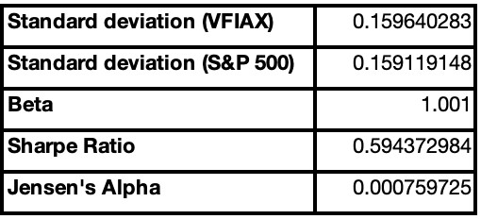
Who should avoid VFIAX?
Figure 6: VFIAX's performance statistics
Short-term traders seeking quick gains should look elsewhere, as the fund is designed for patient capital appreciation. Income-focused investors will find the dividend yield modest compared to dedicated dividend funds. Those seeking downside protection during market corrections won't find it here—VFIAX falls when the S&P 500 falls.
Additionally, investors wanting exposure to small-cap stocks, international markets, or specific sectors should consider other funds, as VFIAX exclusively holds large-cap U.S. companies with no sector tilt.
- Benchmark performance comparison
VFIAX's primary objective is to track the S&P 500 Index rather than outperform it. The following analysis examines how well the fund achieves this goal and how it compares to similar funds.
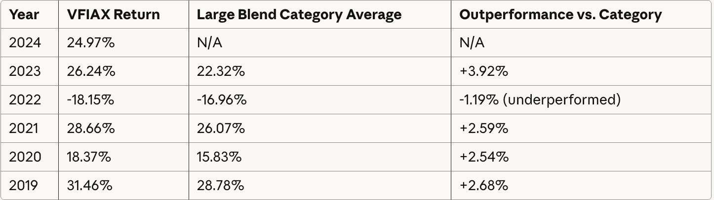
Figure 7: VFIAX's performance compared to average large blend funds
Fund performance vs. benchmark:
VFIAX achieves its objective of closely tracking the S&P 500 Index. The fund consistently underperforms its benchmark by a small margin typically 0.03% to 0.05% annually which directly corresponds to its 0.04% expense ratio. This is the expected outcome for a passive index fund and indicates successful execution of the fund's strategy.
For example, if the S&P 500 returns 25% in a given year, VFIAX would be expected to return approximately 24.96% after accounting for fees. The fund maintains a tracking error below 0.03%, meaning its returns deviate minimally from the benchmark. This tight tracking demonstrates Vanguard's effective index replication strategy.
Comparison to peer funds:
While VFIAX slightly trails its benchmark, it significantly outperforms the average large blend mutual fund. In 2023, VFIAX returned 26.24% compared to the category average of 22.32% a difference of 3.92 percentage points. Similar patterns appear across most years, with VFIAX beating the category average by 2-3% annually.
Did the fund beat the benchmark?
No, and it was not supposed to. VFIAX's goal is to match the S&P 500, not beat it. The fund successfully achieves this objective, delivering returns that trail the index by approximately the amount of its expense ratio. For investors seeking market-matching returns at minimal cost, VFIAX performs exactly as intended.
- Conclusion
VFIAX's disclosures are comprehensive and transparent, providing investors with all material information necessary to evaluate the fund's strategy, risks, and costs through readily accessible prospectuses, shareholder reports, and regulatory filings. The fund strictly adheres to its stated objective and investment discipline, as evidenced by a tracking error consistently below 0.03%, minimal portfolio turnover of approximately 2.3%, and returns that closely match the S&P 500 Index after accounting for the 0.04% expense ratio.
Items not disclosed:
The following items were not publicly disclosed:
- Formal Investment Policy Statement (IPS) - While investment policies can be inferred from the prospectus, Vanguard does not publish a standalone formal IPS document.
- Proprietary trading systems - Details about specific algorithms, trading platforms, and execution strategies remain confidential.
- Portfolio manager compensation - Individual compensation structures for fund managers are not disclosed.
- Real-time holdings - Intraday portfolio positions are not available; holdings are reported quarterly with a lag.
- Security-level transaction history - Detailed buy/sell transactions for individual securities are not disclosed publicly. These omissions are standard practice in the mutual fund industry and do not materially impact an investor's ability to assess the fund. All essential information including strategy, holdings, performance, fees, and risks is transparently communicated.

Reference:
- Vanguard. (2025). VFIAX - Vanguard 500 Index Fund Admiral Shares. Retrieved from https://investor.vanguard.com/investment-products/mutual-funds/profile/vfiax
- Yahoo Finance. (2025). VFIAX Historical Data. Retrieved from https://finance.yahoo.com/quote/VFIAX/history
- S&P Dow Jones Indices. (2025). S&P 500 Index Historical Data. Retrieved from https://www.spglobal.com/spdji/en/indices/equity/sp-500/
- Federal Reserve Economic Data (FRED). (2025). 3-Month Treasury Bill Secondary Market Rate. Federal Reserve Bank of St. Louis. Retrieved from https://fred.stlouisfed.org/series/TB3MS
- Index Fund & Performance Analysis: Malkiel, B. G. (2019). A Random Walk Down Wall Street (12th ed.). W. W. Norton & Company. Morningstar. (2025)
- VFIAX Fund Analysis and Performance Data. Retrieved from https://www.morningstar.com Statistical Methods: Brooks, C. (2019). Introductory Econometrics for Finance (4th ed.). Cambridge University Press.
- Regulatory Information: U.S. Securities and Exchange Commission (SEC). (2025). Investment Company Act of 1940. Retrieved from https://www.sec.gov

