KEBUTUHAN ALAT ZOOM MEETING

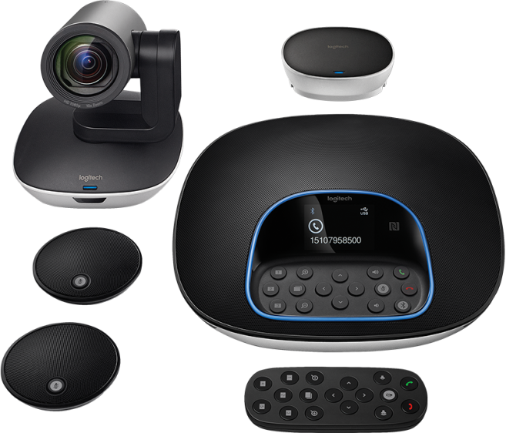Logitech Group I Video Conference Camera I Hd & 10X Zoom

Rp20.999.000

DESCRIPTION :

Conference Cam

Full HD 1080p 30fps

H.264 UVC 1.5 with Scalable Video Coding

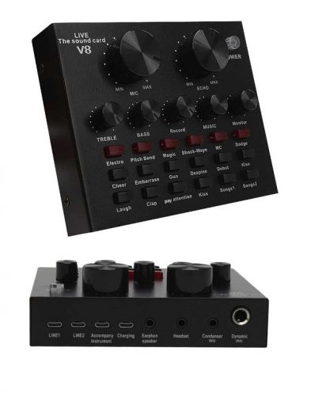Taffware V8s Bluetooth Audio USB External Soundcard Live Adapter v8

Rp300.000

DESCRIPTION :

1 x Taffware Bluetooth Audio USB External Soundcard

Live Broadcast Microphone Headset - V8S  
2 x Micro USB to 3.5mm Jack  
1 x USB Cable  
1 x User Ma nual

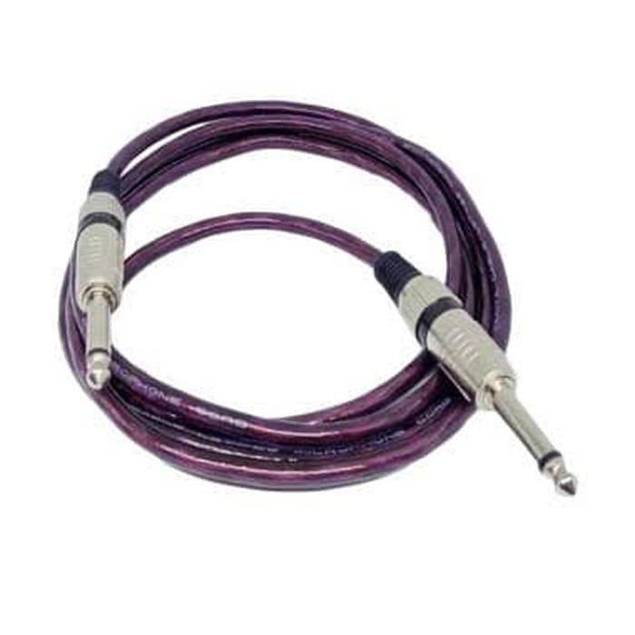Kabel Jeck Audio

Rp300.000