Hierarchical Task Network Editor Software Proposal

Prepared by Leonard Andrew Spencer

# Overview

This project is a tool for creating and editing Hierarchical Task Networks (HTN) to use in game AI. Designers will be able to set the conditions and effects of actions, and assign the child actions which will be used to perform a higher level action. The task network will be displayed visually, to allow designers to easily check their work.

# Product Description

This project will be a desktop application used to create and edit HTNs. Users will be able to create new actions and variables, and set the conditions, effects, and child actions for an action. Actions will be displayed both textually as a list of actions, and visually as a graph of actions and their children.

The HTN will be saved as an XML document, describing the actions and their relationships. This can be used by another application to generate a HTN which can be used by game AI, as long as the HTN’s primitive actions have been implemented.

# Requirements

## User Interface

The user interface will be created using the WinForms library.

At the top of the window are the Menu Strip and Tool Strip.

On the left side of the window is the Element Tab Control. The two tab pages, Actions and Variables, allow the user to view the list of actions or variables, create or delete members of these lists, and select them for editing. Actions can be dragged into the Graph Panel, to display the action as a Node.

In the middle is the Graph Panel. This is used to view the HTN as a graph of actions and their children. Actions are displayed with a custom Node control, which can be dragged around the Graph Panel area and double-clicked to show or hide its children.

On the right side is the Edit Tab Control. The action or variable selected in the Element Tab Control can be edited here. Both Actions and Variables allow their name and description to be edited. Actions can also have preconditions, effects, and child actions added or removed. Clicking the Add Condition, Add Effect or Add Child buttons opens a modal dialog allowing the user to choose the variable or action to be added.

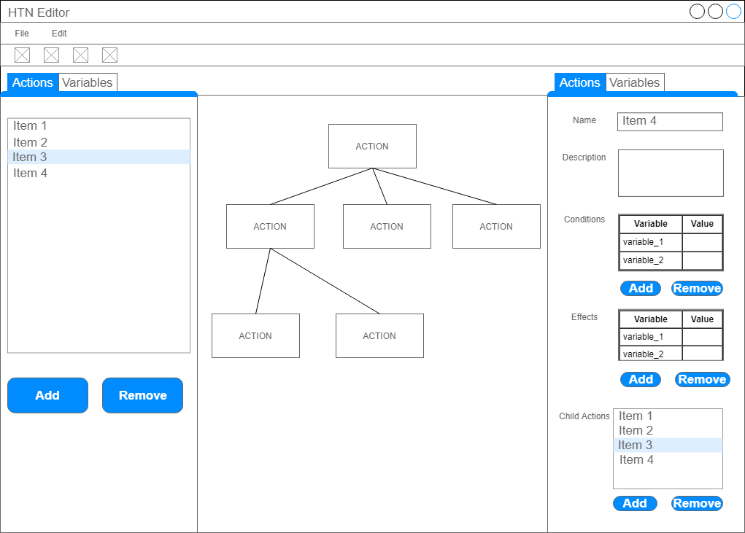

Figure Wireframe of the main form

## Functional Requirements

The editor must be able to save and load data from XML files.