ECEN 340 Project Definition
  - No Smoke Yet
Logan Rasmusson, Tanner Ray, Gavin Mikesell, Shaymon Madrid

Project Scope
Describe the type of project you will be creating. Include details on what it is, what it will do, and why it is important. Are there any industry specifications that are applicable?
Our project is to design and implement an FPGA-based Digital Multimeter using the Basys3 development board and a 12-bit ADC. The multimeter will continuously measure an analog input voltage, convert the sampled data into a digital value, perform the necessary arithmetic to calculate the voltage, and display the result on the Basys3's seven-segment display. A finite state machine (FSM) will control operating modes such as live voltage measurement, peak hold, and minimum and maximum voltage recording, while memory will store measurement data in real time. This project is important because digital multimeters are essential tools used throughout electrical engineering, manufacturing, research, and industrial automation for testing and troubleshooting electronic systems. The design will follow applicable industry specifications, including the timing requirements of the ADC interface, reliable operation at the Basys3's 100MHz system clock, and the measurement limits and resolution provided by the 12-bit ADC, resulting in accurate and real-time voltage measurements.

Lessons to Learn
Describe the key elements you’ll need to learn more about to complete your project. Include information such as “the team will learn about wireless and cloud connectivity” or “the team will learn how to implement power control software” or similar.
To successfully complete this project, our team will need to learn about implementing a complete digital measurement system on an FPGA. This includes interfacing with a 12-bit ADC, designing finite state machines (FSMs) to control measurement modes, performing fixed-point arithmetic to convert ADC counts into voltage values, and using on-chip memory to store measurement data such as peak, minimum, and maximum values. We will also learn how to ensure the design meets timing requirements while operating at a 100MHz system clock, and verify functionality through simulation and hardware testing.

Roles and Responsibilities
Define roles and responsibilities for each team member and report them here. Note the team leader is required, but the others are provided just as examples.
Role | Name | Responsibilities
Leader & Assistant | Logan Rassmasson | - Responsible for coordinating the project schedule, assigning tasks, organizing meetings, ensuring milestones are met, integrating the individual modules into the final design, and preparing the final demonstration and report.
ADC | Shaymon Madrid | - Responsible for designing and testing the ADC interface, implementing the voltage conversion logic, and verifying that analog input values are accurately converted into digital voltage measurements.
7-segment Display & FSM | Gavin | - Responsible for developing the seven-segment display controller, implementing the user interface with buttons and switches, and designing the finite state machine (FSM) that controls the multimeter's operating modes (live measurement, peak hold, minimum, and maximum).
Memory & Testing | Tanner | - Responsible for implementing the real-time memory functions used to store measurement data, developing simulation testbenches, performing hardware verification on the Basys3 board, debugging the integrated system, and assisting with documentation and the final presentation.

Schedule
Proposed Project Timeline
- July 1: Finalize project requirements, assign team roles, and complete the project proposal.

- July 7: Complete the ADC interface and verify analog voltage readings. Finish the finite state machine (FSM) and user interface for selecting measurement modes.
- July 10: Complete the voltage conversion calculations and seven-segment display output. Implement real-time memory features for peak, minimum, and maximum voltage storage.
- July 14: Integrate all modules into a complete digital multimeter and begin full-system testing. Complete simulation, hardware debugging, and verify all required functionality.
- July 16: Write up documentation and submit.

Hardware (FPGA-based) Block Diagram

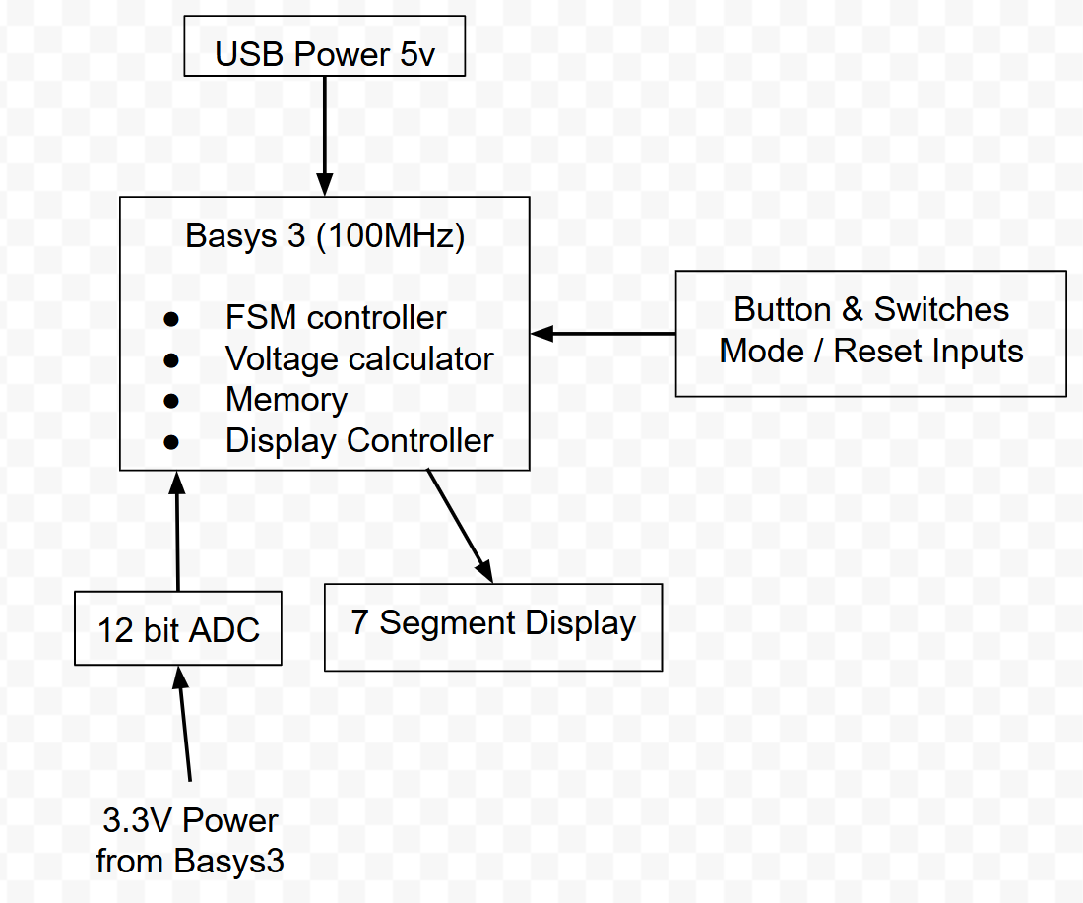

Selection of Elements to Demonstrate in this Design
- Finite State Machine (at least 3 states)
- Real – Time Memory access at 100MHz
- Higher level Math Functions (Multiply or Divide)
- 7-segment display
- External Sensors (light, sound, off-board switches)
- Serial Interface to Other Board
- Analog to Digital Converters (ADCs) or Digital to Analog Converters (DACs)
- Voltage conversion logic
- Peak / Min / Max measurement storage
- Fixed-point arithmetic
- Measurement mode control

Expectations of Testing the Design
The project will be tested in stages before the complete system is integrated. The ADC interface will be verified by applying known input voltages and confirming that the correct digital values are received by the FPGA. The finite state machine (FSM) will be simulated and tested on hardware to ensure the measurement modes such as peak hold, minimum, maximum voltages transitions correctly when buttons are pressed. The voltage conversion logic will be tested by comparing calculated voltage values with expected results for known ADC counts. The real-time memory functions will be verified by confirming that peak, minimum, and maximum values are stored and updated correctly during operation. The seven-segment display controller will be tested to ensure the correct numerical values are displayed. Finally, the complete digital multimeter will be tested using several known DC voltage sources and compared against a commercial digital multimeter to evaluate the accuracy and functionality of the finished system.

