Contents
Copyright 4
Introduction 4
Installation and features 4
Macros Description 5
Toggle highlights 5
Document fields 5
Rename Objects (Figure 3) 5
Check styles 6
Direct Format Cleanup 7
Review of tables 7
Figures adjust 8
Browse Images 8
Limitations, known issues and tips 9
Templates 9
Fields 9
Styles 9
Cleaning direct formatting of Paragraphs 9
Cleaning direct format of Numbers (ordered lists) 10
Tables 10
Images 10
captions of the figures 10
About the translation 11

English | Español | Português

SanityCheck 1.0.1
Macros to unify the format and styles of LibreOffice guides.

Copyright
This document is copyright © 2024 by the LibreOffice Documentation Team. Contributors are listed below. It may be distributed and modified under the terms of the GNU General Public License version 3 or later or the Creative Commons Attribution License,version 4.0 or later.
All trademarks mentioned in this guide belong to their rightful owners.
Author | Contributors
B.Antonio Fernández | Olivier Hallot

Sources
The macros that make up the extension described here are the result of consulting different sources which I name in general terms since it is impossible for me to go into detail. These are:
- The documentation of the Basic language of the different StarOffice derivatives.
- The books: Aprendiendo OooBasic by Mauricio Baeza, OpenOffice.org Macros Explained by Andrew Pitonyak and Programmation OpenOffice.org by Bernard Marcelly.
As well as various consultations to the OpenOffice and LibreOffice forums and the study of other macros in the extensions for LibreOffice.

Introduction
SanityCheck is a macro library for Writer that is intended to help unify the formatting and styles of LibreOffice chapters and guides.
Although some tasks can be performed with Writer's own tools, macros attempt to centralize options that are specific to the chapter format and automate some processes that can be tedious and time-consuming.
As a safety rule, work on a copy of the file you are going to review and make progressive copies of your work.
Use macros preferably in chapters, before assembling the guide, as it will be easier to correct formatting errors and will reduce macro execution time.

Installation and features
Macros are packaged as an extension and are installed like any other extension, from the extension manager. Although it is unlikely that you have version 1.0.0 of this extension, it is recommended that you uninstall it to avoid problems.
- The macros are written in LO Basic so they should be compatible with any operating system without the need to install any dependencies.
- The extension adds a toolbar (Figure 1) as well as a menu named LO SanityCheck and the tools also appear integrated into the In Tabs user interface.
Figure 1: SanityCheck toolbar
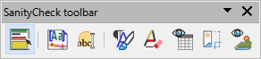
- The macros are available in Spanish, English and Portuguese, with the possibility of adding other languages by adding translations to the L10n module.
- The extension incorporate templates with the guides' own styles (also in the three languages to enable spelling correction):
Chapter template (for individual chapters).
Master Document template (to assemble the complete guide).
Back cover template (to attach to the end of the complete guide).
- Each dialog contains a built-in help page that provides information on the tool's function, and after running the macros a summary of the changes log is displayed.

Macros Description

Toggle highlights
The macro highlight or unhighlight guide styles applied in the document to easily distinguish the styles and check their correct application. It is especially useful for checking if lists have direct formatting applied.

Document fields
The macro opens a dialog where you configure most of the document properties and custom fields used in chapters.
Figure 2: Document fields dialog box
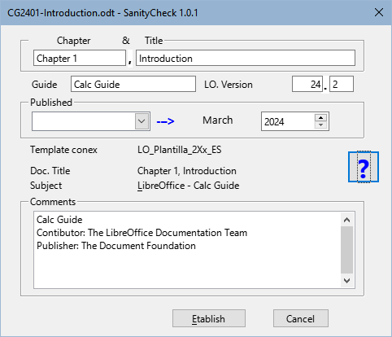
- Note
The Chapter X and Title fields are new fields. These fields are used to set the Title document property and also for the footer. Its use is recommended for the chapter name on the first page.

Rename Objects
This macro allows you to rename sections, frames, table, images and the index with a standard pattern for each object and consecutive numbering according to the order of appearance in the document.
Figure 3: Rename objects dialog box
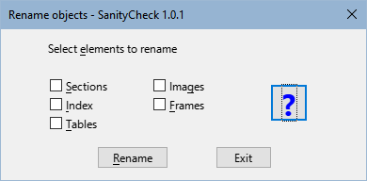

Check styles
- The macro check that the styles used in the chapters follow the template standards to avoid styles alien to the guides (generally styles from previous templates).
- The macro go through the document and mark the paragraphs with a style foreign to the documentation with a comment and highlight the foreign character styles with a black background and yellow font.
- The macro replaces the paragraph styles prior to the version 24 guides with their corresponding updated ones, some with incorrect names (transition to the new template) and the MenuPath character style with Strong Emphasis (remnants of old versions).
- The macro allows the elimination of alien styles when they are not applied to the document.
Figure 4: Style Check dialog box
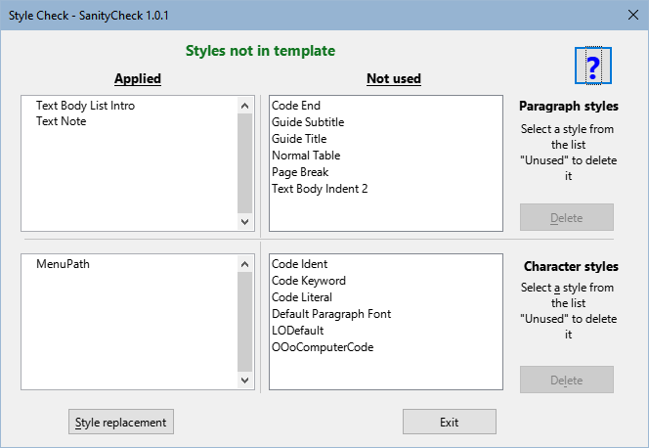
- Note
Macros can't do everything. The reviewer's job is to replace the styles outside the template with the correct ones and eliminate them from the document

Direct Format Cleanup
Figure 5: Format Cleaning dialog box
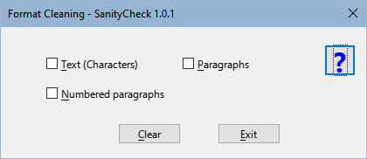
- Text: Clean up direct formatting applied to text fragments or strings.
- Paragraphs: Eliminates direct formatting, including bullets or numbering, applied to normal paragraphs and also cleans up direct formatting of unordered lists.
- Numbered Paragraphs: In this case, the macro removes the direct formatting applied to ordered lists and resets the numbering whenever possible, adding a comment to paragraphs where the numbering may need to be reset.
- Note
For the macro to correctly reset numbering, every list must be preceded by the Body Text, List Intro paragraph style. In many cases the style before the lists is Body text. The macro changes the style of preceding paragraphs to Body Text, List Intro style after a confirmation message.

Review of tables
Using a dialog, this macro allows you to go through the tables of the document and apply the LO User Guides table style to tables with data or optimize the spacing in the content distribution tables. You can edit the document while it is open.
Figure 6: Tables Review dialog box
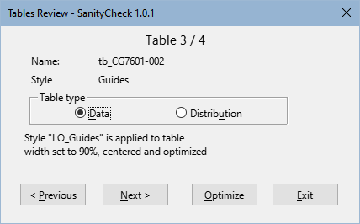

Figures adjust
Figure 7: Images Review Log dialog box
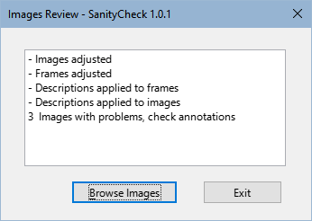
This macro has no initial dialog, it runs with the optimal settings for the frames and images. From the log dialog (Figure 7) you can access the Browse Images macro.
- The macro Applies the appropriate anchor and formatting to images, the frames that contain them, and the captions.
- The macro Gets the caption text to apply to the frame and image description.
- The macro Insert comments in:
Images whose aspect ratio is disproportionate.
Images that have been cropped with Writer.
Poorly formed captions (possible errors in the modification of an already inserted caption).

Browse Images
As with tables, you can browse the images through a dialog that shows information about the images and you can edit the document and some properties of the images and frames to correct errors. Please note that it does not modify the caption of the frames, only their description.
Figure 8: Images Review dialog box
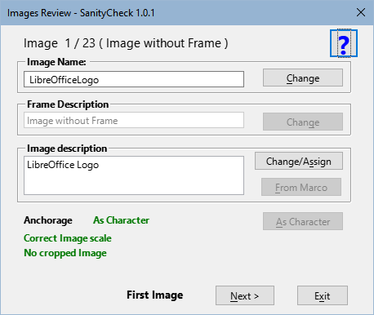

Limitations, known issues and tips

Templates
Macros for checking styles and cleaning up direct formatting are based directly on the styles of the supplied templates.
For macros to work correctly, chapters must have the appropriate template applied using the Template Changer extension or styles must be imported from the template.
Problem:
The templates are copied to the macro installation directory and are accessible to create new documents, but is difficult to access it for the Template Changer extension or for the user themselves.
Solution:
- Create a new document from the template.
- Save that document as a template.
- Import the created template to the user templates directory if necessary.

Fields
The document property fields introduced in version 24 such as Contributor, Editor, etc. are not accessible (at the moment) by macros. If necessary, set these fields in the Writer Document Properties dialog.

Styles
Problems with Style Names:
In some documents, due to the rush to publish the new version, paragraph styles have been created with names similar (but not the same) as they should be. This occurs in some chapters of the Writer 24.2 guide. For example, instead of Body Text, List Intro has the Body Text List Intro style applied (note that this name is without the comma)
Solution:
The macro replaces some of those styles with the correct ones, but it cannot handle all errors. Manually correct the affected styles.
Problem with character styles:
When clearing custom character styles, Writer does not update their status, and they continue to appear as applied even though they are not actually applied.
Solution:
Once the document has been cleaned of a character style, It must be saved and reloaded so that Writer can update the style status and, since it is not in use, it can be deleted.

Cleaning direct formatting of Paragraphs
The macro cannot distinguish what type of direct formatting has been applied to a paragraph, so it eliminates all direct formatting: indentation, numbering, spacing, etc.
Advice:
Use the Toggle Highlight macro before clearing direct formatting of paragraphs for a visual check.
A comparison with a pdf of the chapter you are updating can be very helpful.

Cleaning direct format of Numbers (ordered lists)
The numbering sequence in ordered lists may be interrupted by images, notices, notes or suggestions.
When clearing the format, the numbering sequence is lost and the numbering becomes continuous. The macros try to reset the numbering but it is not easy to distinguish where to reset them. Although the macro warns of points where it could be restarted, The macro is not infallible.
Advice:
Use the Toggle Highlight macro before clearing direct paragraph formatting for a visual check, and review the numbering after running the macro.

Tables
Custom table styles do not apply or function like paragraph or character styles, so even if you apply the LO User Guides style, you will most likely need to adjust the table for page splitting, if necessary and apply more appropriate formatting using Writer's Table Properties dialog.

Images
In some cases, the macro inserts a comment on images that is not understandable.
Problem:
LibreOffice uses many decimals for the aspect ratio of images, (it may use pixels) and macros use a rule of three based on the dimensions of the images and sometimes the operation performed by LibreOffice does not coincide with that performed by the macros.
Solution:
If there is a comment warning of a scaling problem and the width and height percentage are the same on the Crops page of the Image Properties dialog, try increasing both or one of the percentages by one unit and you will not receive the warning.

captions of the figures
In some cases the macro inserts a poorly formed caption comment that is not understandable.
Problem:
The macro gets the text from the caption and removes the “Figure” text based on the colon and space of the sequence. When editing the caption directly there are times when the space after the points is forgotten.
Solution:
Review the caption.
Problem:
In isolated cases the notice of poorly formed caption can be found and the caption was well formed. This may be due to strange formatting in the figure, for example images with a frame inside the caption frame (nested frames).
Solution:
Reconstruct the figure by copying just the image and pasting it into another paragraph (be sure to copy only the image) and insert a new caption.

About the translation
If you have read this far, you will have seen many vocabulary and grammatical errors.
This document is translated from Spanish with Google (some corrections made by me).
I'm sorry my English is so bad but I hope this document was understandable.

