**Packages**

**\*Define a package inside a java program**

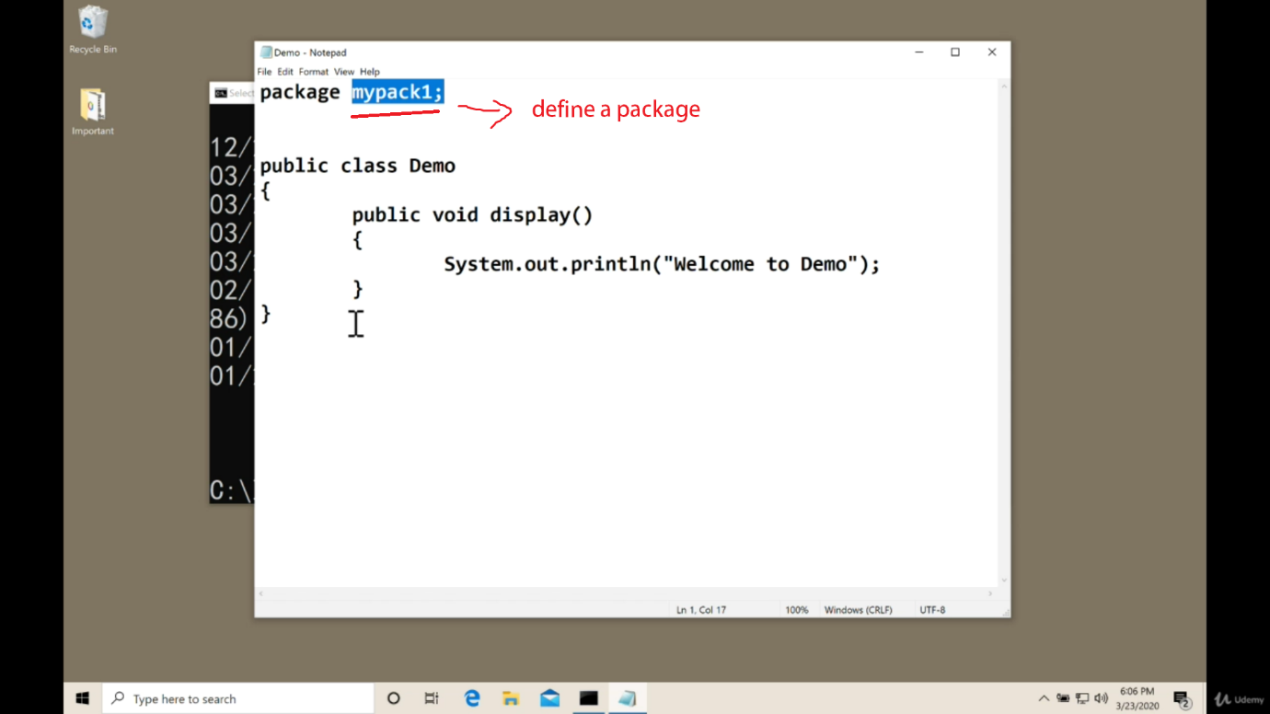

*Create package folder for the very first time.

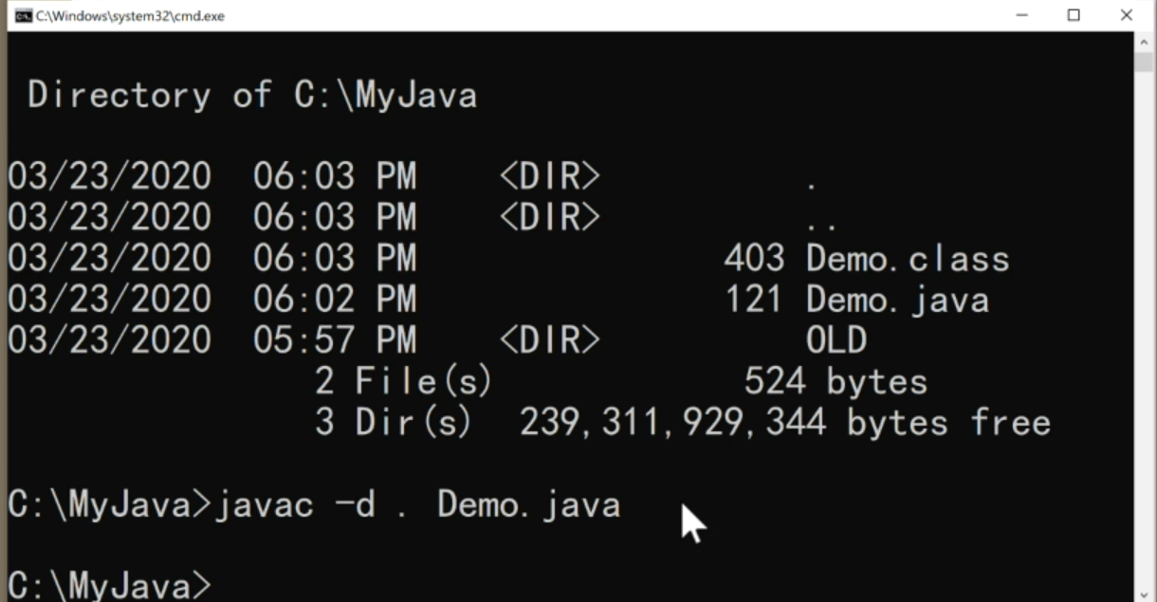

**Javac –d . Demo.java:**

Here –d stands for directory so if the package folder is not existing it will create in the current directory ( **“.”** Means in the current dir)

You can use **javac –d <path for package> <file_name>**

For creating a package directory or just putting a class in the existing package directory it’s necessary to write

***Package package_name***

at the beginning of the .java file

**Sub Packages**

**\*Define a SubPackage**

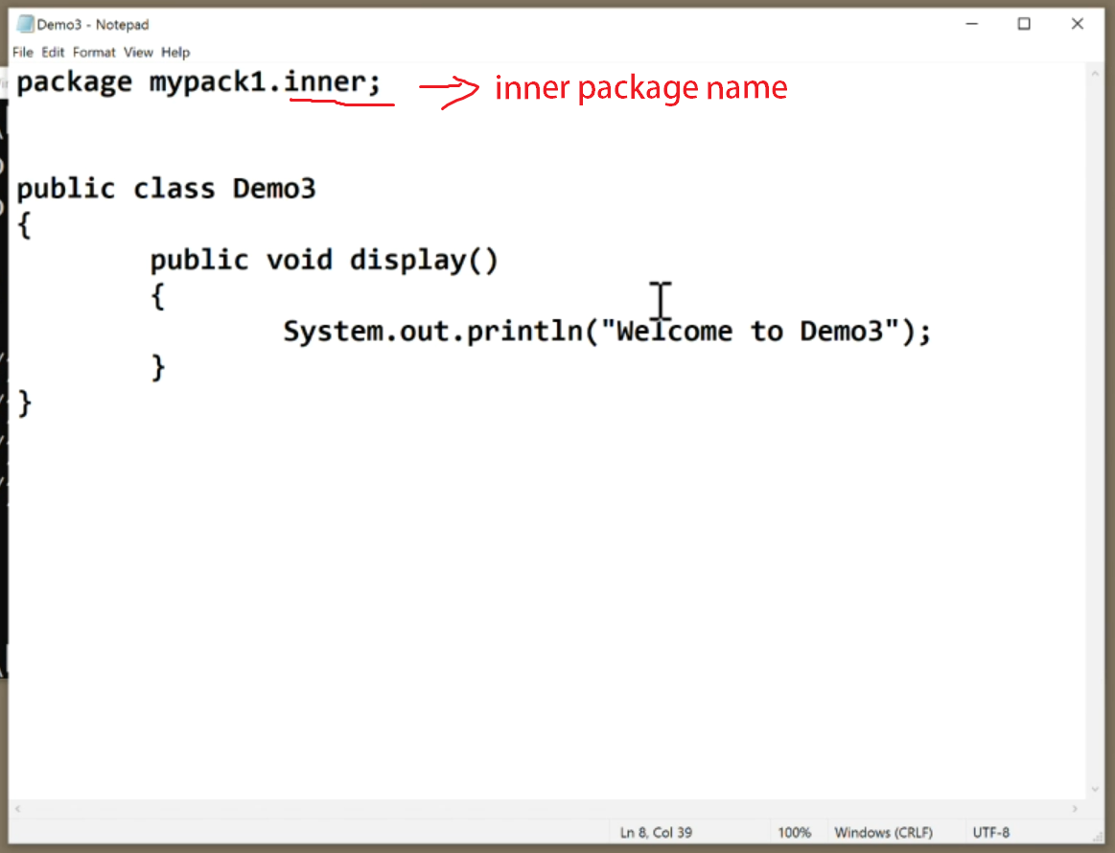

**\*Run this program.**

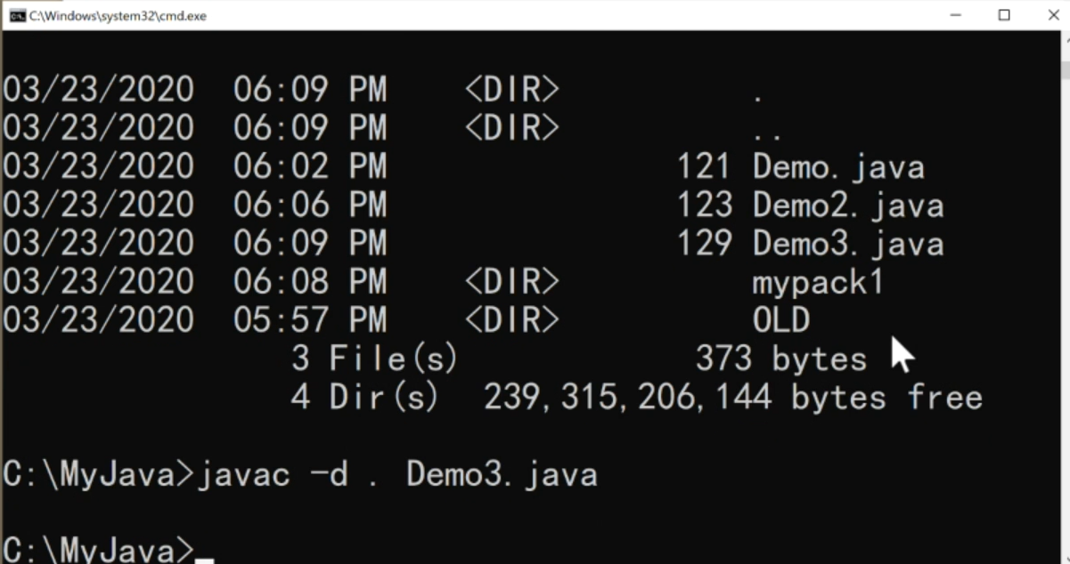

This will just create a another folder(inner) inside mypack1

*keep remember that when you perform with ( **“.”**) you should be just outside of the mypackage1 folder

Like: /dir/mypack1/inner

Then you should be in dir.

**Import classes from Packages**

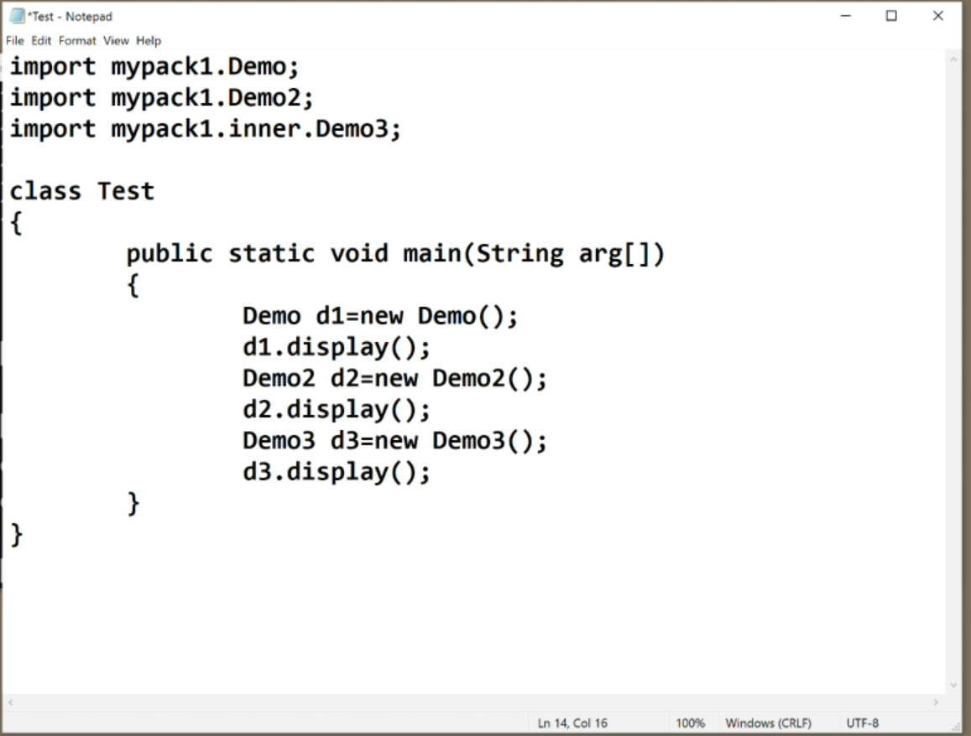

*keep remember that when you perform with ( **“.”**) you should be just outside of the mypackage1 folder

Otherwise you have to set the path

**set classpath=%classpath%.;/path/**

***this will set class path for cmd to access packages and class***