Interfaces

What is an interface?

Ans: an interface is nothing but an abstract class which having no

concrete method in it. So an interface basically forces the sub class to override the abstract methods of interface.

As we use **extends** keyword to extend super class or abstract

Classes here in Interface we use **implement** to implement an

interface

classes are Extended but interfaces are implemented.

The purpose of implementing interface is to achieve

**Polymorphism.**

**\***When you extends a super class to sub class you can only extend only one class but with interface you can implement n number interfaces separating their names by ( **,** )

exmp <interface1> **,** <interface2>

*if you implementing an interface then you must have to override all the method of interface otherwise you have to declare the class as abstract

*when you override a method of interface make sure you make it as **public** (put public before datatype of method)

Otherwise it will throw an error.

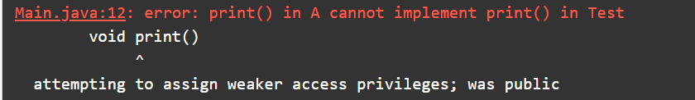

*You can not create an object of an **interface** but you can create a reference of it and can assign it to sub class’s object;